Basic Concepts in Heredity

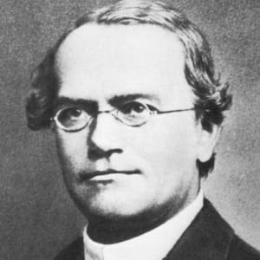
Heredity is the transmission of genetic characteristics from parent to offspring. Heredity affects our everyday lives. It is what makes every individual unique and every family similar. How does heredity work? What is genetics? What are genes and how do they work in terms of heredity? What are genetic tests and how do the results affect individuals? How is physical and mental health related to genetics? These questions and more are addressed in this chapter but first, we need to start at the beginning.
The beginning of heredity and genetics start with “the father of modern genetics,” Gregor Mendel. Mendel was a 19th century Austrian monk who discovered the basic principles of heredity through experiments in his garden (Fig. 1.1). Mendel spent his time as a monk studying and taking notes on pea plants. The experiments Mendel conducted showed inheritance patterns for certain traits. An inheritance pattern is the manner in which a gene is transmitted.
Mendel began his research around 1854, this was focusing on transmission of hereditary traits in plant hybrids. Until this point, it was believed that offspring of any species was a dilute blend of the traits the “parents” were known to have. Over generations, it was expected that the hybrid would eventually revert to the original form. This idea was often questioned because of the continued observation of these short-life organisms.
Fig. 1.1. Gregor Mendel. Photo from biography.com
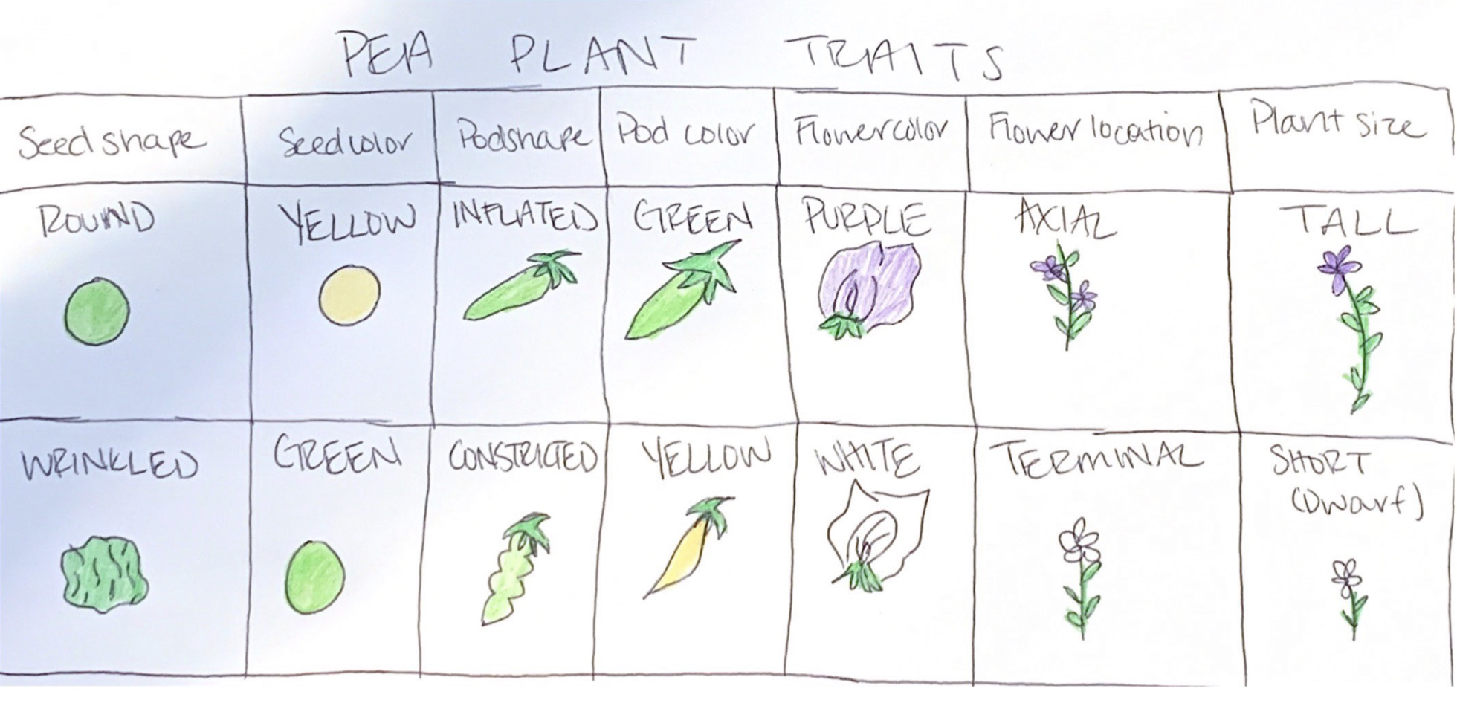
Peas were the plant of choice for this experiment due to their distinct varieties and how quickly they could be produced. Mendel mainly looked at 7 characteristics (Fig. 1.2): shape of seed, color of seed, color of pod, shape of pod, plant height, position of flowers, and flower color. Mendel conducted different experiments where he could see inheritance patterns of these traits in pea plants. Studying these characteristics lead Mendel to his most important conclusions: The Law of Segregation, established there are dominant and recessive traits passed on randomly from parents to offspring—this provided an alternate theory to blending inheritance which was the front runner at the time. The Law of Independent Assortment, established that traits were passed on independently of other traits from parent to offspring. These discoveries eventually proved to be a general application and a foundational principle of biology.
Fig. 1.2. Mendel’s 7 characteristics. Figure drawn by author.

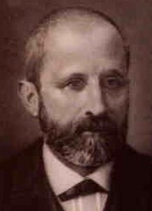
What is Genetics?
Genetics is the study of heredity and the variation of inherited characteristics. These inherited characteristics or traits are determined by specific elements of heredity called genes. Genes are transmitted from parents to offspring during reproduction. In 1869, three years after Mendel’s discovery Friedrich Miescher, a Switzerland born medical researcher, discovered a new type of substance abundant in the nuclei of white blood cells. At the time there was no way of knowing it would be the substance of which genes are made. This substance is called deoxyribonucleic acid (DNA), this is a self-replicating material which is present in nearly all living organisms as the main component of chromosomes. Chromosomes are bound nucleic acids and protein found in most living cells. Chromosomes carry genetic information in the form of genes. Information from these genes are used to build a functional product--this is called gene expression.
Key Terms:
Polypeptide: string or chain of amino acids linked together
Eukaryote: organism whose cells contain a nucleus within a membrane
Messenger RNA (mRNA): subtype of RNA, it carries a portion of the DNA code to other parts of the cell for processing
Nucleotide sequence: succession of base-pairs signified by a series of letters that indicate the order of nucleotides.
Amino acid sequence: basic building block of proteins
Transfer RNA (tRNA): subtype of RNA, helps decode mRNA sequence into a protein
Base-pair: pair of commentary bases in a double-stranded nucleic acid molecules. Cytosine (C) always pairs with Guanine (G), and Adenine (A) with Thymine (T—DNA) or Uracil (U—RNA)

Fig. 1.3. Friedrich Miescher. Photo from dnaftb.org
The Genetic Code
The genetic code is a set of rules by which information is encoded in genetic material, DNA or RNA sequences that is then translated to proteins which then code for a single amino acid. An amino acid is a simple organic compound that contains both a carboxyl (-COOH) and an amino (-NH₂) group. These amino acids link together to form a polypeptide that is expressed in two steps. Within this process, information flows from DNA→ RNA → protein, this directional relationship is known as the central dogma (Fig. 1.4) of molecular biology. The way that this is done is through specific processes called transcription and translation. In transcription, one strand of the gene’s DNA is copied into ribonucleic acid (RNA). RNA is present in all living cells. Typically, its role is to act as a messenger and carry instructions from DNA for controlling the production of proteins. In eukaryotes, the RNA transcript must undergo additional processing steps in order to become a mature messenger RNA (mRNA). In translation, the nucleotide sequence of the mRNA is decoded to specify the amino acid sequence of a polypeptide. This process occurs inside a ribosome and requires adapter molecules called transfer RNAs (tRNAs). During this process, nucleotides of the mRNA are read in groups of three base-pairs called codons. Each codon specifies a particular amino acid or a stop signal. This set of information is known as the genetic code.
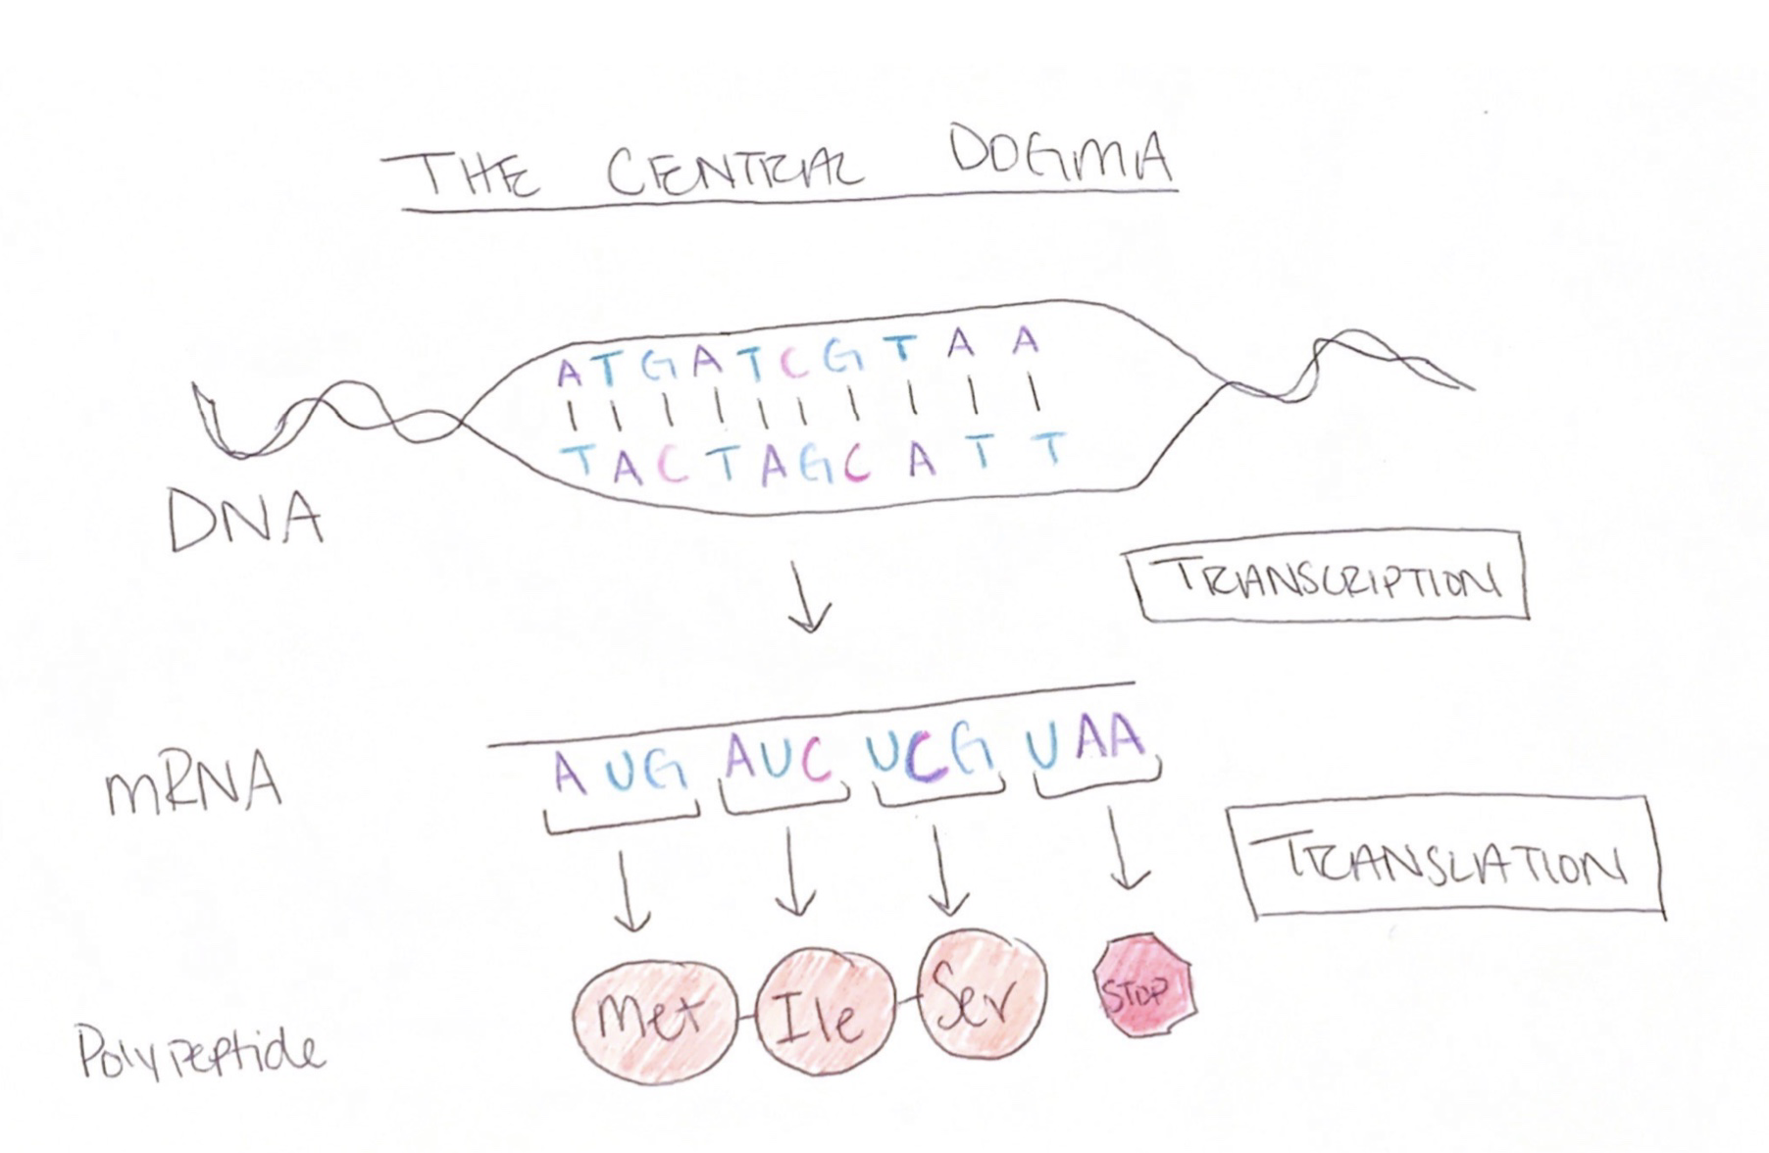
Fig. 1.4. The Central Dogma. Figure drawn by author.

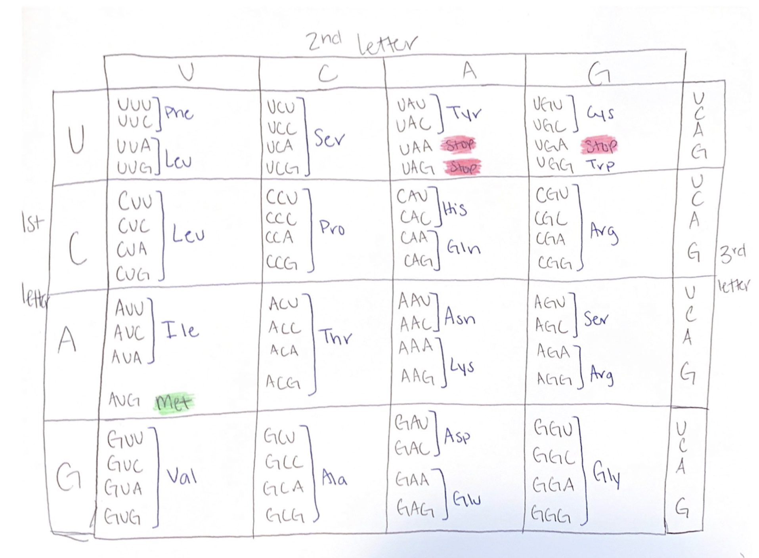
The Genetic Code’s Influence
The genetic code defines a map between the codons and amino acids. Each nucleotide triplet codes for a specific amino acid. The scientists who discovered this particular portion of genetics, Watson and Crick, already had identified 20 amino acids. They did the math for different combinations of 4 bases to try and get the proper number of amino acids possible but they could not find a number that was big enough. So, they settled on a number that is bigger than 20; this suggests redundancy in the code. There are 4 possible nucleotides available for this code, the codons function in a triplet fashion so, with the possibility of 4 base pairs at any of the three positions would equal 64 (4x4x4=64) possible amino acids. After studying this subject more, Watson and Crick decided that there had to be more than one way to get a specific amino acid (Fig. 1.5). This is the “zoomed in” scope of genetics and heredity. These codons are the first step in gene expression. This chapter is mainly focusing on the larger picture, so we are going to “zoom out” to understand how these four letters affect living creatures.
Fig. 1.5. The Genetic Code. Chart drawn by author.
Key Terns:
Allele: pairs of genes on a chromosome that determine hereditary characteristics.
Homozygous: a gene that has two identical alleles. Ex: BB or bb
Heterozygous: a gene that has two different alleles. Ex: Bb

Genotypes and Phenotypes
Going back to Mendel and his pea plants, think about the 7 characteristics (traits) he was observing. These observable traits are called phenotypes. Phenotypes are influenced by alleles that are both physically expressed and not expressed at all, this is the genotype. Mendel’s hybridization experiments show the difference between genotype and phenotype. The pea plants that Mendel was studying were homozygous for the trait he was studying.
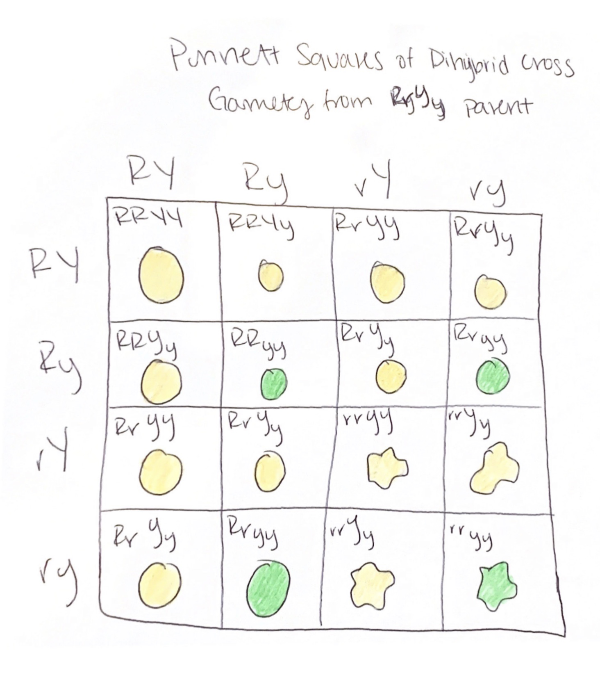
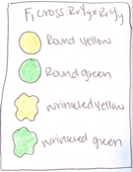
A specific trait we can use to understand this is whether or not the pea plant seed was wrinkled or smooth (round). Smooth seeds (RR or Rr) are dominant to wrinkled seeds (rr). Smooth seeds can either be homozygous or heterozygous because of the dominant trait’s ability to mask the recessive one. Mendel’s law of dominance states that in a heterozygote, one trait will conceal the presence of another trait for the same characteristic. The dominant allele is capitalized and the recessive allele is lowercase. Figure 1.5 shows a Punnett square of a dihybrid cross. This figure shows that these two characteristic do not interact with each other and they are both expressed individually.
Fig. 1.5. Punnett Square. Chart drawn by author.
Family: It’s in Our Genes
Key Terns:
Dominant: A dominant trait is considered as such if it is expressed while only having one copy of that gene present.
Recessive: A recessive trait is considered as such if it expressed only when two copies of the gene are present
Punnett square: square diagram that is used to depict and calculate all possible combinations and frequencies of the varied genotypes and phenotypes among the offspring in accordance to Mendelian inheritance.
Dihybrid cross: describes a mating experiment between two specimens that are equally hybridized (heterozygous).
Heritable trait: trait that can be passed on through genetics
Genome: the complete set of genes or genetic material present in a cell or organism.
Now onto the fun stuff, think about your family. How many times have you heard the phrase, “oh it runs in the family”? There definitely are some things that run in your family that you can clearly see. Hair color, eye color, and even bone structure to the extent where everyone in your family might look eerily similar. Other heritable traits might not be expressed physically such as, autism spectrum disorder (ASD), thyroid/hormone issues, and even muscle composition. There is a large amount of things that can be found in a person’s genome. For now, we are going to focus specifically on how your genes can impact your life whether it be negatively or positively.
Hair color is a very interesting trait to look into because of the variability within different hues, from the lightest blond to the darkest black. The color of an individual’s hair is determined by the amount of pigment, melanin, in hair. An abundance of eumelanin, a type of melanin, gives people black or brown hair. An abundance of pheomelanin, another type of melanin, gives people red hair. Blond hair is caused by very little eumelanin. The amount of melanin in hair is determined by many different genes but the most prevalent being, MC1R. Some people have variations within a copy of the gene and this causes the gene to be turned off or deactivated. This is described as a lack of function, for these individuals there is a lower production of eumelanin which means there is a higher production of pheomelanin. These individuals will either have strawberry-blonde, auburn, or red hair.
Health and Well-being
There are many things that can be influenced by an individual’s health and well-being. One thing that is not commonly thought of is that person’s genetics. Getting different genetic tests done can lead to a person learning more about themselves than where they are from. These tests can show a person the probability of different genetic disorders as well as being able to predict general health. The downside to extensive genetic testing such as these is that it is not widely used enough and the prices for genetic testing can range anywhere from $100 (ancestry) to over $2000 (full health) so it is not easily accessible.
Key terms:
Cystic Fibrosis: hereditary disease that affects lungs and digestive system. The body will produce a thick and sticky mucus that is likely to obstruct the pancreas and clog the lungs.
Huntington’s disease: neurological illness causing involuntary movements, severe emotional disturbance and cognitive decline.
Autosomal: pertaining to a chromosome in the body that is not a sex chromosome. People normally have 22 pairs of autosomes and 1 pair of sex chromosomes (allosome).
Asymptomatic: showing no symptoms
Physical Health
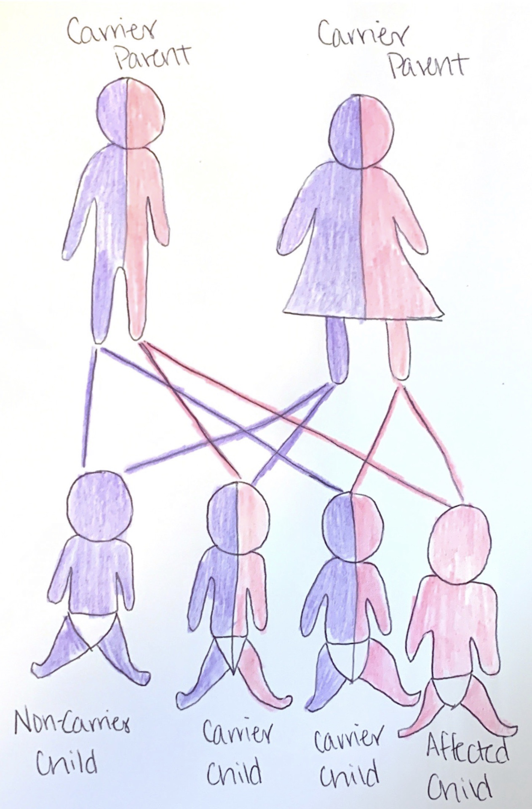
Genetic testing can be done for a multitude of reasons. Most individuals who choose to get genetic testing done do so because of a family health risk and wanting to be prepared for their future. Different types of genetic testing can be done for different reasons such as, diagnostic testing, carrier testing, and prenatal testing. Diagnostic testing can be done to check if an individual has a specific disease. A disease in which genetic diagnostic testing is done is Huntington’s disease, it is inherited in an autosomal dominant manner. Asymptomatic children of an individual who is mutation positive are eligible for testing after their 18th birthday.
Carrier testing is probably the most widely known use of genetic testing besides the recent increase of ancestry testing. Carrier testing is useful if there is a genetic disorder that runs in a person’s family. Going back to the specific science behind genetics, we learned about dominant and recessive genes and well as homozygous and heterozygous alleles. Carriers are individuals who has inherited a recessive allele but do not display the trait or show symptoms (Fig. 1.6). Having this knowledge can be beneficial for the future of the individual. If a person is a carrier for a debilitating genetic disease such as, cystic fibrosis (CF). Being aware of your carrier status is helpful when people are thinking about having a child. If both partners are carriers, their child’s risk of being born with this disease increase.
Fig. 1.6. Example of a carrier. Image drawn by author.
Prenatal testing is done during pregnancy to either screen for or diagnose a birth defect. The goal of this is to provide expecting parents with the knowledge they need to make informed decisions on their future child’s life. These types of tests can be done to look for CF carrier status, Down syndrome, and many more. Prenatal testing is done through two different methods, Chorionic Villus Sampling (CVS), and amniocentesis. CVS involves taking a sample of the tissue surrounding the sac where the fetus is developing. This provides chromosomes as well as other organic materials that can be used for diagnosis of chromosomal abnormalities, genetic birth defects, as well as other conditions. Amniocentesis is done by an obstetrician using a very thin needle to remove a small amount of fluid (amniotic fluid) surrounding the fetus. The same tests are done as CVS but a different sample is being used.
Key Terms:
Screen: not to diagnose but to assess whether or not someone is at high or low risk for a specific condition.
Down syndrome: condition in which a person has an extra copy of chromosome 21.
Chromosomal abnormalities: result in mutations which change the number of chromosomes or change the structure of a chromosome. This may alter the cell’s ability to survive.
Genetic birth defects: single gene disorder. A health condition that is present in a baby at birth.
Obstetrician: a physician or surgeon qualified to practice in childbirth and the processes associated with it.
Autism spectrum disorder (ASD): broad range of conditions characterized by challenges with social skills, repetitive behavior, speech and nonverbal communication
Attention deficit hyperactivity disorder (ADHD): differences in brain development that affect attention and self-control
Bipolar disease: mental disorder that causes unusual shifts in mood, energy, activity levels, concentration, and the ability to carry out tasks
Schizophrenia: long-term mental disorder involving a breakdown between thought, emotion, and behavior. This leads to faulty perception, inappropriate reactions and feelings, and a withdrawal from reality.
Major depressive disorder: mood disorder that causes a persistent feeling of sadness and loss of interest that can interfere with day-to-day functioning.
Well-being: a state of being comfortable, healthy, or happy.
Mental Health
One thing that is not often thought of when it comes to genetics is mental health. When in fact, family history is one of the best clues when looking at risk for developing mental disorders. There are no genetic tests in place quite yet for diagnosing mental disorders but there is always research being done in this area of study. Recently, research has found 5 major mental disorders—autism spectrum disorder (ASD), attention deficit hyperactivity disorder (ADHD), bipolar disease, schizophrenia, and major depressive disorder—share some common genetic components. With an increase of funding and more focus on these specific interests involving research, there will eventually be a way to be able to screen for and diagnose mental disorders. This will help tremendously with personalized treatment.
Well-Being
Having access to information about mental and physical health can greatly improve well-being. A person knowing what may or may not happen in their life can lead to a sense of satisfaction because they are able to plan for any life events that may come their way. Well-being is also improved because the genetic tests that have been described help physicians better treat their patients so they are not only more mentally well but physically.
References
Advanta Analytical Laboratories. (n.d.). Genetics Laboratories. Retrieved from http://www.aalabs.com/What-is-a-genetics-test
Alliance, G. (2009, July 8). INHERITANCE PATTERNS. Retrieved from https://www.ncbi.nlm.nih.gov/books/NBK115561/
Carson, H. L., & Robinson, A. (2019, October 28). Human genetics. Retrieved from https://www.britannica.com/science/human-genetics
Carrier Screening in the Era of Genomic Medicine. (2011, July 12). Retrieved from https://globalgenes.org/2011/07/11/carrier-screening-in-the-era-of-genomic-medicine/
Concept 15 DNA and proteins are key molecules of the cell nucleus. (n.d.). Retrieved from http://www.dnaftb.org/15/bio.html
Genetic Conditions. (n.d.). Retrieved from http://www.aboutgeneticcounselors.com/Genetic-Conditions/Huntingtons-Disease-and-Predictive-Genetic-Testing
Genetics: Studying the Building Blocks of Life. (n.d.). Retrieved from https://insourcedx.com/ISD/demo2/resources/technology/genetics.php
Gregor Mendel. (2019, April 17). Retrieved from https://www.biography.com/scientist/gregor-mendel
NIH. (n.d.). Is hair color determined by genetics? - Genetics Home Reference - NIH. Retrieved from https://ghr.nlm.nih.gov/primer/traits/haircolor
NIH. (n.d.). What are the types of genetic tests? - Genetics Home Reference - NIH. Retrieved from https://ghr.nlm.nih.gov/primer/testing/uses

