  - The Past
Space has always been an object of fascination since the beginning of time. Scientists have always studied the stars and the study of space biology, also called astrobiology, has been around since NASA’s establishment in 1958. NASA defines Space Biology as the “research to build a better understanding of how spaceflight affects living systems.” NASA founded its Astrobiology Program in 1960, although it was called exobiology then. Exobiology is simply the study of life on other planets or in space. The program originally started as studying how life began, both on Earth and if it could exist on other planets. NASA actually funded its first exobiology project in 1959, before the start of the official program. This small project started as trying to design an instrument to detect microbial life in extraterrestrial environments. Soon after, NASA joined into researching an emerging idea known as SETI: The Search for Extraterrestrial Intelligence. This idea spread and eventually began NASA’s famous Project Orion, to build a vehicle safe for human space travel.

Mars

While the manned moon missions are very well known, they provided little information on the Astrobiology and study of life side of NASA missions. Mars, on the other hand, showed comparisons to Earth in its formation and evolution. Exploration of this planet started in hopes of understanding evidence of life beyond Earth. In 1975, Viking 1 became the first spacecraft to land safely on Mars and provided the first atmospheric measurements of Mars (See Image 1.11). The same year NASA was founded, Joshua Lederberg, won the Nobel Prize for discoveries in bacterial genetics. Lederberg’s research had always focused on the possibility of life beyond Earth, and he eventually became a key consultant during the Viking missions.

The Viking lander conducted three experiments on the surface of Mars to search for signs of life. Although no such signs were found, scientists discovered interesting chemical activity in the soil. The unique soil along with solar radiation is considered why living organisms cannot survive on the surface. This is because the solar radiation has caused a toxic surface soil. However, evidence of water was discovered in Viking’s imaging and provided a hopeful future for more excavations on Mars. Despite this information, Mars missions were suspended for many years due to the lack of discovery.

Into Deep Space

In the summer 1977, NASA launched the Voyager spacecraft to explore Jupiter, Saturn, Uranus, and Neptune. It wasn’t until March 1979 that Voyager 1 was able to take pictures of Jupiter (See Image 1.12). Europa, one of Jupiter’s moons, was a subject of interest because of its icy outer layer. A liquid ocean below the ice is an indicator of life. It wasn’t until the Galileo Mission in 1989 that confirmed the presence of a liquid ocean on Europa. The Galileo Mission also provided evidence of an atmospheric layer on Europa, although extremely thin. Both the ocean and thin atmosphere provides a scientific basis for possible life. Europa is not the only

moon to contain water, Callisto and Ganymede of Jupiter have been proven to hold oceans, but have yet to be studied in the same depth as Europa.

Saturn was another deep space planet of interest and Voyager 1 and 2 did several flybys. Soon after, the Cassini mission began its development to orbit Saturn and send a probe to the surface of Titan. The orbiter, Cassini, and the lander, Huygens, launched in 1997, but Huygens wouldn’t land on Titan until 2005. Cassini also found evidence of water on Enceladus, through geyser-like structures spewing ice. Based on other measurements that Cassini took of Enceladus, scientists think there is a large ocean beneath the surface. This discovery has named Enceladus one of the most likely places to have microbial life. Cassini lasted several years longer than planned, but it did meet its end in 2017. The spacecraft’s end was a deliberate dive into the surface of Saturn. Scientists did not want the spacecraft to land on one of Saturn’s moon and contaminate the surface, as the moons might contain life.

Revisiting Mars

Finally, in 1997, studying Mars became a staple in astrobiology once again because of the Mars Pathfinder Rover. Most of Pathfinder’s discoveries were about the Martian atmosphere and temperature, but it also provided geological samples of the environment. This allowed a more accurate analysis of the Martian rocks, dust, and soil. The Spirit and Opportunity Rovers came next; their missions were to find more information on the water activity of Mars. The data received from the rovers shows a history of water on Mars as well as other conditions required for microbial life (See Images 1.13).

In 2002, the Mars Odyssey Orbiter (See Image 1.14) discovered large amounts of subsurface Martian ice, which prompted more missions for further study. The Mars Phoenix Mission took effect in 2007, and its mission was to collect samples from the new polar ice discovery. During its mission, Phoenix was able to confirm the presence of subsurface ice as well as the presence of calcium carbonate and perchlorate. Carbonates are a reliable indicator to the presence of water and perchlorate is a food for many microbes on Earth.

The Curiosity Rover came next, a rover most people have heard of (See Image 1.15). Curiosity’s main goal is to determine if Mars is or ever was able to support microbial life. Launched in 2011, Curiosity was supposed to last around 2 years, and as of March 2020 it is still operational. One of the first samples Curiosity obtained included traces of what scientists consider the “building blocks” for life. These include, hydrogen, oxygen, nitrogen, carbon, sulfur, and phosphorus. A few years later, Curiosity found evidence of methane, which can indicate the presence of organisms, but is not definitive enough for a total confirmation. All of the discoveries made by Curiosity have advanced the knowledge of Mars but have not confirmed the presence of life. Curiosity is still collecting samples, exploring, and continues to search for microbial life.

  - The Present
Current Mars Missions

NASA currently has six ongoing Mars missions. The Mars Odyssey Orbiter and Curiosity Rover, discussed in the previous section, are two of the still operational Mars missions. In 2005, the Mars Reconnaissance Orbiter (MRO) launched, mainly to monitor the observable features of Mars, such as the surface and atmosphere. The MRO’s mission also was to observe potential landing sites for future surface missions. The MRO was able to identify the landing site of the Curiosity Rover, as the MRO was launched before the rover. Over the course of its life, the MRO has been responsible for the tracking of the surface missions, such as Opportunity, Spirit, and Curiosity. Currently, the MRO gave new data on the polar ice cap, specifically the movement of the ice. This provides more information on the Martian climate changes. In 2015, the MRO provided images of “mysterious streaks” occurring on the sides of craters. After further investigation, the streaks held certain hydrated salts, meaning some source of water had to be hydrating the salts (See Image 1.21). This discovery is still considered the strongest evidence for liquid water on Mars.

Other current missions include the Mars Express and the Mars Atmosphere and Volatile Evolution (MAVEN), but Insight is the most current mission. Launched in 2018, Insight was the first mission dedicated to studying beneath the surface. Insight, short for Interior Exploration using Seismic Investigations, Geodesy and Heat Transport, hopes to discover the origins of planet formation.

Hubble Space Telescope

The Hubble Space Telescope launched in 1990. At the time, there had been no discoveries of other planets outside our Solar System. Since Hubble’s launch, there have been over 3,000 planets discovered. It has also made over 1.3 million observations, and counting. What makes the Hubble so special is its sensitive cameras, able to detect objects as small as asteroids outside our Solar System. Hubble has been able to make measurements of the atmospheres of the newly discovered planets. Many planets seem to contain oxygen, carbon, hydrogen, and carbon dioxide, but have been found to be too hot or too for life formations.

One of the most amazing discoveries Hubble has made is observing the process of a star’s birth and death. The observations of a star’s birth show a strong and powerful beginning. It produces large amounts of ultraviolet radiation and shock fronts. For a star’s death, Hubble observed a supernova called Supernova 1987A (See Image 1.22). A supernova sometimes occurs during the death of a large star, a last goodbye of a star. Hubble was able to observe rings forming around the star and spots appearing on one of the rings caused from the explosion. Later, Hubble showed more details of the Crab Nebula’s death. It showed a spinning pulsar had remained at the center

of the nebula. A pulsar is a neutron star that emits electromagnetic radiation out of its poles. These observations are good indicators of our Sun’s birth, life, and eventually its death. Studying our Sun’s life and death is important to astrobiologists. The Sun is one of the most important factors of life, it is one of the main things that keep humans alive.

The Andromeda Galaxy is the closest galaxy to our Milky Way. Andromeda is considered our “twin” as it is also a spiral galaxy (See Image 1.23). While Andromeda was observed long before the Hubble was launched, the telescope is responsible for a more accurate measurement of its distance. Hubble found the galaxy to be 2.5 million light years away. The discovery of Andromeda has allowed scientists to compare and contrast our twin galaxies.

Current Jupiter Missions

Juno, a NASA probe, launched in 2011 toward Jupiter. Its mission is to measure Jupiter’s composition, magnetic field, and gravitational field. It is also looking for indicators on how Jupiter formed. The current theory on Jupiter’s formation is when the Sun formed it left matter, in the form of gas and dust. Gravity then pulled most of that matter to make Jupiter. Juno’s measurements will help scientists determine the accuracy of their current theory. Specifically, measuring the water and ammonia in the atmosphere will help determine if Jupiter has a solid core. A solid core would also help confirm the validity of the current formation theory. To help with these studying the planet’s core, Juno is mapping Jupiter’s gravitational and magnetic fields.

  - The Future
Going to a Star

Ninety-three million miles away lies our Sun. The Parker Solar Probe hopes to come closer to the Sun than any other spacecraft before. The Sun is instrumental in studying life on other planets, as it is the primary reason humans can live on Earth today. The probe was actually launched in 2018, however, it will not even come close to obtaining data for at least seven years. The probe will fly alongside the corona of the Sun, the outermost atmosphere, and obtain measurements of the atmosphere and solar wind (See Image 1.31). Questions about the Sun and the energy it provides have been asked for years. The probe was finally completed because of the advances in thermal engineering which will allow the probe to actually survive the heat of the Sun.

Mars 2020

NASA has a new rover planned for Mars in 2020 (See Image 1.32). It is hoped the rover will be a long term exploration, based on the success rate of the Curiosity rover. Its mission remains very similar to that of Curiosity’s, which is to learn if life ever existed on Mars, but also to study the climate and geology of Mars further.

Saturn’s Future

The Dragonfly mission is the future of Saturn exploration. The mission is currently planned for the year 2026, as a rover mission to Titan. Dragonfly plans to land on Saturn’s moon, Titan, and take more detailed observations of the moon. As astrobiologists believe Titan is a prime candidate for research, they are deeply involved in the instrumentation of the rover. The ocean on Titan has been a topic of interest for scientists. Being able to collect more samples and study it further will advance our knowledge about life on other planets. Hopefully Dragonfly will land on Titan in the year 2034, and thousands of new discoveries will be made.

Deeper Into Jupiter

The Jupiter Icy Moons Explorer, or JUICE, is a potential 2022 mission to explore three of Jupiter’s moons. Europa, Callisto, and Ganymede are the moons of interest, and this mission would be the first to orbit Ganymede. The mission hopes to map the surfaces of the moons, as well as the properties of the ice layers. Also, the mission wants to look further into the presence of organic molecules on each moon.

Europa Clipper is just a concept mission for now. The mission hopes to place a spacecraft in orbit around one of Jupiter’s moons, Europa (See Image 1.33). Since Europa has such strong evidence of water, of course it is of extreme interest to scientists, and in turn gets its own mission. Clipper would determine the thickness of Europa’s ice surface, as well as the depth and salinity of the water. While this mission has no potential launch date, the knowledge obtained would advance life formation theories.

Why is Space Travel and Astrobiology Important?

Astrobiology programs strive to understand the origins of the universe. By studying these origins, scientists can apply the knowledge to Earth. It is known that Mars is similar to Earth in many ways. Studying Mars’ evolution has resulted in a better understanding of Earth’s origins. Since the beginning of space exploration, new technologies had to be created. Humans could not go into space without new technology and industries. These new technologies have opened new improvements on Earth. The GPS was created for space programs, and now it is in every single smart phone. Space exploration has also improved weather prediction, as well as sunglasses. These things can be taken for granted in day to day life, but without the space programs in general, would not have been created.

Images Index

Image 1.11 Image 1.12

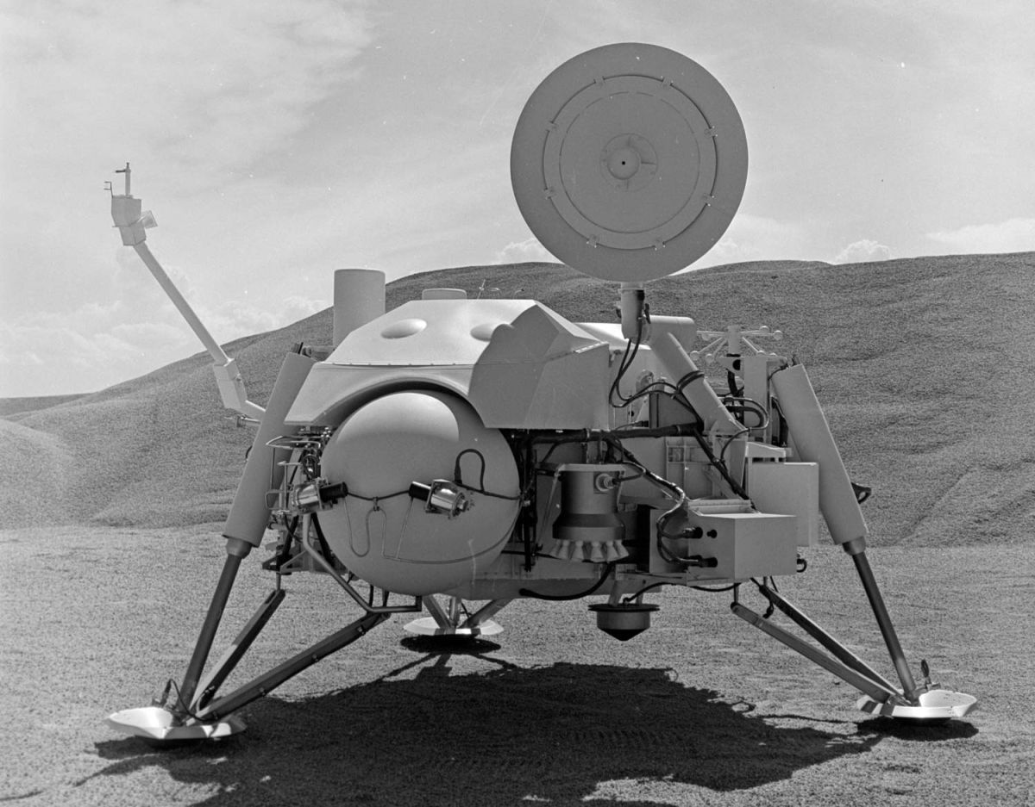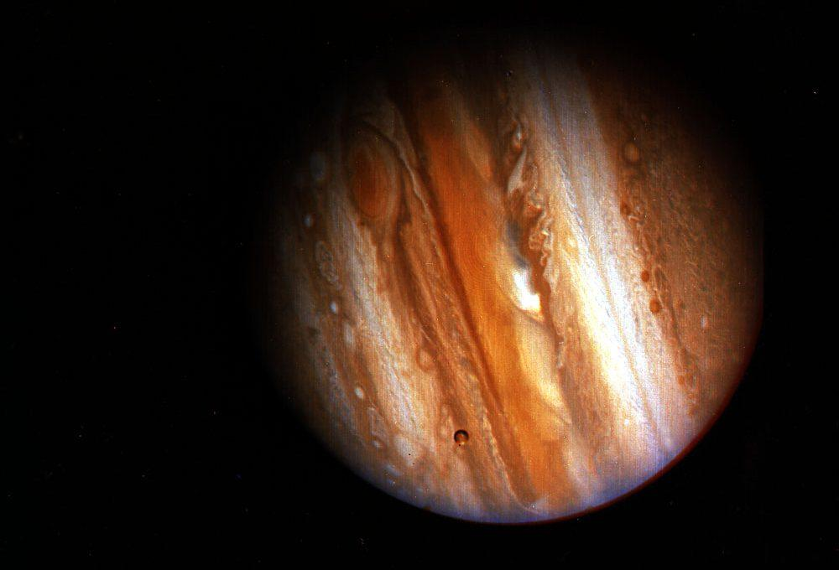

Viking 1 on Mars Voyager 1’s first image of Jupiter

Image 1.13 Image 1.14

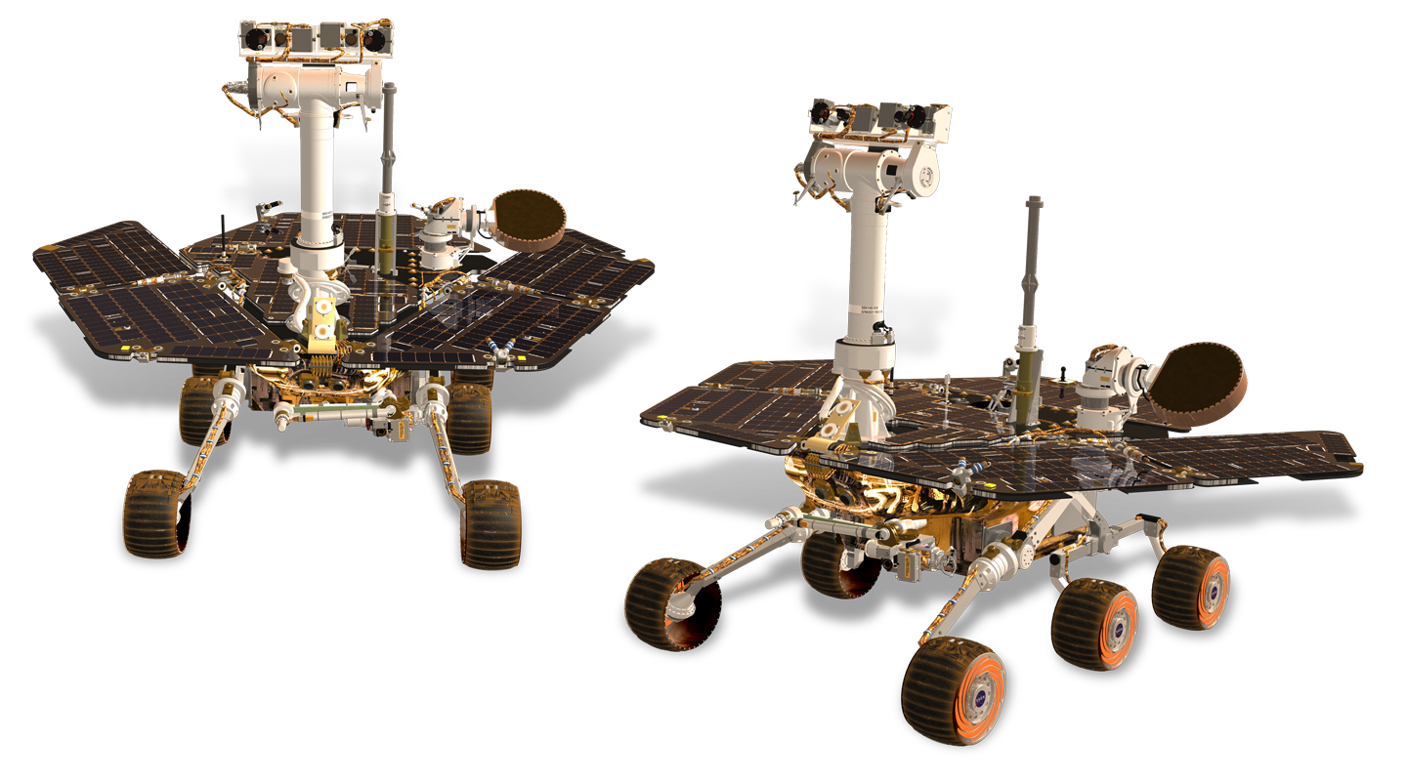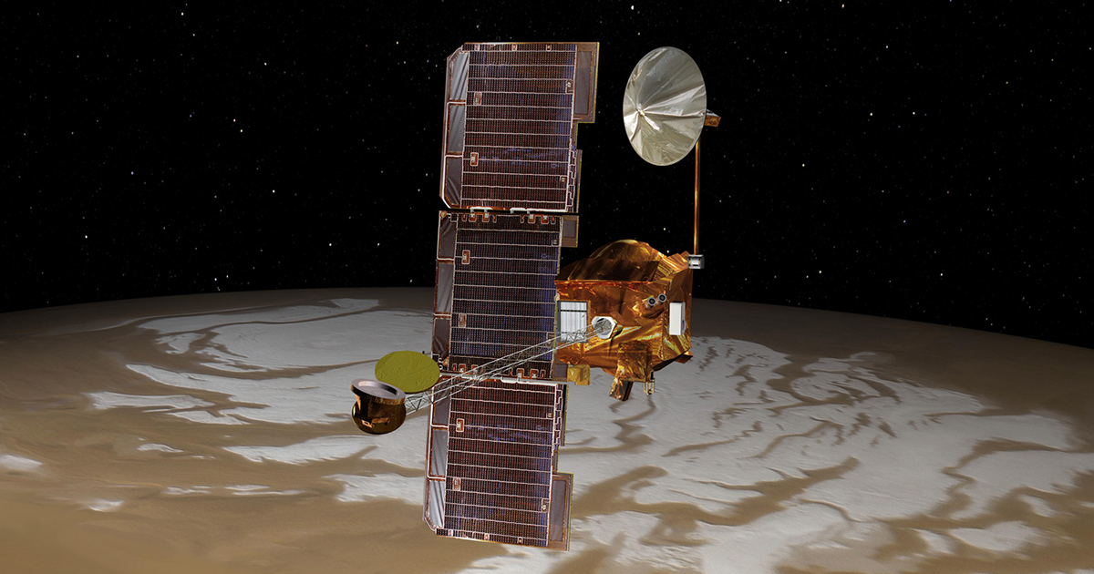

Spirit (left) and Opportunity (right) Mars Odyssey Orbiter

Image 1.15 Image 1.21

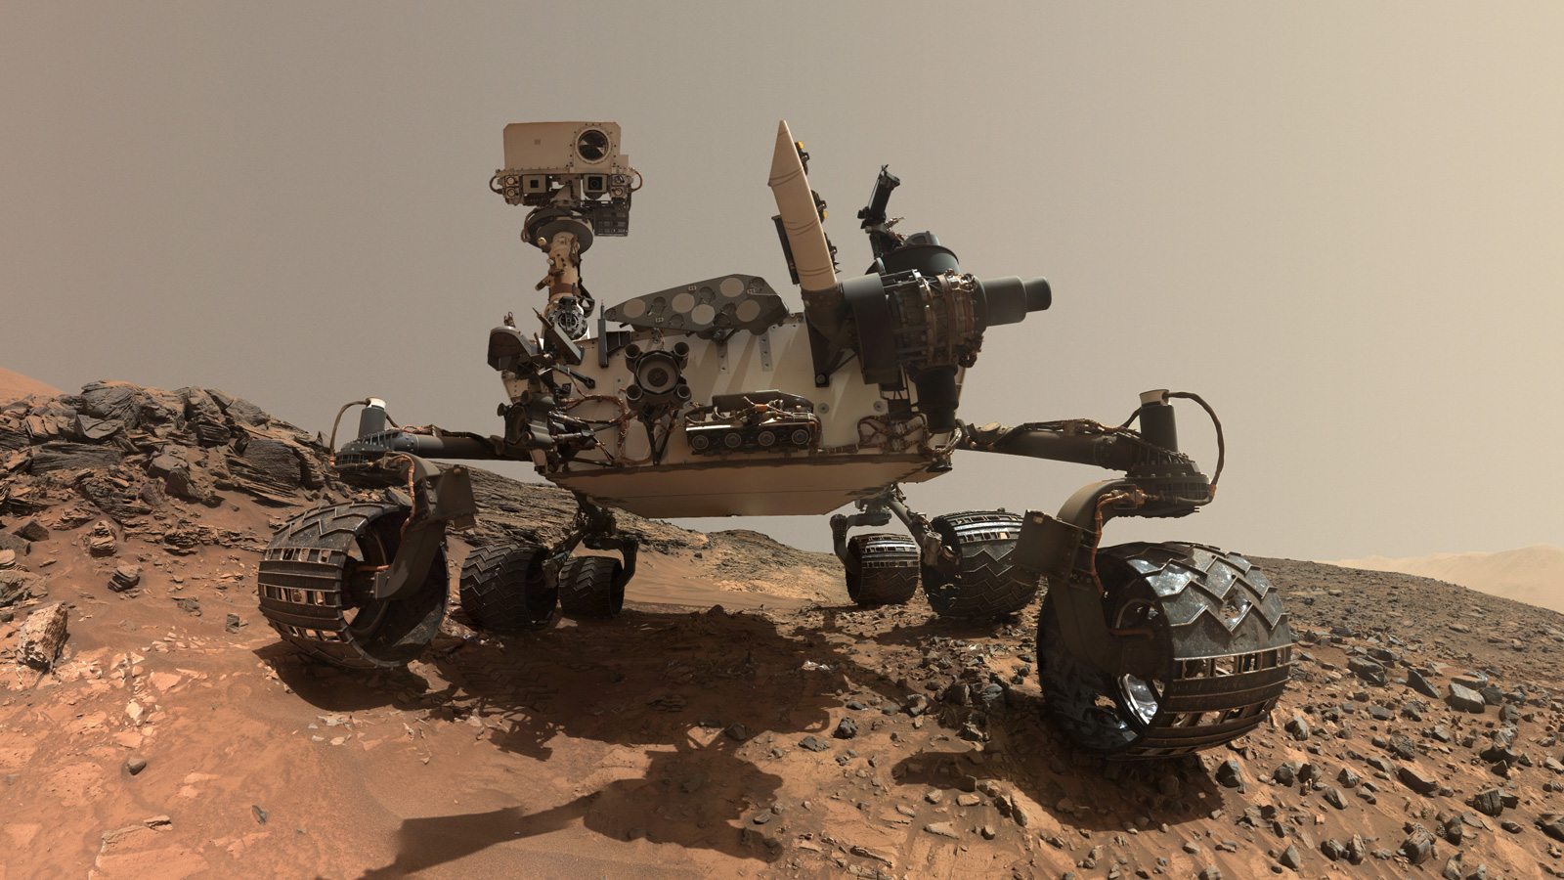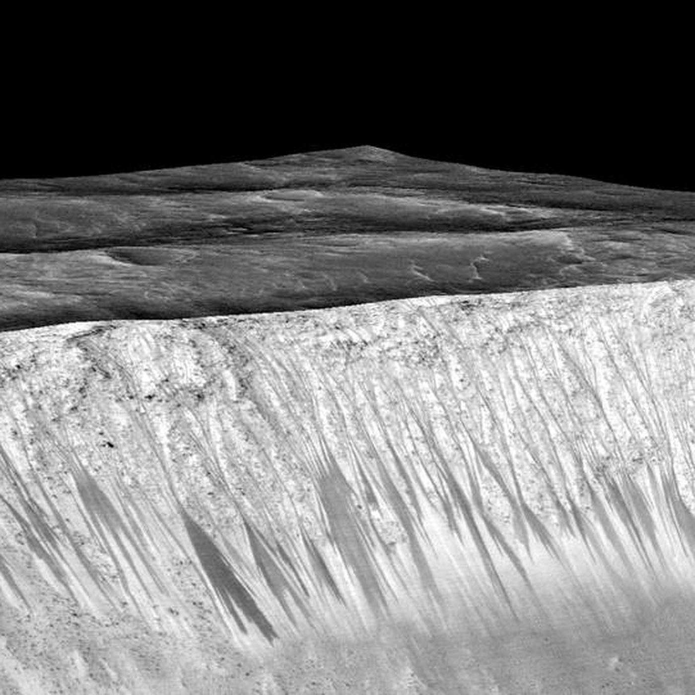

Curiosity rover on Mars surface Mysterious streaks on Mars surface

Image 1.22 Image 1.23

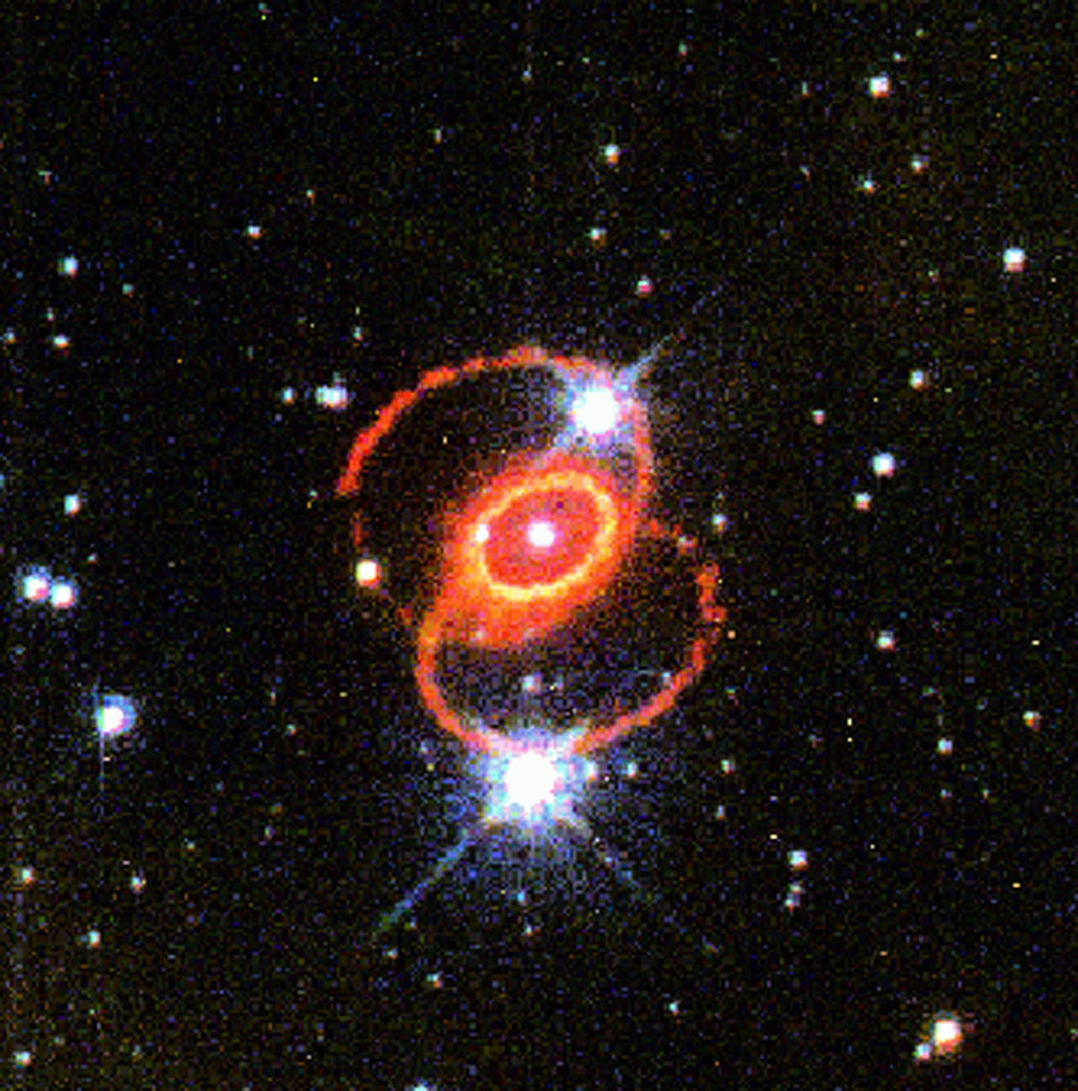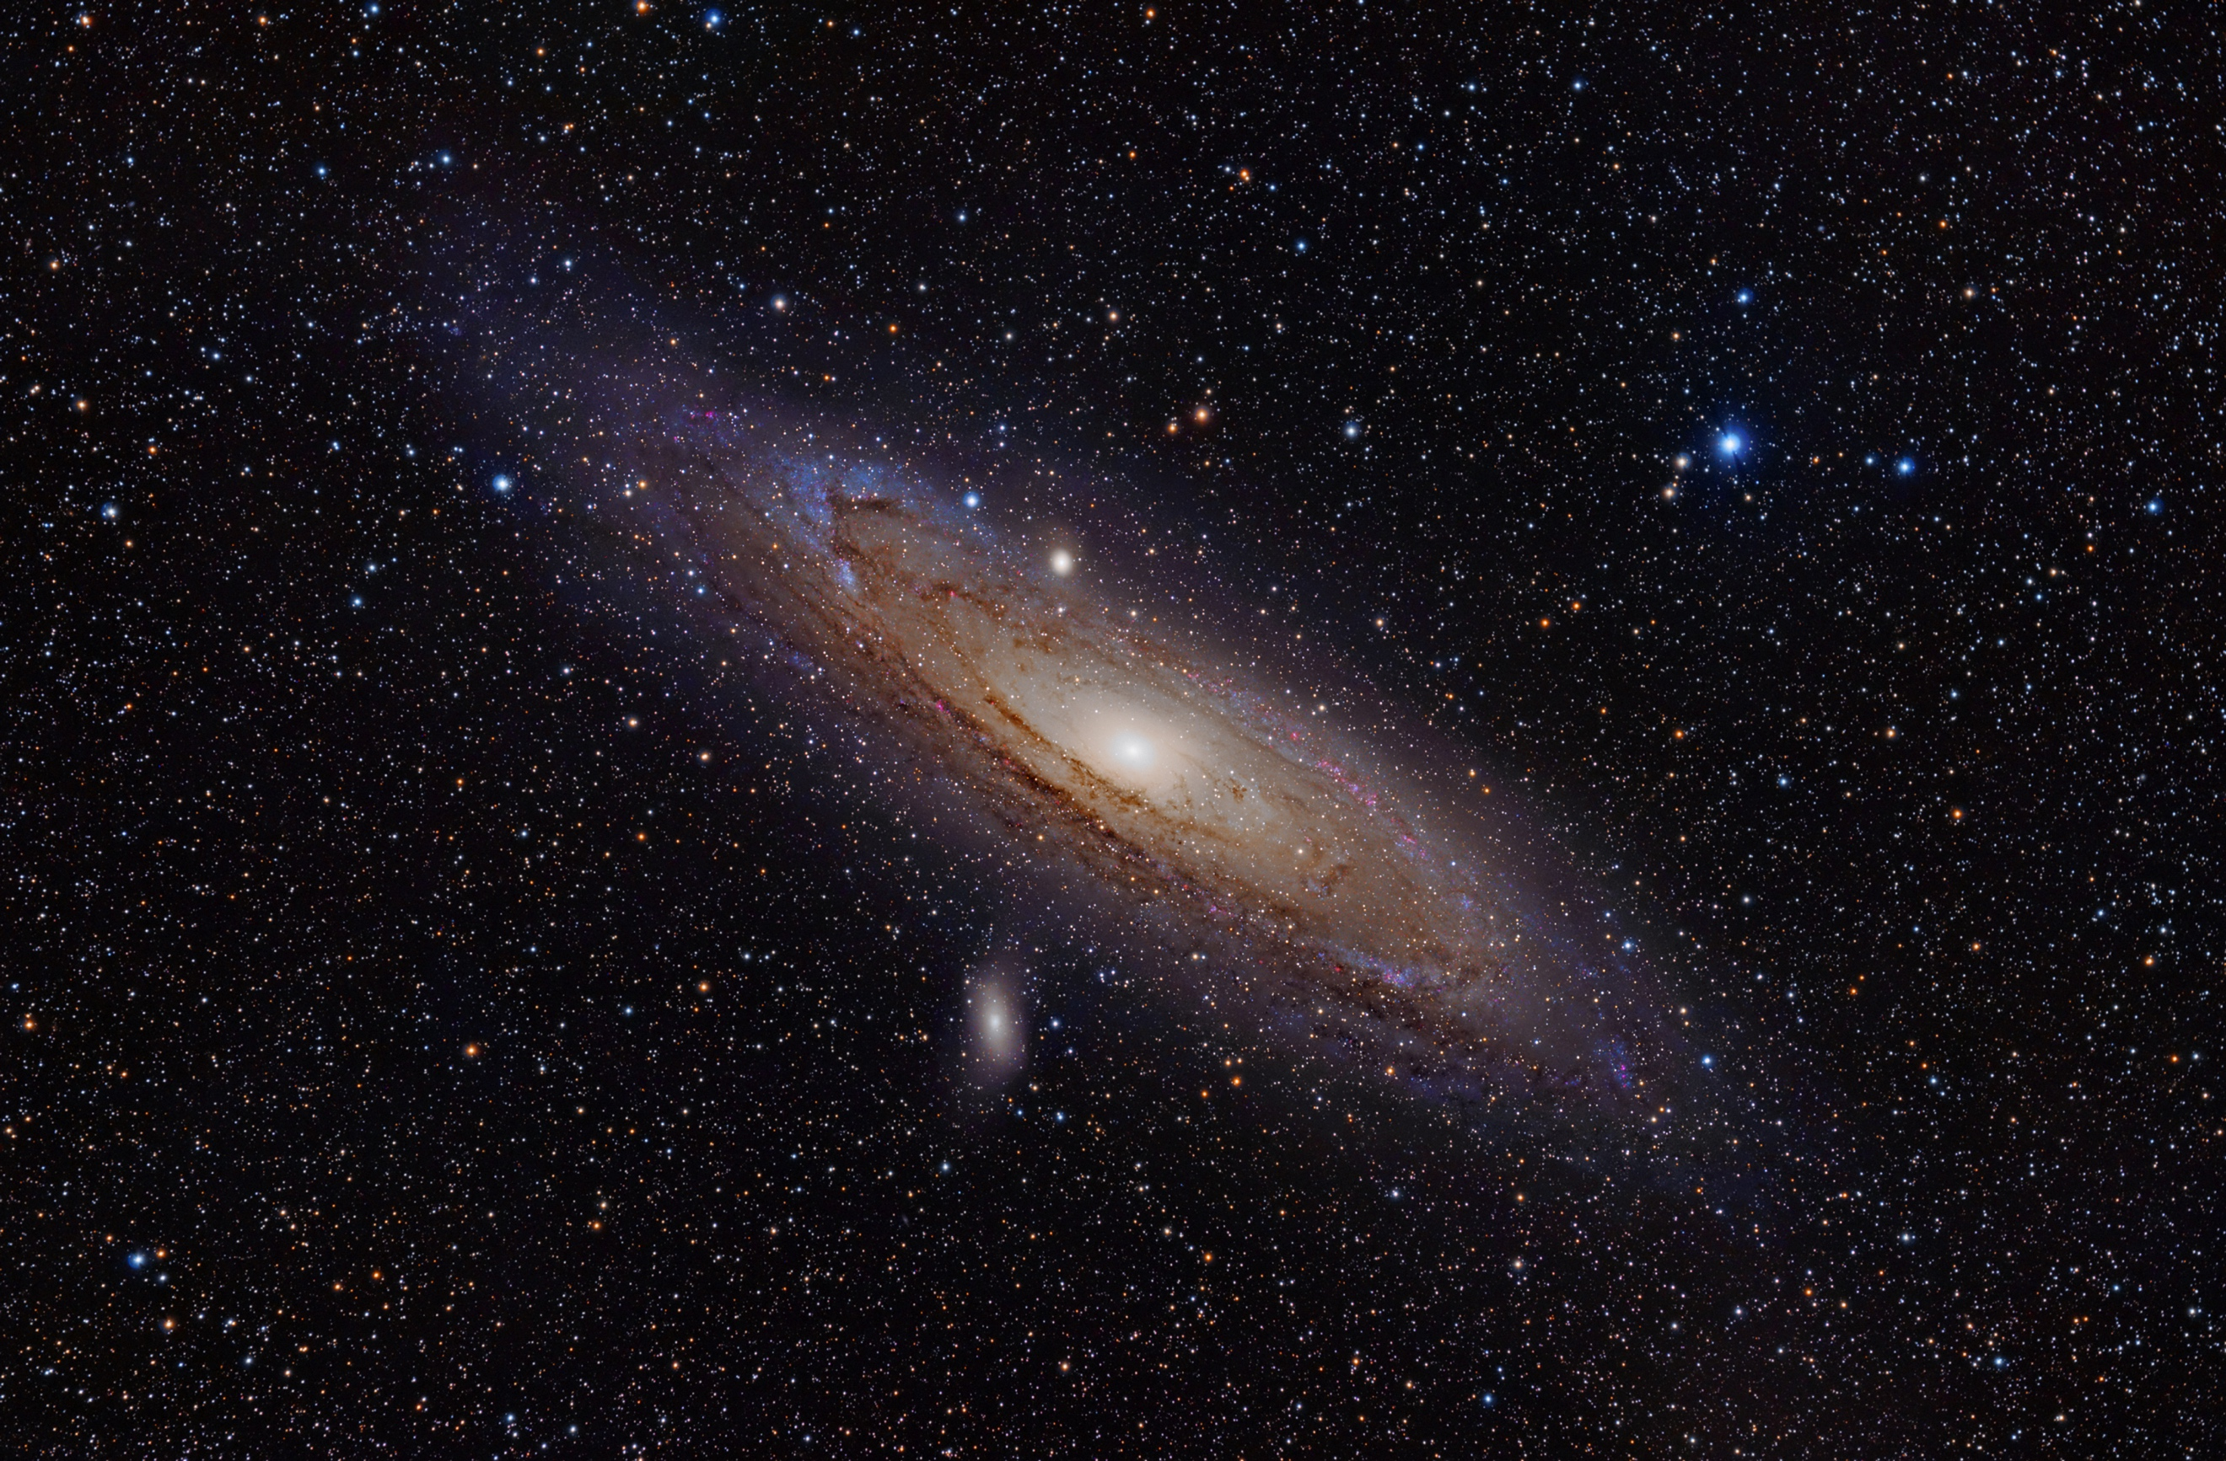

Supernova 1987A Twin galaxy, Andromeda

Image 1.31 Image 1.32

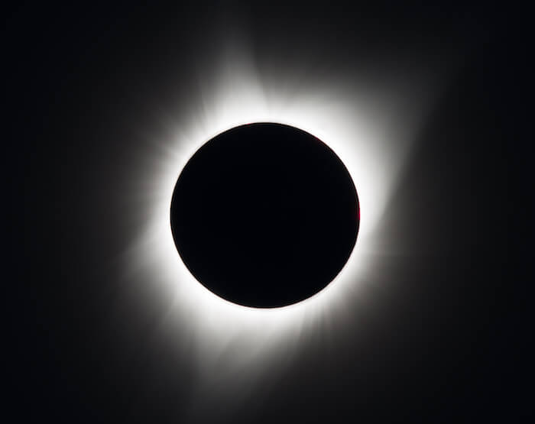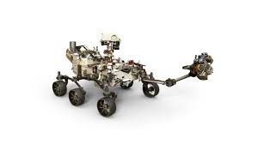

Sun’s corona (shown in white) Mars 2020 rover

Image 1.33

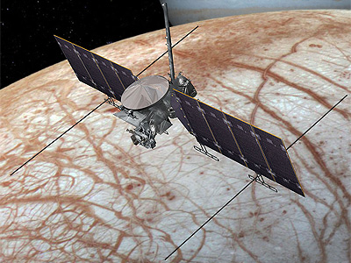

Europa Clipper mission spacecraft.

Word Index

Space Biology: research to build a better understanding of how spaceflight affects living systems

Exobiology: the study of life on other planets or in space

Viking 1: the first spacecraft to land safely on Mars and provided the first atmospheric measurements of Mars

Joshua Lederberg: won the Nobel Prize for discoveries in bacterial genetics, key consultant during the Viking missions

Voyager: a spacecraft designed to explore Jupiter, Saturn, Uranus, and Neptune, launched in 1977

Galileo Mission: confirmed presence of water on Europa in 1989, also provided evidence of an atmospheric layer

Cassini mission: found evidence of water on Saturn’s moon, Enceladus

Mars Pathfinder Rover: rover launched in 1997, allowed a more accurate analysis of the Martian rocks, dust, and soil

Spirit and Opportunity Rovers: missions were to find more information on the water activity of Mars

Mars Phoenix Mission: launched in 2007 to collect samples from Mars’ polar ice. Eventually, confirmed the presence of calcium carbonate and perchlorate

Curiosity Rover: main goal was to determine if Mars is or ever was able to support microbial life, still operational today

Mars Reconnaissance Orbiter (MRO): orbiter launched to monitor the surface and atmosphere of Mars. Also became responsible for tracking Opportunity, Spirit, and Curiosity

Insight: launched in 2018 to study beneath the Martian surface and study the origins of the planet’s formation

Hubble Space Telescope: telescope launched in 1990 with powerful cameras. Has made over 1.3 million observations and discovered more than 3,000 exoplanets

Supernova: can occur during the death of a large star

Juno: a probe launched toward Jupiter to measure Jupiter’s composition, magnetic field, and gravitational field

Parker Solar Probe: a future probe to the Sun. It hopes to study the Sun’s corona

Corona: the outermost atmosphere of the Sun

Dragonfly: rover planned to land on Titan

JUICE: potential 2022 mission to explore Europa, Callisto, and Ganymede. Hopes to map the surfaces of the moons, as well as the properties of the ice layers

Europa Clipper: mission hopes to place a spacecraft in orbit around Europa. It hopes to determine the thickness of Europa’s ice surface

References
Alexander, Sonja. “NASA Space Assets Detect Ocean inside Saturn Moon.” NASA, NASA, 23 Nov. 2015, www.nasa.gov/press/2014/april/nasa-space-assets-detect-ocean-inside-saturn-moon.
Anderson, Gina. “NASA Confirms Evidence That Liquid Water Flows on Today's Mars.” NASA, NASA, 28 Sept. 2015, www.nasa.gov/press-release/nasa-confirms-evidence-that-liquid-water-flows-on-today-s-mars.
Daines, Gary. “NASA's Journey to Mars.” NASA, NASA, 13 Feb. 2015, www.nasa.gov/content/nasas-journey-to-mars.
Dunbar, Brian. “Astrobiology: Its Origins and Development.” NASA, NASA, www.nasa.gov/50th/50th_magazine/astrobiology.html.
Dunbar, Brian. “NASA Advisor on the Search for Life Receives Medal of Freedom.” NASA, NASA, www.nasa.gov/vision/universe/solarsystem/lederberg_freedom_medal.html.
Dunbar, Brian. “Phoenix Mars Lander.” NASA, NASA, 2 Mar. 2015, www.nasa.gov/redplanet/phoenix.html#:~:text=.
Garcia, Mark. “Orion Spacecraft.” NASA, NASA, 15 Jan. 2015, www.nasa.gov/exploration/systems/orion/index.html.
Garner, Rob. “Discoveries.” NASA, NASA, 27 Jan. 2017, www.nasa.gov/content/goddard/2017/highlights-of-hubble-s-exploration-of-the-universe.
Garner, Rob. “Parker Solar Probe: Humanity's First Visit to a Star.” NASA, NASA, 24 May 2017, www.nasa.gov/content/goddard/parker-solar-probe-humanity-s-first-visit-to-a-star.
Greicius, Tony. “Phoenix Mars Lander Overview.” NASA, NASA, 25 Mar. 2015, www.nasa.gov/mission_pages/phoenix/overview.
Howell, Elizabeth. “JUICE: Exploring Jupiter's Moons.” Space.com, Space, 14 Feb. 2017, www.space.com/35692-esa-juice-facts.html.
Howell, Elizabeth. “Mars Curiosity: Facts and Information.” Space.com, Space, 17 July 2018, www.space.com/17963-mars-curiosity.html.
Kaufman, Marc. “NASA Astrobiology.” NASA, NASA, astrobiology.nasa.gov/about/history-of-astrobiology/.

NASA Jet Propulsion Laboratory. “Mars Reconnaissance Orbiter.”
NASA. “Mars Exploration Rovers.” NASA, NASA, 7 Sept. 2019, mars.nasa.gov/mars-exploration/missions/mars-exploration-rovers/.
NASA. “NASA Astrobiology.” NASA, NASA, astrobiology.nasa.gov/missions/2020-mars-rover/.
NASA. “NASA Astrobiology.” NASA, NASA, astrobiology.nasa.gov/missions/dragonfly/.
NASA. “NASA Astrobiology.” NASA, NASA, astrobiology.nasa.gov/missions/europa-clipper/.
NASA. “Viking 1 & 2.” NASA, NASA, 7 Sept. 2019, mars.nasa.gov/mars-exploration/missions/viking-1-2/.
Northon, Karen. “NASA's Dragonfly Mission to Titan Will Look for Origins, Signs of Life.” NASA, NASA, 27 June 2019, www.nasa.gov/press-release/nasas-dragonfly-will-fly-around-titan-looking-for-origins-signs-of-life.
Siegel, Lee J. “Looking for Carbonates in Dry Places.” Astrobiology Magazine, 9 Oct. 2002, www.astrobio.net/news-exclusive/looking-for-carbonates-in-dry-places/.
“Voyager - Mission Overview.” NASA, NASA, voyager.jpl.nasa.gov/mission/.
Webb, Carlyle. “Space Biology.” NASA, NASA, 16 Oct. 2017, www.nasa.gov/spacebio.
Wiles, Jennifer. “Why We Explore.” NASA, NASA, 13 June 2013, www.nasa.gov/exploration/whyweexplore/why_we_explore_main.html#.Xnt2eNNKhQI.

