Basics of DNA
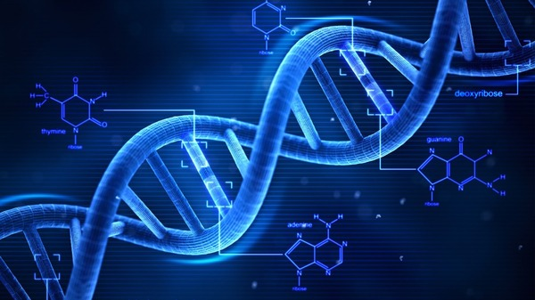

IMPORTANT TERMS
Genome: A complete set of genetic material of an organism
Adenine: Building block for DNA and also is used to store energy in cells

FUN FACT: CG pairs bond more tightly than AT pairs, so long stretches of CG make for stronger helices than the stretches of AT do.

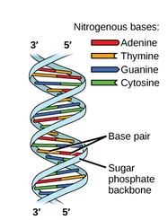
Fig. 1.1 Base pairing of DNA strands. Photo from hcrowder.com

Introduction to this chapter
In this chapter, we will take an in depth look at genetic materials that comprise the human genome. In order to understand a genome, you need the basics first. The goal of this chapter is to understand what DNA is, how it works, and its role in genetics and genetic traits.
Introduction to DNA
DNA, short for Deoxyribonucleic acid, is the inherited materials that comprise humans and almost all other organisms. It contains all the information necessary to make each human unique. DNA is a two stranded molecule in the shape of a ‘double helix’ and is made up of four distinct bases. Imagine a ladder that has been twisted. The rungs are the bases and the two outside pieces are the backbone. The backbone is made up of Phosphate and sugar while the rungs are made of nitrogen bases and hydrogen bonds. A Nucleotide is a basic structural unit for DNA containing a five-sided sugar, a phosphate group and a nitrogenous base. The four bases, when placed in a certain sequence, instruct the genome on how to look and behave. Each strand of DNA is made up of long sequences of these four bases. The four bases of DNA are Adenine, Cytosine, Guanine and Thymine.
DNA Bases
Each base plays an important role and depending on their order, mean something different. Even though there can be billions of bases of DNA in an organism, they are limited in how they can be put together. Adenine, for example, only pairs with or sits next to Thymine. Likewise, Thymine only pairs with Adenine. That leaves Cytosine and Guanine to pair up. The bases always pair this way, A with T, C with G and are held together by a hydrogen bond (fig. 1.1).
DNA Replication
Each strand of DNA has a beginning and an end. The beginning is called 5’ or five prime. The end is called 3’ or three prime. The two strands in DNA run antiparallel. This means one strand will run from 5’ to 3’ while the next runs 3’ to 5’ (fig. 1.1). During DNA replication, these strands are separated or unzip. DNA replication is semiconservative. This means each strand of DNA serves as a template for the creation of a new, complementary strand. The strands are synthesized from the 5’ end to the 3’ end and once completed, the result is two identical DNA double helices. Each strand with one newly synthesized strand and one old strand. Several different enzymes play a big role in this process, the most important being DNA Polymerase. DNA Polymerase is responsible for synthesizing the DNA. Meaning, it adds new nucleotides, one by one, to an ever-growing chain of DNA, making sure to only pair the correct bases and complimentary pairs to the strands template. They can only add these nucleotides to the 3’ end of the DNA strand. This process is not accomplished without the help of a short chain of nucleotides called a primer and some energy from those very nucleotides.
Replication Forks
DNA replication is not a randomly occurring event in any way. Every aspect of DNA replication is precise. It all starts in a specified location called the origins of replication. This origin is 245 bases long and mostly comprised of A-T base pairs. Specialized proteins recognize the origin and bind to the location site in order to begin un-zipping the DNA. An enzyme called Helicase is the first to begin loading itself onto the origin of replication. Its job is to “unwind” or unzip the DNA strand and thus break the hydrogen bonds holding the strands together. This causes the creation of two Y-shaped forms called the replication forks and these forks move in opposite directions from each other as the replication process proceeds (fig. 1.2). Single-strand binding proteins are then used to coat the two separated, Y-forked, strands of DNA to keep them from re-bonding back together. This leaves a problem in the replication process though. DNA polymerase can only add nucleotides to the 3’ end. Because of this, it can not add the first nucleotide to the newly formed replication fork. So, what next? 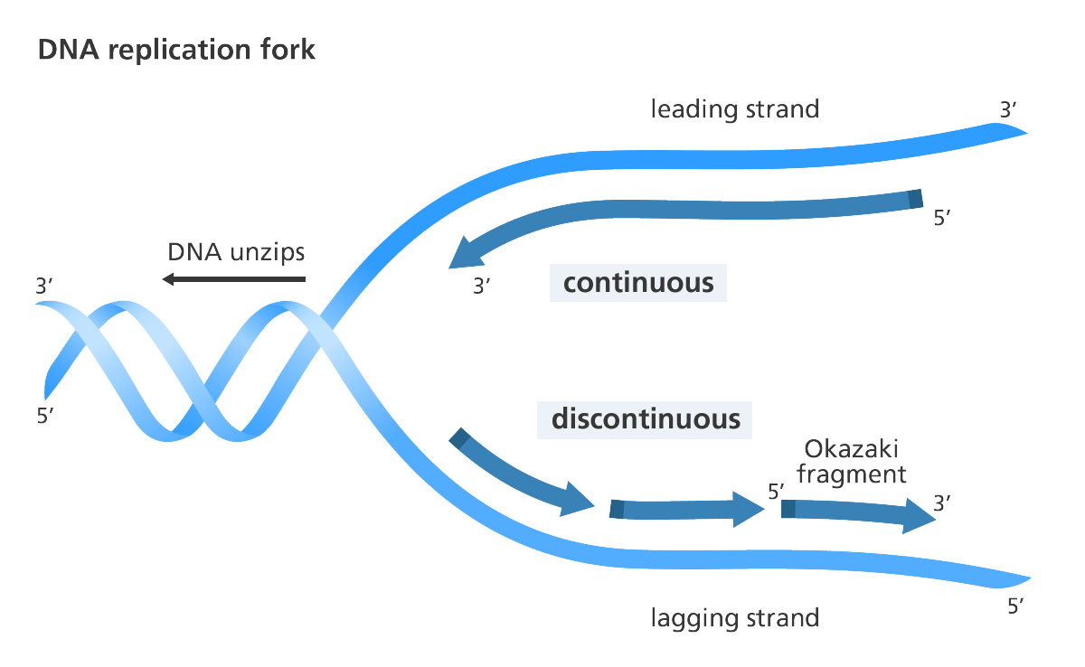
Fig.1.2 DNA Replication Fork Photo from yourgenome.org
Leading and Lagging
This is where an enzyme called primase comes into play. Primase creates an RNA primer, a short stretch of nucleic acid, complementary to the template. This creates the 3’ end the DNA polymerase needs in order to get to work. The two strands are distinguished as the Leading Strand and the Lagging Strand (fig 1.2). The Leading strand runs 5’ to 3’ and towards the fork and is continually made since it runs the same direction as DNA polymerase moves. The Lagging strand, on the other hand, runs 5’ to 3’ but away from the fork. Thus, it is made in fragments as the fork moves forward. The fragments are called Okazaki fragments. Named for the Japanese scientist who discovered them, each Okazaki fragment requires a new primer to start. Once the Polymerases are done replicating, it falls off and the end result is two identical DNA molecules.
IMPORTANT TERMS

Transcription: Process where DNA is copied into RNA
Translation: Process of translating the sequence of an mRNA molecule to a sequence of amino acids during protein synthesis
Codon: Nucleotides in groups of three
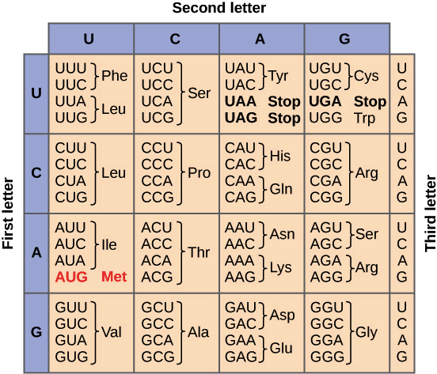
Fig. 1.4 Genetic Code Table photo from khanacademy.org
Nucleus: Organelle found enclosed in nuclear membrane, it contains the majority of a cell’s genetic materials
Mitochondria: Double-membrane-bound organelle, produce ATP (energy)
Genes: unit of heredity
Non-coding DNA: components of DNA that do not encode protein sequences
Mitochondrial DNA: DNA located in the Mitochondria
Chloroplast DNA: DNA found in chloroplast, also called cpDNA

Genetic Code
The specific way in which Adenine, Thymine, Cytosine and Guanine are bonded create a kind of special code called DNA’s Genetic Code. DNA’s Genetic Code allows for DNA and RNA sequences to be “decoded” into the appropriate proteins and amino acids. When a gene is providing instructions to make a protein, the instructions are expressed in two-steps. These two steps are Transcription and Translation. Cells are able to decode the mRNA by reading their Codons. Most codons specify an amino acid. Three “stop” codons are used to mark the end of a protein (fig. 1.3). The Genetic Code is essentially a roadmap between codons and amino acids. This “map” is often summarized into a table (fig. 1.4) which shows a full set of the relationship between codons and amino acids
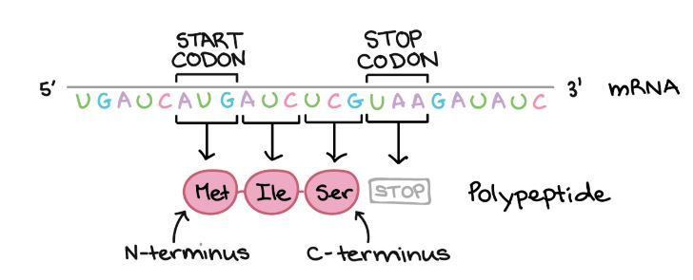.
Fig. 1.3 Codon photo from khanacademy.org
Genome
Now that you have a basic understand of what DNA is made up of and how it replicates, it is time to learn what it actually does. DNA is the chemical that comprises a genome. A genome is an organism’s complete set of genetic instructions. Meaning, a genome contains all the genetic information needed for an organism to form, grow and thrive. DNA is mostly located in the cell nucleus, but a small portion can also be found in the Mitochondria. The Genome includes both the genes and the noncoding DNA, the mitochondrial DNA and the Chloroplast DNA. A single gene consists of enough DNA to code for a single protein. A genome is the sum total of an organism’s DNA. The human genome contains approximately 3,000,000,000 base pairs, packed into 23 pairs of chromosomes. If your genome were printed out it could Fill two-hundred 500-page telephone directories. Your genome is not JUST made of up DNA though. It also contains a little something called RNA.
RNA
If you have ever looked in the mirror and wondered where your genetic traits come from, you know to look no further than your DNA. DNA traits are hereditary. This means they are passed on from parent to offspring. These traits determine your appearance. Physical traits like eye color or hair color are some of the first things people think about when they consider genetic traits. As it turns out though, DNA does not determine your physical traits. They are actually the result of DNA being sequenced into RNA and then further being changed into proteins. Most observable traits are found in proteins; however, it has been found that RNA does house some traits as well. RNA or Ribonucleic acid is a macromolecule, like DNA, and is essential for all known forms of life. RNA comes in two different forms that perform different tasks. mRNA and tRNA. mRNA, or messenger RNA, transfers information from the genome into proteins by method of translation. tRNA, or transfer RNA, transfers amino acids to the translation site so that they can be given to the ribosomes to make protein as instructed during translation. Your genetics also determine things like predispositions to cancer or early balding. There is a huge list of things you can learn from your DNA.
Genetics: A history
With all of this information, it makes it much easier to understand the concept of genetics. However, in 1865, an Austrian monk, made the first major ripple in the field of genetics. Gregor Mendel, known today as the “father of genetics”, began his study of genetics in 1850’s (fig. 1.5). He turned the study of heredity into a full-fledged science. Terms like genes did not exist yet so he had to start from square one. In 1857, he studied the peas he grew at the monastery. He studied them for eight years, searching for key traits and breeding certain peas together to get 7 specific traits with careful pollination (fig. 1.6).

Fig 1.5 Gregor Mendel Photo from Wikipedia.org
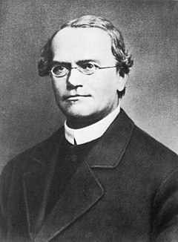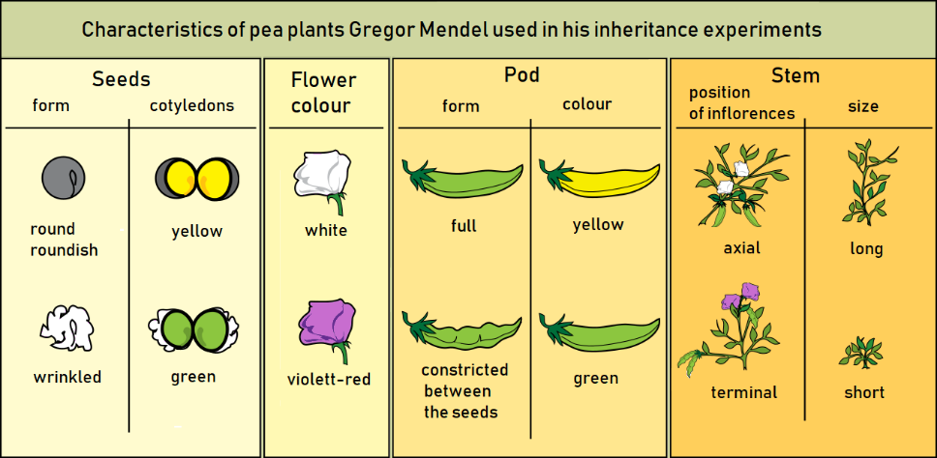
Fig. 1.6 Gregor Mendel’s Pea Plant Characteristics Photo from Wikipedia.org
Gregor’s impact on the field of genetics was immense, even though his work was not recognized in full force until 1900. This stemmed two unique fields of study. One of the fields focused on the physical traits and aspects of heredity. The traits that are passed on from one generation to the next. Thomas Hunt Morgan’s research at Columbia University contributed greatly to this side of genetic exploration (fig. 1.7). He did a study using fruit flies. Just like Gregor, he was breeding specific fruit flies to get specific traits. Traits like eye color or wing shape (fig. 1.8).

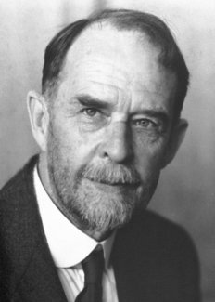
Fig. 1.7 Thomas Hunt Morgan Photo from nobelprize.org
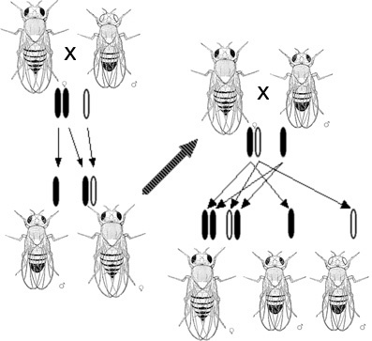Fig. 1.8 Hunt’s fruit fly chart Photo from Wikipedia.org
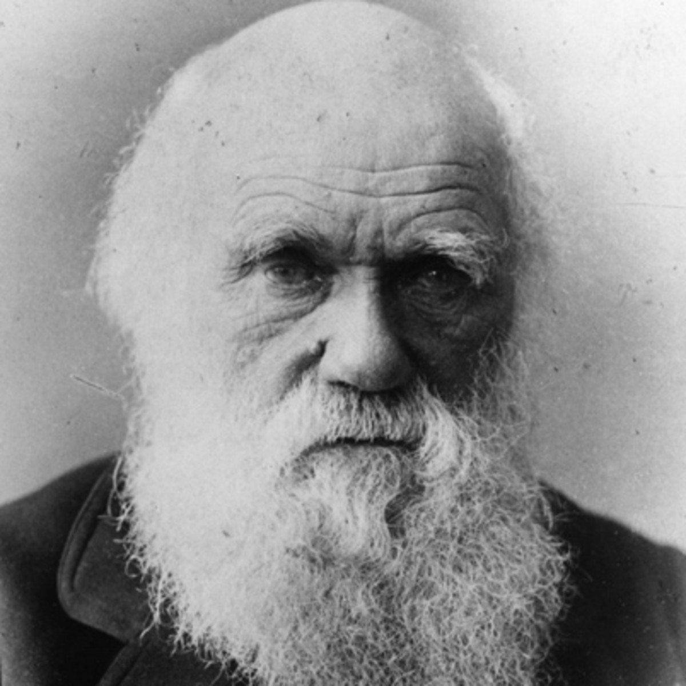Fig. 1.9 Charles Darwin Photo from bibliography.com
The other route that emerged catered towards the potential implications of evolution on Mendel’s research. Charles Darwin, a British naturalist and biologist, published On the Origin of Species in 1859 (fig. 1.9). Darwin believed evolution was a very slow process. Something that happened gradually over time with natural selection favoring certain traits over others in order to create something superior to the last. While Darwin’s evolutionary theories and Mendel’s inheritance tests seem to be polar opposite, in 1918 R.A. Fisher indicated that the two sciences could actually be related. If certain traits were the product of mendelian factors, the Darwinian selection could potentially favor specific variations in those same traits and thus slowly evolve still. It was not until the 1953 that James Watson and Francis Crick would be the first to determine that DNA was a double helix. From there, all the amazing information we know today was slowly but surely discovered and further understood.

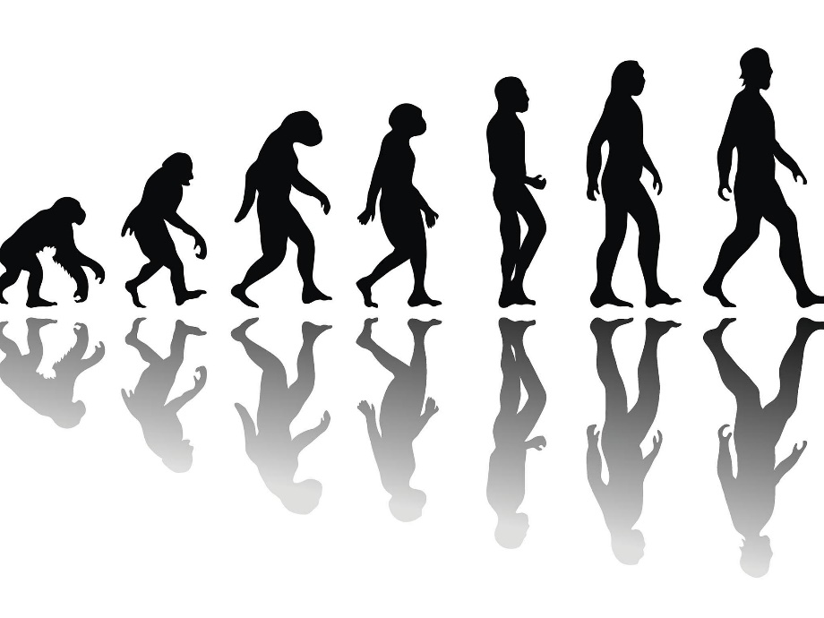
Punnett Square

Fig. 1.10 Punnett Square Photo from

IMPORTANT TERMS
Probability: Mathematical measures of likelihood

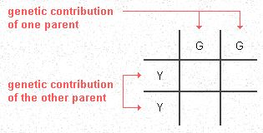
Fig. 1.11 photo from palomar.edu
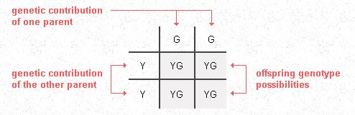
Fig 1.12 photo from palomar.edu

Whenever you are dealing with genetics, there is a neat tool available to you to determine genetic probability. It is called a Punnett Square (fig 1.10). A Punnett Square is essentially a visual representation of probability calculations. You can use it to figure out what genetic traits are stronger and more likely, and which are less likely to occur. It is not used for ALL kinds of genetics. This is because some genes are expressed in five-genes or more.
Let’s say you have two pea plants, like Gregor Mendel would have used. One is Yellow from a family of peas that have been bred to only produce yellow peas. The other is Green, also from peas bred to only produce green peas. You decide to cross breed them, what would you end up with? A Punnett Square can help! One genotype is YY (Yellow, Yellow) and the other is GG (Green, Green) (fig 1.11) To get the results, simply copy the row and column-head, your genomes, across OR down into the empty boxes. The results would be as shown in figure 1.12.
If you were to change it very slightly, the entire result would change. If you took the resulting YG pea plants and cross bred them, you would end up with four completely different possible outcomes instead of one (fig 1.13).
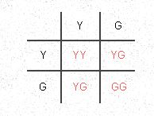
Fig. 1.13 photo from palomar.edu

References
Christopher P. Austin, M.D. Deoxyribonucleic Acid (DNA). (n.d.). Retrieved from https://www.genome.gov/genetics-glossary/Deoxyribonucleic-Acid
Christopher p. Austin, M.D. Translation. (n.d.). Retrieved from https://www.genome.gov/genetics-glossary/Translation
Dennis O’Neil. Probability of Inheritance. (n.d.) Retrieved from https://www2.palomar.edu/anthro/mendel/mendel_2.htm
Eliot Margulies, Ph.D. Transcription. (n.d.). Retrieved from https://www.genome.gov/genetics-glossary/Transcription
James Tabery. Genetics. (2019, August 13). Retrieved from https://plato.stanford.edu/entries/genetics/#ScieGene
Leslie G. Biesecker, M.D. Ribonucleic Acid (RNA). (n.d.). Retrieved from https://www.genome.gov/genetics-glossary/RNA-Ribonucleic-Acid
Molecular Mechanism of DNA Replication. (n.d.). Retrieved from https://www.khanacademy.org/science/biology/dna-as-the-genetic-material/dna-replication/a/molecular-mechanism-of-dna-replication
Nucleotides and Bases. (n.d.). Retrieved from https://knowgenetics.org/nucleotides-and-bases/
The genetic Code. (n.d.). Retrieved from https://www.khanacademy.org/science/biology/gene-expression-central-dogma/central-dogma-transcription/a/the-genetic-code-discovery-and-properties
What is a Genome? (2017, January 6). Retrieved from https://www.yourgenome.org/facts/what-is-a-genome
What is DNA? (2016, January 25). Retrieved from https://www.yourgenome.org/facts/what-is-dna
What is DNA? (2020, March 17). Retrieved from https://ghr.nlm.nih.gov/primer/basics/dna
What is DNA Replication? (2016, January 25). Retrieved from https://www.yourgenome.org/facts/what-is-dna-replication

