Tissue Engineering

Introduction

Imagine that you own a bicycle. This bicycle is very special because it was specially designed for you. Every bicycle part was made to fit your exact height, weight, and length of your arms and legs. You ride your bike every day to get to school, and one day while riding you notice your bike’s tires are a little worn down. All of a sudden, you here a pop and you look down to realize that one of your tires is flat. You decide to take your bicycle to the local bike shop to get a new one. The repair man tells you that your bicycle has old tires that were custom made for you. Finding a replacement tire with the exact fit is going to be difficult but the repair man manages to find one that is not exactly the same, but will work. Now, whenever you ride your bike to school, you notice that the ride isn’t as smooth and that the new tire is a little too big for the bike. Wouldn’t it be great if there was a place where you could get bike tires especially made for your custom made bike?
Now imagine that the bike is your body. Your tissues, organs, and cells were made especially for you. A tissue is a group of cells in the body that perform a function. An organ is a group of tissues in the body that also come together for a specific function. The bike shop represents a team of doctors and biomedical engineers. Whenever someone needs a new organ or tissue; transplants from donors can be used. These transplants can be very successful but sometimes our own body has trouble accepting these transplants. The body can even reject transplants completely. When your body rejects an organ, your body may react with a high fever, by feeling tired, or even with flu-like symptoms. Instead of relying on transplants, doctors and biomedical engineers have come together to create a field of science known as tissue engineering. Tissue engineering is a field of science that involves making custom cells, tissues, and organs that a body will accept.

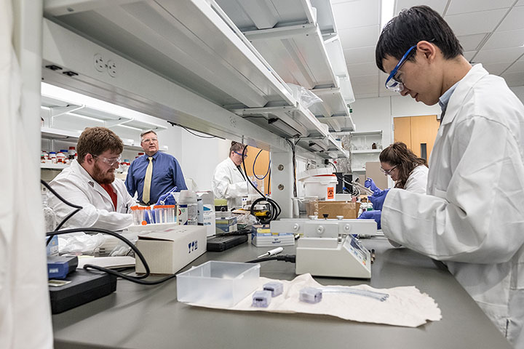
History of Tissue Engineering

Tissue engineering is a relatively new field of science that combines cells, biomaterials, and engineering with the purpose of restoring or making current body tissues better. However, the idea of making or replacing damaged human tissues has been around for centuries. One of the most important restorations humans have considered is making devices that can replace body parts that are important to movement such as walking, chewing, or standing. The devices usually used to replace body parts are known as prosthetics. Prosthetics were historically made from wood with leather straps but can now be made from a combination of plastics and metal that can endure high-strain activities. These prosthetics are made from a variety of materials to take the place of arms, legs, teeth, and other tissues. Think of the elderly who have lost teeth but can now chew with prosthetic dentures, or Paralympic track athletes that compete with the help of prosthetic running blades.
Figure 1: Biomedical engineering students at the University of Michigan. Source: https://www.egr.msu.edu/bme/graduate-programs
Humans don’t always need to depend on prosthetics. For smaller and less severe circumstances, the body is able to regenerate various tissues on its own such as skin, muscles, blood, and bones. Some tissues may take longer to heal than others. Breaking a bone may take months to heal while a small cut to the skin may only take a few days. If you were to fall and scrape your knee, your body would be able to heal itself within a few days under normal circumstances. Your body would regenerate skin cells to replace those that have been lost. However, there are times during a severe injury where the tissues cannot fully be restored or are replaced with a thicker, fiber-like tissue known as scar tissue. If someone were to lose a large part of skin or a piece of bone, the body may not be able to restore it to its original state. Could there be ways to help restore tissue that could not be replaced easily by the body?
Figure 2: Paralympic athletes compete at the 2016 Olympic Games. Source: https://www.athleticsweekly.com/athletics-news/para-athletics-world-records-reset-2018-blade-rule-change-64372/
Using grafts, or tissue replacements from the same body, can be a solution to this problem. The idea of replacing a tissue with another has been utilized as far back as the late 1500’s. In 1597, we see evidence of attempts to surgically replace tissues from an Italian surgeon, Tagliacozzi of Bologna. He described how to reconstruct nose and face skin tissues using skin from the arm in his book titled Decusorum Chirugia per Insitionem.
Since the invention of anesthesia, surgical grafts have now become common. There has now been successes in the use of skin grafts, dental bone grafts, small muscle grafts and even bone grafts for skeletal reconstruction in leg and arm surgeries. Skin grafts are especially important to patients who have suffered severe burns or wounds that could cause severe scarring in the skin. The use of skin grafts and muscle grafts is important to deep wounds where muscle or bone is exposed.
Although there have been many great advancements and we continue to use prosthetics and tissue grafts for many treatments, there is still a need for many people who have a constant need to fix diseased or damaged tissues. Many patients across the world do not have access to complex surgeries or may be in need of an organ donor. With the advancement of health and medicine, the lifespan of humans has also increased. As we age, many of our tissues become less functional, and damaged or diseased tissues cannot be replaced as easily. The constant need for tissues and our aging population has led to an advancement in research and development of biomaterials.

Biomaterials

Biomaterials are created materials that interact with living cells and tissues that can be made from a variety of chemicals and proteins. The making of biomaterials is an essential part of tissue engineering. Within the last one hundred years, the development of biomaterials has greatly expanded. One important contribution is the development of biocompatible alloys. Biocompatible alloys are a mixture of metals that can be placed in the body without the body rejecting them. These metals, such as stainless steel and cobalt chrome, can be used to make plates, screws, and nails for bone injuries as well as artificial joint implants. This improves the method of having to rely on traditional casts on the outside of a bone fracture. These biocompatible alloys allow for a lightweight method that fixes the bone internally. Now, instead of having to carry a heavy plaster cast on a fractured leg bone, patients can now have biocompatible screws inserted on the bone with a lighter weight boot around the leg.
Biomaterials can also be made at a very small level, even smaller than cells. There has recently been a revolutionary development of biomaterials at the molecular level. Biomaterials can be made from polymers, which are large molecules that have a repetitive structure. Polymers are like small, identical building blocks that can be used to make larger structures. Chemical engineers have produced many kinds of polymeric material that is both biocompatible and strong. An example would be polyethylene, which has been used as strong material for the development of hip replacements.
Polymers can also be used to make small screws, pins, or plates that can be inserted into the body. Some tissues cannot be completely replaced by biomaterials, but polymers can be used as scaffolds to build these tissues. A scaffold is a structure placed outside of a building when it needs to be repaired from the outside. When the repair is done, the scaffold is taken away. In the same way, polymer scaffolds can be used to help tissues such as bone or cartilage build and regenerate quickly. One way of testing different polymers as scaffolds is through lab work done by biomedical engineers. Some polymers may be good for growing cells, but may not be sturdy enough to support movement or pressure when the body moves. Other polymers may be very sturdy, but may not be biocompatible or lack the ability to promote the growth of cells.
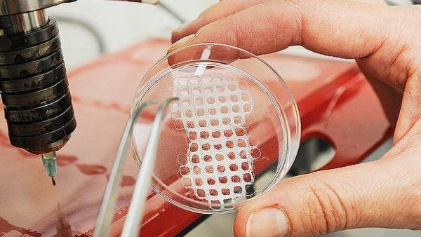
There are many tissues such as skin, cartilage, or artery tissue that have been replaced in humans using biomaterials, but there are also many complex tissues that have not yet been replaced in humans. Organ tissues such as the heart, lung, and liver have been regenerated using biomaterials inside labs but there is still much research to be done in order to make sure this is safe to test on humans. Most of the current research of tissue engineering takes place inside the lab where tissues are regenerated inside plates or environments that are similar to the human body. If those biomaterials are successful after many experiments, then they are tested on living organisms such as mice.
Figure 2: Creation of a scaffold to grow cells. Source: http://ricecatalyst.org/volume-10/2017/6/the-creation-of-successful-scaffolds-for-tissue-engineering

Lab mice are very important in deciding whether these biomaterials can be successful in living organisms. After many experiments on mice, these biomaterials can be tested on other organisms and eventually on humans. If a biomaterial proves to be very successful on human experiments with little or no issues, then this biomaterial can be used on humans as a treatment. The time it takes between developing a biomaterials and testing it on humans can last many years and even decades. This can be a very slow process because biomedical engineers and doctors have to make sure these materials are safe.

Rejection of Biomaterials

Since biomaterials are a combination of a variety of materials, one of the biggest obstacles to biomaterials is that many materials are not fully compatible to the human body. For example, a biomaterial for bone tissue may be made from many proteins that are usually found in the human body as well as polymers that may not be natural to the human body. The body may reject an entire biomaterial due to one substance that may be unnatural to the body. To make things even more complicated, some bodies may accept unknown materials fully while others may not. When the body rejects a biomaterial it can cause an immunological response. An immunological response is when the immune system in the body tries to get rid of any dangerous substances in the body. When bacteria or viruses enter a healthy body, the body sends white blood cells to try to engulf or kill the bacteria. The body may also program cells infected by viruses to die. This programmed cell death is also known as apoptosis. These things may happen when the body does not recognize a biomaterial. Biomaterials may be attacked and can even cause cell death around the infected area. This can be similar to when a body rejects a transplant and can cause fever, or feeling sick.

Stem Cell Technology

Tissue engineering typically uses transplanted cells on a scaffold to try and rebuild a tissue. For example, skin cells can be placed with a biomaterial to regenerate skin tissue and bladder cells can be placed on a different biomaterial to regrow bladder tissue. This is a common method but can also lead to some complications. What happens when the original cells used to regrow a tissue are infected or simply don’t work? That is where stem cell research is important. Stem cells are cells in the body that can develop and specialize into any kind of cell. For example, a stem cell can turn into a simple red blood cell or even a very complex neuron cell which is found in the brain.
Stem cells are not very abundant and can only be found in a few places in adult humans. They can be found inside some fully developed tissues such as bone marrow, the brain, and even skin. These stem cells usually develop into specialized bone, brain, or skin cells depending on where they are from. Another kind of stem cells comes from human embryos. An embryo is an unborn human that is still developing in its mother. These stem cells are very unique because they have the capacity to develop into any kind of cell. A third kind of stem cell is known as hematopoietic stem cells, which are stem cells that can specialize into any kind of blood cell. These hematopoietic stem cells can be found in the umbilical cord of newborn babies and in the adult bone marrow.
Stem cells can be very important in replacing damaged or diseased tissues in the human body. They can also be very important in tissue engineering, where normal specialized cells cannot be used to replace a tissue. Since stem cells are in limited supply and there are many ethical concerns about using embryonic stem cells, a third kind of stem cell has been developed known as induced pluripotent stem cells. These stem cells are adult cells that have been modified to turn back into a cell that resembles an embryonic stem cell. These cells have been developed in labs and are being tested in a wide variety of experiments. Although much research is still needed to understand these stem cells, we can be hopeful that they can open a new door for the field of tissue engineering.

Engineering Tissue Models

Another aspect of tissue engineering is the creation of tissue models. Models are a recreation of a tissue or organ that mimics the real thing. Many models have been made in laboratories to mimic the lungs, heart, eye, intestines, pancreas, and many more. These models are made for the purpose of understanding how certain drugs work on the body or learning how the body can possibly protect itself from bacteria or viruses. The better a model is designed, the more realistic it is. Models are made from a wide variety of things, but can include biomaterials and different kinds of cells.
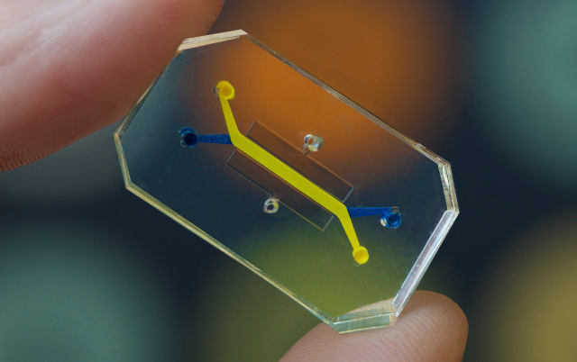
One of the most remarkable engineered models are Organ Chips. The Organ Chips are small engineered models about the size of a thumb drive that contain a variety of cells and biomaterials used to mimic a specific organ. The Organ Chips combine computer microchip technology alongside living cells to mimic real organ environments. For example, the Lung Airway Chip is made of biomaterials which contain lung and blood cells. They also contain small airways that mimic the flow of air in a lung as well as fluids that mimic the flow of blood. This Lung Airway Chip is used to study how certain bacteria enter the lung as well as the effects of medication on lung tissue.
Figure 3: Organ on a chip. https://www.the-scientist.com/news-opinion/organs-on-chips-31020

It is very important to continue to engineer new models for different kinds of tissues to allow for more research to be done. Having models like this allows us to better understand how organs works and combining models can also give us ideas of how the entire body works together. The better and more realistic models are, the easier it is to understand the impacts of medications, bacteria, viruses, and biomaterials in the human body.

Robotics

A new and interesting research field for biomedical engineers is the development of robotic prosthetics, which are a combination of robotic technology, biomaterials, and prosthetics. These prosthetics have mainly focused on the development of robotic arms that use the electrical signals from your muscles to create movements. This can be very important for trying to replace very fine movements that can be done by the hand or wrist. Robotic prosthetics can be used to pick of objects, draw, and even play certain instruments. Many new robotic arm prosthetics are currently being researched to allow patients to gain a sense of pressure and texture on the robotic arm through electrical signals and technology.

Future Research & Beyond

Tissue engineering is a very interesting and fast growing filed. With the rapid advancements of medicine and technology, tissue engineering has greatly expanded within the last few decades. Although tissue engineering has greatly increased, there is still a need to continue to research and develop new biomaterials for the future. As our population grows older, we need faster, low-risk, and less expensive ways to help aging patients regenerate tissues that cannot be replaced as easily. We also need creative solutions for patients who do not have healthcare or do not live close to areas that have more access to healthcare. Tissue engineering can hopefully help bridge a gap between medicine and those needing care.
There is also a large need for the development of more tissue and organ models. The better we understand how tissues and organs work, the easier it is to understand how certain medications will work on them. The future holds many experiments and research for the field. Overall, there is great hope for the field of tissue engineering and future for biomedical engineers looks very promising.

Sources

De Boer, H. (n.d.). The history of bone grafts. Clinical Orthopaedics and Related Research., (226), 292-298.

Im, G. (2020). Biomaterials in orthopaedics: The past and future with immune modulation. Biomaterials Research., 24, 7.

Shimizu, R., & Kishi, K. (2012). Skin graft. Plastic surgery international, 2012, 563493. https://doi.org/10.1155/2012/563493

Vacanti, J. (2014). Principles of tissue engineering / (3rd ed.). Amsterdam ;: Elsevier / Academic Press.

https://stemcells.nih.gov/info/basics/6.htm

https://wyss.harvard.edu/technology/human-organs-on-chips/

