Chapter 1

The Human Immune System

Introduction:
We live in a world full of microorganisms as there are microbes in almost every habitat in nature. From easy-to-live places such as soil, food, and surfaces that are commonly used, to more extreme places such as hostile thermal vents at the bottom of the ocean, scorching hot and extremely dry deserts, and frozen snowfields, microorganisms are able to inhabit and colonize almost everywhere on earth. This means that they are also found inside virtually every living organism, including humans. Foreign microorganisms and viruses that are able to enter the human body and cause infection or disease are called pathogens and although the debate to label viruses as microorganisms still continues, this chapter will consider them as so for simplicity. Because pathogens can cause harm to us, our bodies have a natural defense, the immune system, that not only eliminates the pathogen but also prepares the body for a potential future infection of the same pathogen. This chapter will focus on what the immune system is, differentiate types of immunity, and detail the specialized functions of the immune cells that make it up.

1.1 The Human Immune System (Concepts of Immunity)

The Human Microbiome
Microorganisms are found everywhere within humans. From head to toe, inside and out, our bodies are teeming with microbes. Almost all of the microorganisms that make up our natural flora are harmless and actually assist us in a lot of our bodily functions and processes. Most of these organisms, called commensal organisms, live in the gut. Commensal organisms not only help us with natural functions like digestion, but they also act as a barrier for pathogens. There are 3 main ways that they act as barriers: They cover receptors, compete for nutrients, and stimulate the immune system. Commensal organisms naturally cover a lot of surface inside of our bodies, this makes it more difficult for a pathogen to bind to receptors inside the body in order to establish an infection. These organisms, just like us, need nutrients to survive and are able to compete with pathogens for them. This makes it much more difficult for a pathogen that has penetrated the body to get the nutrients that it needs to survive. Our natural flora also regularly stimulates the immune system because after all, they are not part of us. Due to their presence, our immune system is almost always slightly activated and ready to respond to an infection.

Pathogen Entrance
Our bodies are constantly prone to infection from pathogens due to the nature of their existence in almost every environment. Microbes are able to penetrate the body through any opening that the body has. This includes the mouth, nose, eyes, urinary tract, and any wounds that create an entry point. Fortunately, our bodies have natural barriers that are able to stop many infectious microbes before they are able to infect us and begin replicating. Our bodies have natural barriers that infectious microbes must overcome in order to establish an infection. These barriers have physical and/or chemical properties that assist in repelling pathogens. For example, the saliva in your mouth contains many antimicrobial agents, or any compound that destroys microbes and prevents their development, such as lysozymes and peroxidase, that act as both a chemical and physical barrier to pathogens attempting to inhabit the host. If a pathogen is able to successfully avoid these barriers and penetrate the body, a network of immune cells, tissues, and organs are activated by specific responses in order to eradicate it. These responses are categorized into two types of immunity, innate immunity and adaptive immunity.

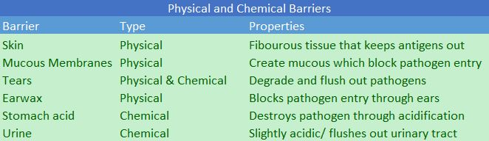
Figure 1- There are many barriers that a pathogen must get through in order to infect a person. Listed above are a few different types of natural physical and chemical barriers along with how they prevent infection.

Innate vs Adaptive Immunity
After a pathogen has made entry into a person and makes its way into extracellular space inside the body, specialized cells are able recognize antigens, which is any specific portion of a pathogen that immune cells are able to recognize, and either destroy it directly through cell-specific responses or enable other immune cells to be able to perform a variety of antimicrobial tasks. The first cells to recognize and act upon a pathogen belong to the innate immunity response. Innate immunity is the first response to an infection and is usually activated within minutes of infection. The goal of innate immunity to contain the spread of a pathogen through cellular processes such as phagocytosis, the ingestion of an antigen by a cell, and activate complement or other immune cells through the production of cytokines, small proteins that are secreted by immune cells as a method of activation and other communication. The secondary response to an infection is the adaptive immunity response. Cells that belong to the adaptive immune system specialize in recognizing activated phagocytic cells that have already ingested a pathogen to further degrade it and/or create a memory of it in order to prevent future infections. This response is more specialized than that of the innate immune system but takes longer to activate, usually within a few days. Although the responses are categorized separately, it is important to note that they are interconnected and influence each other through activation and cytokine communication.

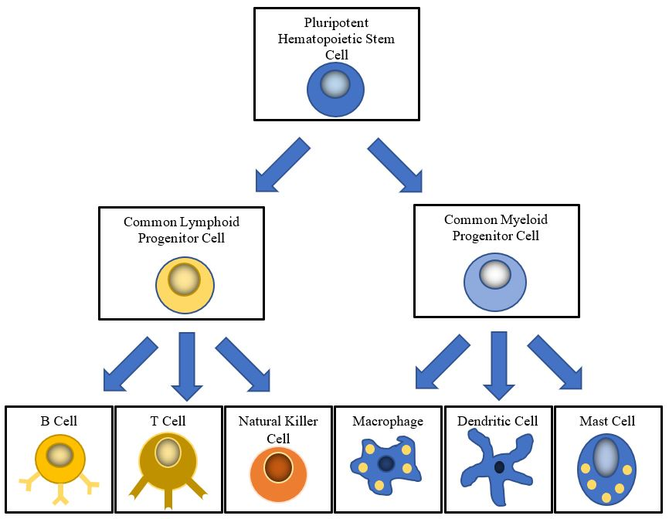
Figure 2- The immune cells that make up the lymphoid and myeloid lineages all derive from a pluripotent hematopoietic stem cell that is found in the bone marrow. The two lineages derive from lymphoid and myeloid progenitor cells respectively.

Cells of the Immune System
The immune system consists of many types of specialized cells that perform various functions at the overall aim to get rid of a pathogen. We will detail their specific functions in section 1.2 and 1.3. Every cell in the immune system is derived from a progenitor cell that is produced in the bone marrow. This cell is called a pluripotent hematopoietic stem cell. Depending on the environment and condition of an infection, a pluripotent hematopoietic cell is able to further mature and divide into two types of common progenitor cells. These two progenitor cells will further mature and produce various immune cells that are categorized into two lineages respectively. One progenitor cell that is produced by a pluripotent hematopoietic stem cell is a common lymphoid progenitor. The cells that derive from this progenitor cell belong to the lymphoid lineage. These cells are all part of the adaptive immune system, with the exception of innate lymphoid cells. Cells that belong to the lymphoid lineage are B cells (plasma cells), T cells, natural killer cells, and innate lymphoid cells (ILCs). The other progenitor cell that a pluripotent hematopoietic cell can mature into is a common myeloid progenitor. The cells that derive from the common myeloid progenitor cell belong to the myeloid lineage and mostly make up the innate immune response. Common myeloid cells include dendritic cells, macrophages, neutrophils and mast cells.

1.2 Innate Immunity

Recognition and Inflammation
As stated before, the cells of the innate immune system are the first to recognize a pathogen that has entered the body. This is because the innate immune system is naturally present and doesn’t require prior sensitization to an antigen. The goal of the innate immune system is to recognize an antigen and stop the spread of it throughout the body. The innate immune system is activated once innate immune cells become activated by the presence of a pathogen. Specialized inflammatory inducers detect proteins and other molecules that are not found throughout the body, presumably a pathogen, and trigger an inflammatory response. Inflammation is the product of an inflammatory response that is indicated by heat, redness, swelling, and pain. Inflammation allows specialized cells that are found in the bloodstream to move towards the site of infection. Therefore, inflammation results in redness and swelling. Molecules that trigger an inflammatory response through inducers are called inflammatory inducers. Common inflammatory inducers are ATP and bacterial lipopolysaccharides, which are not found within the human body. Once inflammation has occurred, sensor cells are able to recognize it and begin acting against the pathogen.

Sensor Cells
The class of innate immune cells that recognize inflammation are called sensor cells. Sensor cells have receptors on their cell surface called pattern recognition receptors (PRRs) that are able to recognize simple compounds commonly found on pathogens. These common structures are called pathogen-associated molecular patterns (PAMPs). PRRs are able to recognize PAMPs because they are not natural found inside of our bodies. Once a sensor cell has recognized a PAMP, it produces cytokines that recruit other specialized cells to the site of infection. Remember that cytokines are used as a form of communication between cells as cells use the cytokine gradient to travel throughout the body. The specialized cells that are recruited to the site of infection are then able to perform a variety of specialized functions in order to contain the antigen.

Phagocytosis and Compliment Activation
In order to achieve the second goal of the innate immune system, innate immune cells that are recruited to the cite of infection must be able to slow the spread of the pathogen throughout the body. The most common and effective way of doing this is through phagocytosis. Phagocytosis is the ingestion of bacterial or viral particles by specialized innate immune cells called phagocytes. Common phagocytes are macrophages, mast cells, and dendritic cells. These cells are able to engulf an invading pathogen and depending on the type of phagocyte, carry out further specialized functions to ensure immunity.
In order for the immune system to work properly, the innate immune system must somehow recruit cells of the adaptive immune system. This is done through activating the compliment system. In a nutshell, the compliment system is the part of the immune system that activates phagocytic cells and antibodies to eliminate a pathogen as well as damaged cells from the host. The compliment system also works to promote inflammation. Phagocytes and compliment activation are vital for the innate immune system to communicate with adaptive immune system and function properly.

1.3 Adaptive Immunity

The Second Line of Defense
After the innate immune system has started to recognize the pathogen, the adaptive immune system is recruited to eliminate the pathogen and prepare for future infections of the same pathogen. This is done by the cells that derive from the lymphoid lineage. These cells include T cells, B cells, natural killer cells, and innate lymphoid cells (ILCs). These cells take longer to react than those of innate immunity, but they are more precise and have a much greater impact as there are able to have memory.

T Cells
T cells derive from the common lymphoid progenitor just as the other lymphoid lineage cells that are a part of the adaptive immune system do. T cells mature in the thymus, hence the name T cell. From the thymus, where immature T cells are located, a T cell will further mature into one of three main types of T cells. These are memory T cells, cytotoxic T cells, and helper T cells. Each type of T cell contains T cell receptors (TCRs) on the cell membrane. These receptors are able to recognize antigens that are presented to them from other immune cells. Helper T Cells recognize the antigen through the
Major Histocompatibility Complex II (MHC II) that is located on the phagocytic cells from the innate immune system through antigen presentation. Once a helper T cell has recognized an antigen through the MHC II, the cell will then become “activated” and begin dividing quickly as well as produce cytokines to regulate the immune response.
Cytotoxic T Cells are a class of T cells that recognize antigens through the Major Histocompatibility Complex I (MHC I) instead of the MHC II as seen in helper T cells. Unlike MHC II, the MHCI is found on all somatic cells, or cells that have a nucleus. This means that cytotoxic T cells function as a regulatory T cell that communicates with all of your body’s cells. Once a cytotoxic T cell recognized an antigen through the MHC I in a somatic cell, it becomes activated and destroys the infected cell. Cytotoxic T cells are also able to screen the body for tumor cells and destroy them.
The last major class of T cells is Memory T Cells. Memory T cells are able to recognize antigens through both MHC I and MHC II. There are many subclasses of memory T cells, but their overall function is to recognize and antigen and then prepare the body for a future infection of the same pathogen through memory. After an infection, memory T cells are able to genetically recombine and replicate in order to provide long term immunity to a pathogen. The helper T cells that get produced after an infection will then go on to circulate throughout the body as protection.

B-Cells
Another type of adaptive immunity cells that derives from the common lymphoid progenitor is B cells. B cells, like T cells, are able to recognize antigens and respond through a variety of functions in order to eradicate the pathogen. Instead of using TCRs as T cells do, B cells produce and sometimes secrete antibodies as a means of antigen recognition. Antibodies are able to directly interact with an antigen, unlike TCRs that have to recognize an antigen through an MHC. As T cells mature in the thymus, B cells mature in the bone marrow, hence B cell. As a B cell matures, it will develop into one of two major B cell classes: plasma cells and memory B cells.
Plasma B cells are mature B cells that actively produce and secrete antibodies that have a much higher affinity to an antigen than that of cells from the innate immune system. There are 5 main types of antibodies that plasma B cells can produce, but only one plasma B cell can produce one class of antibodies. Once antibodies are produced and secreted, they serve three main functions. They need to recognize an antigen, opsonize (track via proteins) the antigen, and activate compliment in order to communicate with the innate immune system.
The other main class of B cells are memory B cells. Memory B cells derive from parent B cells that have already fought off an infection. Memory B cells have the same antibodies as their parent B cell, so they are able to recognize and respond faster to a future infection. They remain dormant in the bloodstream as they circulate, screening our blood for antigens. Their job, along with T cells, determine the overall capability of the adaptive immune system.

The Big Picture
Although the adaptive and innate immune responses vary in response time, cell type, and functionality, it is important to remember that they help each other in the overall goal to rid your body of antigens. The two immune responses work together, through cytokines and the complement system, in order to achieve that goal. Their goal of recognition is portrayed mainly in the innate immune system and the capability of memory is highlighted in the adaptive immune system. This amazing natural defense is full of many types of cells that perform a variety of functions.

References
E. Wherry, D. Masopust., “Adaptive Immune System”. Viral Pathogenesis (Third Edition), 2016.

R.C. Budd, KA. Fortner., “T Lymphocytes”. Kelley and Firestein's Textbook of Rheumatology (Tenth Edition), 2017

Steven A. Porcelli, “Innate Immunity”. Kelley and Firestein's Textbook of Rheumatology (Tenth Edition), 2017

Kondo, Motonari. "Lymphoid and myeloid lineage commitment in multipotent hematopoietic progenitors". Immunological Reviews, 2010

