Inheritance and variation of traits
Mitosis Vs Meiosis
Mitosis consists of four phases (prophase, metaphase, anaphase, and telophase) and the genetic material has very little to no change (mutations, which will be covered later in the chapter) and will only produce 2 diploid cells by the end. However, in meiosis, things become more complicated. Meiosis is one of two vital parts to sexual reproduction, the other vital part being fertilization. In meiosis I, we observe the change from 1 diploid cell to 2 haploid cells and after meiosis 2 the production of 4 haploid cells. In meiosis, we also observe the exchange of genetic material (recombination).
Meiosis consists of similar phases to mitosis, but in total has eight distinct phases. For the first part of meiosis (meiosis I) there is: prophase I, metaphase I, anaphase I, and telophase I. These first four phases are responsible for producing 2 haploid gamete cells from 1 diploid somatic cell. Between prophase I and metaphase I is where the exchange of genetic material is observed (crossing over), which allows for the recombination of genes. In prophase I, spindle fibers form and the nuclear envelope begins to break down. In metaphase I, homologous chromosome pairs align. Each pair of homologous chromosomes have four chromatids. Anaphase then proceeds after metaphase when the spindle fibers (formed in prophase I) pull apart the homologous chromosomes to opposite side of the cell. Telophase is then observed when the pairs of chromatids have reached each end of the cell and a new nuclear enveloped (sometimes) will have formed. Half of the number of chromosomes are now present in comparison to the original nucleus. After interphase I, eventually we will see the second half of meiosis.
This other half (meiosis II) consists of prophase II, metaphase II, anaphase II, and telophase II. This part of meiosis is important because it produces 4 haploid cells. The first phase in this cycle is prophase II. In prophase II, the nuclear envelope disappears and spindle fiber begin to form again. In Metaphase II, the chromosomes line up down the center of the cell and spindle fibers attach. During Anaphase II, sister chromatids separate and are pulled to opposite side of the cell. In the last phase: Telophase II, the nuclear envelope forms. This process has created 4 genetically different cells (unlike in mitosis where the cells are identical). These cells in humans are referred to as sperm cells in males, and eggs or polar bodies in females.

- In figure 1 below there is a model of both meiosis I and II. Observe the number of chromosome the cell has at the beginning in prophase I and compare them to the chromosomes in telophase II. How are they different?
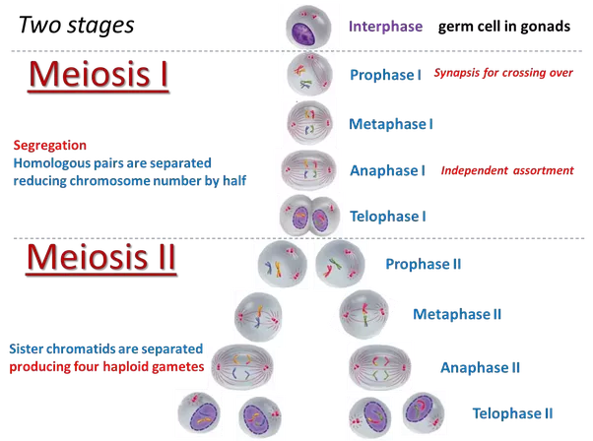

Haploid and diploid
The differences between haploid and diploid cells, are in the number of chromosome pairs that are produced. Haploid cells (denoted n) are often Gametes (sex cells that hold genetic information). A diploid cell, is a cell that hold double the amount of genetic information as a haploid cell (denoted as 2n). This is because in mitosis the two daughter cells need twice the information than the single parent cell. For haploid cells, they return to diploid cells after fusing together (therefore having twice the amount of genetic information). As an example: two haploid cells: n+n=2n ending as a diploid cell. An example seen in humans: At the beginning of meiosis I, the cells start with a diploid number of cells. The end of Meiosis II produces 4 haploid cells. When a sperm cell and a polar body fuse together, they produce a diploid zygote. A zygote being a fertilized sex cell.
Differences in organisms
Meiosis occurs in some species of bacteria, but the bacteria stays at a haploid state. In plants, the cells half of the time will be haploid and the second half they will be diploid (after fertilization). In animals, fertilization will proceed after meiosis occurs for sex cells. But for the majority of their life they will remain diploid.
Sex Determination
Animal chromosomes are categorized into two kinds of chromosomes: sex chromosomes, or autosomes. In this section we will focus on sex chromosomes. In humans, we have two kinds of sex chromosome pairs, they are XX (female) and XY (male). However, this is not the only way of sex determination in organisms. Drosophila for example, have sex determination based on the ratio of sex chromosomes they have.
Mendelian genetics
In the mid-1800’s a friar named Gregor Mendel noticed a pattern in pea plants he was growing to study. He observed that traits can be tracked as distinct units known as alleles (he labeled them as factors) and can hold a variation of dominant and recessive traits. His studying of these naturally occurring patterns developed what is known as Mendel’s Laws of inheritance:
- Law of segregation: states that a pair of alleles are separated during the creation of gametes
- Law of independent assortment: states that there is an independent distribution of alleles, in other words: allele distribution is random
- Recessive and Dominant traits: observes that alleles of a certain trait can hold priority over another. Meaning that dominant alleles with take priority over recessive alleles. Therefore, the phenotype of the organism will be that of the dominant alleles and the recessive alleles will be suppressed.
Monohybrid crosses, Dihybrid crosses and Punnett Squares
During Mendel’s studies he used a model to track and predict the frequency of certain genetic traits. This model is called a Punnett Square. With a Punnett Square, one is able to take a set of parental alleles and cross another set of parental alleles and develop a predicted frequency of phenotypic outcomes. This is known as a test cross. A phenotype is a genetically displayed trait created by alleles. The phenotype displayed depends on four factors: homozygosity, heterozygosity, recessive traits and dominant traits. For example, in figure 2 below: a cross between two homozygous (yy=green, YY=yellow) parents will yield offspring that are heterozygous and will have the dominant phenotype (Yy=yellow).
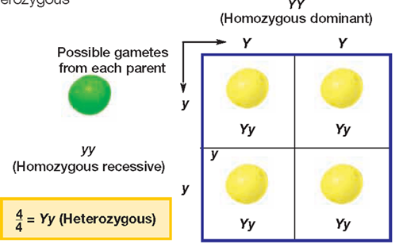
- When crossing one pair of traits it is known as a monohybrid cross. This is displayed in the figure above. If one where to use this new generation of yellow, heterozygous peas (F1 generation) as parents to a new generation (F2 generation) what is the ratio of displayed phenotypes?
Dihybrid crosses track the displayed frequencies of two pairs of traits. A test cross of two individuals with two pairs of traits that are both heterozygous, along with their frequencies are displayed in figure 3 below.
Figure 3. There are two pairs of traits that are being crossed. This produces four different phenotypes. Because of the law of independent assortment. One must assume all possible outcomes. With a Punnett Square we can see the frequency of each phenotype. 9/16 are round and yellow, 3/16 are round and green, 3/16 are yellow and wrinkled, and 1/16 are wrinkled and green.
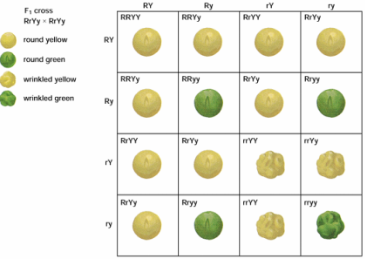
Mutations
Replication of DNA, meiosis and mitosis are not perfect events. In rare events sometimes the chromosomes or DNA strands are subject to different kinds of mutation. The forms of mutation that we see happens to chromosomes are: deletions, where an entire piece of a chromosome is missing or lost. Translocations, are when a piece of a chromosome detaches from one (like a deletion) and will attach itself to another end of a different (non-homologous) chromosome. And inversions, when a piece of chromosome breaks off and then reattaches itself to the same chromosome in a different place.
Mutations that happen during the replication of DNA are known as gene mutations. The most common kind of gene mutation is a point mutation. In this mutation there is an addition, substitution, or removal of a nucleotide. It is worthy to note however, that not all genetic mutations result in a major change. Sometimes a silent mutation will occur. This happens when there is a substitution of a nucleotide that does not affect the sequence or functions of amino acids and proteins.
Overall, these mutations can lead to a variety of genetic disorders such as: sickle cell anemia, cystic fibrosis, muscular dystrophy, and many more. However, these kinds of mutations may not always lead to acquiring a genetic disorder. There is a form of mutation that has more prevalent effects to an organism’s chromosomes than most. This form of mutation is called nondisjunction. Nondisjunction occurs during and right before anaphase I and II. When the sister chromatids (in meiosis I) OR homologous chromosome (in meiosis II) are lined up there is a chance they will not split at the centromere; and will remain together. That means that when a zygote is produced, there is a chance that zygote will have too few chromosomes (lethal), too many chromosomes (which lead to disorders like trisomy 21 in humans, a form of polysemy), or will have the normal amount. The frequency of a zygote being normal, lethal, or polysomic will depend on if the nondisjunction occurred in meiosis I or meiosis II. Below in figure 4 there is a model of normal meiotic division and nondisjunction in meiosis I and II
- What outcomes are lethal when nondisjunction occurs in meiosis I? What about
meiosis II?
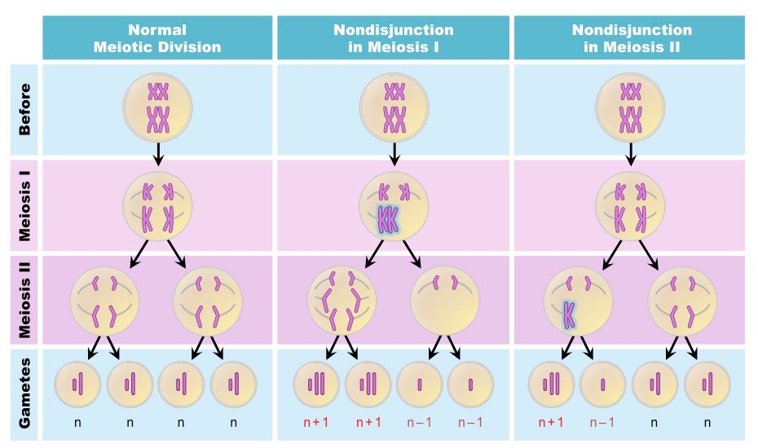
There are genetic disorders that are involved with sex chromosomes and nondisjunction. Such examples are Klinefelter’s Syndrome, the victims of which hold three sex chromosomes (XXY a trisomy condition). This disorder leads to a male whose growth is stunted, possibly mentally handicapped, and will have some feminine features. A possible monosomy condition is when one of the X chromosomes is either damaged (remember structure= function) or missing due to nondisjunction. This causes there to be only one functional X chromosome. This mutation can create a genetic disorder called Turner syndrome. This disorder leads to a female who may develop a variety of conditions throughout their life and will also experience stunted growth.

Pedigrees
It is very important that the science and medical communities work together to develop an understanding on how to model these genetic orders on how they are inherited. This is where a pedigree comes in to use. A pedigree is a familial analysis of genetic traits and how they are inherited. In conclusion, one uses a pedigree to track genetic traits through many generations of one family. This means one could track a disorder that runs through a family.
Pedigrees are not exclusively used for tracking genetic disorders. Rather, they are widely used to track many kinds of genetic traits and genetic similarities. Such as hair color, eye color, and genetic conditions. This allows a perspective on who could be a recessive carrier of a genetic disorder, sex linked inheritance, and the development of mutations.

Chromosome Mapping and Current Uses of genetics
While many traits can be modeled and predicted through pedigrees and Punnett Squares, there are some traits that are more complicated to track and predict. Traits are located on a specific position on a chromosome, and these are called a locus (loci is the plural form). Multiple traits are often located on different loci on a chromosome. This means that when crossing over occurs, there is a chance that genes will become separated therefore making a different phenotype. This likelihood of separation depends on the distant between loci. The further apart two traits are the more likely they are to separate. The frequency of displayed traits can be used to develop a chromosome map, which is a linear diagram of the physical distance between multiple traits.
Chapter terms, definitions, and concepts
Recombination | The exchange of genetic material.
Haploid | Haploid cells (denoted n) are often Gametes (sex cells that hold genetic information). These cells hold half of the normal amount of genetic information that normal cells have.
Diploid | A cell that hold double the amount of genetic information as a haploid cell (denoted as 2n). often referred to as a somatic cell.
Gametes | Sex cells that hold genetic information.
Law of segregation | A pair of alleles are separated during the creation of gametes.
Law of independent assortment | There is an independent distribution of alleles, in other words: allele distribution is random.
Recessive and dominant traits | Alleles of a certain trait can hold priority over another. Meaning that dominant alleles with take priority over recessive alleles. Therefore, the phenotype of the organism will be that of the dominant alleles and the recessive alleles will be suppressed.
Punnett square | A quantitative model that can predict the ratio of some phenotypic crosses in plants and animals.
Test cross | A set of parental alleles that is crossed with another set of parental alleles developed into a predicted frequency of phenotypic outcomes via Punnett Square.
Phenotype | A genetically displayed trait.
Monohybrid cross | Crossing one pair of alleles to develop a frequency of possible offspring.
Dihybrid cross | Track the displayed frequencies of two pairs of traits.
Deletion | An entire piece of a chromosome is missing or lost.
Translocation | When a piece of a chromosome detaches from one (like a deletion) and will attach itself to another end of a different (non-homologous) chromosome.
Inversion | When a piece of chromosome breaks off and then reattaches itself to the same chromosome in a different place.
Gene mutations | Mutations that happen during the replication of DNA.
Point mutation | An addition, substitution, or removal of a nucleotide.
Silent mutation | Occurs when there is a substitution of a nucleotide that does not affect the sequence or functions of amino acids and proteins.
Nondisjunction | When the sister chromatids (in meiosis I) OR homologous chromosome (in meiosis II) are lined up there is a chance they will not split at the centromere; and will remain together.
Pedigree | A familial analysis of genetic traits and how they are inherited.
Locus | A specific location of a chromosome.
Loci | Multiple locations of a chromosome.
Chromosome map | A linear diagram of the physical distance between multiple traits.
Zygote | A fertilized sex cell

References
Biologydictionary.net, 20 Jun. 2018, https://biologydictionary.net/silent-mutation/.
Chapter 8 “Monohybrid Cross vs Di-hybrid Genetic Cross”. (2020, March 26) Weebly. Retrieved from https://lloydscientists.weebly.com/chapter-8-monohybrid-cross-vs-di-hybrid-cross.html
Children resemble their parents (2020, March 26). DNA from the Beginning. Retrieved from http://www.dnaftb.org/1/bio.html
Halmeck, W. (2016, July 26). How do you explain the process of meiosis II in a diagram? Quora. https://www.quora.com/How-do-you-explain-the-process-of-meiosis-II-in-a-diagram
Helena, C. (1979) Biology Third Edition. Worth Publishers.
Holt, Rinehart, Winston (1999). Modern Biology.
Monohybrid cross. (2020, March 26). Slide Player. Retrieved from https://slideplayer.com/slide/3413131/
Non-disjunction (2020, March 26). Bioninja. Retrieved from https://ib.bioninja.com.au/standard-level/topic-3-genetics/33-meiosis/non-disjunction.html

