INSIGHT FROM A SCIENTIST
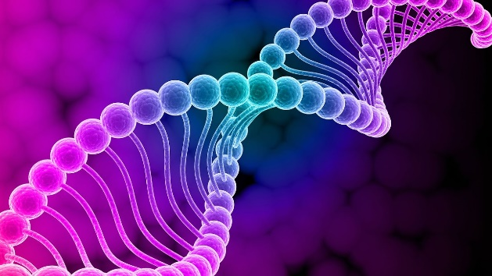
Figure 1. DNA Structure.
DNA is the genetic information within a living being. Our DNA is basically the blueprint for our lives. Interestingly enough, each human living has roughly 99.9% identical DNA as all other people, while it is around 0.1% that makes each of us unique. While DNA is responsible for our physical characteristics, it is also responsible for things happening inside of our bodies that aren’t always visible. DNA expression is how the DNA inside our bodies is translated into functional cells (typically proteins) inside our bodies. These expressions are important because it is how our bodies handle our genetic information.
Professor Donald Ruhl at Oklahoma State University has revolved his research around DNA expression for many years now. Professor Ruhl initially graduated from the University of Missouri in St. Louis with a degree in chemistry. With an abundance of experience in research with the FDA, Cornell University, and a Ph.D. in Pharmacology and Physiology, Ruhl has managed to conduct his own lab at Oklahoma State University.
Professor Ruhl’s lab is mainly focused on how the Swi/Snf chromatin remodeling complex can lead to cancer. The Swi/Snf chromatin remodeling complex is found in eukaryotes (cells containing a nucleus) and is responsible for how proteins are associated to remodel how DNA is stored and expressed. The Swi/Snf chromatin remodeling complex is used in his lab to specifically see how tumors are expressed due to the abnormalities in the complex expressions. This research can help doctors and scientists target the expressions and readings that can cause tumors and help find therapeutic drugs to help the problem.
Referring to Professor Ruhl’s publication, he explains how the research into epigenetics (the study of the changes of the phenotype of an organism rather than the genetic code) can help better understand the expressions of the DNA.
- DNA methylation (the addition of a methyl group to a compound that will not change the DNA sequence but will change the expression).
- Nucleosome positioning (position of a double helix of DNA).
- Histone modifications and histone variant deposition (both can alter gene expression)
The above are examples his lab uses to help find the expressions that cause DNA abnormalities which can express oncogenic phenotype.
Within his lab, he expresses the importance of ATP-dependent processes and how they can be manipulated to understand the process of cancerous cells within the body. ATP-dependent processes can be altered to be turned “on” or “off” to prevent/activate the production of specific outcomes. The research lab focuses on both healthy and unhealthy hosts to see how the studies can help treatment in the future. If doctors and scientists can find out how to prevent or activate specific pathways to alter gene expression, they might be a step closer to finding the cause of many diseases linked to the expressions.
There is a clear importance for the research Professor Ruhl is conducting and they are in hopes to find more correlations between gene expressions and gene functions as they continue with new hypotheses.

References
Hah, Nasun, et al. “A Role for BAF57 in Cell Cycle-Dependent Transcriptional Regulation by the SWI/SNF Chromatin Remodeling Complex.” Cancer Research, U.S. National Library of Medicine, 1 June 2018, www.ncbi.nlm.nih.gov/pmc/articles/PMC288201/.

