Recent Developments in Treating Neurological Diseases Through the GI tract
Author:
Major:
Department of Microbiology and Molecular Genetics, Oklahoma State University, Stillwater, OK 74078, USA
Key Words:
Alzheimer's disease, ginsenoside Rg1, tree shrew, gut microbiota, Morris water maze, tau protein

Microbiology has had a boon over the recent decades in the department of microbiome research. There have been further developments that have been made on the front of the connection between the large microbiome in the GI tract and the brain. This brain-gut axis is conciliated through, neurotransmitters, cytokines, hormones, and bioactive metabolites. If this connection is functioning poorly, say through something like dysbiosis, then this can lead to metal health issues such as, anxiety and depression or even more extreme neurodegenerative disorders like Alzheimer's disease. Recent research has shown promising results in the direction of microbiota-based treatments for such neurological diseases. based on gut microbiome to assist those struggling with neurological disorders such as Alzheimer's disease. These developments shown that using metabolites, such as Curcumin, have a positive effect on mental health but also in rebalancing GI flora.
Introduction

Over the last twenty years research over the human microbiome has been flourishing.⁴ A productive discovery is the observation the body's normal flora can synthesize metabolites that can moderate a multitude of functions in the body, therefore the state of dysbiosis, the imbalance of a microbiota, can also create a negative impact upon the body.⁸ Discovered connections between the Gastrointestinal Microbiota and the brain in particular have given are also include within that impact.¹
Roughly thirteen percent of the global population suffer from mental disability and disorder.⁷ This supports the acknowledgment of mental health in health polices across the globe and its appearance in the United Nations' Sustainable Development agenda. This global spotlight upon metal health has been a great motivator for scientist in their efforts to unravel the capacities in which the gut plays into the creation of neurological disorders.¹
The gut-brain axis, or the system of communication the gut microbiota has with the mind or state of being¹⁰, has been shown to be used by gut microbes in sustaining homeostasis.⁵ It has been shown to be a bidirectional connection between the central nervous system and the enteric nervous system.² This connection has many highways and service roads that connect with cognition, memory and emotion hubs within the brain.² This communication involves the hormone producing centers of the brain, the hypothalamus and the pituitary gland, as well as the chemokines and cytokine using immune system and the neurotransmitters crucial to the communication in the autonomous nervous system as depicted in Figure 1.²
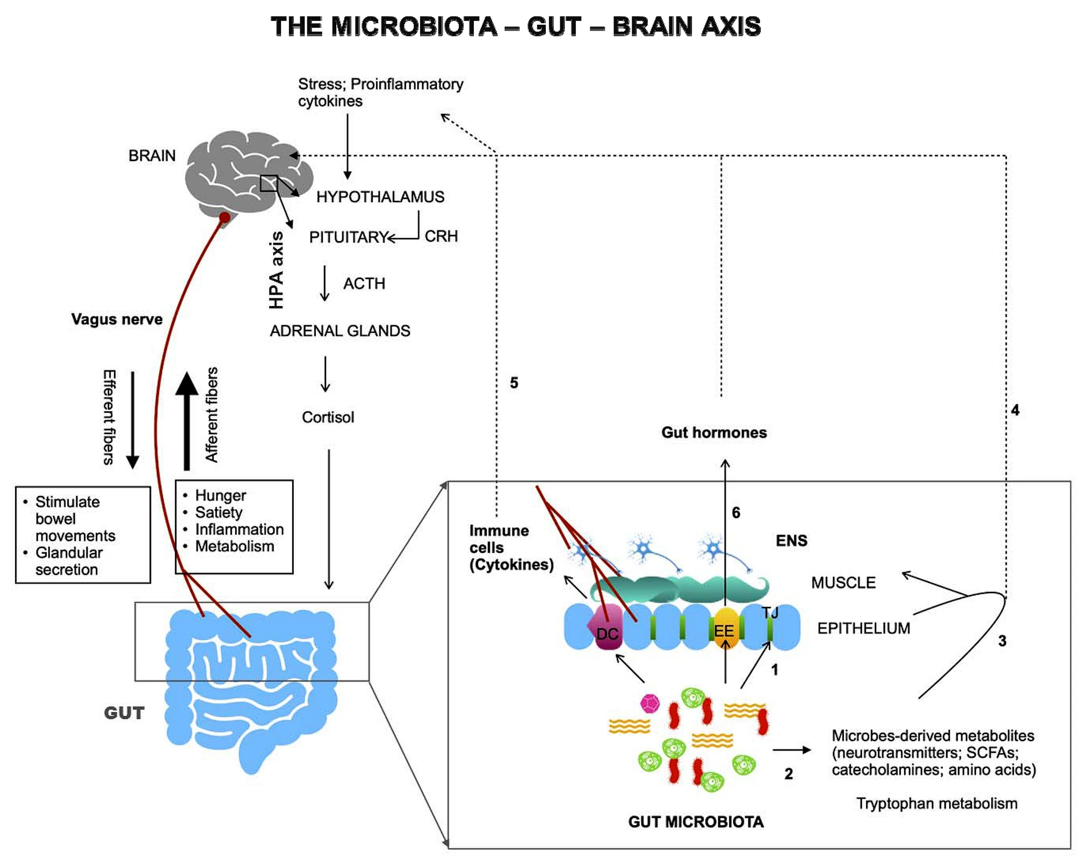
Fig 1. This is a depiction of the three major pathways of the Microbiota-Gut-Brian Axis.¹⁰
Problems in any one of these pathways can negatively impact homeostasis.² Changes in homeostasis in GI tact can lead to changes in the levels of gut microbial metabolites, and research shows a correlation to these effected levels and neurological afflictions like chronic anxiety disorders, depressive disorders and Alzheimer's.^{3,6,12} The relationship between balances and imbalanced interactions or the Microbiota – Gut -Brian Axis is shown on Figure 2.
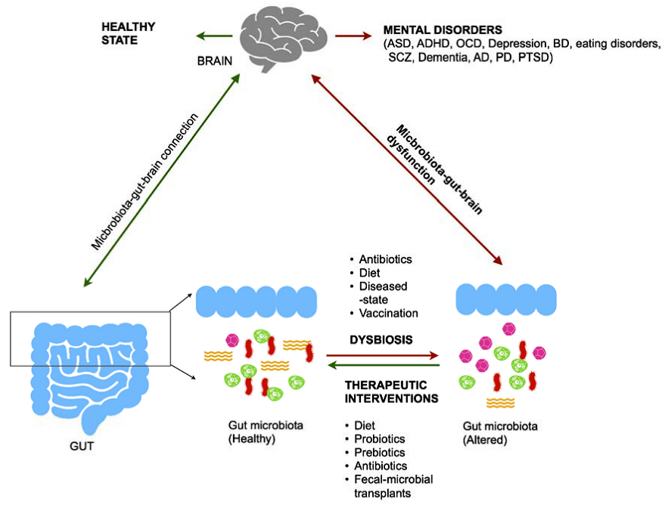
Fig 2. This is a depiction of the Microbiota-Gut-Brain Axis in relation to a balanced and imbalanced microbiota. Shown are potential disorders compared to a healthy mental state and lists of some common causes for dysbiosis and some common therapeutic interventions that would be implemented to attempt to correct the imbalance.¹⁰

Recent Progress

In a recent study, the "Bidirectional Interactions Between Curcumin and Gut Microbiota in Transgenic Mice with Alzheimer's Disease" headed by Ph.D. Zhen-Zhen Sun, where mice with Alzheimer's Disease (AD). Where three levels of a substance called curcumin, which is a natural polyphenolic compound derived from turmeric. This was given to the mice in a control dosage (no curcumin), a low dosage of curcumin, and a high dosage of curcumin. Both the influences that curcumin had on the microbiota and the how the microbiota were observed.
On various metrics it was found the curcumin led to improved cognitive and memory ability as well as a reduction of amyloid plaque in the hippocampus (a common marker of neurodegenerative disorders).⁹ The gut microbiota held more diversity when exposed to the curcumin and the metabolite analysis suggests that curcumin when metabolized bio-transformed into substances that been reported to have neuroprotective properties.⁹

Discussion

Theses findings show a very positive out look for the potential of metal health treatments through the microbiota. Another study involving AD prone tree shrews having their brains injected with the neuroprotective agent Ginsenoside Rg1 shows similar positive results in same categories as the curcumin study.¹¹ They both showed an improvement terms of behavioral displays of improved cognition and memory retention.^{9,11}
These result were both shown in the same Morris water maze test, in which a rodent is place in water a directed to swim towards the same hidden platform over and over again.^{9,11} The shrews when their hippocampus was examined also had less amyloid plaque when given Rg1.¹¹ This further indicates that the metabolites made from the curcumin within the mice GI tract had similar neuroprotective properties to the direct neuroprotective substance Rg1.
The general microbiota balancing improvements took place in both studies^{9,11}, really shows that the remarkable levels in which the brain and the gut microbiota communicate. This sort of research brings forth a great opportunity for other scientist interested in studying these and other potentially neuroprotective and dysbiosis healing substances to increase their bioavailability. Further research in this field may give way to a break though to create more accessible and effective treatments for mental disorders ranging from anxiety and depression all the way to Alzheimer's disease.

References

- Bastiaanssen TFS, Cussotto S, Claesson MJ, Clarke G, Dinan TG, Cryan JF (2020) Gutted! unraveling the role of the microbiome in major depressive disorder. Harv Rev Psychiatry 28:26-39. https://doi-org.argo.library.okstate.edu/10.1097/HRP.0000000000000243
- Carabotti M, Scirocco A, Maselli MA, Severi C (2015) The gut-brain axis: interactions between enteric microbiota, central and enteric nervous systems. Ann Gastroenterol 28:203-209
- Caspani G, Kennedy S, Foster Jam Swann J (2019) Gut microbial metabolites in depression: understanding the biochemical mechanisms. Microb Cell 6:454-481. https://doi-org.argo.library.okstate.edu/10.15698/mic2019.10.693
- Cullen CM, Aneja KK, Beyhan S, Cho CE, Woloszynek S, Smirnova E, Karstens L, Dorrestein PC, Li H, Sen Gupta A, Cheung K, Powers JG, Zhao Z, Rosen GL (2020) Emerging priorities for microbiome research. Front Microbiol 11:136. https://doi-org.argo.library.okstate.edu/10.3389/fmicb.2020.00136
- Dinan TG, Cryan JF (2017) The microbiome-gut-brain axis in health and disease. Gastroenterol Clin North Am 46:77-89.
- Galland L (2014) The gut microbiome and the brain. J Med Food 17:1261-1272. https://doi-org.argo.library.okstate.edu/10.1089/jmf.2014.7000
- GBD (2017) Disease and Injury Incidence and Prevalence Collaborators (2018) Global, regional, and national incidence, prevalence, and years lived with disability for 354 diseases and injuries for 195 countries and territories, 1990-2017: a systematic analysis for the Global Burden of Disease study 2017. Lancet 392:1789-1858. https://doi-org.argo.library.okstate.edu/10.1016/S0140-6736(18)32279-7
- Rogers GB, Keating DJ, Young RL, Wong ML, Licinio J, Wesselingh S (2016) From gut dysbiosis to altered brian function and mental illness: mechanisms and pathways. Mol Psychiatry 21:738-748. https://doi-org.argo.library.okstate.edu/10.1038/mp.2016.50
- Sun.Z.-Z. "Bidirectional Interactions Between Curcumin and Gut Microbiota in Transgenic Mice with Alzheimer's Disease." Applied microbiology and biotechnology. 104.8 (2020): 3507-3515. Web.
- Vema, H. "Human Gut Microbiota and Mental Health: Advancements and Challenges in Microbe-Based Therapeutic Interventions." Indian journal of microbiology. 60.4 (2020): 405-419. Web.
- Wang, L. "Improving Alzheimer's Disease by Altering Gut Microbiota in Tree Shrews with Ginsenoside Rg1." FEMS microbiology letters. 367.4 (2020): n pag. Web.
- Zhang L, Wang Y, Xiayu X, Shi C, Shen W, Song N, Fu X, Zhou R, Xu YF, Huang L, Zhu H, Han Y, Qin C (2017) Altered gut microbiota in a mouse model of Alzheimer's disease. J Alzheimer's Dis 60:1241-1257. https://doi-org.argo.library.okstate.edu/10.3233/JAD-170020Return

