Ethically Observing and Testing Animal Behavior
Understanding Animal Behavior and Why We Study it.
What is animal behavior and why do people study it? Animal behavior is anything that an animal does. This could be movement, interacting with others, or even eating. This topic is studied for many reasons. Scientist, students, and even the average person observe animal behavior. Often times scientist study animal behavior in order to understand its interaction with one another or to the environment better. By understanding this they can help protect them from damage caused by humans. They can also use this information to
Global warming is the heating of earth’s atmosphere caused by things such as an overload of Co2.
detect changes in the Environment such as global warming.
Students often are given assignments to go out into the world and
observe animal behavior. This is often done to help them understand
the importance of animal behavior and work on writing reports. The
average person may not realize that they are observing animal
behavior. When they are out at the park watching the birds or
feeding the ducks this is a form of observing animal behavior. Students watching a bird outside the classroom window are observing animal behavior. Even a dog walker is observing animal behavior by watching how the dog interacts with its environment or on a leash. Almost everywhere you go someone is observing animal behavior.

How Observation and Testing is Done?
Now that what animal behavior is and why people study it is understood we will look at the different ways it is observe/test. There are three main ways scientist go about testing and observing animal behavior. One of them which is todays standard
Scientist that often observe animal behavior are wildlife biologist, Zoologist, grad students, and lab technicians.
for the most ethical ways of observing animal behavior is by using
computers, simulations, and researching past experiments that have
been done. Observing animals out in nature from a distance is
another way to watch for animal behaviors. This type of observation
often includes brief interaction with the animals in order to help
keep track of them. Some ways this would happen is by tagging witch is a way to mark animals. This is to be avoided if possible; however it is often required in
Tagging is often done by clipping a nail, putting a tag on a foot or ear, or leaving a paint mark on the animal. These markings are usually noninvasive to keep from disrupting natural behaviors.
order to keep track of the animals being observed. In order to
observe animals in this type of a way there are rules and regulations
that must be followed. Rules such as these are put into place to
insure animals are ethically handled and may continue their
natural way of life after the experiment is over. The third way to
test animals is the most difficult to get approved. This is observing
animal behavior in a lab. Reasons for the difficulty of approval are
location, sanitation, collection of the animals, and what is done
with the animals after the experiment. This type of experiment is
avoided if possible. It can be very costly to have a proper location and maintain sanitation. Collecting animals can also be costly and also requires proof of how the animals were collected. Doing this helps keep people from hiring poachers and people that
will not put the safety of the animals first. Taking measures such as these also
help insure accuracy of the animals as well. This is because animals
Poachers are people that illegally trap or kill animals for profit.
will react more naturally if not put under stress or possibly be
harmed. Through this you can see that these measures are not
Toxins that have been injected into animals and are then released may cause harm to scavengers. Animals that have been in human contact are venerable to humans out in nature. Animals that are held for an extended period of time or are born in captivity are not likely to know how to survive on their own.
only done for the safety of the animals but the accuracy of the
experiment as well. Unfortunately this type of experiment often
tampers with the animals in a way that makes them unfit to be
released back into the wild. Administering toxins, human
interaction, holding time, having offspring in the lab are all
reasons for not being able to release animals back into nature.
Due to this at the end of an experiment these animals are either
used for another experiment if possible or humanly euthanized and properly disposed of. Leading to the death of animals is why this type of animal behavior observation is avoided if possible.
Sometimes this type of research is the only way to get much needed Answers. However, currently it is no longer as easy to get ahold of animals for experiments. Many scientist revert to reusing animals. Shown in photo 1 below this paragraph there are some pros and cons to the reuse of animals in an experiment. As you can see from these types of animal behavior observation experiments there is a lot that goes into making them ethically sound.

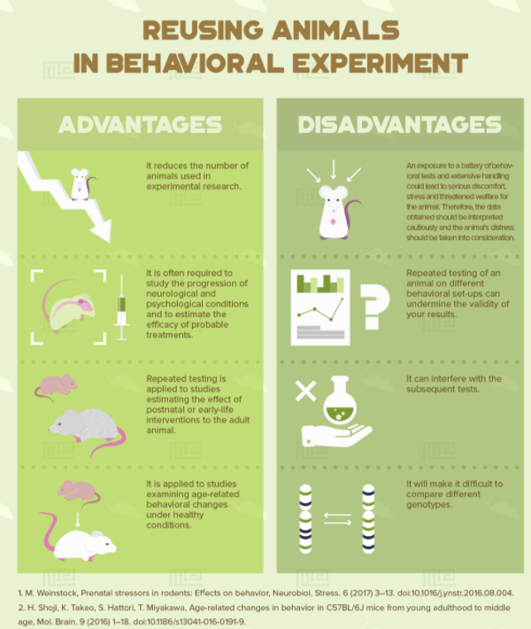
Photo 1

How Does Testing Get Started?
In today’s world there are many different lengths a
scientist must go through in order to get permission to observe
animals. An example of such organizations is “the Association
for the Study of animal behavior and the animal Behavior Society
have formed ethical and Animal Care Committees, respectively,
and each appoints an Ethics Editor that serves on the editorial board of Animal Behavior”
(Elsevier 1). Programs such as this require scientists to have ethical experiments. In order for them to accomplish this they require scientist to wright a proposal and submit it to them. They the review this proposal by looking for a few key factors. These factors are things such as if the experiment is necessary, ethical, cost effective, or beneficial? If the answer to some of these questions is no then they will write the scientist back with an explanation of why and suggestions of how to make it better. Some ways they might suggest to make an experiment better is by doing the experiment online or getting answers through looking at experiments that have already been done.

Why Scientist Have to Get Their Experiments Approved?
Now that you know the types of experiments we currently use, why we take measures to insure the animals are handled in an ethical way. We will take a look into the present and past by looking at two experiments. It is important to note the present and past for a few reasons. This is because it is important to keep up with present errors and make them known to help spread prevention of future mistakes. It is important to remember the past to keep from repeating it, the past has been used to get to the standards we have now, and to decide for ourselves how they could have done better. Both present and past are important to take note from in order to learn from them and make improvements. Figure 1 shows a present day example of an unethical animal behavior experiment done in 2014. Volkswagen decided to trap 10 monkeys into air tight containers with car emissions entering them. They did this to try and show that the fumes were not harmful to the environment. The reason this experiment is unethical by today’s standards is because Volkswagen was committing fraud. They had a dummy test run that showed the emissions were not as bad as they truly were. Due to this they were knowingly putting the monkeys in harm’s way. The lesson to learn from that not everyone can be trusted. There might need to be more rules put into place to keep incidents such as this from happening. For example, possibly having educated people go check or supervise the experiments that are not a part of the organization. The important take away here is to remember that the system is not always perfect and we should continue to learn from experiments such as these to try and prevent the problem from occurring in the future. Figure 2 show a past experiment that was not done properly. Louis and Chester decided to take a short cut in their experiment. Instead of doing the math and taking the time to do the experiment correctly. As a result of this unethical behavior no matter how hard they tried to undo it the damage was too great. As a result the elephant died. This result could have been avoided had they not been impatient. Today’s regulations would have also prevented this mistake as well. The lesson to learn is that you should always take your time and be precise when doing an experiment.

Figure 1
“FRANKFURT — In 2014, as evidence mounted about the harmful effects of diesel exhaust on human health, scientists in an Albuquerque laboratory conducted an unusual experiment: Ten monkeys squatted in airtight chambers, watching cartoons for entertainment as they inhaled fumes from a diesel Volkswagen Beetle.
German automakers had financed the experiment in an attempt to prove that diesel vehicles with the latest technology were cleaner than the smoky models of old. But the American scientists conducting the test were unaware of one critical fact: The Beetle provided by Volkswagen had been rigged to produce pollution levels that were far less harmful in the lab than they were on the road.” (Ewing, 1)

Figure 2
“in 1962, when Tusko the elephant (not the one pictured) was given LSD simply for the sake of seeing how the magnificent beast would react to such a substance.
Unfortunately, the researchers, Louis Jolyon West and Chester M. Pierce, had no idea how much LSD it would take to dose an elephant. Rather than erroring on the side of safety, the doctors decided that they didn’t want to have to do the experiment again just because they underdosed the elephant the first time. They ended up deciding to give Tusko 297 milligrams, which is about 3000 times the dosage a human takes, despite the fact that an elephant weighs about 90 times more than the average human.
After being dosed, Tusko immediately started running around in his pen and soon lost control of his movements, eventually collapsing to the ground and going into seizures. To counteract the LSD, the doctors gave the elephant 2,800 milligrams of an antipsychotic. The drug reduced his seizures slightly, but didn’t stop them. After another hours, the doctors decided to give Tusko a barbiturate to calm him down, but it didn’t help. He died a few minutes later.” (Harness, 1)

Why is it Important to Remember all of this Information?
We have gone over what animal behavior is and why people study it, ways that scientist observe/ test animal behavior, what it takes to get an animal behavior experiment approved, and why it is important to keep up to date with unethical present and past experiments. So what should be taken away from all of this? Remember that all around you people possibly even you are observing animal behaviors. Try to view all that we can learn from them, how they help us, and why we need to preserve the ability to do so. It is up to the present and up and coming generations to protect animals and use what they have to show us in an ethical way. We must that remember that it is always better to do things the right way the first time around, because more likely than not the unethical way won’t work properly anyways. Continuing to learn how the whole process works will help give people the opportunity to help continue to improve the system. Remember to appreciate the bird you watch outside of that classroom window next time and make your own educated behavioral observations.

Citations
Engineers Author Details Maze Engineers MazeEngineers MazeEngineers makes behavioral mazes for all species with high p, M., & Details, A. (2019, January 21). How many behavioral tests can i perform on a single animal? Retrieved March 26, 2021, from https://conductscience.com/maze/how-many-behavioral-tests-can-i-perform-on-a-single-animal/
Ewing, J. (2018, January 25). 10 monkeys and A Beetle: Inside VW's campaign for 'Clean Diesel'. Retrieved March 06, 2021, from https://www.nytimes.com/2018/01/25/world/europe/volkswagen-diesel-emissions-monkeys.html?mtrref=www.google.co.uk&gwh=C87ADA69C4241B0A1DAB4C0F7661C24E&gwt=pay
[2021, Guidelines for the treatment of animals in behavioural research and teaching, Elsevier, 1]
Harness, J., 1, H., JillHarness, & S, R. (2011, April 01). 5 science experiments gone wrong. Retrieved March 06, 2021, from https://www.neatorama.com/2011/03/23/5-science-experiments-gone-wrong/

