The Race to Cure Cancer

Key Words:

Cancer | Cell Replication
Breast Cancer | Prostate Cancer
Cancer Recurrence | Second Cancer
Chemotherapy  Cancer Screening | Cancer Treatment  Cancer Prevention
Stem Cells | Gene Editing

Key Ideas:

1) Cancer is a complex grouping of nontransmissible diseases that affect the cells in the human body.

2) It is difficult to find a singular cure to cancer due to the wide variety of cancers and the variability of cancer causes.

3) There are several promising leads in the field of cancer research that could lead to a cure.

Introduction:

Many people have heard of cancer, but how many people actually know what cancer is? There is so much talk about the “race to cure cancer”, but how is it that not a single researcher has been able to proudly proclaim that they have achieved a miracle – that they have cured cancer? Has this so-called race amounted to anything? Is there any hope for us to cure cancer in the near future? In this chapter, these questions shall be answered.
What is Cancer?

In order to understand the “race to cure cancer”, one must first understand what cancer is. According to the National Cancer Institute, “cancer” is not a single disease, but rather a broad term that encompasses a variety of diseases with similar attributes. All cancers affect the cell replication process; whereas typically the cells in the human body stop growth and division (i.e. replication) when the need for additional cells has been fulfilled, cancerous cells continue the replication process uncontrollably beyond the need for additional cells. While having more cells in the human body may seem to be beneficial, the truth is actually the opposite. The replicating cancerous cells can cause a multitude of issues within the human body, which can be life threatening.
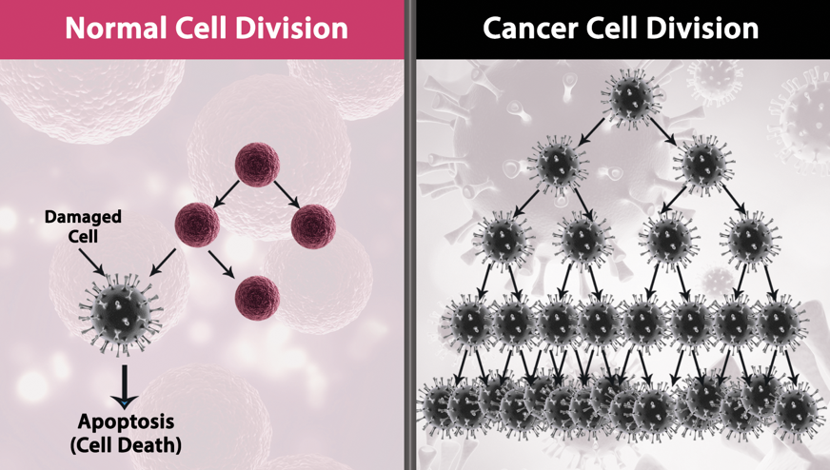
Figure 1: The normal cell division process (left) versus the cancerous cell division process (right)

To get a clearer understanding of cancer, let’s discuss the two common forms of cancer: breast cancer and prostate cancer.
Breast Cancer is a form of cancer that predominately affects women, though it is diagnosed in men as well. Cells within the breast tissue replicate abnormally and cause abnormal lumps in the breast, which can lead to death if untreated. These cancerous lumps can be removed through the surgical removal of one or both breasts, chemotherapy, and/or radiation, though this does not guarantee a person to be “cancer free”.
Prostate Cancer is a form of cancer that solely affects men, as it affects a portion of the body that is not found in women. Cells within the prostate gland replicate abnormally and cause tumors, which can prove to be fatal if unchecked. These tumors can be removed through the surgical removal of the prostate gland, hormone therapy, and/or chemotherapy. Once again, removing the tumors does not necessarily make a person “cancer free”.

Why is Cancer Difficult to Cure?

While there are currently many treatments available for those diagnosed with cancer, medical professionals tend to shy away from using terms like “cure”, as most treatments are not guaranteed to be permanent. Cancer recurrences, or treated cancer that redevelops within the host, are common. There is even a chance of a second cancer, or form of cancer different to the previously treated cancer, developing following treatment. It is near impossible to deem a patient to be one-hundred percent cancer free simply because there is currently no cure for cancer. But why is there not a cure for cancer? This question can be rather difficult to answer, but there are two widely agreed upon reasons: the variety of cancer and the causes of cancer.
Because cancer encompasses many different diseases, finding a singular cure is proving to be rather impossible. Cancer affects different parts of the human body in different ways, which causes a wide variety of symptoms that must be managed alongside curing the cancer itself (for example in lung cancer, patients often develop lung damage that is far beyond what human cells can fix on their own, resulting in lowered lung capacity and increased risk for different lung diseases). The singular cure that many believe to be out there would have to account for the hundreds of cancers and their respective effects on the human body.
There are also many unknowns in the causes of cancer, which some believe may assist in finding the cure for cancer. Cancer can be caused by a wide variety of reasons, such as poor genetics, unhealthy lifestyle choices, and mutations. That being stated, it is not really known why cancer occurs, we simply know that it does occur.

What Progress Has Been Made?

Cancer treatment has progressed wildly throughout time. Technology has advanced and so too has our medical capabilities. There once was a time where chemotherapy, which is perhaps the most commonly thought of cancer treatment, did not even exist. Our ability to utilize radiation to cleanse ourselves of cancer was once something unimaginable. In this section, the major advancements that have been made in the field of cancer research, such as chemotherapy, shall be discussed.

Cancer Treatment:

Often times, speaking about cancer goes hand-in-hand with speaking about cancer treatments. Cancer treatments are not necessarily a “cure” for cancer, but rather a solution that can potentially remove cancerous cells from the human body for an undetermined period of time. These cancer treatments can be permanent or they can be only a temporary solution for the patient. Despite having no guarantee of working, cancer treatments have saved the lives of millions of people since their creation. So, what are some possible cancer treatments?
Chemotherapy, as discussed previously, is often thought of when cancer treatment is brought up. With such a prevalent idea, one would think that chemotherapy had been around for centuries. But chemotherapy is actually a fairly recent invention, with its first use in cancer patients dating back to 1956 – less than seventy years ago. This revolutionary treatment alone has saved countless lives and it is not even a century old!
Another option for cancer treatment that is not quite as new, but has become far more refined over the years, is surgery. In cases where chemotherapy can be avoided, patients often undergo surgery to remove cancerous tissue from their bodies. The first surgical procedure is estimated to have happened somewhere in 6500 B.C., and there is evidence to suggest that the ancient Romans were the first to utilize surgery to treat cancer. That being stated, more often than not, surgeries to remove cancerous tissue would be unsuccessful for a variety of reasons (blood loss, the return of cancer in following years, etc.) until the mid-to-late twentieth century. Now, surgeons have more advanced tools (such as lasers, surgical grade liquid nitrogen, and micro video cameras) that allow for cancer treatment via surgery to be far more successful than what it once was.

Cancer Screening:

On top of cancer treatments, modern technology has also brought about the creation of cancer screening, or checking the body for cancer prior to a patient exhibiting symptoms. Cancer screening by no means prevents cancer from occurring, but it does allow for medical professionals to catch the cancer early, which ultimately means that treatment is more likely to be successful for the patient. The most common types of cancers that are screened for are breast cancer and prostate cancer. It is recommended that women get screened for breast cancer (i.e. get a mammogram from a medical professional) every one to two years, while men should get screened for prostate cancer (i.e. undergo a prostate exam by a medical professional every two years. Breast cancer and prostate cancer are not the only two types of cancers that can be detected early through screening, however, and it is recommended that people who are at an enhanced risk for any form of cancer should undergo screening frequently.

Cancer Prevention:

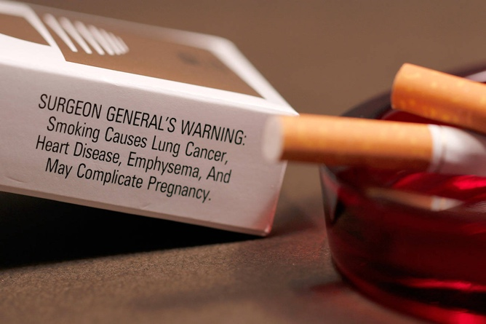
Finally, thanks to modern technology, medical professionals have come to understand what puts patients at a higher risk for cancer, thus they have come to understand how some cancer can be prevented. Cancer prevention is not as much of an exact science as cancer screening and cancer treatments, however, as it only takes into account one or two factor that tend to cause cancer. One can be genetically more likely to get certain forms of cancer such as breast cancer, but some forms of cancer have more to do with lifestyle choices than genetics. For example, it is now known and widely accepted that smoking drastically increases one’s chance of developing lung cancer – so much so that every pack of cigarettes in the United States has a warning label. Thus, if one avoids smoking, they “prevent”, or drastically reduces their chance of getting lung cancer. Other healthy lifestyle choices are said to reduce the risk of cancer, such as exercising frequently and maintaining a healthy diet.
Figure 2: The Surgeon General’s Warning that is required by law to be displayed on all tobacco products

What Does the Future Hold?

Despite no current “cure all” for cancer, the future is looking rather bright due to several promising leads in the field of cancer research.
Gene editing is one such promising lead. The idea of editing genes is rather new to humans, but could prove to produce the cure for cancer given time. The idea behind curing cancer via gene editing is quite simple: utilizing complex gene editing technology, one could theoretically remove cancer causing genomes or even cancerous cells within the human body, thereby eliminating any possibility and/or trace of cancer. Unfortunately, the theory is quite difficult to replicate in the real world, though many researchers are very hopeful.
Stem cells are another rather promising lead. Stem cells are a special type of human cell that have the ability to become any number of different cells within the human body. Because these cells are able to replicate into different cells, many believe that they will be able to cure cancer one day. It is the current theory that stem cells will be able to regrow or completely replace tissue damaged by cancer and replace cancerous cells altogether.

Conclusion:

Cancer is a wide variety of diseases that there is currently no cure for due to the difficulties that come with it being such a broad set of diseases. Though there is no cure, the future does not look bleak. Technology is rapidly advancing, and cancer research has already resulted in so many life-saving treatments such as chemotherapy. Many are hopeful that the cure for cancer is right around the corner, especially considering the promising leads of gene editing and stem cell transplanting.

Questions:

Please answer the following questions based on the chapter.

- What is cancer?

- Is there a cure for cancer?

- Are there solutions for patients who have been diagnosed with cancer?

Definitions:

Breast Cancer: A form of cancer occurring mainly in women that affect the cells within the breast tissue.
Cancer: A grouping of potentially fatal diseases that affect the cell replication process within the human body, causing mutated or “cancerous” cells to replicate far beyond the needs of the body.
Cancer Prevention: Reducing the likelihood of a patient developing cancer, often through choosing healthier lifestyle choices.
Cancer Recurrence: Previously treated cancer recurring in the host.
Cancer Screening: Catching cancer early through one or more cancer detecting tests.
Cancer Treatment: Ridding the patient of all signs of cancer for an indeterminate period of time through a variety of methods.
Cell Replication: The creation of new cells in the human body, normally occurring only when the need for new cells arises.
Chemotherapy: A cancer treatment method that utilizes extremely strong chemicals to kill off the cancer cells within the body.
Gene Editing: The process of “editing” the human genome through modern-day technology. Often includes “snipping out” mutations or other “bad genes” and replacing these sections of the human genome with “good genes”.
Prostate Cancer: A form of cancer occurring solely in men that affect the cells within the prostate.
Second Cancer: A cancer that occurs in patients who had previously been treated with and/or diagnosed with a completely different form of cancer.
Stem Cells: Specialized, “generic” human cells that can transform into almost any other human cell, such as a brain cell.

References:

American Cancer Society. (2014). Evolution of Cancer Treatments: Surgery. Retrieved from https://www.cancer.org/cancer/cancer-basics/history-of-cancer/cancer-treatment-surgery.html
American Cancer Society. (2014). Evolution of Cancer Treatments: Chemotherapy. Retrieved from https://www.cancer.org/cancer/cancer-basics/history-of-cancer/cancer-treatment-chemo.html
American Cancer Society. (2018). Cancer Facts and Figures 2018 [PDF].
American Cancer Society. (n.d.). Cancer Screening Guidelines by Age. Retrieved from https://www.cancer.org/healthy/find-cancer-early/screening-recommendations-by-age.html#40-49
Centers for Disease Control and Prevention. (2020). Cancer Screening Tests. Retrieved from https://www.cdc.gov/cancer/dcpc/prevention/screening.htm
Mayo Clinic. (2020). Chemotherapy. Retrieved from https://www.mayoclinic.org/tests-procedures/chemotherapy/about/pac-20385033
MountainView Hospital. (2015). The Evolution of Surgery. Retrieved from https://mountainview-hospital.com/about/newsroom/the-evolution-of-surgery
National Cancer Institute. (2015). What Is Cancer? Retrieved from https://www.cancer.gov/about-cancer/understanding/what-is-cancer
Stanford Children's Health. (n.d.). What are Stem Cells. Retrieved from https://www.stanfordchildrens.org/en/topic/default?id=what-are-stem-cells-160-38
Sterling, J. (2020). CRISPR Technique Effectively Destroys Metastatic Cancer Cells in Living Animal. Retrieved from https://www.genengnews.com/news/crispr-technique-effectively-destroys-metastatic-cancer-cells-in-living-animal/

