The Central Nervous System
Key Terms
Central Nervous System, or CNS, is the control center for the entire body. This complex of nervous tissue is responsible for organizing and monitoring all the functions of the body.
The brain is an organ made of soft tissue that serves as the coordinating center of all activity.

Section 1: What is the CNS?
Have you ever wondered how you process information? How does information travel from our brain and turn into movement or speech or absolutely everything else? How do your muscles know what your brain is thinking when you decided to get up and stretch your legs after studying for hours? How does your throat know to swallow when you take a sip of water? All this information gets processed in a central location known as the Central Nervous System.
The central nervous system is part of a larger system called The Nervous System. This system is responsible for processing all information to ensure that all parts of the body are taken care of and accounted for. The Central Nervous System, or CNS, consists of only the brain and the spinal cord. Makes sense, right? The brain and spinal cord are in the center of the body, hence the “central” nervous system. This central axis gathers information from the entire body and organizes reactions and responses to the external environment. Its most important goal is to make sure that information coming from the rest of the body (the peripheral nervous system) is received and analyzed properly so that it can proceed with the proper response. The CNS is responsible for way more than we even know. For this reason, it is very well protected – the brain is housed within the skull and the spinal cord within the vertebrae of the spine. It controls everything from our thoughts, emotions, and movements to the unconscious release of hormones and regulation of breathing.
What is the brain?
Weighing approximately 3lbs, the brain is the most complex part of the human body. Even though it only makes up a small fraction of our total body weight, it controls absolutely everything. This organ is the source of all the qualities that make up the human being.
Since this organ is responsible for processing all the information coming in and out of the body, it requires a high level of organization. For this reason, it is split into four lobes, all with unique job descriptions: Temporal, Occipital, Parietal, and Frontal.
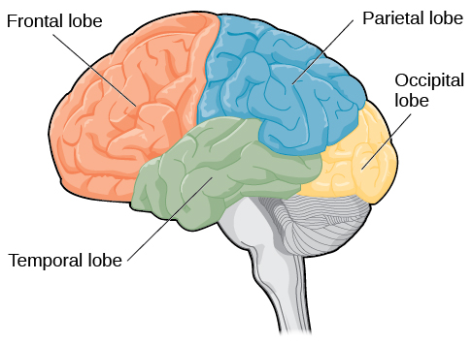
(Lumen Learning)
The frontal lobe is located in the anterior (front) part of the brain. This section is responsible for reasoning, motor control, language comprehension and emotions. It contains a very important area called the motor cortex, which is responsible for coordinating and controlling all the movement in the body. So, when you sit down and stand up, just know that your motor cortex is responsible for making sure that happens when and how you want it to! Another important area in the frontal lobe is the Broca’s area – this is where language production occurs. So next time you can’t remember a word or you get “tongue tied”, just know that you can blame the Broca’s area for that! There is a famous case of an individual named Padma who suffered from damage to the Broca’s area. She was a very smart, working mother who got in a car accident and damaged the Broca’s area of her brain. She completely lost the ability to speak at all. Nothing was wrong with her vocal cords, but she simply could not produce words. She can still do everything normally, just without saying a single word.
The parietal lobe is the section of the brain located directly posterior (behind) the frontal lobe. This lobe is responsible for processing all information from the body’s senses, and holds an area known as the somatosensory cortex. Any touch, temperature change, or pain is processed by this lobe.
The temporal lobe is located on both sides of the brain, and is responsible for hearing, emotion, and memory. This lobe, along with the frontal lobe, is also associated with some parts of language comprehension. This lobe contains a section called the auditory cortex which is the area of the brain dedicated to all things auditory. Anything you hear is processed in this area of the brain. When you are listening to your favorite music, you can thank the auditory cortex. And then when you can’t stand the sound of someone’s voice, you can still thank the auditory cortex! Another important area of this lobe is called the Wernicke’s area, which is vital for speech comprehension.
Key Terms
Neurons are the cells of the brain, responsible for sending and receiving chemical and electrical signals.
Glial Cells are the supporting cells for neurons.
And lastly, the occipital lobe, located at the very back of the brain, is primarily responsible for all things visual. Everything you see and perceive is processed and translated in this lobe.
(Lumen Learning)

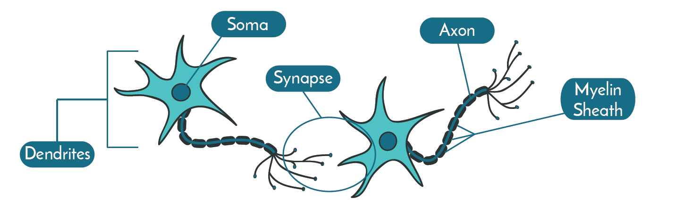
(Dana)
Neurons
We have all heard of neurons. We know they exist in the brain. But what are these infamous little beings?
Neurons are the cells in the brain that “send and receive electrical and chemical signals” (Dana). Just as the cells are the building blocks of the human being, so neurons are to the brain. These brain cells are responsible for all the signaling, messaging, and interpreting of information that occurs within the brain. These cells are what give us humans the ability to think, hear, see, touch, move, and understand. Think of the greatest inventors, the most talented singers, the Olympians that run like machines – none of this is possible without the constant and tireless work of neurons.
A neuron is composed of three parts: the cell body, the dendrites, and the axon. The cell body is the part that withholds the structure and shape of the neuron, supplies energy, and contains genetic information. The dendrites are the little projections from the cell body that receive chemical and electrical signals from other neurons. The axon is the longest and largest projection from the cell body, and is responsible for sending chemical and electrical signals to other neurons. This signal is sent through the part of the axon called the axon terminal.
In order to send a signal from one neuron to another, the neuron fires an action potential from its axon to the dendrite of an adjacent neuron. An action potential is basically a wave of energy that moves along the membrane of the axon.
Key Terms
The spinal cord is the bundle of nerve fibers that are enclosed within the spine, that for the axis of information between the brain and the rest of the body.
Efferent Nerves are the nerves that conduct signals from the brain to the body.
Afferent Nerves are the nerves that conduct signals from the body to the brain.
Even though is seems like the neurons do all the work, they wouldn’t be very helpful to us without glial cells. Glial cells are absolutely vital in holding neurons together and in place. They act almost like a glue, making sure that neurons are able to reach each other. They also help with signaling. (Dana)
What is the Spinal Cord?
The spinal cord is the other half of the CNS.
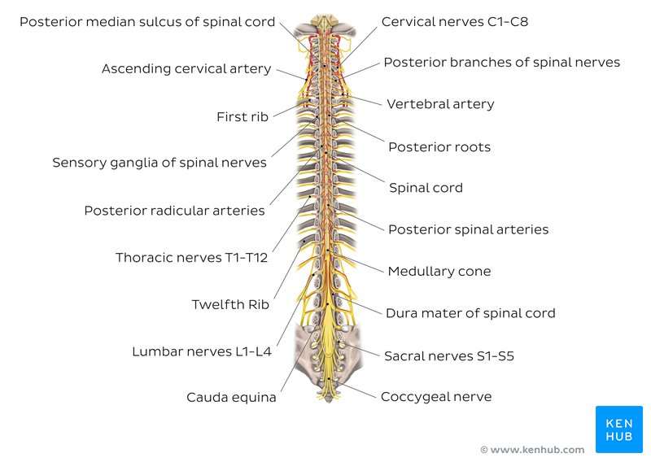(kenhub)
To get a visual of the spinal cord, see the figure above. It is responsible for taking all the information from the brain and giving it to the rest of the body. What good would it be if you thought of standing up, but your body didn’t do it, and it just remained a thought? That would do absolutely nothing for you! In order for the thought in your brain to actually tell your body to do something, it has to travel through the spinal cord! On the other hand, think of this – your hand is on a hot stove. But your brain doesn’t know that your hand is being burned, so it doesn’t tell your hand to move. The information can’t just travel from your brain to your hand… the information has to also be able to travel from your hand to the brain! This also occurs in the spinal cord. This is why your spinal cord has two highways of nerves: efferent nerves, which conduct information from the brain to the body, and afferent nerves, which give information from the body to the brain.
The spinal cord is divided into regions to better understand its many physiological functions: cervical, thoracic, lumbar, sacral, and coccygeal.
As you would imagine, injury to the spinal cord usually results in some level of paralysis. If the brain is unable to “talk to” the body, it won’t be able to tell it to stand, or move in any way. (Kenhub)

Stimulation of the CNS
I am sure we have all seen our grandparents play an infinite number of solitaire and crossword puzzle games… have you ever wondered why? I am sure we have also noticed that adults love to drink things like coffee… ever wondered why? By doing things like repetitive games or drinking coffee, our brains are “stimulated”. To stimulate your brain is to exercise it, to keep it from getting old and tired. When we stimulate our brains, we make those connections between neurons that are so vital to our brain’s overall function. Our brains are stimulated every day in an infinite number of ways! Every time you move your eyes to see something new, your brain makes a neural connection. Every time you open a book, smell a flower, kick a soccer ball, or play a game of solitaire, your brain is making a new neural connection! These are all natural ways our brain makes connections. What happens when we drink coffee? This is a new type of stimulant. Our brains are very tightly regulated. They function great on their own, so what happens when we introduce an outside source of stimulation into our system?
“Stimulants increase alertness, attention, and energy, which are accompanied by increases in blood pressure, heart rate, and respiration.” (SpineUniverse)
Stimulation of the brain by making it work for itself is one thing, but adding something into your body to somehow stimulate your brain is another thing completely. When we add a synthetic stimulant into our body system, our brain doesn’t have to work as hard on its own, because there is something else doing some of that work for it. As this continues to happen, the brain becomes used to working “part time” and eventually realizes that it no longer needs work on its own all the time. This is how people become addicted to stimulants like coffee… if they stop, the brain doesn’t work quite as well! Other common stimulants that you may recognize are cocaine and Adderall. (spine verse) Stimulants may be used for some short-term treatments of brain disorders, such as attention deficit disorder. But when a perfectly functioning brain introduces stimulants without a doctor’s explicit instruction to do so, it only results in overall decreased brain function.
So, now that we understand how stimulants work on the brain and their effects, we can begin to explore what takes place on a molecular level. The stimulating effects of caffeine on the CNS come largely from the way it binds to adenosine receptors. Let me clarify – the molecular structure of caffeine is very similar to that of a naturally occurring brain neurotransmitter known as adenosine.
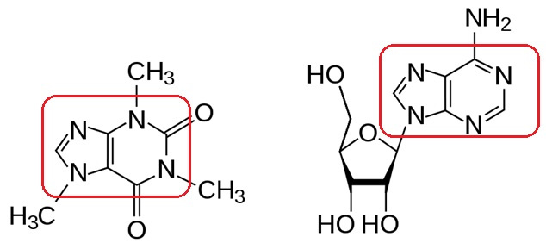
https://schientist.wordpress.com/2013/09/12/coffee-buzz/
Adenosine is a very specific natural neurometabolite released in the brain, that binds to specific receptors to effectively make us sleepy. Caffeine acts as an adenosine-receptor antagonist. When several adenosine receptors are being “clogged” by caffeine molecules, this inhibits the action of adenosine binding. In turn, this inhibits us from becoming sleepy. (Mcgill)

Work Cited

Vasković, J. (2020, October 29). Spinal Cord (N. McLaren, MSc, Ed.). KenHub. https://www.kenhub.com/en/library/anatomy/the-spinal-cord

Weaver, E. A., II, & Doyle, H. H. (2019, August 8). Cells of the Brain. Dana Foundation. https://dana.org/article/cells-of-the-brain/#:~:text=The%20most%20common%20brain%20cells,necessary%20for%20proper%20brain%20function

Lobes of the Brain. (n.d.). Lumen.Retrieved March 25, 2021, from https://courses.lumenlearning.com/waymaker-psychology/chapter/reading-parts-of-the-brain/

Brain Basics. (n.d.). National Institute of Neurological Disorders and Stroke. Retrieved March 25,2021, from https://www.ninds.nih.gov/Disorders/Patient-Caregiver-Education/Know-Your-Brain#:~:text=The%20brain%20is%20the%20most,qualities%20that%20define%20our%20humanity

Central Nervous System (CNS) Depressants and Stimulants. (n.d.). Spine Universe. Retrieved March 25,2021, from https://www.spineuniverse.com/treatments/medication/central-nervous-system-cns-depressants-stimulants

How Drugs Affect Neurotransmitters. (n.d.). The Brain From Top to Bottom. Retrieved March 25, 2021, from https://thebrain.mcgill.ca/flash/i/i_03/i_03_m/i_03_m_par/i_03_m_par_cafeine.html#:~:text=Adenosine%20is%20a%20central%20nervous,down%2C%20and%20you%20feel%20sleepy.&text=Caffeine%20acts%20as%20an%20adenosine,but%20without%20reducing%20neural%20activity

