Agrobacterium: Plant Cancer turned to Genetic Engineer

TOPIC OVERVIEW:

There is a plethora of bacteria that can be found in all aspects of life from the soil, to the water, and to the very skin of a human body. Soil bacteria in itself can range from rhizobia, agrobacterium, and several other forms of bacteria. These types of bacteria can be beneficial or a hindrance to most plants. A beneficial soil bacteria is rhizobia, the bacteria that converts nitrogen into a usable form for plants. Agrobacterium in particular was originally seen as a harmful plant and soil bacteria. It was equivalent to a plant having cancer. This was due to the tumorous growths that would be produced upon the infection of these disease ridden bacteria. This infection is called crown gall, a plant disease caused by agrobacterium that makes tumors form across the roots of plants at a wound site (Grabowski et. al). Using this disease, researchers were able to note that the bacteria was able to genetically splice the bacterium's DNA plasmid into the plant itself. It was believed that this bacteria type could be the future of genetic engineering due to its unique abilities. This was later achieved with increasing technology and is still being studied and modified upon today.

In this chapter we will discuss in further detail what agrobacterium is. We will also explain the process the bacteria uses to incorporate its DNA plasmid into the plant's DNA. Finally the use of this will be explored in the process of modern molecular genetics and genetic engineering.

PROPERTIES OF AGROBACTERIUM

1.1 What is Crown Gall
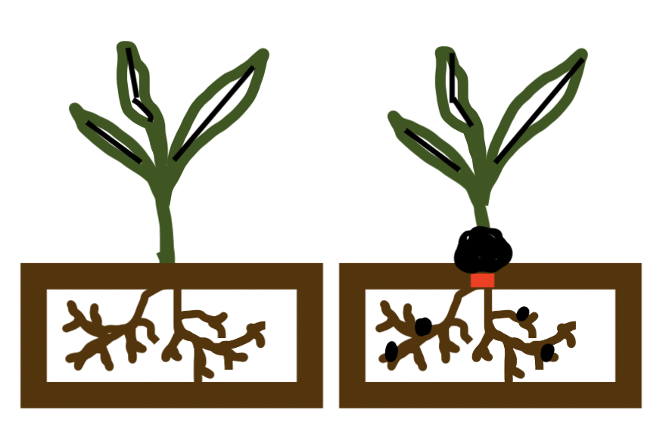
Agrobacterium, Agrobacterium tumefaciens, was formerly known as the bacteria that caused a disease in plants called crown gall. This bacteria was known to be a part of a disease that makes crown gall. Crown gall in itself is associated as the equivalent of plants having cancer. This is due to the irregular tumors that form on the essential parts of the plant. Specifically these tumors will form over the roots, then depending on the type of DNA given by the agrobacterium, the tumors can be found on the trunk, branches, and several other locations of the plant (Grabowski et. al). Crown gall can be commonly seen on several important plants, for example fruit trees, roses, willows, and monocots. These plants all form large woody growths that are easily visible and are commonly used as examples due to the drastic phenotype the plants produce when infected with crown gall (Grabowski et. al).
Figure 1:
On the left side represents a traditional plant, note the lack of grow around the base of the stem near the ground and the lack of nodules present on the roots. The right side represents a plant infected with agrobacterium. Near the base of the stem touching the ground is a large tumor just above the red box symbolizing the wound site. Tumors may be present at the base of the stem due to the initial entry. In this case the primary tumor is at the base of the stem touching the ground while the secondary tumors are present as black circles on the roots.

To understand how the disease crown gall can form these tumors, we need to understand how the bacteria is able to enter the plant itself. Scientists discovered almost 100 years ago that the bacteria was able to enter the plan through wounds on a plant's root. These wounds can be caused by human activities, plant activities, and other natural processes. For instance, common human activities that create micro wounds on a plant are grafting, agriculture, and gardening in general. Several plant activities such as root damage cause these wounds to limit their healing, therefore increasing the risk of the bacteria entering the wounds. A third instance that increases the chance of infection are insects.

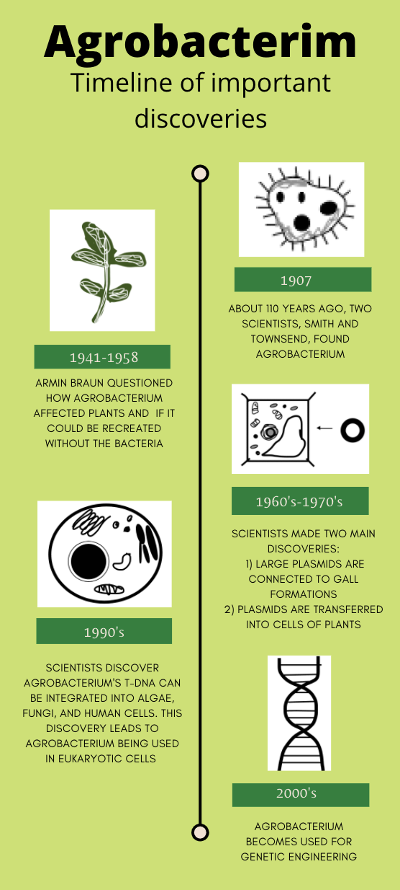
Looking inside these plant tumors, scientists were able to determine that the tumors were caused by plant cells rapidly growing and dividing. This uncontrollable growth leads to a tumor being formed within 2-4 weeks in the average growing season. This is called the primary gall. During the rest of the growing season, secondary galls will form a short distance from the initial tumor location. Over the course of the growing season, these tumors will break down and the bacteria will retreat back to the soil (Grabowski et. al).

1.2 Early history of Agrobacterium
The initial discovery of agrobacterium was in 1907 by a group of scientists named Erwin Smith and Charles Townsend. These scientists were investigating the cause of crown gall disease and hypothesized the disease was caused by a bacteria. They later named this as Bacterium tumefaciens, today this is referred to as Agrobacterium tumefaciens (Nester 2015). This was a major discovery as plant pathogenic bacteria was only discovered 20 years beforehand (Nester 2008). Research on this new bacteria rapidly began and within 30 years scientists were able to make several important discoveries about agrobacterium (Nester 2015).

The first major discovery came in 1941 and was expanded upon until 1958. This encompassed how the bacteria was able to create crown gall disease. This process started by a graduate student located at Rockefeller Institute named Armin Braun (Nester 2008). Braun was interested in the question posed by a German scientist, why is the agrobacterium difficult to remove from the tumor tissues (Nester 2008)? Studying this question, Braun proposed several key points. The first major point was determined by the ability of tumor cells to be grown in a media culture without the use of two essential plant hormones, Auxin and Cytokinin. He also noted that the use of agrobacterium did not alter the plant itself, instead it was used as an apparatus to move the genetic material. The third and final point that Braun proposed was the idea of a tumor inducing principle. He termed this TIP. Due to the lack of technology at the time, Braun was unable to gather evidence to support his claims and the scientific community did not adapt this information until molecular genetics was created (Nester 2015).
Figure 2:
Agrobacterium was initially discovered in 1907 by a group of scientists exploring the cause behind crown gall disease. These scientists termed the name agrobacterium that would be heavily explored upon in the next century. The next major discovery was in the 1940’s and 1950’s by a graduate student at the Rockefeller Institute named Armin Braun. Braun was looking into what was causing the tumors formed by agrobacterium. He discovered that the bacteria itself was not required for virulence. The next two decades were focused on the plasmid inside the bacteria’s DNA. In the 1990’s, tDNA from agrobacterium was able be used in virtually every eukaryotic cell. Today this bacteria is used for genetic engineering in plants and is branching out into other types of organisms (Nester 2008).

Over the next several decades, scientists expanded upon Braun’s basic idea behind agrobacterium. In the late 60’s and early 70’s it was discovered that the TIP was DNA that was transferred from the bacteria itself into the cells of the plant’s root. During that same time, Allen Kerr determined that agrobacterium had the potential to be virulent, or transfer disease causing viruses and bacteria. A year later, George Morel found that the tumors caused by this bacteria contained secondary amines, octopines, and nopaline. These tumors were also able to contain lysopine depending on the exact genetic material. Other scientists used Morel’s contributions to determine that the bacteria would change its production values depending on the codons used. They also determined that the bacteria was able to degrade the opines (Nester 2015). Another scientist named Robert Hamilton found that heat removes the agrobacterium virulence (Nester 2008).

The next major discovery about agrobacterium was found by Ivo Zaenen, he noticed that the plasmids found in the agrobacterium were abnormally large. This was later confirmed to be the largest mega plasmid at the time (Nester 2015). A plasmid of this size was deemed a mega plasmid, this one specifically was termed the TI plasmid.

THE SCIENCE BEHIND AGROBACTERIUM

2.1 The C58 Genome
One of the most peculiar things about agrobacterium is the genome structure and its ability to incorporate plasmids into plant cells DNA. This is mainly due to the C58 genome. This DNA sequence has 4 replicons, these replicons in specific are a circular chromosome, a linear chromosome and 2 mega plasmids. The mega plasmids are termed pTiC58 and pAtC58 (Nester 2015). This C58 was first discovered and named by two groups of scientists that published at the same time as each other. One team was the Hiram college working with the company Monsanto. The other group was the University of Washington and the company El DuPont de Nemours. They compiled a full genome of this particular gene before genome sequencing was a common practice (Nester 2015).

2.2 The Vir region
Inside the C58 genome is a region called the Vir region, this region is the cause of disease for a specific strain and is roughly 30 genes long. 66.6% of the genes in this region were found to be responsible for tumor growth (Nester 2015). These genes inside this region are the largest section present in the TI plasmid. One gene in specific is called VirE2. This gene is still being understood by scientists today, some researchers believe the purpose of the VirE2 is to help tDNA be transported. Others believe it may help coil the DNA later once it has been integrated. A third possibility is that it could help protect the strands against degradation in the cytoplasm and help the plasmid reach the host cell (Gelvin). Understanding this region is an important part towards fully understanding the process being agrobacterium and until it is fully explored, the engineering ability of agrobacterium will not reach its full potential.

MODERN USE AND GENETIC ENGINEERING

3.1 Beginnings of Genetic Engineering
While agrobacterium is a unique bacteria, it also holds 2 main unique properties and characteristics that makes it known to be nature's genetic engineer.

- The ability to incorporate a plasmid into a plant cell's DNA.
- The ability of the bacteria to make opines for its own metabolism.

There are several issues that are associated with this type of genetic modification. The first issue has to deal with the size of the TI plasmid. As noted in section 1.2, Ivo Zaenen discovered that the TI plasmid was known as a mega plasmid and noted the impressive size was the largest seen at the time (Nester 2015). Due to the large nature of this plasmid, there can be an issue incorporating the plasmid into DNA segments. To solve this issue, scientists typically split the plasmid into two smaller sections. This process is used in most labs that are studying agrobacterium today (Nester 2008).

There is also the problem of gene stability once incorporated into the plant's genome sequence. To obtain this, scientists developed the ability to remove the oncogene in agrobacterium. This means that the overall tumor producing gene was removed. Surprisingly, without this gene present, agrobacterium was still able to regenerate itself and integrate into a normal plant cell (Nester 2008). This was an important step towards making agrobacterium a possible genetic engineering mechanism. After this critical discovery, scientists began looking into making antibiotic resistant genes and experimented on a strain of tobacco by using a nopaline synthase promoter. These studies found they could successfully create an antibiotic resistance and inadvertently led to what is known as the agricultural industrial revolution. This revolution led to the company called Monsanto starting to genetically engineer their plants (Nester 2008).

3.2 Modern Genetic Engineering
After discovering that plasmids can be split into pieces and still be functional, scientists began using agrobacterium to introduce foreign genes into host plant cell’s. Many scientists began doing cis (same) integration gene methods, these in particular are time expansive and are specific to an exact region on the TI plasmid. The second type of engineering was splitting the plasmid into sections, this process limited tumor growth but had to act in a different section on the plasmid than the initial section (Gelvin).

Using the above two methods, agrobacterium has allowed scientists to make plants that have DNA and traits that came from other plants, or transgenic plants (Gelvin). Scientists also are making changes to the specific regions in the plasmid and bacteria itself. Some are changing the acidic conditions the bacteria can grow in. Others are changes to the outer membrane of the bacteria, and increasing the possible host range. Today, scientists are able to use agrobacterium for most genetic engineering that can be focused on eukaryotic cells and has a genome that is relatively understood (Nester 2015).
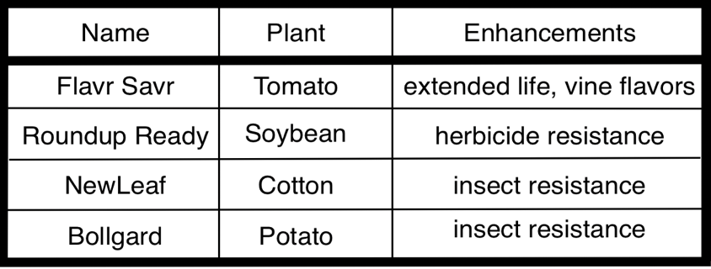
have the same taste as a tomato off the vine and allowed tomatoes to be picked when they are ripe instead of being artificially ripened. This tomato was popular in the late 1980’s and was the first genetically modified produce item to be readily available to consumers. There was no difference determined by scientists other than the ripeness gene. Sadly, the tomato had to be removed from consumer use after a scientist blamed a mutation of a rats DNA on genetic engineered foods being eaten instead of the hazardous gene (Bruening).
Figure 3:
Agrobacterium was the basis of each of these genetically modified crops today (Deacon). The first readily available crop was the tomato hybrid. Flavr Savr was created by flipping and reinserting the gene that caused ripening of the fruit. This gene was then put into the plants DNA via Agrobacterium and was mass produced. These tomatoes were found to

CONCLUSION

Agrobacterium is an important bacteria that can naturally engineer plant cells using a plasmid. This plasmid, typically called the TI plasmid can independently carry a small DNA sequence and be incorporated into a plant cell's DNA strand. This method of transport is the basis behind Agrobacterium genetic engineering. Looking into the TI plasmid itself, scientists were able to determine that this bacteria had unique properties that allowed it to take advantage of its situation and make each host the perfect area for it to thrive inside of. Scientists today are using this idea of incorporating a plasmid into DNA by taking out the virulent protein codes and making this bacteria a mechanism of transmission. Scientists are now able to genetically modify most plants and even some eukaryotic cells, giving them many more opportunities to fix common diseases by building resistance and the ability to easily modify the host. Without Agrobacterium, the concept of genetic engineering in plants would be more difficult and not as prevalent in modern research.

Definitions:
Agrobacterium: a bacteria that is called nature's genetic engineer due to the movement of plasmids into plants DNA and the ability of creating virulence with different proteins
Crown gall: a plant disease formed by agrobacterium that creates tumors on the roots of said plant
Oncogene: a gene that can create a tumor cell
Opine: compounds produced by agrobacterium, typically in a crown gall tumor
Plasmid: a piece of DNA, typically circular in nature, that can independently replicate independently from the main cells DNA
Primary gall: the first tumor in crown gall
Replicon: DNA that replicated from a single piece of DNA
Rhizobia: soil bacteria that is able to fix nitrogen for plant use
Secondary gall: any subsequent tumors formed by crown gall
TIP: a tumor inducing principle
Transgenic: Contains DNA from another species
Vir region: region responsible for the agrobacterium’s virulence of tumors
VirE2: a DNA proteins that binds to nonspecific pieces of DNA and role is ambiguous

References:

Bruening, G. and Lyons, J. M. “the case of the FLAVR SAVR tomato”. California Agriculture. (2000). http://calag.ucanr.edu/Archive/?article=ca.v054n04p6

Deacon, J., Robertson, A., and Isbister A. “The Microbial World: Biology and Control of Crown Gall (Agrobacterium tumefaciens)”. Institute of Cell and Molecular Biology, the University of Edinburgh. http://archive.bio.ed.ac.uk/jdeacon/microbes/crown.htm

Grabowski, M. and Koetter, R. “Crown gall”. University of Minnesota Extension. (2019). https://extension.umn.edu/plant-diseases/crown-gall

Gelvin, S. “Agrobacterium-Mediated Plant Transformation: the Biology behind the “Gene-Jockeying” Tool”. Microbiology and Molecular Biology Reviews. (2003). https://www.ncbi.nlm.nih.gov/pmc/articles/PMC150518/

Nester, E. Agrobacterium: The Natural Genetic Engineer 100 Years Later. APS Centennial. (2008). https://www.apsnet.org/edcenter/apsnetfeatures/Pages/Agrobacterium.aspx
Ward, D. and Zambryski, P. “The six functions of Agrobacterium VirE2”. Proceedings of the National Academy of Sciences of the United States of America. (2001). https://www.pnas.org/content/98/2/385

Nester, E. “Agrobacterium: nature’s genetic engineer”. Frontiers in Plant Science. (2015). https://www.frontiersin.org/articles/10.3389/fpls.2014.00730/full

