Organelles and Their Function within Eukaryotic Cells

Within the human body eukaryotic cells are made up of organelles that perform all necessary cellular functions. Eukaryotic cells re made up of a nucleus, mitochondria, rough endoplasmic reticulum, smooth endoplasmic reticulum, Golgi body, ribosomes, cell membrane, cytoplasm, lysosomes, microtubules, and microfilaments.

Nucleus
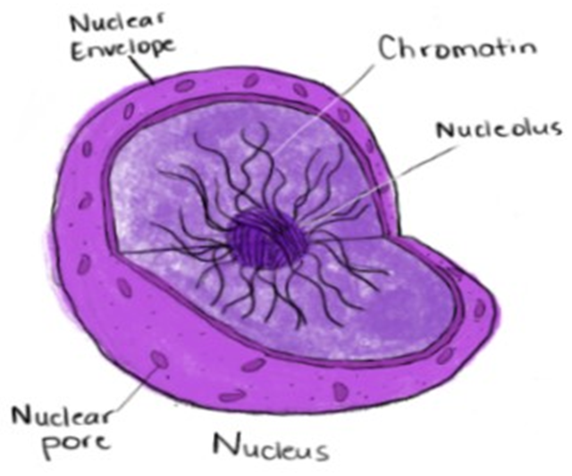
The nucleus is one of the most important organelles in the cell as it houses the cell’s chromosomes. The nucleus contains an area called the nucleolus which is dark in color and is where rRNA is synthesized. The nucleus is surrounded by the cell membrane that protects and contains the chromosomes. It is made up of a phospholipid bilayer that has nuclear pores on its surface which allows molecules to permeate the cellular membrane. The two types of molecules allowed to pass are RNA proteins complexes, RNA, and proteins that are traveling into the nucleus.
Chromatin
Nuclear Envelope
Nuclear Pore
Nucleus
Nucleolus
Figure 1.1 The Nucleus is comprised of a nuclear envelope that surrounds the chromatins and nucleolus and is studded with nuclear pores. The nuclear envelope is composed of a phospholipid bilayer that has areas throughout where the two layers fuse, these are the nuclear pores. The nucleolus is dark, and some cells can have more than one. Chromatins are composed of histone proteins and DNA which appear as a web or lumpy strands.

Mitochondria
Mitochondria are found in almost every eukaryotic cell. They are referred to as the “powerhouse of the cell”. They generate energy which the cell then uses for cellular processes. This energy is made from proteins, fats, and carbohydrates that are found in the food we eat. When these molecules are broken down the energy produced is called ATP and is used throughout the whole body. This is done through a process that is called the electron transport chain or oxidative phosphorylation. This is done by breaking down glucose and then using the resulting energy to attach phosphate groups to ATD forming ATP. This process is known as aerobic cellular respiration and requires oxygen to perform this cycle. When the body requires high amounts of energy from ATP that are being generated currently, mitochondria can split themselves in half and grow to their original size again. This allows for twice the amount of energy to be produced.
Diseases that can result from complications related to the mitochondria include but are not limited to Kearns-Sayre syndrome (KSS), Leigh syndrome or subacute necrotizing encephalomyopathy (MILS), Mitochondrial encephalomyopathy, lactic acidosis and stroke (MELAS) and Maternally inherited deafness and diabetes (MIDD).
Mitochondria
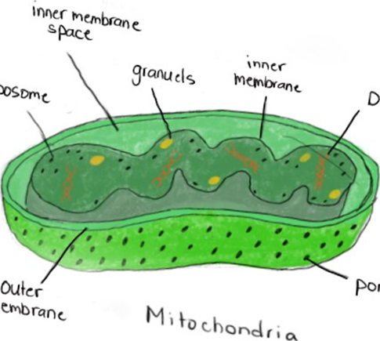
Figure 1.2 The mitochondria is the site of ATP synthesis that generates energy for the rest of the cell. They also store both RNA and DNA and have pores on their surface for easy transportation through the membrane.
Outer Membrane
Ribosome
Pore
DNA
Inner Membrane
Granules
Inner Membrane Space

Rough Endoplasmic Reticulum
The rough endoplasmic reticulum is named for it’s rough exterior due to the ribosomes attached to its surface. On the surface of the rough endoplasmic reticulum, protein is synthesized when it is then sent to either the vacuole or lysosome.
There has been recent evidence to indicate that when the ER is under stress it can lead to metabolic diseases like type 2 diabetes, neurodegeneration, and cancer.

Smooth Endoplasmic Reticulum
The easiest way to identify and remember the smooth endoplasmic reticulum is that it unlike the rough endoplasmic reticulum, it does not have ribosomes embedded on the surface. The smooth ER is filled with enzymes that catalyze lipids found in carbohydrates, synthesizes sex hormones and other steroid hormones. It removes drugs form the body along with the liver and kidneys and takes up, synthesizes,
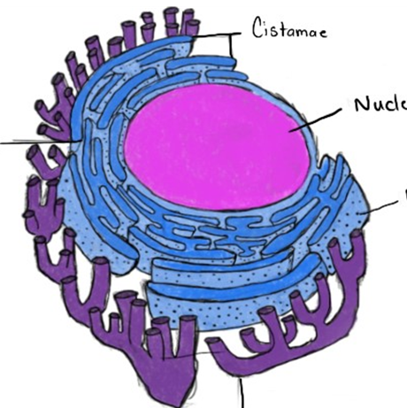
and transports fats within the intestinal epithelium. Smooth ER does not occur in most cells in the body, but it found in cardiac and skeletal muscle cells where it stores and releases calcium ions.
Ribosome
Smooth Endoplasmic Reticulum
Rough Endoplasmic Reticulum
Nucleus
Cisternae

Figure 1.3 Endoplasmic Reticulum The rough endoplasmic reticulum is distinguishable by a bumpy appearance due to the ribosomes on the surface. The smooth endoplasmic reticulum surrounds the outside of the rough ER. The entire endoplasmic reticulum surrounds the nucleus with the rough ER being the closest.

Golgi Body
The Golgi body also known as the Golgi apparatus is made up of stacked membranes that range depending on the cell. In humans, these can be up to 20 membranes compared to plants which have a few hundred. Golgi bodies are essential and large in cells found in the pancreas. Its main function is to prepare and encase certain proteins determined by the location their being transported to. This is done in a process that begins when a vesicle detaches from the rough ER and then merges with the Golgi body. Within the Golgi body phosphate groups and sugar groups are attached to the glycoproteins which are then labeled for their designated location. Once labeled the proteins are split into three different vesicles based on location and the ones leaving are separated from the Golgi body into secondary vesicles where they travel to the membrane and exocytosis is performed. The large size of Golgi bodies are essential in pancreatic cells because they are also the site of transmembrane proteins and lipids being packaged into vesicles to be transported to the surface of the cells. It is also the site of lysosome production which is done by packaging hydrolytic enzymes.
Golgi Body
Forming vesicle

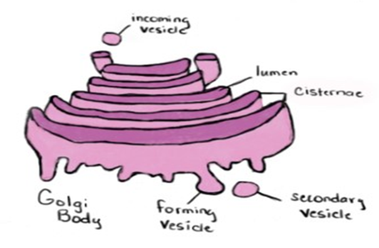
Incoming vesicle
Secondary vesicle
Golgi Body
Forming vesicle
Cisternae
Lumen
1.4 The Golgi Body packages molecules coming into the Golgi body from the ER. The molecules are labeled and packaged based on their destination and then are either held with in the Golgi Body or released from the organelle in a secondary vesicle.

Lysosome
Lysosomes are a sac like vesicle that are the site of digestion. Lysosomes contains hydrolytic enzymes that are able to break down most organic molecules found within the body. These enzymes are synthesized within the ribosomes found in the rough endoplasmic reticulum and then are encased in the Golgi body. Lysosomes are very extraordinary little organelles. The membrane contains hydrogen ion “pumps” which sustains the low pH found within the organelle it also keeps the acid hydrolases within in cell but allows for waste and other products to leave or be used by the cell. It is also the site of disarming viruses and bacteria of their toxins or other harmful mechanisms. It also breaks down organelles that are no longer functional, synthesizes glycogen and releases thyroid hormones from thyroid cells, and is essential in breakdown unnecessary tissues for example the uterine liner during menstruation.
The cause for many autoimmune diseases like rheumatoid arthritis find their origins when the lysosome is broken down due to too much Vitamin A in the human body.
Plasma Membrane
Lipid Bilayer
Hydrolytic Enzymes
Transport Proteins
Lysosome
Figure 1.5 The lysosome has a phospholipid bilayer and plasma membrane that helps to contain hydrolytic enzymes.

Ribosome
Ribosomes are made up of two subunits which are made up of proteins and RNA. Only when ribosomes are synthesizing proteins are the subunits combined. To synthesize protein, transfer RNA (tRNA) and messenger RNA (mRNA) are needed. tRNA transports amino acids which mRNA, which carries DNA code needed to produce proteins and other molecules. There are two different types of ribosomes; one is bound to an organelle surface or are found free floating in the cytoplasm. The ribosomes found attached to membranes synthesizing proteins that are bound as well. Free ribosomes synthesize proteins that are found in the cytoplasm and other organelles that are found outside of the inner membrane. Ribosomes are found in all cell types in the Eukarya, Archaea and Bacterial domains.
Ribosome
Polypeptide Chain

tRNA
mRNA
Larger subunit
Amino acid
Smaller subunit
Figure 1.6 The ribosome is composed of a larger subunit in top and a smaller subunit on the bottom. Messenger RNA feeds through the ribosome while tRNA builds a polypeptide chain.

Microtubules and Microfilaments
Microtubules and Microfilaments help support and add structure to cells. Microtubules perform functions other than just structure but arrange the proteins within the cytoskeleton. Microtubules themselves are made from globular proteins that highly organized and mobile. They can construct and breakdown arrangements quickly and efficiently. Microtubules form tubules from the proteins that they are composed of this is what forms that matrix that directs and arranges the cytoskeleton. Microfilaments are made up of their own unique matrix of the protein actin. The filaments span from the surface of the cell to the plasma membrane. Having this composition means that they function in adding shape and movement to cells. It is also important when cells divide because it along with myosin helps to form the cleavage ring that divides the cell in two. These proteins may sound familiar as they are the proteins found in muscle cells responsible for muscles being able to contract.

References
Nucleus. 2020, May 08.https://teachmephysiology.com/histology/cell-structures/nucleus/
Raven, Johnson, Mason. (2011). Biology. McGraw Hill.
Marieb, E. N. (1992). Cells: The Living Units. In Human Anatomy and Physiology (Second ed., pp. 76-87). The Benjamin/Cummings Publishing Company.
Segre, J., Dr. (n.d.). Nucleus. https://www.genome.gov/genetics-glossary/Nucleus
Types of Mitochondrial Myopathies. MDA. 2020, April 02.https://www.mda.org/disease/mitochondrial-myopathies/types

