Improved immune responses from cancerous tumors following the reaction with the pathogen
Author: Catalina Molina
Major: Microbiology and Cell Molecular Biology
Department of Microbiology and Molecular Genetics, Oklahoma State University, Stillwater, OK 74078, USA
Key Words:
Pathogenic Bacteria, Immune system, Salmonella sp., Antitumor, Antigens

The immunosuppressive characteristics of cancerous tumors are what make the disease to deadly and hard to treat within the field of medicine. With the ever growing presence of immunotherapy, the chances of survival are becoming greater. The body’s immune response along with their cells are suppressed and cannot defend or stop the tumor from growing and along with the rapid replication of the cancer cells. This study utilizes our immune cells capability in stopping the tumor from growing and eventually eliminating the tumor itself with the aid of the pathogen, Salmonella sp., that will be used as a carrier for the antigens to the be carried outs of the mass where the immune cells are to then able to be presented to the T cells, which have dendritic cells attached to them, then finally were marked for destruction along with the presence of radiotherapy; showed the effectiveness of this combination of treatments. This is an astounding finding as it leads pathways and identifies more ways in treating and hopefully assisting the body in getting rid of acclimation of tumors and disease. Although pathogens are the main causes of infection and disease, they are also able to become utilized in treatments and aid in the improvement in our immune systemic responses.

Introduction
Pathogenic bacteria are a type of infectious agents; that causes diseases, unlike the natural microbes within our natural microbiome. The body’s immune response relies on the presence of the foreign organisms’ antigens which allows the innate immune response to activate and go to the source of infection, allowing the immune cells to invade and attack. When it comes to tumors, they are very skilled at remaining invisible within the body due to their rapid replication of cancerous cells that also release inhibitor molecules for the purpose of attacking and suppressing the immune cells’ ability to detect, invade, and eliminate. The only cells that can continue with their function of identifying, attaching to the antigens to alarm, then cause a immune responses are dendritic cells, but this response is not enough without the other immune cells. The tumor will continue to grow at an increased rate due to the suppression of the other important immune cells that are primarily responsible for eliminating foreign disturbances. Our innate immune response is usually effective against everyday pathogens and can quickly disintegrate their presence.
Salmonella sp. are very commonly used within the medicine community for their effectiveness within cancer treatments in order to boost our immune responses against cancer cells growth. The characteristics of this pathogen are proven useful in invading tumors along with having immune cells, dendritic cells, attached to them. This is important due to the nature of tumors and our own innate ability to conquer these genetic diseases. A tumors’ ability to grow at exponential rates, along with the very low number of dendritic cells available surrounding the mass, their ability to alarm the targeting immune cells are ineffective due to those immune cells that cannot retain their normal functions due to the tumor releasing their molecules for suppression of these immune cells. Consequently, because of this, the cancer is able to take over and provide fatal results. With the presence of the dendritic cells alone, they are not able to slow or prevent further growth due to their nature and function. This study takes into consideration of finding ways to get the antigens from the inside of the tumor to the outside of it and present them to the other immune cells that are then able to activate the immune systematic events that are then able to slow down the growth and eventually call for destruction of the cancerous mass [1].
With the involvement of the pathogen that is in fact a vector in increasing immune responses within cancer treatments, scientists are able to find out if there are other ways in getting the antigens to the immune cells outside of the tumor itself. This review will look at the importance of the pathogen in cancer treatment, as well as its function in initiating our immunorepsonses to tackle the problem at its source. The immune system is a powerful tool in healing the body and utilizing that with the help of modified foreign pathogens, will provide important information for cancer treatment and the understanding of the immune cells, their interaction with foreign diseases within the body, and in healing malicious diseases.

Recent Progress
Within the cancer treatment field, there are up and coming immunotherapy options that are having great success in treatment. In this review, a specific type of immunotherapy treatment was used along with the combination of radiotherapy that allowed scientists to see the decreased growth and elimination of cancerous tumors leading to survival from the terminal disease. In this finding, the scientists thought of a way to pull the antigens out of the mass and mark it for destruction. They found that with radiation treatments alone, they caused an increased number of antigens presented within the mass, but they remain within the tumor due to the suppression of the immune cells right outside of the tumor along with the barrier it forms around itself. This led the scientists to test whether the bacteria were able to transport the antigens to the outside of the cell to be able to further activate the immune responses [4].
Since the bacteria, Salmonella, is used mostly for its ability to boost our own immune system, as well as its mobile, flagellated appearance, it provided a way of transportation for the antigens. They decided to make a vaccine with the contents of this bacteria along with the addition of positively charged nanoparticles, which act as a magnet for the antigens due to the antigens negatively charged nature, to attach to the strain of Salmonella and be escorted out of the tumor due to the negative environment within the tumor. Once the antigens were escorted out of the tumor, with the presence of the nanoparticles along with attachments of dendritic cells, they were able to be introduced to the T cells, which are the immune cells that mark foreign cells for cellular death. This resulted in the immune systematic response closing in on the tumor and preventing it to continue to grow and possibly killing the tumor all together [3].
After a testing of this was done, they proposed to use the same methods for tumor ridden mice, specifically tumors due to colon, breast, and melanoma cancer. With the use of the vaccine and its contents inside, plus the radiotherapy, the tumor in all three mice were stunted in growth, shrinking, and some being completely eliminated. The positive results of the trial gave researchers more context and basis for further studies on developing more cancer treatment vaccines and utilizing Salmonella to its fullest extent. There are other types of therapy that utilize this positively charged bacterial pathogen which have proven to increase its effectiveness on different types of immunotherapies. This can be an everchanging look on how cancer is treated, and the integration of immunotherapy use alongside radiation therapy. This can change the usage of pure radiation treatments that cause more harm than good due to the nature of the tumor, creating a barrier within itself exploiting and depleting the body while suppressing the immune system. The microenvironment that resides within our own microbiome can be a positive thing and with the help of our good bacteria, they can lead the way to decreasing the growth of these tumors and sustain a healthy environment within ourselves.

Discussion
The study of immunotherapies being effective and beneficial in treatment of cancer is a growing topic. The use of the pathogen Salmonella is critical and is proven to be most effective when it comes to our immune defenses [3]. The results from this study are proven and show the actual progress and results of the vaccine being injected into the mass, with the contents being inserted into the mass, then creating an attachment of the antigens and signaling by dendritic cells, finally coming outside the mass, then beginning the start of the systematic immune response, eliminating, and reducing the diseased cells [2]. These results prove the importance of bacteria and their role in our health as a whole. We are made of bacteria and although pathogens are harmful, modifying and utilizing them seems to be beneficial in treatments, specifically cancer [1].
The importance of immunotherapy is to find ways to preserve out healthy cells as well as our microbiome and to decrease the consequences of usual current cancer treatments that cause more harm to our body than good. Even with these proven results, questions are still asked regarding the effects of having a pathogen injected into a tumor, what effect it has on the body, and what it means for the nature of the tumor. The reasoning why Salmonella causes such an immune response and if the reasoning is truly due to the modifications done to the bacteria. This also brings to course the findings and implications of new immunotherapies on different types of cancers and how they can create a new age of treatment that is more beneficial and life sustaining than the current treatment of radiation that is mostly the primary treatment for cancer [1]. In an age of new ways of using our own immunity in treating diseases, there are also questions as to what else can provide an enhancement to our immunity and immune responses; are bacteria going to become a main source of treatment for cancers and what ways we can integrate new findings in our current treatments, weighing the pros and cons of life sustainability.

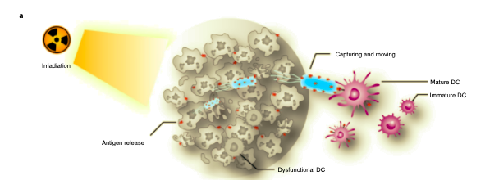
Figure 1.A [3]
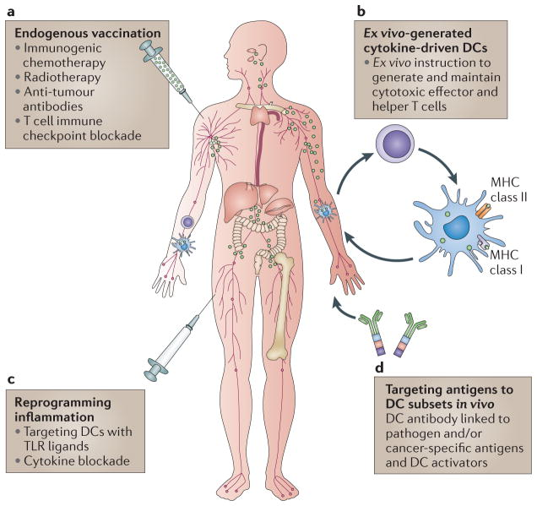
Figure 6 [2]

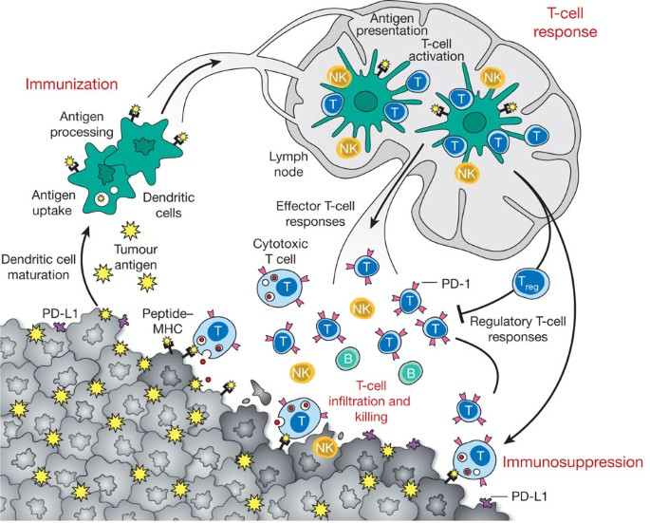
Figure 1 [1]
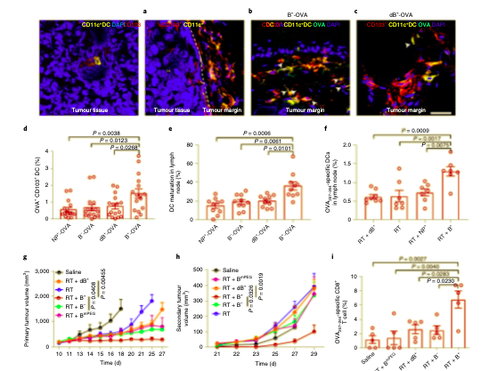
Figure 2 A-I [3]
References

[1] [[1] Mellman, I., Coukos, G. & Dranoff, G. Cancer immunotherapy comes of age. Nature 480, 480–489 (2011).

[2] [[2] Palucka, K. & Banchereau, J. Cancer immunotherapy via dendritic cells. Nat. Rev. Cancer 12, 265–267 (2012).

[3] [[3] Wang, Wenguang, et al. “Systemic Immune Responses to Irradiated Tumours via the Transport of Antigens to the Tumour Periphery by Injected Flagellate Bacteria.” Nature Biomedical Engineering, vol. 6, no. 1, 2022, pp. 44–53., https://doi.org/10.1038/s41551-021-00834-6.

[4] Natalia Mesa. “Modified Salmonella Revs Immune Response, Combats Tumors in Mice.” The Scientist Magazine®, https://www.the-scientist.com/news-opinion/modified-salmonella-revs-immune-response-combats-tumors-in-mice-69673

