Dear Editor,

Please find enclosed a modified version of my Microreview manuscript “Transcription and Translation”. To address the concerns and comments raised by the 3 reviewers, I made the following changes to improve and clarify the manuscript. It is my hope that these changes make the manuscript acceptable for publication in Microreviews in Cell and Molecular Biology.

Sincerely,
Vanessa Hernandez

Reviewer 1:
Reviewer 1 raised the most concerns regarding the overall quality of my paper. I found them helpful
because they provided useful finishing touches to add. In response I went through my paper and
changed a few details to make it flow better, and to improve the overall quality.

Reviewer 2:
Reviewer 2 found no errors in my paper.

Reviewer 3:
Reviewer 3 found no errors in my paper.

Chapter 1: Transcription and Translation

Introduction
Gene expression is a process that allows for humans to have the characteristics that make us so unique. Proteins are complex molecules that drive gene expression. They make up such a large portion of cellular processes in our body and influence things like our hair, nails, and regulate organ functions. Proteins are brought about by two main processes: Transcription and Translation. Where one takes information from DNA and transcribes it to mRNA, and another takes that mRNA and translates it into a protein. This chapter will break down the steps that are involved in making a complex molecule, and also look beyond the details to show the bigger picture.
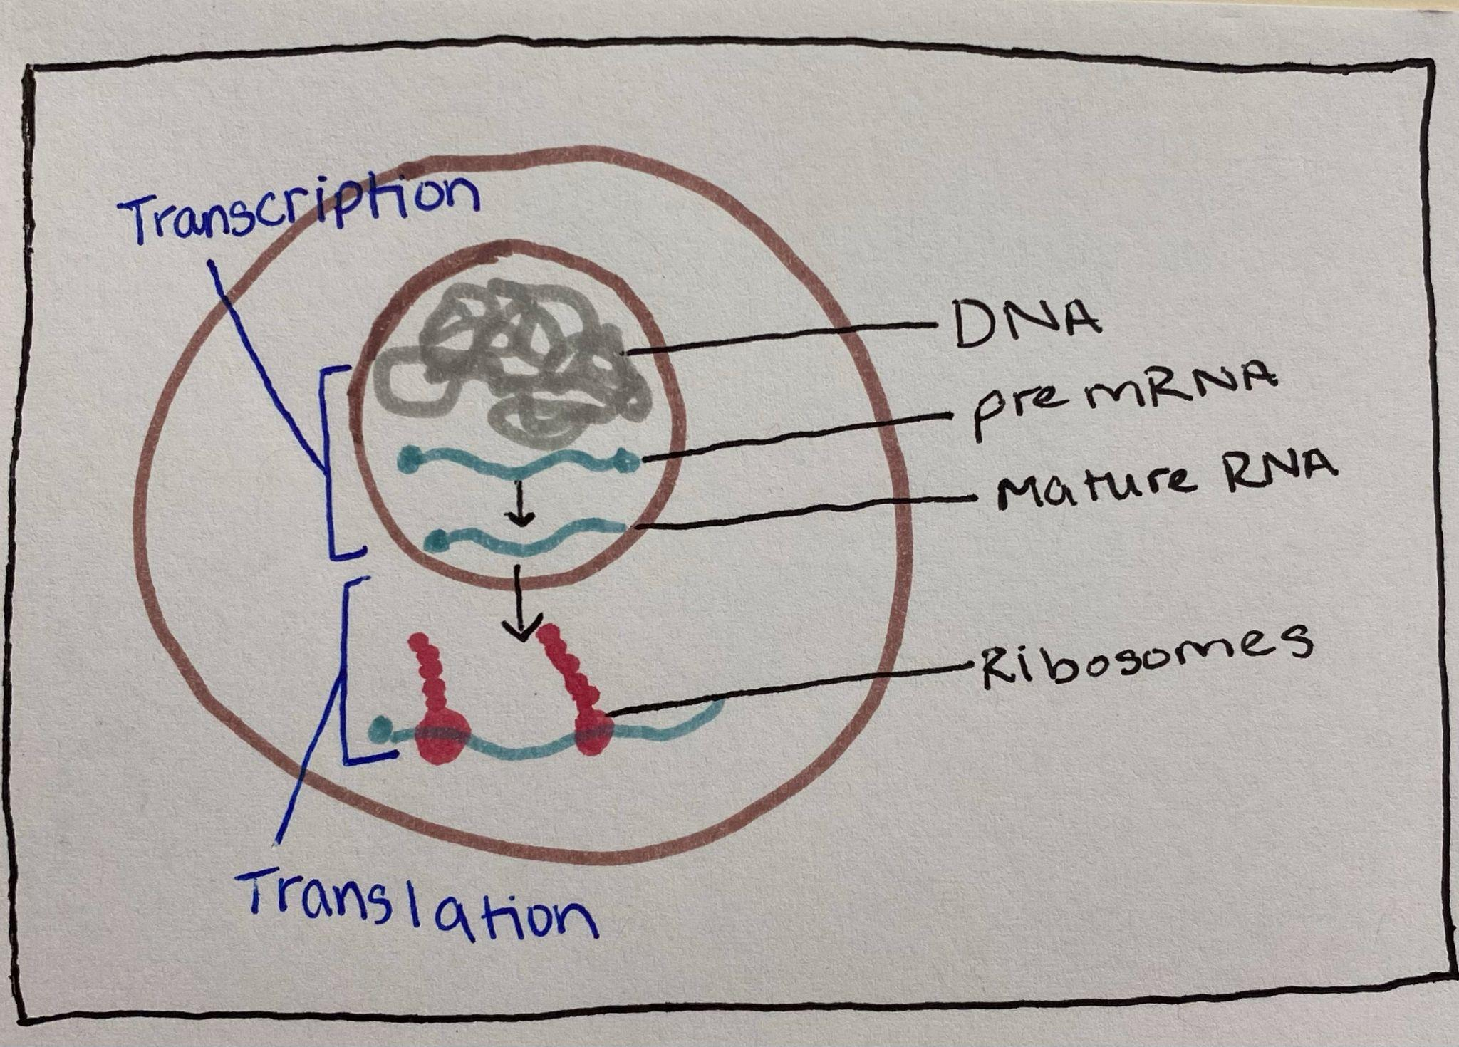
1.1 Transcription

What is transcription? Transcription is the process of copying a strand of DNA by RNA Polymerase to create a new strand of messenger RNA (mRNA) (Alberts, Johnson, Lewis et al. 2002). The entire process of transcription, from creating an RNA strand to splicing, occurs within the nucleus of a cell. This process is similar to DNA replication, but instead of copying a DNA strand to create another identical strand, transcription creates a strand of RNA that will be used to relay information from DNA throughout the cell.
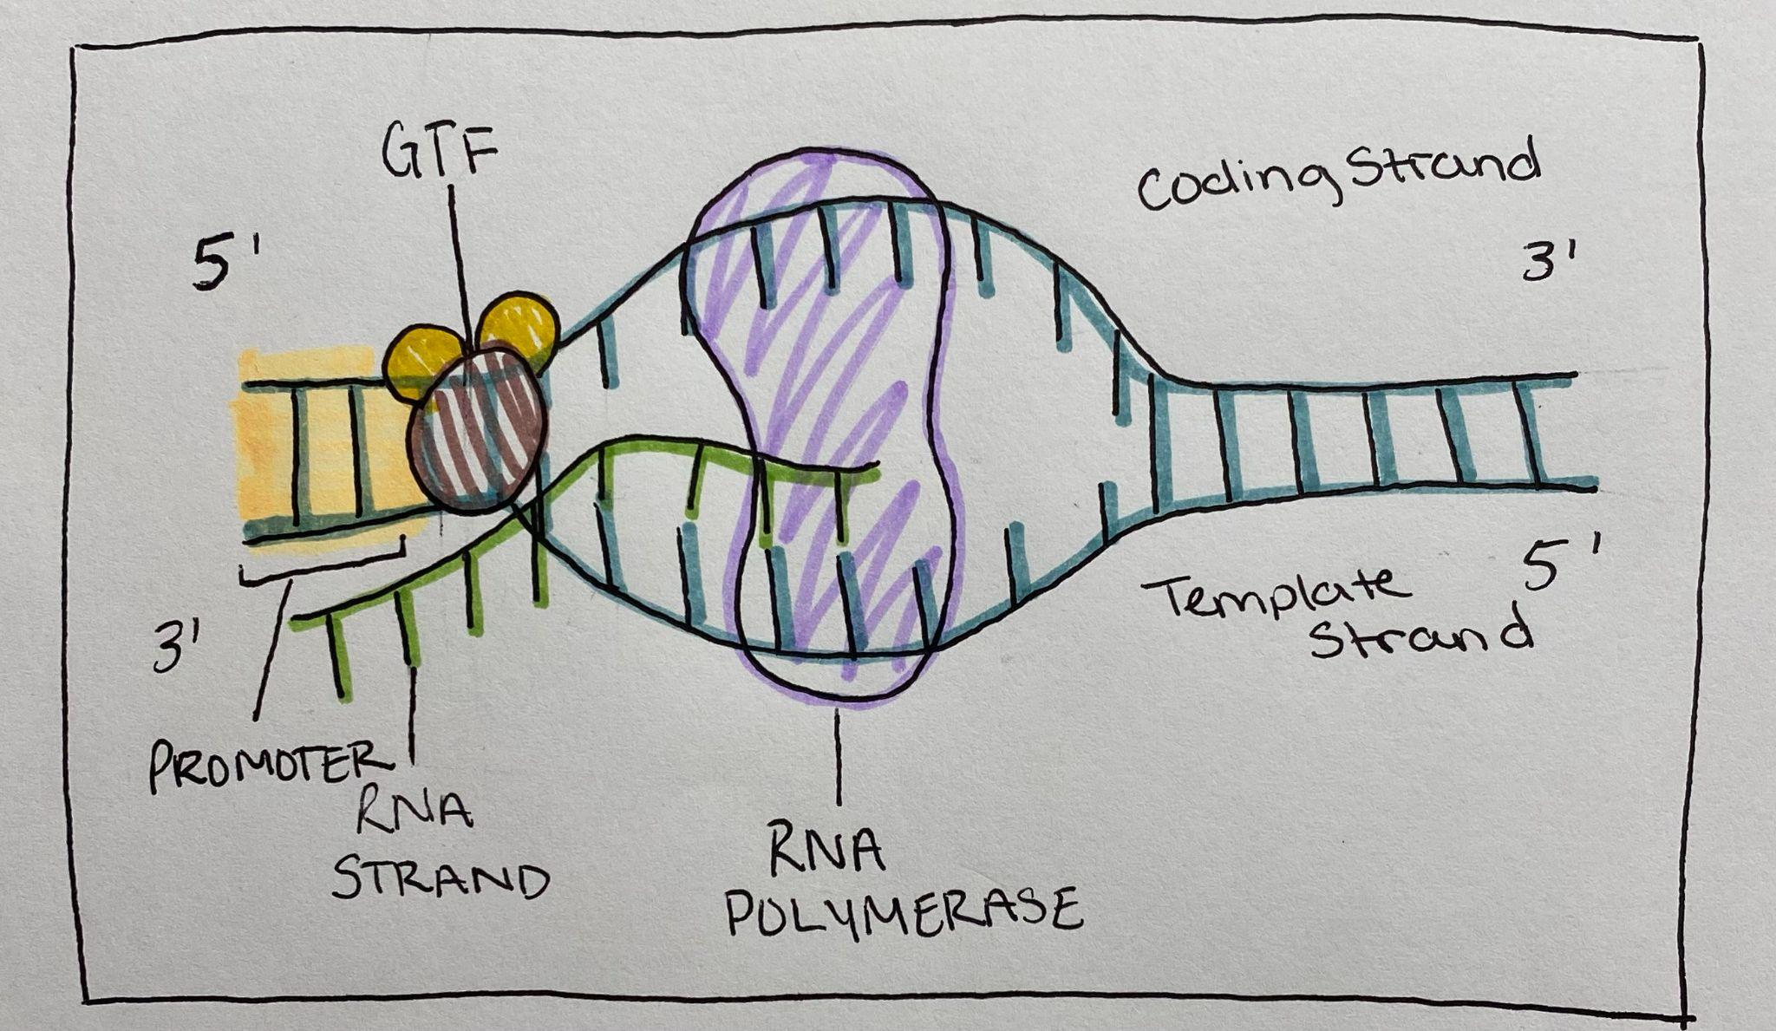
Before transcription begins there are a few conditions that need to be met, and tools that are needed. A general transcription factor binds to the DNA strand and recruits the most important tool needed: RNA Polymerase. RNA polymerase is the enzyme that unzips the double stranded DNA and creates a complementary strand of RNA using ribonucleotides (Urry, Cain, Wasserman et al. 2016). RNA polymerase will locate the promoter region that signals the starting site of transcription for a gene and begin pulling the two DNA strands apart so that it can read the template strand and add the complementary ribonucleotides (Deyholos, Harrington 2017). Just as in DNA replication, RNA polymerase can only add nucleotides in the 5’ to 3’ direction. Once the DNA has been unzipped it begins making an RNA strand by reading the template strand and adding the nucleotides accordingly.

Nucleotides are what make up DNA and RNA strands. They are composed of a pentose sugar, a phosphate group, and a nitrogenous base. The difference between a DNA strand and an RNA strand is that RNA is that RNA uses ribose sugar rather than deoxyribose. Also, RNA has a unique nucleotide called uracil that replaces thymine as the complementary to adenine (Alberts, Johnson, Lewis, et al. 2002). After the elongation of RNA, RNA polymerase reaches a terminator that signals the enzyme to stop transcription. It then releases the RNA strand, and the DNA it was transcribing (Alberts, Johnson, Lewis, et al. 2002).

Post Transcriptional Modifications
After elongation, an enzyme adds a sequence of about 50-100 adenine bases to the end of the newly transcribed mRNA. The mRNA is made up of introns (intervening sequences) and exons (expressed sequences). These sequences will be read and the introns which mostly code for non functioning proteins will be cut out, while the entrons will be kept and put back together. This process is known as splicing, and is necessary because if the introns are not cut out, or if the exons get spliced instead, it could lead to the wrong kind of amino acids being made later on, or it could cause non functioning proteins to be made (Fowler, Roush, Wise 2013). After splicing the mRNA strand becomes a mature mRNA strand, and is now ready for translation.
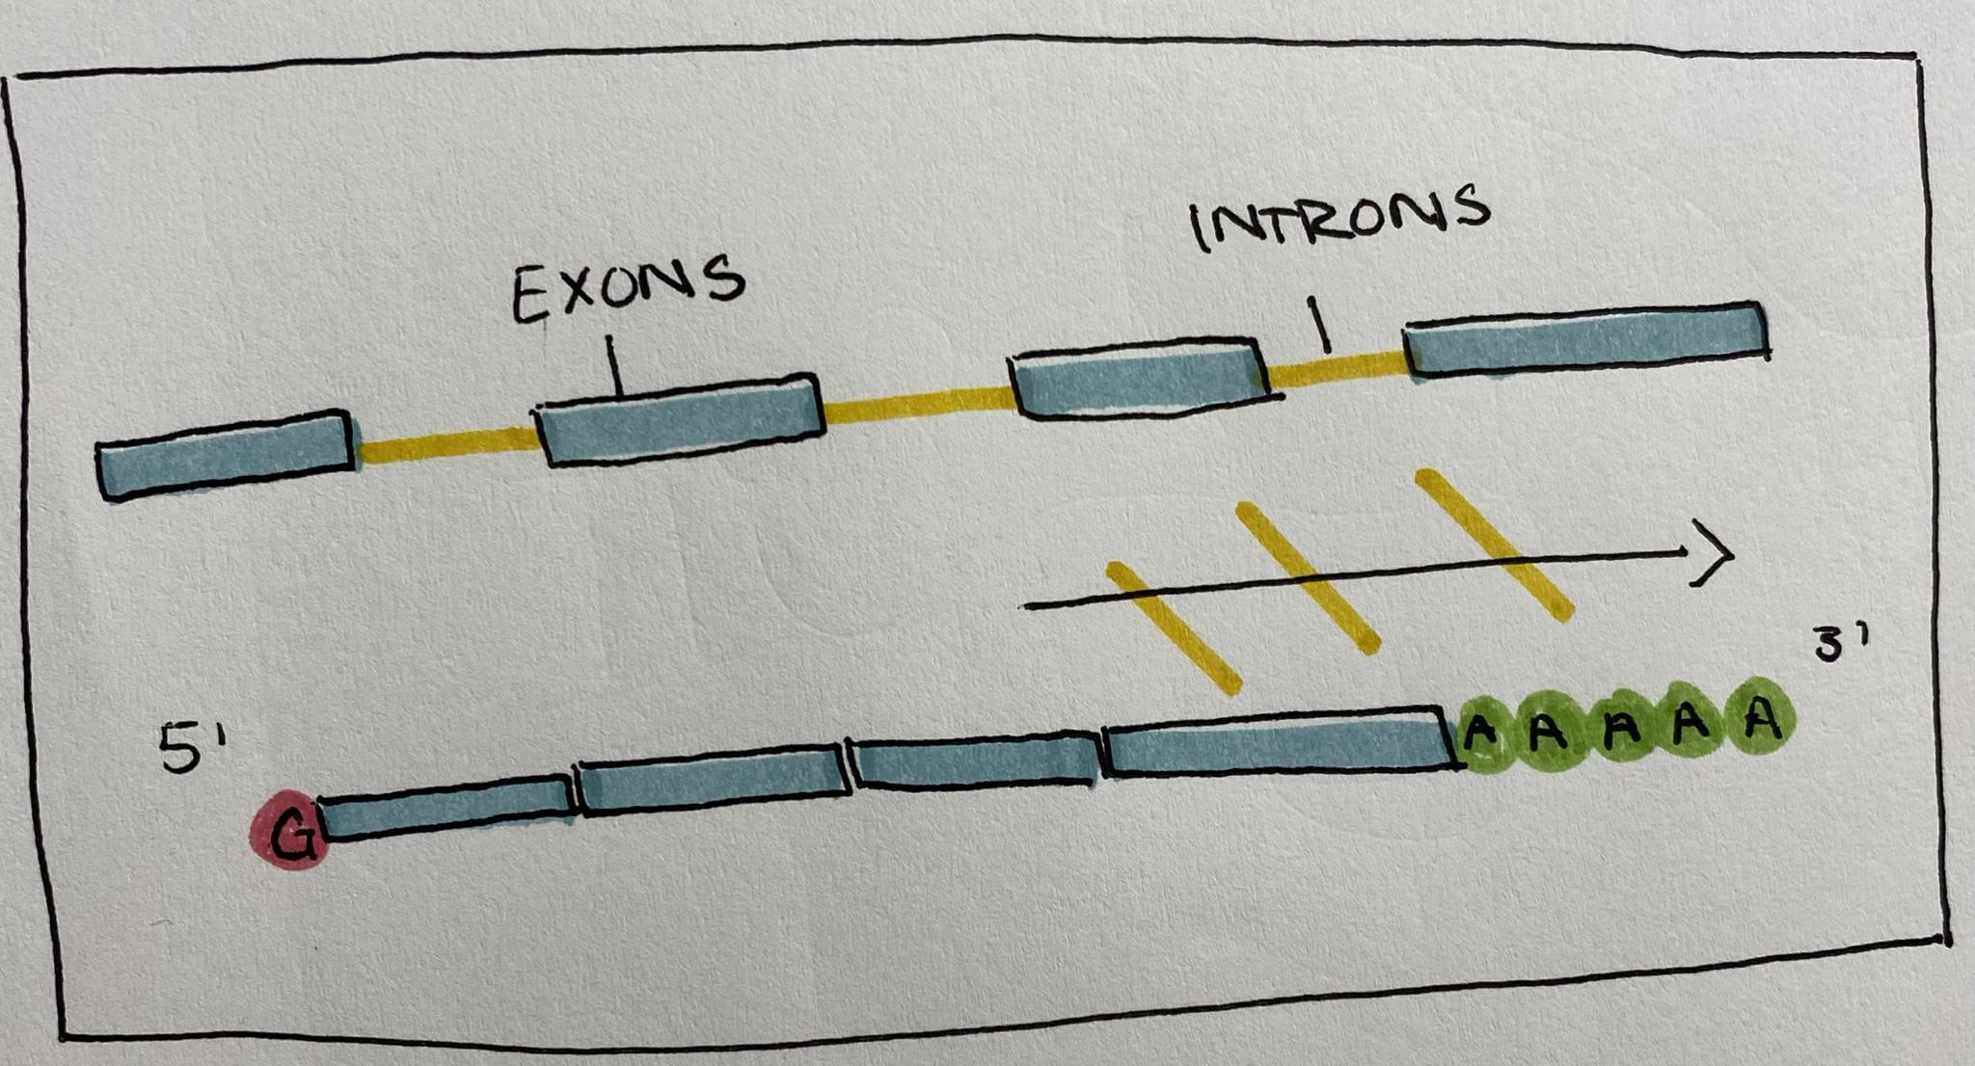

Transcription in Prokaryotes
In prokaryotes transcription and translation occur simultaneously. Because all of the necessary components are in a single environment, as RNA polymerase elongates the RNA strand ribosomes bind and translate the mRNA (Urry, Caine, Wasserman et al. 2016).
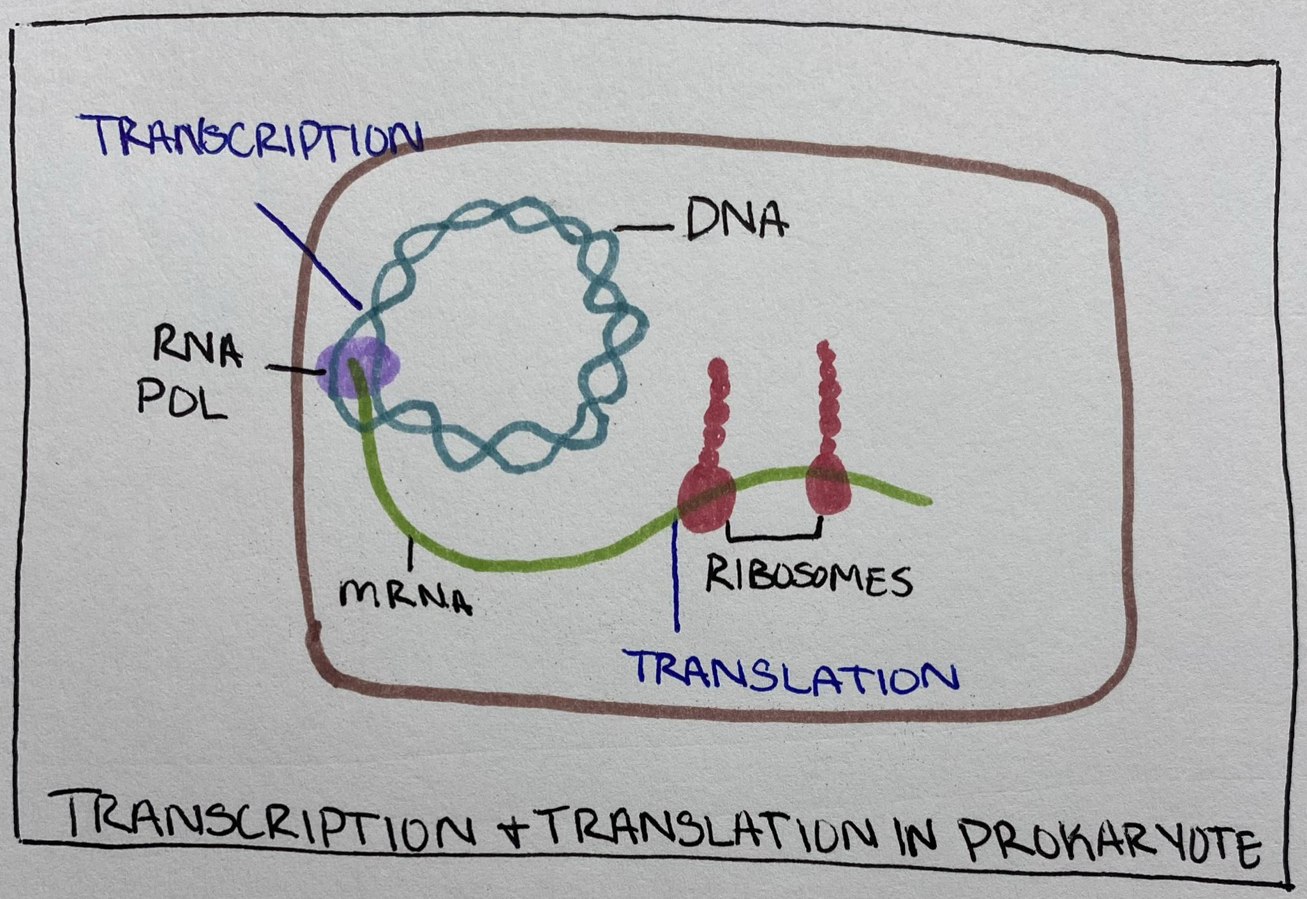
1.2 Translation

After all of the post transcriptional modifications have been made, the mRNA strand exits the nucleus to be translated. Translation is the process of synthesizing proteins from mRNA (Urry, Cain, Wasserman et al. 2016).

Mature mRNA is made up of ribonucleotides, these nucleotides form codons in groups of three. Codons are the three nucleotide sequences that code for specific amino acids (Fowler, Roush, Wise 2013). This relationship makes up the genetic code.
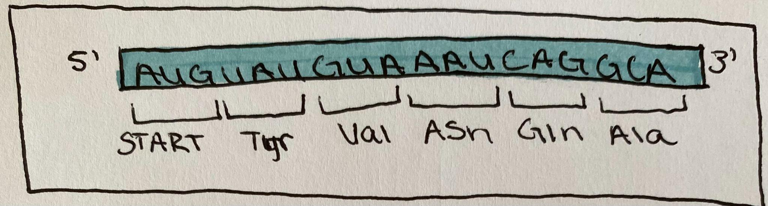
There are multiple components that go into completing translation. Ribosomes are ribonucleoprotein complexes that are made up of two subunits: large and small. They are located in the cytoplasm and bind to mRNA to facilitate translation (Fowler, Roush, Wise 2013). Transfer RNA (tRNA) is the translator that reads the codons on mRNA and transfers amino acids from the cytoplasm to create a polypeptide chain (Urry, Cain, Wasserman et al. 2016).

More About tRNA
tRNA is a complex structure that is responsible for creating the polypeptide chain in protein synthesis. It is a single strand of RNA that has folded into itself creating loops, and held together by hydrogen bonds. Of these loops, one of them forms an anticodon site, where the tRNA matches the base pairs to the mRNA codons (Urry, Cain, Wasserman et al. 2016).
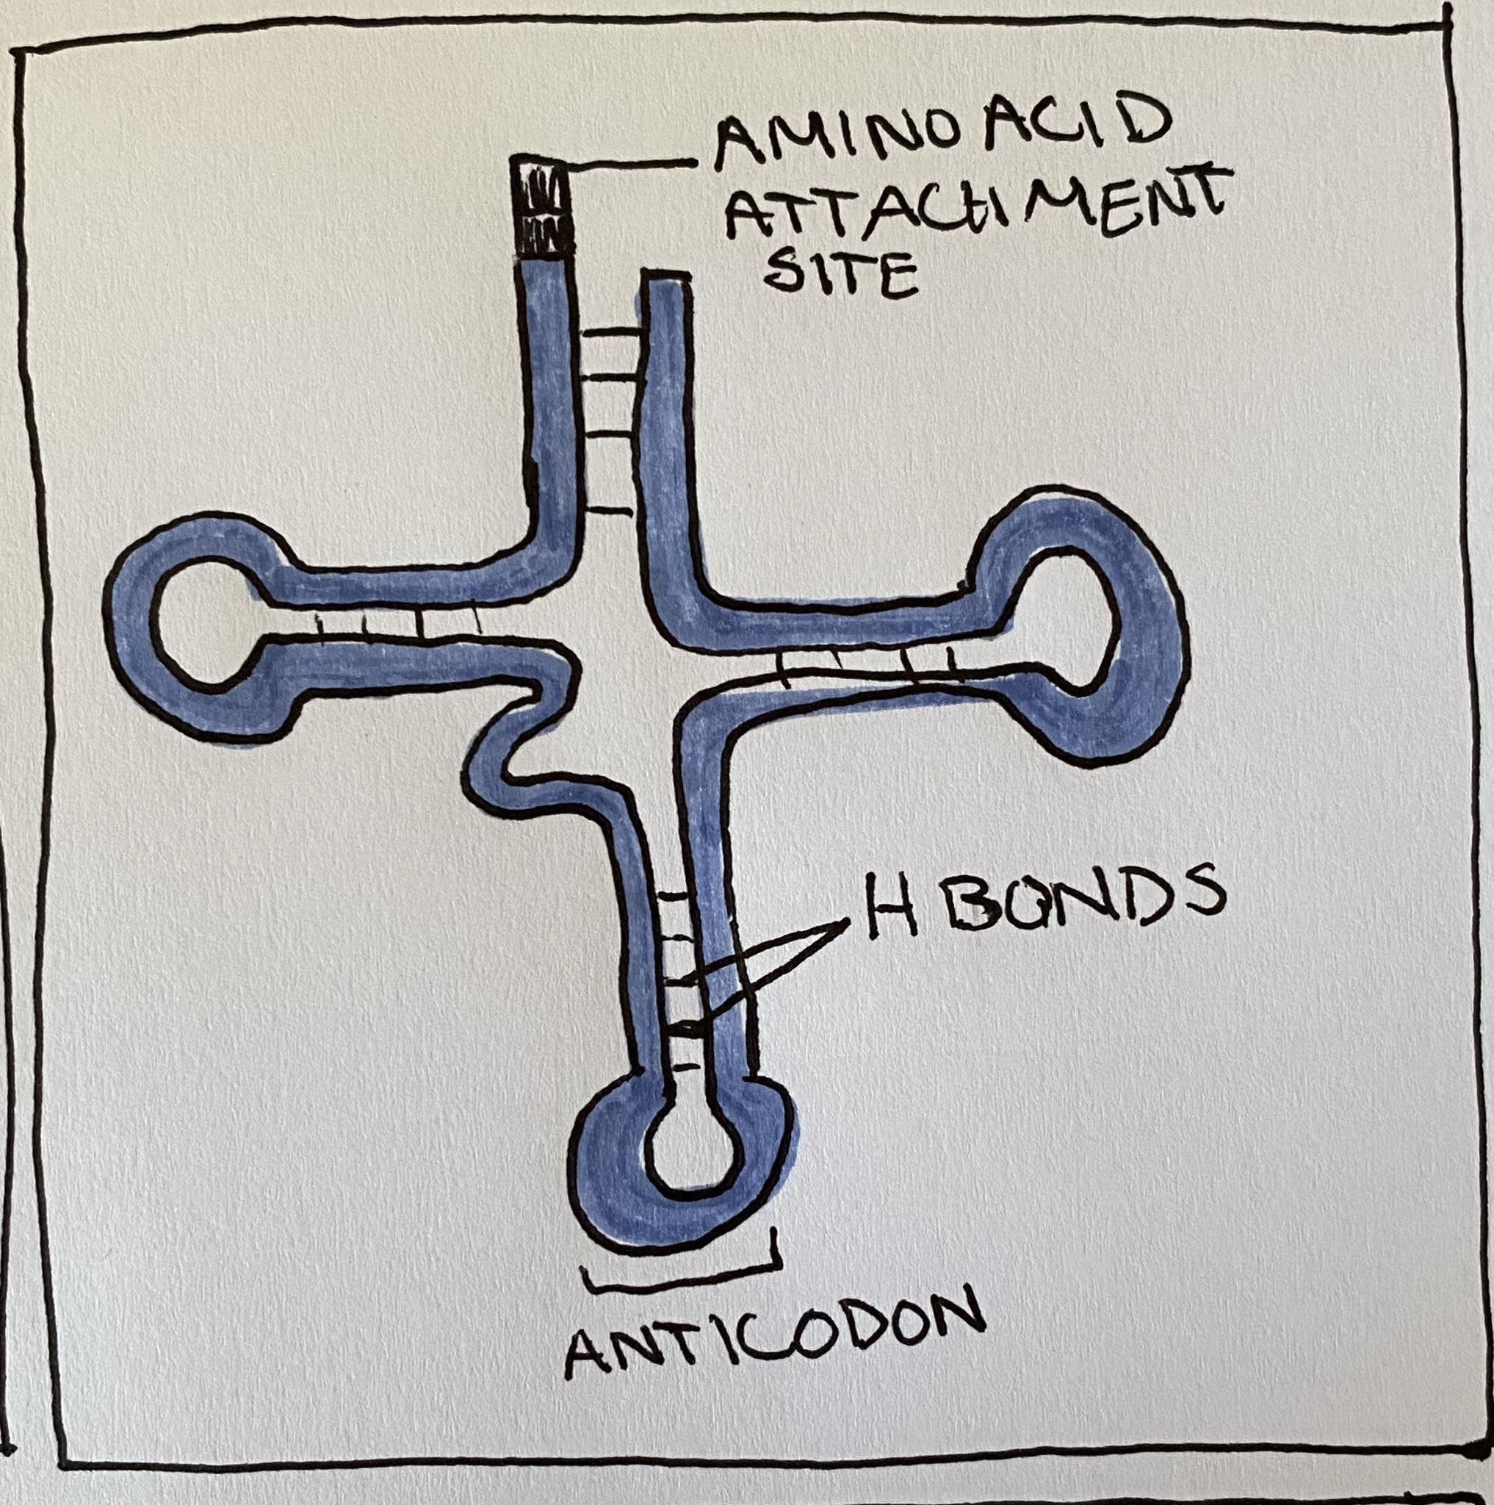
The tRNA is able to recognize specific codon sequences, and bind the exact amino acid needed because of aminoacyl synthetases, enzymes that catalyze the attachment of an amino acid to tRNA through covalent bonds (Urry, Cain, Wasserman et al. 2016).
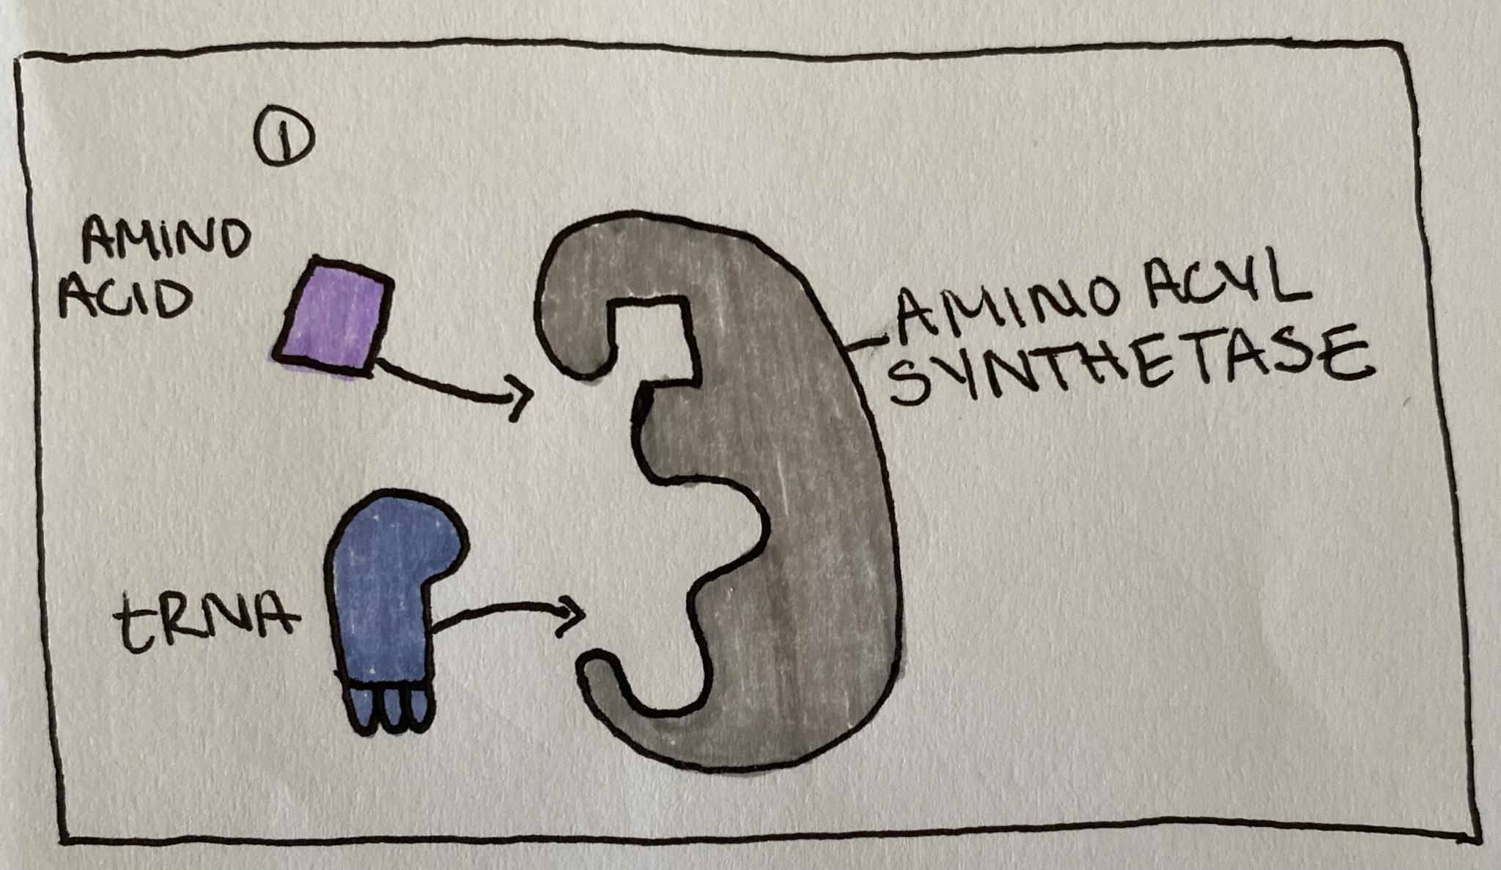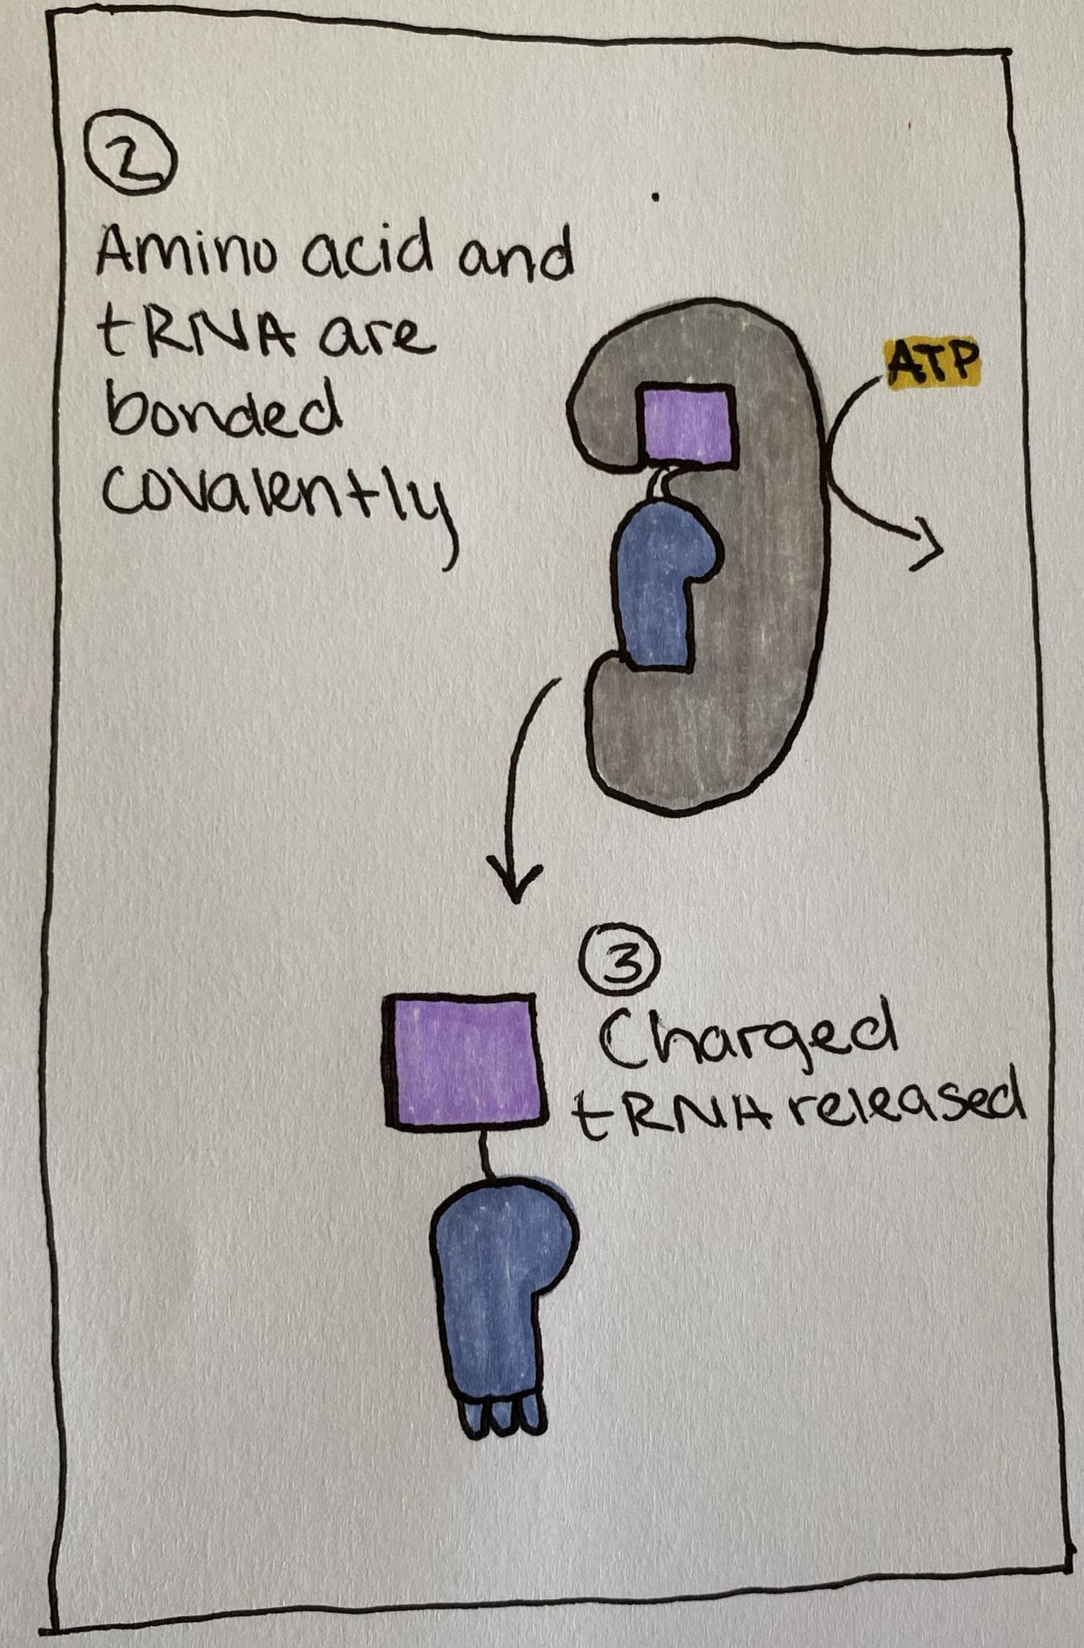

Ribosome Structure
The structure and function of a ribosome is what allows for translation to occur smoothly. The small subunit is what binds to the mRNA, and the large subunit provides the location needed for tRNA to bind to mRNA and create a polypeptide chain.
Ribosomes contain three important compartments for translation: E, P, and A. The P site is what holds the tRNA in place while the polypeptide chain grows. The A site holds the next tRNA with its corresponding amino acid to be added to the growing chain. The E site is where tRNA exits the ribosome (Urry, Cain, Wasserman et al. 2016).
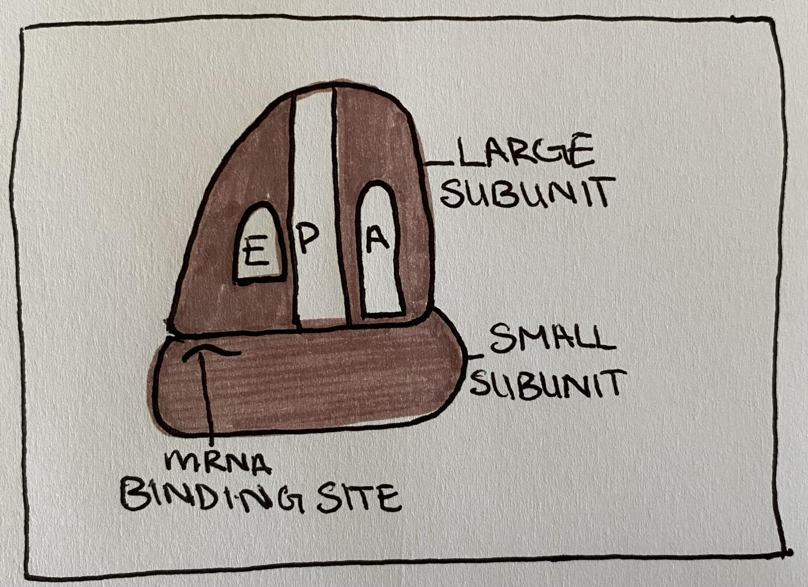

Translation Step-by-Step

So now we know all of the tools needed, and what their functions are. How do they all come together?
First, the mature mRNA will leave the nucleus where it will be found by the small subunit of the ribosome. Then, a tRNA will bind to the complex and locate the start codon (AUG). Once the large subunit binds, initiation will be complete. The next stage is elongation, as the mRNA moves along through the ribosome tRNA will continue to bind in the A site. This will add more amino acids to the growing chain in the Psite, and the uncharged tRNAs will exit the ribosome through the E site. This process will continue until the ribosome reaches termination by a stop codon (UAG, UAA, or UGA). These codons signal for translation to stop, completing the polypeptide chain. A release factor binds to the A sit of the ribosome, and the mRNA along with the polypeptide chain is released. The polypeptide chain coils into a three dimensional shape and forms a protein. This new protein will go through some post translational modifications, and then finally it will receive its function in the cell (Urry, Cain, Wasserman et al. 2016).
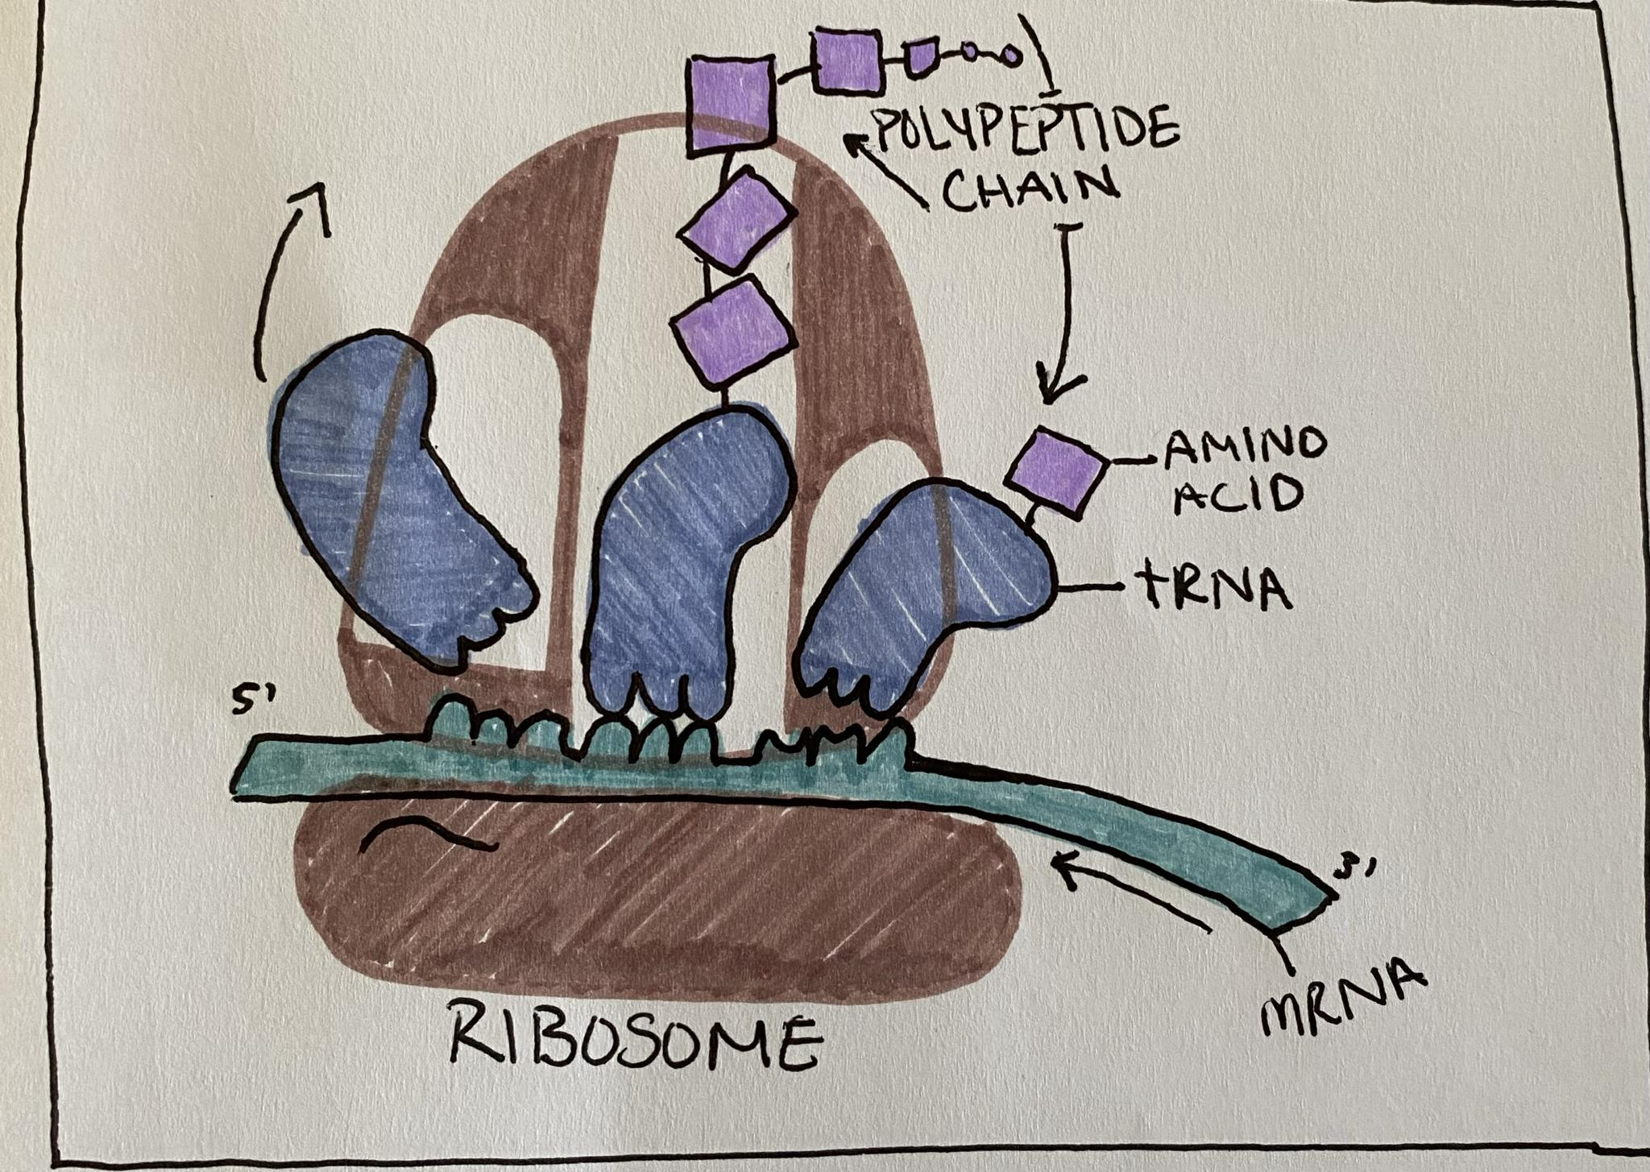

References:
Alberts B., Johnson A., Lewis J., et al. 2002, From DNA to RNA, Molecular Biology of the Cell, Garland Science 4th ed. https://www.ncbi.nlm.nih.gov/books/NBK26887/#_A981_:~:text=All%20of%20the%20RNA%20in%20a,used%20as%20the%20template%20(Figure%206%2D7).
Deyholos M., Harrington M.. 2017, Open Genetics Lectures, Department of Biological Sciences, University of Alberta
Fowler S., Roush R., Wise J., 2013, Concepts of Biology, OpenStax, https://openstax.org/books/concepts-biology/pages/1-introduction

Urry L. A., Cain M. L., Wasserman S. A., Minorsky P. V., Reece J. B. 2016, Campbell Biology, Pearson Publishers, 11: 390-408.

