Chapter 1 Antibiotics
Vocabulary

Key concepts

History of Antibiotics

How Antibiotics Function

Individual Responsibility
- Viruses
- Probiotics
- Prebiotics
- Substrates

- Toxicity
- Exogenous
- Endogenous
- Coefficient
- Plasmid
- Chromosome
- Phage

- Pathogens
- Susceptible
- Biodiversity
- Bacteriostatic
- Bactericidal
- Gram positive
- Efficacies

- Gut Flora
- Petri Dish
- Antimicrobial
- Disinfectants
- Pathologist
- Isolate
- Septic

To most, antibiotics are a mysterious medication prescribed for various ailments that miraculously clear their symptoms with little to no noticeable side effects. The mechanisms in which antibiotics work are not well known to the general public, and depending on the antibiotic in question, they may not be known at all. Antibiotics are so much more than a mysterious panacea. There are a variety of antibiotics that can be prescribed, each with its own function and purpose. From their discovery to current day problems, antibiotics bring with them a flurry of questions and potential. Hopefully this chapter not only serves as an introduction to understanding the nuance of antibiotics but also sparks curiosity into the field of microbiology.
Understanding the function of antibiotics sets the framework for comprehending both their importance and their danger. Antibiotics were revolutionary to the field of medicine due to their ability to clear bacterial infections. However, knowing the mechanism in which antibiotics target bacteria allows one to see how they may pose a threat to the beneficial bacteria residing in human digestive tracts. Recent research diving into gut flora, the microbes that inhabit a host, has discovered that microbiomes play a key role in a variety of health-related problems.
Several of the problems that antibiotics pose stem from lack of consumer awareness. Over prescription and lack of patient compliance are two large contributors to the growing issue. Going forward everyone has their own role to play in the prevention of antibiotic resistance. At the end of this chapter, the reader should be able to not only recount the history of antibiotics and their function but be able to think critically about how antibiotics should be handled.

1.2 The Discovery of Antibiotics

The history of antibiotics begins in London on September 28th, 1928 [1,2]. Shortly after dawn, Alexander Fleming, a Scottish bacteriologist returned to his lab at St. Mary’s Hospital after a vacation in Suffolk [1,2]. Fleming realized that he had left a petri dish uncovered on his desk [1,2]. This petri dish had been inoculated with Staphylococcus aureus [1,2]. The peculiar thing was that the dish had been contaminated with fungus, identified as Penicillium notatum. Fleming discovered that the fungus produced areas of bacteria free zones [1,2]. Upon identifying the fact that Penicillium had antimicrobial properties, he isolated it and grew a pure culture [1,2]. Alexander Fleming found that the mold was still effective, even when it was diluted 800 times, and was less toxic than the current disinfectants [1,2]. This revolutionary discovery would go on to shape modern day medicine.
Roughly 10 years later, pathologist Howard Florey and biochemist Ernst Chain isolated the active substance of penicillin [2]. By 1941, it was ready for human testing [2]. Right before the start of World War II, Florey and Chain developed methods to mass produce penicillin [2]. 400 million units of pure penicillin were made the following year [2]. Strikingly, by the time World War II ended, American pharmaceutical companies were producing 650 billion units a month [2]. In 1945, Florey and Chain were awarded the Nobel Prize [2]. Their contribution to the manufacturing of antibiotics not only affected current day pharmaceutical practices but saved countless lives during the war.
It is important to note that antibiotic resistance, a common problem today, was first warned against by none other than Alexander Fleming.
It is not difficult to make microbes resistant to penicillin in the laboratory by exposing them to concentrations not sufficient to kill them, and the same thing has occasionally happened in the body. The time may come when penicillin can be bought by anyone in the shops. Then there is the danger that the ignorant man may easily underdose himself and by exposing his microbes to non-lethal quantities of the drug make them resistant. [2]
While not quite accurate for pharmaceutical practices in America, Fleming hit the nail on the head for several countries across the globe. Various countries do not regulate antibiotics, and despite the regulation in the United States, antibiotics are still prescribed at alarmingly high rates. Fleming’s statement can be applied to patients who do not finish their prescriptions, as they would be “underdosing themselves.” While it is interesting to see Fleming’s predictions coming to pass, antibiotic resistance is a serious threat to public health and will be addressed later on.

1.3 How Antibiotics Work

Antibiotics target structures unique to bacteria cells. This not only allows for the treatment to mass target a wide variety of bacteria, but it also means that antibiotics leave human cells relatively unharmed. The benefit for this is that doctors can treat unknown infections without having to take the time to identify the root cause. This cuts back on time and expensive tests. Another positive aspect is that antibiotics can be used in instances with multiple bacteria present. In an infection such as a septic wound, the likelihood of several different pathogens is high. Also because of its wide spectrum of effects, antibiotics can be prescribed as a preventive measure in instances where one is highly susceptible to infection. The drawback to mass targeting is that the human body relies on bacteria. Not all bacteria are pathogenic, and antibiotics decrease the biodiversity of gut flora. Gut flora is beneficial in both strengthening the immune system and working as a population limiting factor for harmful bacteria.
There are two main types of antibiotics: bacteriostatic and bactericidal. Bacteriostatic is a broad term for a type of antibiotic that stalls bacterial cellular activity instead of directly killing bacteria [3]. These antibiotics tend to hinder bacterial protein synthesis pathways [3]. It is important to know that bacteriostatic antibiotics require patients to have functional immune systems and are not suggested for immunocompromised individuals. This is because the antibiotic only stalls bacterial growth while the host immune system fights off the infection, without the addition of the host’s body, infection has a chance to persist [3].
The most commonly used bacteriostatic antibiotics are tetracyclines, macrolides, clindamycin, trimethoprim/sulfamethoxazole, linezolid, and chloramphenicol [3]. Each said antibiotic has its own unique function and purpose. Based on the function of bacteriostatic antibiotics, the bacteria causing the infection should be identified before prescription. As they target particular structures in cell growth, bacteriostatic antibiotics are more specific and must match a plethora of requirements [3]. Not only does the type of pathogen play a role in prescription, but so does the location of the infection, health of the host, and commonality of the bacteria [3].
Bacteriostatic antibiotics are interesting because they tend to lack several of the qualities that make antibiotics appealing to medical practitioners. They tend to be most effective on gram positive bacteria, they have different efficacies when treating bacteria of varying aerobic tolerances, and they lack efficiency on several common pathogens [3]. That noted, they still serve a purpose. One particular reason to use bacteriostatic antibiotics is that their toxicity tends to be lower, meaning they have less severe side effects on the host [3]. This results in them being prescribed for out-patients [3]. They are also fairly effective against atypical infections [3]. Perhaps most importantly, due to their lack of broad-spectrum effects, they can be utilized as a way to force medical practitioners to identify pathogens and properly prescribe treatment options, reducing the rate of over prescription. In addition, variety is key in minimizing antibiotic resistance.
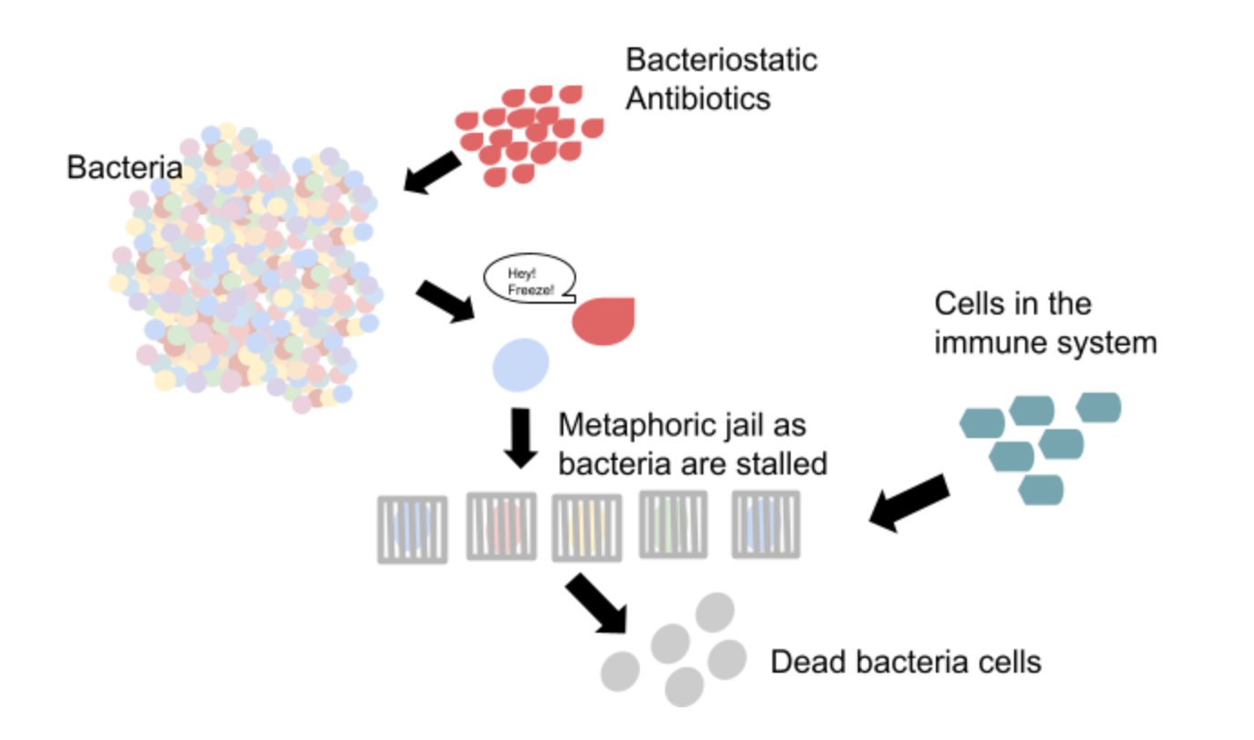
The other classification of antibiotics, bactericidal, kills the bacteria cells [4]. This tends to be done by destruction to cell envelopes [4]. Destruction can be exogenous or endogenous [4]. Exogenous death is when outside factors, namely chemicals, damage the cell membrane [4]. Endogenous death is when the compound causes the bacteria cell to either destroy its own cell wall or fail to replenish it. Death can also occur by destruction to DNA. This can be done externally or internally.
Classification of bacteriostatic and bactericidal antibiotics, however, is not clean cut. Bacteriostatic antibiotics have the potential to, and oftentimes do, kill the pathogen they are intended to fight against [4]. Upon analysis, it was found that bacteriostatic antibiotics tend to kill at a slower rate than bactericidal antibiotics [4]. A proposed solution to the conundrum of classification is to develop a bactericidal coefficient for each bacteria and antibiotic [4]. This would allow for easy comparison between rates of cell death, and thus a more accurate classification system. Something else to note: the rate at which bacteria are killed tends to be proportional to the maximum rates of growth of their populations [4]. This is believed to be because of limitations on resources [4]. As antibiotics limit available nutrients, infections with high population density tend to die faster. So, when developing a bactericidal coefficient, population size must be accounted for.

1.4 Current Day Problems

Antibiotics have become integral to current day medical practices. The problem is that antibiotic resistance is starting to become a prevalent issue. Antibiotic resistance has become an issue in large part due to agriculture and medical practices [5]. The better safe than sorry approach enacted by farmers and doctors alike has had unforeseen consequences.
The problem with bacteria is that they excel at sharing genetic make-up. Bacteria can produce what is known as a plasmid, which are free floating genetic material not incorporated into the chromosomal DNA and can be shared between bacteria. Bacteria can also perform horizontal gene transfer as well as pass on genetic information after death. What this means is that bacteria that are resistant to antibiotics have multiple ways to pass on said mutation. When one factors in that bacteria have fast replication speeds, the result is the notable effect of natural selection occurring in a short period of time.
When farmers mass prescribe antibiotics to their livestock, they are producing an environment for antibiotic resistant bacteria to prosper and replicate; that bacteria will later reach consumers. In addition to the impact of mass prescription on livestock, there is also the potential of antibiotics to leak into water reserves. These water reserves are the perfect environment for the creation of antibiotic resistant strains.
In addition, doctors prescribe antibiotics fairly loosely. Not only does the over prescription of antibiotics have the chance to produce a similar scenario as that of the water reserves in one's own body, but it also weakens the immune system, making one susceptible to further infections. This is due to the importance of microflora. One’s microbiome plays a large role in a variety of health aspects. Having a diverse microbiome enhances the immune system as well as provides a healthy ecosystem of gut flora. Diversity allows for balance and healthy competition that keeps each bacteria in line. Antibiotics throw that balance off by killing beneficial bacteria. This can allow opportunistic pathogens to prosper and upon their abundance become pathogenic.

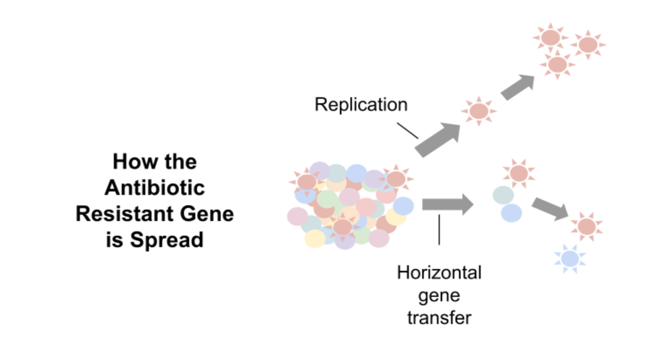
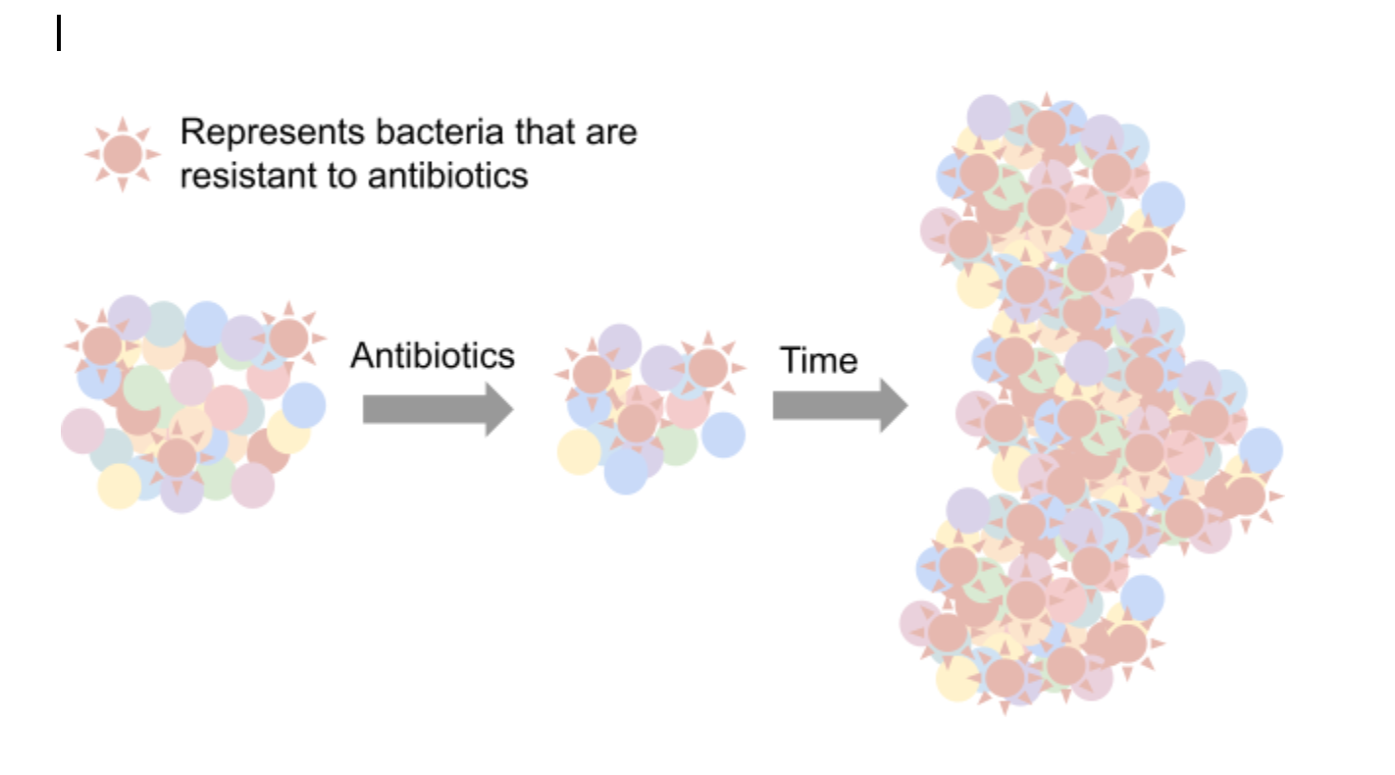

1.5 Solutions

In terms of antibiotic alternatives, phage therapy is a hot button topic. Phage therapy is the use of viruses to target and destroy bacterial cells [5]. Currently, phage therapy is unreliable, as several studies have shown varying levels of success [5]. The problem stems from the fact that most phages require extensive creation in the lab [5]. Phages must be tailored to the specific bacteria causing the infection, or else they are seen to have minimal effects [5]. In addition, phages are only viable for a couple of hours after they are created [5]. Probably the largest obstacle in the utilization of phage therapy is that they are rendered ineffective in infections with multiple types of bacteria due to their specificity [5].
One possible solution for bacterial infection is the use of probiotics. Probiotics are considered beneficial bacteria. They help diversify the microbiome, and in doing so strengthen the immune system. They also serve as a population limiting factor for harmful bacteria, as they create more competition, hindering pathogens by decreasing resources. This can be paired with prebiotics, which are substrates that support the growth of probiotics. Prebiotics are nutrients that are consumed by the host. One example is fiber. Fiber not only supports beneficial bacteria, but it also hinders absorption of sugar. By doing so, it decreases the rate in which sugar can be made available to bacteria. This also acts as a limiting factor for pathogens.

1.6 Conclusion

All in all, antibiotics work in a variety of ways to fight bacterial infections. Every type of antibiotic is unique and serves its own purpose. Thanks to Alexander Fleming, Howard Florey, Ernst Chain, and countless more, antibiotics have become a lifesaving treatment widely available to the general population.
Despite their profound positive impact, antibiotics still have negative repercussions in terms of microflora diversity and the creation of antibiotic resistant bacteria. This chapter was meant to serve as a focal point of understanding, in the hopes of educating consumers. The hope is that one walks away with the intention to discuss with medical practitioners whether or not antibiotics are truly necessary in one's treatment plan, and upon the commitment to antibiotic treatment, one develops dedication to seeing the prescription to fruition.
The adoption of practices such as the consumption of prebiotic supplements and prebiotic substrates would even further benefit the public, especially when done alongside necessary antibiotic treatments. At the very least, the goal of this chapter was to be educational, but hopefully it inspired future scientists and doctors alike to attempt to discover new treatment options. New antibiotic alternatives are waiting to be discovered, and perhaps one will be as revolutionary as a simple mistake made by a certain Scottish bacteriologist.

Resources
[1] Society, M. (n.d.). The history of antibiotics. Microbiology Society. Retrieved March 5, 2022,
from https://microbiologysociety.org/members-outreach-resources/outreach-resources/
antibiotics-unearthed/antibiotics-and-antibiotic-resistance/the-history-of-antibiotics.html
[2] The discovery of antibiotics – part 1. ReAct. (2020, November 6). Retrieved March 5, 2022,
from https://www.reactgroup.org/antibiotic-resistance/course-antibiotic-resistance
-the-silent-tsunami/part-1/the-discovery-of-antibiotics/
[3] ​​Loree, J., & Lappin, S. (2021, August 27). Bacteriostatic antibiotics. StatPearls [Internet].

Retrieved March 5, 2022, from https://www.ncbi.nlm.nih.gov/books/NBK547678/

[4] Baquero, F., & Levin, B. R. (2020, October 6). Proximate and ultimate causes of the

bactericidal action of antibiotics. Nature News. Retrieved March 5, 2022, from

https://www.nature.com/articles/s41579-020-00443-1

[5] Altamirano F.L.G., J. J. Barr. “Phage Therapy in the Postantibiotic Era”. American Society

for Microbiology (2019)

