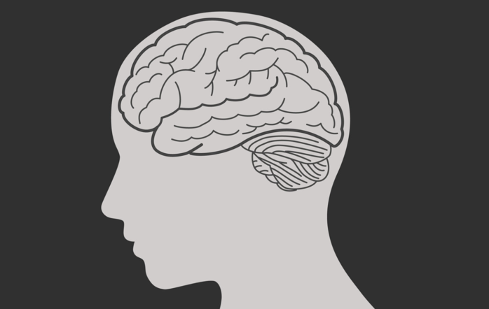

Within the brain, cell growth in mental illnesses such as depression stem directly from the hippocampus. With cases relating with **Clinical Depression**, many have a smaller hippocampus that, therefore, has fewer serotonin receptors. These specific serotonin receeptors are what make people feel happier and allow complex communication across various circuits that make for enhanced emotion processing. Research has shown that an excess amount of cortisol is often times produced in those who are diagnosed with clinical depression and aids in the inhabitation of serotonin receptors. There are a variety of different factors that can and will ultimately contribute to **Clinical Depression** such as: diabetes, heart disease, arthritis, kidney disease, HIV, AIDS, lupus as well as Multiple Sclerosis (MS).

There are a variety of different factors that play into the role depression has on the human body. The causes and effects of the various forms of **Clinical Depression** are dependent on the nature of one in question as well as the nuture of the circumstances behind the mental illness. Depression, in many cases can and will be genetic depending on the various smaller genes that are shared and the effect that they have on the hippocampus. In the human body, the hippocampus is related to memory and emotion, and often times shrinks when one is experiencing a mental illneses such as depression.With the effects on the brain, depression is directly related to various cell growth as well as brain connections and networking for the body.

**How Depression Effects the Brain**

**Mental Health:** a person’s condition with regard to their psychological and emotional well-being.

**Anxiety Disorder:** A condition in which one has anxiety that does not go away and can get worse over time.

**Bipolar Disorder:** A disorder associated with episodes of mood swings ranging from depressive lows to manic highs.

**Clinical Depression:** A mental helath disorder characterized by persistently depressed mood or loss of interest in activitys, causing significant impairment in daily life.

**Dementia:** A group of thinking and social symptoms that interferes with daily functioning.

Attention defict disorder: A chronic condition including attention difficulty, hyperactivity, and impulsiveness.

**Post Traumatic Stress Disorder:** A disorder in which a person has difficulty recovering after experiencing or witnessing a terrifying event.

*Mental Health Bipolar Disorder*

*Anxiety Dementia*

*Clinical Depression Post Traumatic Stress Disorder*

*Chemical Inbalances Obsessive Compulsive Disorder*

*Effects on the Brain*

**New Vocabulary:**

***Chapter 1: Section 1***

**An Insight into the Effects of Biological Health Disorders on the Body**

*Mental e*

***Health***

***Chapter 1: Section 2***

***Anxiety Disorders***

There are differing forms of anxiety disorders that have the ability to characterize a person’s life in a detrimental way. The difference in a specific diagnosis pertaining to anxiety disorders play a major role in treatments, and what a person’s day to day life may look like. Some of the different forms of anxiety disorders include, but not limited to: **Agoraphobia, Generalized Anxiety Disorder, Separation Anxiety Disorder, Social Anxiety Disorder (Social Phobia), Specific Phobia, Substance-induced Anxiety Disorder,** and **Unspecified Anxiety Disorder**.

**Agoraphobia** is a type of anxiety disorder that is characterized by fear. This type of fear can appear in a variety of different manners and ways such as avoidance of specific places, or situations that bring about a feeling of anxiousness, and anxiety. People dealing with agoraphobia often times have an overwhelming feeling of helplessness, embarrassment, or a sense of feeling trapped in whatever situation that they are in. **Generalized Anxiety Disorder** is looked at in a broader sense, with many different driving factors that affects someone psychologically. This specific type of anxiety is categorized by excessive anxiety in all sorts of situations, and even ordinary day to day routines. **Generalized Anxiety Disorder** not only effects one mentally, but physically as well. The constant worry, and in extreme cases, panic attacks, often times can lead to shortness of breath, chest pain, and heart issues. Many times **Generalized Anxiety Disorders** go hand in hand with other

**Developing Anxiety**

**Anxiety Disorders** have underlying causing agents that allow the disorder to be presented outward to a specific person. Many times, medical issues that one is dealing with are linked to the anxiety that is being expressed. Common medical issues related to **Anxiety Disorders** include, but not limited to: Heart Disease, diabetes, thyroid issues, drug usage, chronic pain, anti-anxiety medication, and other various medications, and tumors. These medically related issues can be extremely hard on a person’s body and can cause an increased sense of worry and fear amidst everything. As anxiety increases, one’s body can tend to put out a fight or flight response due to the hormones present in human bodies, hence triggering and underlying **Anxiety Disorder.** Certain medications, as mentioned, have the ability to alter the chemical makeup of one’s body and brain, which in turn can lead to the depleation of hormones needed to stabililitize anxiety.Other factors that can contribute to the development of an **Anxiety Disorder** include trauma, intense stress, family history (blood related) of **Anxiety Disorder**, and other health disorders, specifically depression.

biological disorders such as **Depression** due to the constant feeling that something bad is going to happen, fear or terror. **Separation Anxiety Disorder** is different from other anxiety disorders in that it is often times seen in those who are, or have been separated from key people in their lives during their development. A feeling of abandonment presents itself in an anxious manner of not knowing who or what they are going to lose next. **Social Anxiety Disorder** is an anxiety disorder that involves fear, and anxiety around social situations. With this specific type of disorder, going out in public may be hard and jeopardized with the constant fear of being judged by those someone is around at the time. **Specific phobia** varies from person to person and deals with a specific object, situation, or person that one has anxiety around. These phobias around a specific thing are a result of past trauma that someone relates to them and would rather avoid whatever it may be all together. This type of anxiety disorder is more impulsive with its onset, and because of this, often times causes panic attacks. **Substance-induced Anxiety Disorder** is characterized by anxiety around the use, misuse, or withdrawl of alcohol, drugs, or medications. There are a wide variety of symptoms that accomplice this disorder such as anxiety, or panic. **Unspecifed Anxiety Disorder** is used to diagnose someone when there is anxiety present in someone, but it is not debilitating to their day to day lives, and the anxiety that is present does not fit into the categories of any of the other anxiety disorders.

**Causing Agents**

***Bipolar Disorder***

***Chapter 1: Section 3***

Developing a disorder like **Bipolar Disorder** is based on a number of causing agents. Often times, people diagnosed with **Bipolar Disorder**, have a combination of both environmenta, and social factors forming the disorder, as well as specific chemical imbalances playing a role in development. **Bipolar Disorder** can be traced to genetics, but there is uncertainty around this topic due to no specific gene being a common link to **Bipolar Disorder**.

Certain situations may be triggering for this certain type of disorder and may lead to the causation of it developing. Breakdowns of relationships, varying forms of abuse such as physical, sexual, and even emotional have been known to trigger emotional responses within the body depicting **Bipolar Disorder**. These specific situations that some may come across have the ability to affect the brain in a certain way, therefore expressing signs of **Bipolar Disorder**.

Other examples of causing agents for **Bipolar Disorder** include problems withmoneey, work, physical illnesses, as well as various forms of sleep disturbances. All of these factors play a role in contributing to the manic, and depressive episodes **Bipolar Deepression** expresses itself in.

**Bipolar Disorder** is often times difficult to pinpoint, and diagnose due to the similarities to **Anxiety Disorder**, and **Depression**. People expressing symptoms of irritation, restlessness, paranoia, hyperactivity, impulsivity, and mood swings trigger key points for health professionals in regards to **Bipolar Disorder**. There are various forms of **Bipolar Disorder** that people may be affected by including: **Bipolar I Disorder, Bipolar II Disorder,** and **Cyclothymic Disorder**.

**Bipolar I Disorder** is characterized by a series of both manic episodese as well as depressive episodes. With **Bipolar I Disorder**, the manic episodes that express themselves often times last for at least a week, and have the ability to last longer. As for the depressive episodes, they have the ability to last over two weeks. These manic episodes present themselves in a way that is shown as excessive elated thoughts, racing thoughts, irritability, and a feeling of powerfulness. The depressive episodes show signs of sadness, and hopelessness, hopelessness, emptiness, worthlessness, and a feeling like it is impossible to do day to day tasks along with various other contributing factors.

**Bipolar II Disorder** is similar to **Bipolar I Disorder**, but differing in the way depressive, and manic episodes are presented. With **Bipolar II Disorder**, there are significantly more depressive epsidoes presented compared to manic episodes. Many times the manic episodes that are present are far less severe than that of **Bipolar I Disorder**. The same characteristics of manic and depressive epsiodese are there including a feeling of being elated and wired during a manic episode, and feeling down and extremely low during a depressive episode.

**Cyclothymic Disorder** varies from person to person in how detrimental the disease is mentally for a specific person. When diagnosed with **Cyclothymic Disorder**, one often times shows signs, and symptoms of a certain type of **Bipolar Disorder**, but does not meet the clinical requirements during their manic, or depressive episodes. This is a far less severe form of **Bipolar Disorder** that is a combination of manic and depressive symptoms that last a much shorter time period than other bipolar diagnoses.

**Bipolar Disorder** has a major effect on the brain that can ultimately affect the rest of one’s life. When someone is diagnosed with **Bipolar Disorder**, studies have shown that specifically the gray matter in the brain is reduced. This gray matter is an important part of processing thoughts, and feelings, as well as controlling a variety of different aspects in the human mind. The gray matter that is present helps people regulate day to day motor skills such as: balancing, drawing, talking, writing, as well as reaction time. There are various neurotransmitters that are implicated, and when diagnosed with **Bipolar Disorder**, these specific neurotransmitters are defective in producing the correct amount of hormones and chemicals for the human body to properly function.

Specific neurotransmitters that are affected include noradrenaline, and serotonin. Noradrenaline has the ability to increase alertness, concentration, and can speed up human reaction time. Serotonin is the chemical produced that contributes to happiness, anxiousness and general mood stabilization. These chemicals are extremely important to the general health and well being of an individual throughout their day to day life, as well as in social situations.

***Dementia***

***Chapter 1: Section 4***

**Dementia:** a chronic or persistant disorder of the mental processes caused by brain disease or injury and marked by memory disorders, personality changes,a nd impaired reasoning

**Post Traumatic Stress Disorder:** a condition of persistent mental and emotional stress occurring as a result of injury or severe psychological shoc, typically involving disturbance of sleep and constant vivid recall of the experience, with dulled responses to others and to the outside world

**Amygdala:** a roughly almond-shaped mass of gray matter inside eeach cerebral hemisphere, involved with the experiencing of emotions

**Prefrontal cortex:** the gray matter of the anterior part of the frontal lobe that is highly developed in humans and plays a role in the regualton of complex cognitive, emotional, and behavioral functioning

**Hippocampus:** the elongatd ridges on the floor of each lateral ventricle of the brain, thought to be the center of emotion, memeory, and the autonomic nervous system.

**New Vocabulary**

**Dementia** is characterized by excessive damage to the brain in many different ways depending on the differing types that are diagnosed. The most common form of **Dementia** diagnosed is Alzheimers followed by Vascular Dementia, Lewy Body Dementia, Frontotemporal Dementia, Parkinson’s, and Huntington’s.

When it comes to Alzheimer’s, there are extremely high levels of proteins inside, and outside of the brain cells that subsequently become detrimental to the functioning aspect of the brain. With these high levels of protein, it often times becomes hard for someone to focus and think clearly because of the effect on the various neurotransmitters responsible for this basic human function. The **hippocampus**, in relation to Alzheimer’s, also plays a major role in memory dictation. With Alzheimer’s, the brain cells are damaged to an extent where it leads to memory loss.

The other varying forms of Dementia, as mentioned, are just as debilitating to ones mental health. Vascular Dementia is the second most common form of Dementia that is diagnosed. This specific form is due to microscopic bleeding in the brain as well as blood vessel blockage, hence contributing to memory loss and depleaeted brain functioning.

**Post Traumatic Stress Disorder (PTSD)** affects millions of people globally every year. This specific disorder is related to traumatic events that happen in someones lifetime. These traumatic events can, and will range from events such as war, abuse, assault, injuries, extreme medical diagnoses, or various other sorts of trauma occurring throughout someones life. There are a variety of systems in the brain that are effected when someone is dealing with **Post Traumatic Stress Disorder** that, in turn, make it a complicated lifestyle for those living with it.

In many cases, **Post Traumatic Stress Disorder** is a natural human response to trauma that has occurred with whatever situation one is dealing with at the time. When **PTSD** is triggered due to a specific situation, or event that has occurred, certain systems within one’s brain get far more sensitive than normal, and tend to trigger easier, thus sending the said person’s brain into overdrive, or flight-or-fight mode. As mentioned, it varies from person to person, as well as case to case, but often times than not, specific parts of the brain that are responsible for thinking and memory will stop functioning in the proper way that they are supposed to.

Within the human brain, the **amygdala** is, in a sense, the human alarm system that has the ability to alert one’s body when something is not as it should be. With people that are diagnosed with **PTSD**, this system is in overdrive, and extremely overreactive. With an overreactive **amygdala**, it is extremely hard to think, as well as function because of the chemicals being produced causing extreme worry, and hypervigilance.

Aside from the **amygdala**, people that have been diagnosed with **PTSD** have a **prefrontal cortex** that is underfunctioning. The **prefrontal cortex** is a key component in human brains that is used every day for thinking through decisions, and ultimately deciding when to halt thinking when neurons go into overdrive because of a specific situation that one may be in. Someone dealing, or diagnosed with **PTSD** does not have the ability to control when to stop their brain from going into overdrive because their **prefrontal cortex** is not working how it properly should.

***The Effects of PTSD***

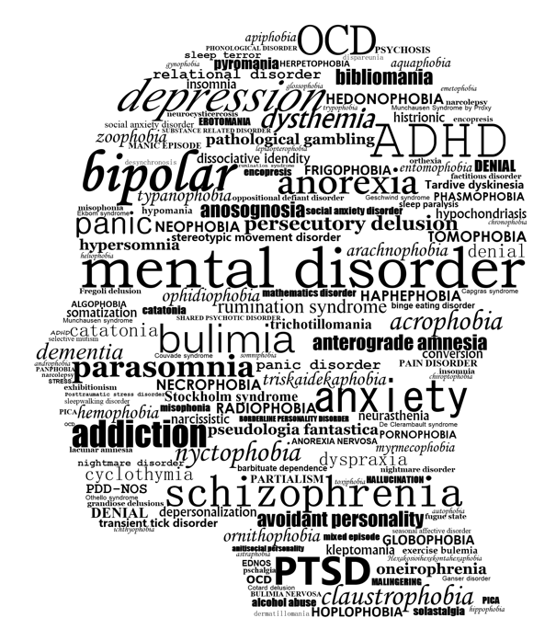

31, John CampoMay, et al. “It's Time to Recognize Mental Health as Essential to Physical Health.” *STAT*, 30 May 2017, https://www.statnews.com/2017/05/31/mental-health-medicine/.

“Anxiety.” *MedlinePlus*, U.S. National Library of Medicine, 20 Sept. 2021, https://medlineplus.gov/anxiety.html.

Bruce, Debra Fulghum. “Causes of Depression: Genetics, Illness, Abuse, and More.” *WebMD*, WebMD, https://www.webmd.com/depression/guide/causes-depression.

“Effects of Bipolar Disorder on the Brain and Behavior.” *StoneRidge: Center for Brains*, 16 Aug. 2020, https://pronghornpsych.com/how-does-bipolar-disorder-affect-the-brain/.

“How PTSD Affects the Brain.” *BrainLine*, 7 May 2019, https://www.brainline.org/article/how-ptsd-affects-brain.

*NHS Choices*, NHS, https://www.nhs.uk/mental-health/conditions/bipolar-disorder/causes/#:~:text=Bipolar%20disorder%20is%20widely%20believed,include%20noradrenaline%2C%20serotonin%20and%20dopamine.

“Oxford Languages and Google - English.” *Oxford Languages*, https://languages.oup.com/google-dictionary-en/.

“The Science of Depression.” *NAMI California*, https://namica.org/blog/the-science-of-depression/.

“What Causes Depression?” *Harvard Health*, 10 Jan. 2022, https://www.health.harvard.edu/mind-and-mood/what-causes-depression.

“What Is Dementia?” *Alzheimer's Disease and Dementia*, https://www.alz.org/alzheimers-dementia/what-is-dementia#:~:text=Dementia%20is%20caused%20by%20damage,and%20feelings%20can%20be%20affected.

**National Mental Health Hotline:** 1-800-662-HELP (4357

**Citations**

Mental Health is not simply dealing with emotions, and cognitive thinking, but rather specific brain functions that affect the way neurons are able to submit, and transfer messages throughout the human body. Whether it is **Depression, Anxiety, Bipolar Disorder, Dementia,** or **Post Traumatic Stress Disorder**,there are a variety of different aspects that go into the formation, and causation of these disorders.

Causing agents for mental health disorders can, and are due to environmental factors, developmental factors, as well as genetical factors. One may be predisposed to being diagnosed with a certain disorder simply because there is a family history of similar diagnoses that run in their family. Aside from genetics, there are are situations in someone’s life that may have ean impact on a certain diagnosis of a specific disorder. Life events can, and will play a major role in the development of a mental health disorder that is showing present in a certain person.

All in all, every different diagnosis presents various different challenges that present themselves in extremely different ways. The brain is altered based on the differing neurotransmitters, and parts of the brain that are affected with every different disorder, and treatment is possible with the help of medical professionals.

***Overview: Mental Health***

***Chapter 1: Section 5***

*Finding An Agent That’s Right For You*