MICR 4990 PEER Review Science Writing
Chapter 4:
The Women that Genetics Forgot

Throughout the scientific world, many have come to recognize such names like: Crick and Watson, Mendel and Borlaug; but few have ever herd of Rosalind Franklin, Esther Lederberg, and Nettie Stevens. In this chapter we will look at a few of the top female scientist, whom, without their love and dedication to genetics, would still have us wondering if sex was determined by the environment or what the true structure of DNA looked like. We will also discuss the “Matilda Effect” and how this affected many early female scientists from gaining the recognition for their discoveries.
Let us first start with defining what the “Matilda Effect” is:
“The Matilda effect is the systematic repression and denial of the contribution of woman scientists in research, whose work is often attributed to their male colleagues. This effect was first described in 1993 by science historian Margaret W. Rossiter. The Matilda Effect It is named after the U.S. women's rights activist Matilda Joslyn Gage, who first observed this phenomenon at the end of the 19th century. The Matilda effect is related to the Matthew effect, since eminent scientists will often get more credit than a comparatively unknown researcher, even if their work is shared or similar. Rossiter provides several examples of this effect: Trotula, an Italian physician (11th–12th centuries), wrote books which were attributed to male authors after her death, and hostility towards women as teachers and healers led to her very existence being denied. Known cases of the effect from the 20th century include among others Rosalind Franklin, Lise Meitner, Marietta Blau and Jocelyn Bell Burnell.”
Because of this phenomenon, many brilliant and esteemed female scientist never got the recognition the so deserved for the discoveries in their respective fields. In this chapter, we will look at just a few distinguished women, and some of their contributions to science.

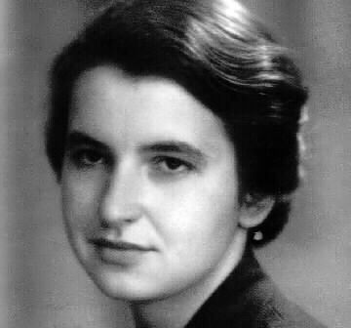
Rosalind Franklin
Let us first look at the amazing Rosalind Franklin, and how she revolutionized the world of Biology and Genetics. Born in 1920, London; Franklin used x-rays to take pictures of DNA. Franklin graduated with a doctorate in physical chemistry from Cambridge University in 1945, then spent three years at an institute in Paris where she learned x-ray diffraction techniques, or the ability to determine the molecular structures of crystals. She returned to England in 1951 as a research associate in John Randall's laboratory at King's College in London and soon encountered Maurice Wilkins, who was leading his own research group studying the structure of DNA. Franklin and Wilkins worked on separate DNA projects, but by some accounts, Wilkins mistook Franklin's role in Randall's lab as that of an assistant rather than head of her own project. Meanwhile, James Watson and Francis Crick, both at Cambridge University, were also trying to determine the structure of DNA. They communicated with Wilkins, who at some point showed them Franklin's image of DNA, known as Photo 51, without her knowledge. Photo 51 enabled Watson, Crick, and Wilkins to deduce the correct structure for DNA, which they published in a series of articles in the journal Nature in April 1953. Franklin also published in the same issue, providing further details on DNA's structure. Franklin's image of the DNA molecule was key to deciphering its structure, but only Watson, Crick, and Wilkins received the 1962 Nobel Prize in physiology or medicine for their work.
(photo 51)
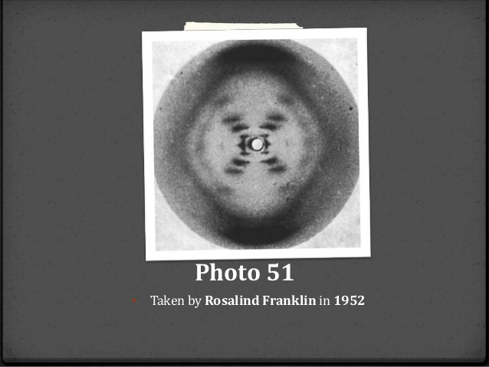
Franklin died of ovarian cancer in 1958 in London, four years before Watson, Crick, and Wilkins received the Nobel. Since Nobel prizes aren't awarded posthumously, we'll never know whether Franklin would have received a share in the prize for her work.
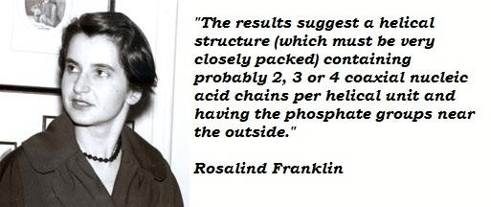

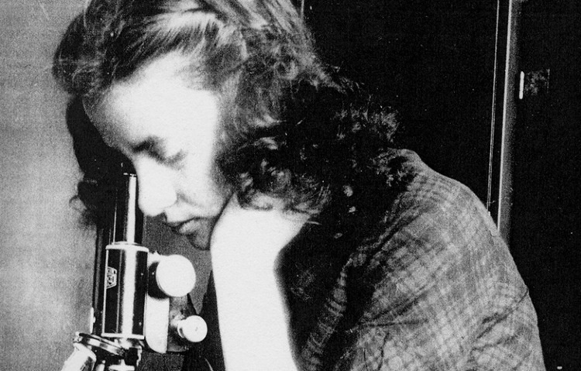
Esther Lederberg
Another leading female scientist in the field of Genetics, is Esther Lederberg. Lederberg is known for: the discovery of the bacterial virus λ, the transfer of genes between bacteria by specialized transduction, the development of replica plating, and the discovery of the bacterial fertility factor F. Born in 1922, in the Bronx, she would grow up to lay the groundwork for future discoveries on genetic inheritance in bacteria, gene regulation, and genetic recombination. At the age of 20, Lederberg, then Zimmer, graduated Cum Laude with her undergraduate at New York City’s Hunter College; there she engaging in research on Neurospora crassa with Bernard Ogilvie Dodge. After graduating from Hunter, she continued her research with N. crassa, where she published her first works in genetics. In 1944 she entered a master’s program at Stanford, and in 1946 she was awarded a Master’s of Arts. Zimmer married in 1946, and she began work on her doctorate at the University of Wisconsin. Her thesis was "Genetic control of mutability in the bacterium Escherichia coli." Joshua Lederberg, her now husband, accepted a position there as Associate Professor. She completed her doctorate under the sponsorship of R. A. Brink, in 1950, the same year that she discovered the lysogenicity of lambda bacteriophage. Lederberg, along with her first husband Joshua Lederberg, also developed a way to easily transfer bacterial colonies from one petri dish to another, called replica plating, which enabled the study of antibiotic resistance. The Lederberg method is still in use today. Lederberg also wasn't treated fairly in terms of her academic standing at Stanford, she had to fight just to be appointed as a research associate professor, whereas she surely should have been afforded full professorial rank. Upon her death in 2006, her injustice was summed up in her eulogy by Stanly Falkow; while preparing his remarks he had checked the internet and found “a suggested topic for a term paper to meet the requirements for a passing grade in a bioethics course in Pomona College." He read:
“Martha Chase, Daisy Roulland-Dussoix, and Esther Lederberg are women who participated in important discoveries in science. Martha Chase showed that phage genetic material is DNA not protein. Daisy Dussoix discovered restriction enzymes, and Esther Lederberg invented replica plating. Yet each of these discoveries is often credited to the male member of the team (Al Hershey, Werner Arber, and Joshua Lederberg, respectively). Using the resources of the library (at least five sources), write a five-page paper that examines how history of science has treated each discovery (generally by Hershey, Arber, and Josh Lederberg, who all received the Nobel prize) and include your own appraisal of how you might have reacted to the reward structure in each case.”
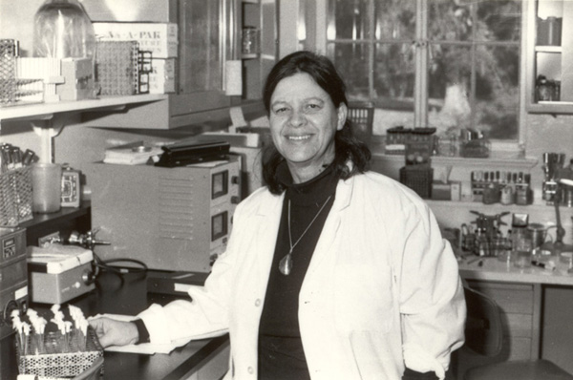

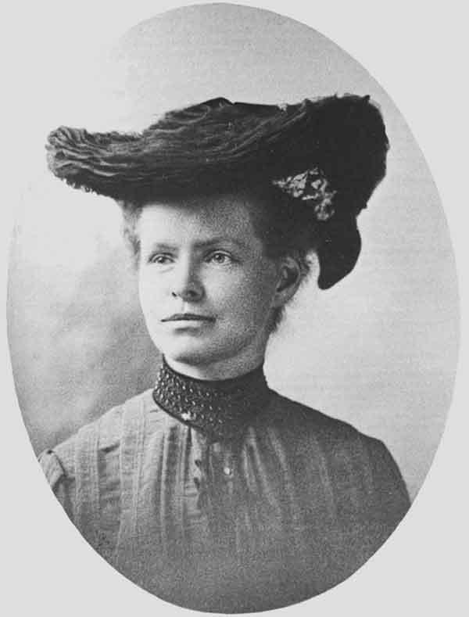
Nettie Stevens
Last but surly not least we will look at Nettie Stevens. Born in 1861 in Vermont, Nettie Stevens performed studies crucial in determining that an organism's sex was dictated by its chromosomes rather than environmental or other factors. She graduated at the top of her class. At Stanford, she received her B.A. in 1899 and her M.A. in 1900, having returned to college after an initial career as a school teacher. Stevens was one of the first American women to be recognized for her contribution to science. Her research was done in Bryn Mawr College. She discovered that in some species chromosomes are different among the sexes, by observations of insect chromosomes. The discovery was the first time that observable differences of chromosomes could be linked to an observable difference in physical attributes, i.e. if an individual is a male or a female. By working on mealworms, she was able to deduce that the males produced sperm with X and Y chromosomes, the sex chromosomes, and that females produced reproductive cells with only X chromosomes. This was evidence supporting the theory that sex determination is directed by an organism's genetics, not its environment. Stevens fell victim to a phenomenon known as the Matilda Effect, a term we defined earlier in this chapter. Thomas Morgan Hunt, a prominent geneticist at the time, is often credited with discovering the genetic basis for sex determination. Stevens died on May 4, 1912 from breast cancer, at Johns Hopkins Hospital; following her death, Thomas Hunt Morgan wrote an extensive yet dismissive obituary for the journal Science, implying that she was more of a technician than a scientist. This later assessment discredits his earlier statement in a letter of recommendation: "Of the graduate students that I have had during the last twelve years I have had no one that was as capable and independent in research as Miss Stevens..."
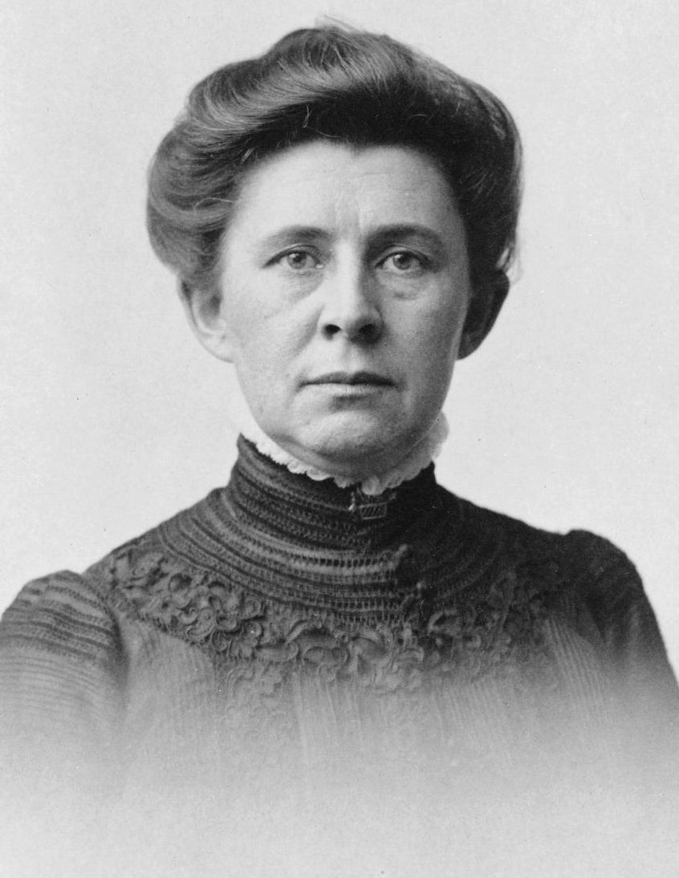
Throughout history, women of science have been over looked, shadowed and out shinned by their male counter partners. From an analysis of more than a thousand research publications from the years 1991-2005, it was shown that male scientists more often cite the publications of male authors than of female authors. In 2012, two female researchers from Radboud University Nijmegen showed that in the Netherlands the sex of professorship candidates influences the evaluation made of them. Similar cases are described in an Italian study corroborated further by American and Spanish studies. US male scientists still receive more recognition and awards compared with women scientists, despite similar achievements. This difference is diminishing. It was more pronounced in the nineteen-nineties than in the 2000s. Women are starting to get the recognition they deserve, but equality is still years away.

There are thousands of women, every day that go unnoticed and who are underappreciated. If you know of a female scientist, let her know that her work and efforts are valued, and that what she is doing means something.

Work cited:
http://news.nationalgeographic.com/news/2013/13/130519-women-scientists-overlooked-dna-history-science/
https://en.wikipedia.org/wiki/Matilda_effect
https://en.wikipedia.org/wiki/Rosalind_Franklin
https://en.wikipedia.org/wiki/Nettie_Stevens
http://schaechter.asmblog.org/schaechter/2014/07/esther-lederberg-pioneer-of-bacterial-genetics.html

