Archaea and Bacteria
One late night on August 28th of 1854, as most of the populace was asleep in London, England, a mother was forced to remain awake while caring for her abruptly sick - and ever crying - infant of six months old. Instead of seeking rest for herself during the short sprees of time that her child would fall asleep, she would gather up her babies watery and soiled linens in order to dispose of them in a cesspit located outside of her house. It was this crucial act that led to one of London's most prolific outbreaks of Cholera, a diarrheal disease caused by Vibrio cholerae. In a matter of 8 days, more than 600 lives were claimed as a result of the outbreak.
Vibrio cholerae is a perfect example of a bacterium, or a microorganism - an organism so small that the naked eye cannot detect its presence without the help of a microscope. In many instances, bacteria can enter the human body and cause great harm and infection, as such is the case with Vibrio cholerae. However, many bacterial species also pose numerous advantages in a variety of different ways, such as nutrient absorption and boosting the immune system. Outside of the human body, bacteria can offer benefits to the ecosystem by converting nitrogen into oxygen, releasing nutrients into the ground needed for prosperous farming, antibiotic production, biofuel production, etc.
The following concepts will be covered in this chapter:
- The diversity and evolution of bacteria
- Morphology and structure
- Nutrition and metabolism
- Reproduction
- Ecological roles
Diversity and Evolution
The three domains (Eukarya, Bacteria, and Archaea) encompass and categorize all of life on earth. The domain Eukarya, is comprised of all the animals, plants, fungi and protists. Additionally, all of these organisms are eukaryotes and have a more complex cell structure than that of bacteria or archaea. To compare, members of the domain Bacteria and Archaea all have a prokaryotic cell structure, a much simpler cell structure that lacks the organelles that eukaryotes posses. Although extremely small, altogether bacteria and archaea form the largest biomass on earth with an estimated 10³⁰ ( that is 1,000,000,000,000,000,000,000,000,000,000 to give some perspective on the matter) individual organisms residing in nearly every nook and cranny imaginable (Brooker et al).
As one can assume, 10³⁰ individuals of any species leaves for the possibility of great diversity and bacteria are no exception. It is currently estimated that there are 10⁷ to 10⁹ different species of bacteria on the planet. In fact, a single spoonful of soil may contain upwards of 10,000 different species alone (3). Apart from their great diversity, bacteria are also Earth's most archaic organisms, with many scientists believing that their origins began more than 3 billion years ago (Brooker et al). With such deep roots in history and massive diversity, bacteria have managed to produce a number of incredible metabolic functions that allow them to obtain the energy needed for survival whilst living in the oddest of environments. Hot springs, super-chilled lakes, volcanic vents, etc. are all perfectly fine places for a bacterial species to settle down and multiply in order to live a comfortable life.
Now that Bacteria have been touched upon, let us bring our focus to Archaea. Many scientists believe that archaea share a common ancestry with Eukarya due to a number of common characteristics. A few prime examples are protein and RNA polymerase similarities between the two domains. It has been revealed by scientists that archaea and eukarya have more than 30 shared ribosomal proteins, all of which are completely absent in bacteria (Brooker et al). Additionally, the RNA polymerases of the two domains are closely related as well (Brooker et al). However, even with such strong similarities between the two domains, archeae still posses enough unique features to be separated into a different domain. Most notably, the difference between archaeal and eukaryotic cell walls. Archaea's cell walls are produced by ether-bonded phosphlipids that are extremely resistant to polar temperatures of extreme heat and extreme cold (Brooker et al). To contrast, eukaryotic cell walls are made up of ester-bonded phospholipids that do not have such environmental resistances. Archaea's ether-bonded cell walls may explain why archaea tend to thrive so well in extreme environments. 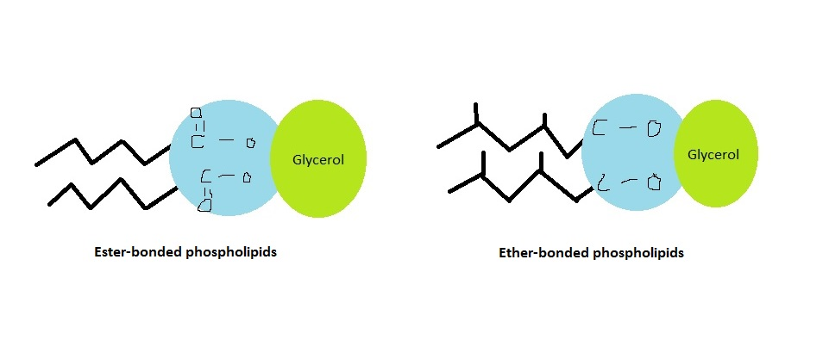
One key factor that played a major role in the evolution of archaea and bacteria is known as horizontal gene transfer. "What is horizontal gene transfer?" one may ask. Horizontal gene transfer is the process in which cellular organisms receive and use genetic material from other cellular organisms without being directly related to each other (Brooker et al). For example, in vertical gene transfer, a child recieves his or her genetic material from the parents (Brooker et al). However, if humans could use horizontal gene transfer, a child would be able to gain genetic material by holding hands with another person. Obviously, this is a very dramatized example, but should be able to get the point across that in horizontal gene transfer, an organism does not have to be the offspring of another organism in order to gain it's genetic material. Bacteria and archaea use this process constantly in order to gain an evolutionary advantage over competing organisms and even the environment itself. For example, E. coli, a common bacteria in the human gut, has at least 17% of its genetic makeup made up from other bacteria (Brooker et al).
After reading this section, it should be clear to see that the domain archaea and bacteria are extremely diverse and numerous. This diversity came from their ability to use horizontal gene transfer to their advantage and have allowed the prokaryotes to be extremely successful on planet Earth.
Morphology and Structure
It should come as no surprise that bacteria and archaea come in a wide variety of shapes and sizes. Just as humans can be tall, short, fat, and skinny; bacteria can be round, rod shaped, come in pairs, or in long chains. The term Morphology refers to all the shapes and sizes that bacteria come in.
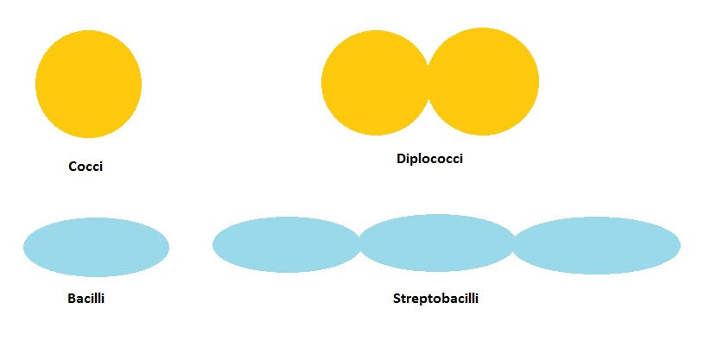
Two extremely common types of bacteria are spherical and rod-shaped, otherwise known as cocci and bacilli respectively. To build off of that, some bacterial species can come in pairs (Diplo-), clumps (Staphylo-), or chains (Strepto-). It would not be surprising if most readers were confused after reading this, so let us focus on this subject some more. A spherical bacterial species that comes in pairs would be refered to as diplococci. If the same species were to come in clumps, it would be referred to as staphylococci. The same trend plays out for spherical species that come in chains. Species of this nature would be referred to as streptococci. Similar rules apply for rod shaped bacteria. Paired, rod shaped bacteria are diplobacilli. And streptobacillus are bacterial species that are rod shaped and chained. However, not all archaea and bacteria come as sphere or rods, many are spiral shaped and flexible (spirochaetes) or spiral shaped and rigid (spirilli) (Brooker et al). In any case, the morphology of a bacteria can in many cases determine the function of that bacteria. For example, bacteria with an elongated shape may be more adept at swimming in water than a completely spherical bacteria.
Regardless of what shape a cellular organism comes in, they will always have certain structures in order to keep alive and reproduce. One such structure is the cell wall, also known as the cellular membrane. The cell wall performs the critical action of protecting an organism from external threats, as well as maintaining homeostasis inside the organism. The cellular membrane also serves as a gate that allows much needed nutrients and proteins to enter the cell. Inside the cell is a viscous liquid called the cytoplasm in which all of the cell's metabolic functions occur. Being prokaryotes, bacteria and archaea lack any membrane-bound organelles that an eukaryote would have, such as mitochondria and a membrane bound nucleus (5). Instead, bacteria and archaea have a free floating nucleus with no membrane to surround it (5). Another pivotal structure found in some, but not all, prokaryotes is the flagellum. This structure, which resembles a tail, spins in a motion that either pushes or pulls the organism in a certain direction (Brooker et al).

References
1. Brooker, Robert, J et al. (2014) Biology: BIOL 1134 University of Oklahoma. McGraw-Hill Companies, Inc.
2. http://www.ncbi.nlm.nih.gov/pmc/articles/PMC539005/
3. http://www.nytimes.com/2011/08/30/science/30species.html?_r=0
4. http://www.microbeworld.org/types-of-microbes/bacteria/where-they-re-found
5. http://webprojects.oit.ncsu.edu/project/bio183de/Black/prokaryote/prokaryote1.html

