The Thyroid
Introduction
In endocrinology, the thyroid gland and the hormones it produces are essential to homeostasis, metabolism, and overall health of an individual. The endocrine system and the nervous system work together to secret hormones and target specific organs that have protective and essential effects on the body. The thyroid gland produces thyroid hormones, which are regulators of growth, development, and metabolic rate. In this chapter, you will learn about the thyroid gland, its effect on the body, and the diseases that can affect it.

Thyroid Histology
The thyroid gland is made of many cells and tissues that help it function. It is a butterfly-shaped gland that is located in the front of the lower neck. It is located below the larynx and in front of the trachea, more specifically between the C5 and T1 vertebrae of columna. The thyroid has two side lobes, called lobus dexter and lobus sinister, connected by the isthmus, a bridge, in the middle. The thyroid contains many blood vessels, giving it the brownish-red color. The thyroid develops from the endoderm through the merging of the primitive pharynx and tongue base media line during the third gestational week. The thyroid gland development is regulated by the thyroid transcription factor 1 (TTF-1), thyroid transcription factor 2 (TTF-2), and homeobox-8. These factors work together to manufacture follicular cell growth and the development of thyroid-specific proteins such as thyroid stimulating hormone (TSH) receptor and thyroglobulin.
The basic functional unit of the thyroid gland is the thyroid follicles. These spherical structures are the basic functional units of the thyroid gland that produce thyroid hormones. Their size varies and they are packed tightly to compose the lumen, the majority of the thyroid gland. The outside layer of the thyroid follicle is composed of cuboidal epithelium cells. These cells, called thyroid follicular epithelial cells, perform a major role in the biochemical synthesis and secretion regulation of thyroid hormones. The single cell, protein-like center of the thyroid follicle is called the thyroid colloid, and it is composed mostly of thyroglobulin. The colloid also serves as an extracellular storage site for thyroid hormone. The entire thyroid gland is enclosed by a fibrous capsule, in which thin collagenous septa extend from it and divide the thyroid follicles into lobules.

Thyroid Hormone Synthesis
The thyroid hormone synthesis occurs in the follicles of the thyroid. The two thyroid hormone subtypes are thyroxine (T4) and triiodothyronine (T3); adding iodine to tyrosine amino acids forms these hormones. Iodine, from dietary intake, is absorbed from the gastrointestinal system and diffused in the extracellular fluid. The most efficient thyroid hormone is T3, although the most synthesized thyroid hormone by the body is T4. The synthesis of thyroid hormone occurs in a few major steps. The iodine travels through the blood and passes through the Sodium/Iodine symporter pump into the thyroid follicle cell by active transport. The thyroid-stimulating hormone, TSH, stimulates the rate of the Na+/I- symporter pump. Thyroglobulin in the follicle exits into the colloid through exocytosis, and the iodine is transported from the cytoplasm though the sodium-independent chloride/iodide transporter, pendrin, into the colloid. The NADPH dependent thyroperoxidase enzyme in the presence of hydrogen peroxide facilitates the oxidation of iodine. As the iodine concentration of the cell rises organification increases. Organification in the thyroid gland, is the process of incorporation or binding of oxidized iodine into the thyroglobulin tyrosine residues for the production of thyroid hormone. During this step, the inactive thyroid hormone forms are synthesized, monoiodotyrosine (MIT) and diiodotyrosine (DIT). The coupling reaction then occurs, to couple iodotyrosine molecules together. The formation of thyroxine (T4) is from the combination of two diiodotyrosine molecules and the formation of triiodothyronine (T3) is from the coupling of diiodotyrosine and monoiodotyrosine. Although T4 is the major coupling reaction, T3 is more biologically active than T4. The majority of T3 is produced outside the thyroid gland in the peripheral conversion from T4 in a deiodination reaction, which removes an iodine from the outer ring of T4 using the enzyme iodothyronine deiodinase. The iodinated thyroglobulin reenters the follicular cells through phagocytosis and passes into lysosomes were it is broken down, releasing T4 and T3 from their peptide linkage.

Thyroglobulin
The colloid in the thyroid follicle lumen is mostly the glycoprotein, thyroglobulin. Each thyroglobulin molecule has 70 tyrosine amino acids and contains 6 MIT, 4 DIT, 2T4, and 0.2 T3 residues. Thyroglobulin synthesis is dependent upon thyroid stimulating hormone and occurs in the endoplasmic reticulum and Golgi apparatus of thyrocytes, also called thyroid follicular cells. The thyroglobulin polypeptide chain is manufactured on the cytosolic surface of the rough endoplasmic reticulum. It then is moved in the lumen of the endoplasmic reticulum and undergoes a series of conformational modification while a carbohydrate chain is synthesized and added to the chain of polypeptides. Suflation then occurs when the thyroglobulin dimer enters the Golgi apparatus. Uniodinated mature thyroglobulin is relocated from the Golgi apparatus to the surface of the thyrocyte.

Thyroid Hormone Secretion
Free thyroid hormones diffuse out of lysosomes and into the blood through the plasma membrane of the cell. The hormones bind to carrier proteins for transportation to target cells. The main carrier proteins are serum albumin, thyroxin-binding prealbumin (TTR), and thyroxin-binding globulin (TBG). T4 binds to thyroid-binding globulin protein, which is responsible for the diffusion of large amounts of the T4 hormone in extracellular fluid. TBG has the highest rate of binding and serum albumin has the lowest rate of binding, although it has the highest plasma concentration. The thyroid hormone T3 binds to fewer proteins and therefore making it more active in the intracellular region. The half-life of T4 is about six days, while the half-life of T3 is less than a day. T3 is more active than T4 since T4 binds to cytoplasmic proteins upon entering the target cell. The most important mechanism in controlling the synthesis and secretion of the thyroid hormones is the hypothalamus-pituitary-thyroid axis.

Hypothalamus-Pituitary-Thyroid Axis
The hypothalamic-pituitary-thyroid (HPT) axis functions to sustain normal, circulating levels of thyroid hormone that is essential for biological functions of tissues. The HPT axis is a negative feedback loop where the rate of the process decreases as the concentration of the product increases. The thyroid gland is regulated by the concentration of the pituitary hormone, thyroid-stimulating hormone (TSH) or thyrotropin. The regulators of TSH production are the inhibitory action of the thyroid hormone and the thyrotropin-releasing hormone (TRH) stimulatory effect. TRH is a stimulus to the synthesis and release of TSH. TRH synthesis is regulated directly by the thyroid hormones, T3 and T4. Thyroid releasing hormone secreted from the hypothalamus stimulates the release of TSH from the anterior pituitary, which then stimulates the release of thyroid hormone from the thyroid gland.
The TRH is transported to the anterior pituitary through the hypothalamic-hypophysial portal blood. The TRH receptor on the anterior pituitary is G-protein coupled. The binding of TRH to the TRH receptor activates Gq protein and phospholipase C (PLC) which creates a series of events in the anterior pituitary. The activation causes hydrolysis of PIP₂ to IP₃ and diaglycerol. IP₃ stimulates the release of Ca²⁺, and Ca²⁺ stimulates the release of TSH. Diaglycerol creates more TSH by activating protein kinase C (PKC), which initiates protein phosphorylation and activates TSH α and β subunit gene transcription.
TSH more specifically initiates proteolysis of thyroglobulin, which instigates the release of the thyroid hormone into the blood. TSH binds with TSH receptors on the surface of the thyroid cell. The effects of TSH result from the activation of the second messenger system, cyclic adenosine monophosphate (cAMP), of the cell. TSH also controls thyroid metabolism such as glucose uptake, O2 consumption, glucose oxidation, phospholipid turnover, and DNA/RNA synthesis.
In summary, thyroid hormone regulations can be controls by four mechanisms classic hypothalamic-pituitary-thyroid axis, pituitary and peripheral deiodianses, thyroid auto regulation, response to iodine, and TSH receptor antibodies. The regulation results in a fairly stable level of circulating thyroid hormone in the body.

Thyroid Hormone Physiology
Thyroid hormone has a relatively long lasting physiological effect on the body. Thyroid hormone controls thermogenesis, the production of heat in a body. It increases the basal metabolic rate, which results in increased oxygen utilization and in heat generation possibly through an increase in mitochondrial oxidative phosphorylation, although the process is not completely understood. The thyroid hormone also increases respiration rate and cardiac output. Thyroid hormone also modulates metabolic effects. Through the up-regulation of an enzyme in gene transcription, thyroid hormone stimulates protein turnover, lipid turnover, and carbohydrate metabolism. It also increases the effects of insulin, epinephrine, and growth hormone secretion. Thyroid hormone also controls normal development, growth, and normal brain function. It stimulates the secretion of growth hormone and insulin growth factor-1 (IGF-1). It increases target-cell responsiveness to catecholamines by increasing the amount of epinephrine receptors. Through this increase in receptors it mimics the sympathetic nervous system and facilitates an increase in heart rate and force of contraction.
Thyroid hormone requires dietary iodine in order to be produced. Iodine, is a trace element essential for life, and is the basic substance for the synthesis of thyroid hormone, T3 and T4. Iodine is taken into the body orally and is in foods such as seafood, vegetables, and iodized salt. The daily intake recommended for adults is 150μg, 110-130μg, and 220μg for pregnant women.

Thyroid Diseases and Pathologies
Thyroid disorders can be separated into two categories: hyperthyroidism and hypothyroidism. Hyperthyroidism is a condition in which the thyroid gland is overactive and produces an excessive amount of thyroid hormone. Hypothyroidism is a condition represented by an underactive thyroid gland in which the gland is not producing sufficient amounts of thyroid hormone.
Graves’ disease, a form of hyperthyroidism, is an autoimmune disease where antibodies develop and bind to the TSH receptor, thus stimulating the overproduction of thyroid hormone. The binding of the antibodies creates excess TSH leading to the production of a goiter, an enlargement of the thyroid gland. Graves’ disease inflicted individuals also exhibit the symptom of exophthalmos, the inflammation of the eye tissue causing the eyes to protrude. There are two treatments for Graves’ disease. One is the administration of the drug propylthiouracil (PTU), which inhibits the coupling reaction and type I deiodinase, thus reducing the amount of thyroid hormone produced. Second is the administration of radioactive iodine, I¹³¹, to kill the thyroid gland and stop production of thyroid hormone, however the individual must take synthetic thyroxine hormone tablets for the rest of their life.
Some other causes of hyperthyroidism are thyroid adenomas that cause high amounts of thyroid hormone but low levels of TSH, therefore not producing a goiter. Also, pituitary adenomas that facilitate the pituitary to secrete excess TSH causing the thyroid gland to secrete excess thyroid hormone.
Euthyroid sick syndrome, a form of hypothyroidism, occurs in acute and chronic severe illness and causes derangements of thyroid hormone levels due to alterations in peripheral metabolism of T4 and binding of T4 to TBG. The amount of TSH can also be decreased during fasting or illness.
Hashimoto’s syndrome is an autoimmune attack on the thyroid. It causes low levels of T3 and high levels T4 and TSH. It can produce an enlarged thyroid and myxedema, which is edema in face, hands, and feet. The treatment is thyroxine tablets to decrease TSH levels and bring hormone levels back to regular.
Cretinism, a form of hypothyroidism during fetal development, results from either an iodine deficiency or congenital defect, such as lack of TSH receptor on the thyroid gland. Cretinism usually results in mental retardation and dwarfism. If treated early with synthetic thyroid hormone, the effects of hypothyroidism can be reversed.
Inadequate dietary supply of iodine can lead to hypothyroidism and a goiter formation. Without the adequate levels of iodine in the blood the body cannot convert enough iodine into thyroid hormone for the body’s basic needs. Goitrogens, compounds that interfere with iodide uptake, such as turnips and other related vegetables, can also cause hypothyroidism. Treatment is thyroxine tablets to provide the body with the necessary amount of thyroid hormone.

Conclusion
The histology, physiology, and synthesis of the thyroid and its hormones have been addressed in this chapter. The thyroid gland is a very important and essential gland and the production of thyroid hormone help to maintain homeostasis, affect metabolism, development, cellular differentiation, growth, and other mechanisms in the body. The thyroid gland is crucial in the function of the endocrine system, and when it does not work properly, various negative effects on the body can occur.

References:
Bowen, R. (2003). Thyroid and Parathyroid Glands. Retrieved March 04, 2016, from http://arbl.cvmbs.colostate.edu/hbooks/pathphys/endocrine/thyroid/index.html.
Brandt, David (1999). University of California Irvine. Thyroid Gland and Endocrinology. Irvine, CA
Bursuk, E. (2012). Introduction to Thyroid: Anatomy and Functions. Thyroid and Parathyroid Diseases - New Insights into Some Old and Some New Issues. DOI: 10.5772/37942.
Ingbar, S. H., & Galton, V. A. (1963). Thyroid. Annual Review of Physiology, 25, 361-384. DOI: 10.1146/annurev.ph.25.030163.002045.
Luo, Y., Ishido, Y., Hiroi, N., Ishii, N., & Suzuki, K. (2014). The Emerging Roles of Thyroglobulin. Advances in Endocrinology, 2014, 1-7. DOI: 10.1155/2014/189194.
Marino, M., Zheng, G., Chiovato, L., Pinchera, A., Brown, D., Andrews, D., & Mccluskey, R. T. (2000). Role of Megalin (gp330) in Transcytosis of Thyroglobulin by Thyroid Cells: A NOVEL FUNCTION IN THE CONTROL OF THYROID HORMONE RELEASE. Journal of Biological Chemistry, 275(10), 7125-7137.
Mariotti, S. (2011). Physiology of the Hypothalamic-Pituitary-Thyroidal System - Thyroid Disease Manager. Retrieved March 04, 2016, from http://www.thyroidmanager.org/chapter/physiology-of-the-hypothalmic-pituitary-thyroidal-system.
Mcaninch, E. A., & Bianco, A. C. (2014). Thyroid hormone signaling in energy homeostasis and energy metabolism. Ann. N.Y. Acad. Sci. Annals of the New York Academy of Sciences, 1311(1), 77-87. DOI: 10.1111/nyas.12374.
Nowak, F. V., (2009). Ohio University. The Thyroid Gland: Function and Regulation. Athens, Ohio.
Pathway Medicine. (2013). Thyroid Hormones. Retrieved March 04, 2016, from http://www.pathwaymedicine.org/thyroid-anaplastic-carcinoma

Figures:

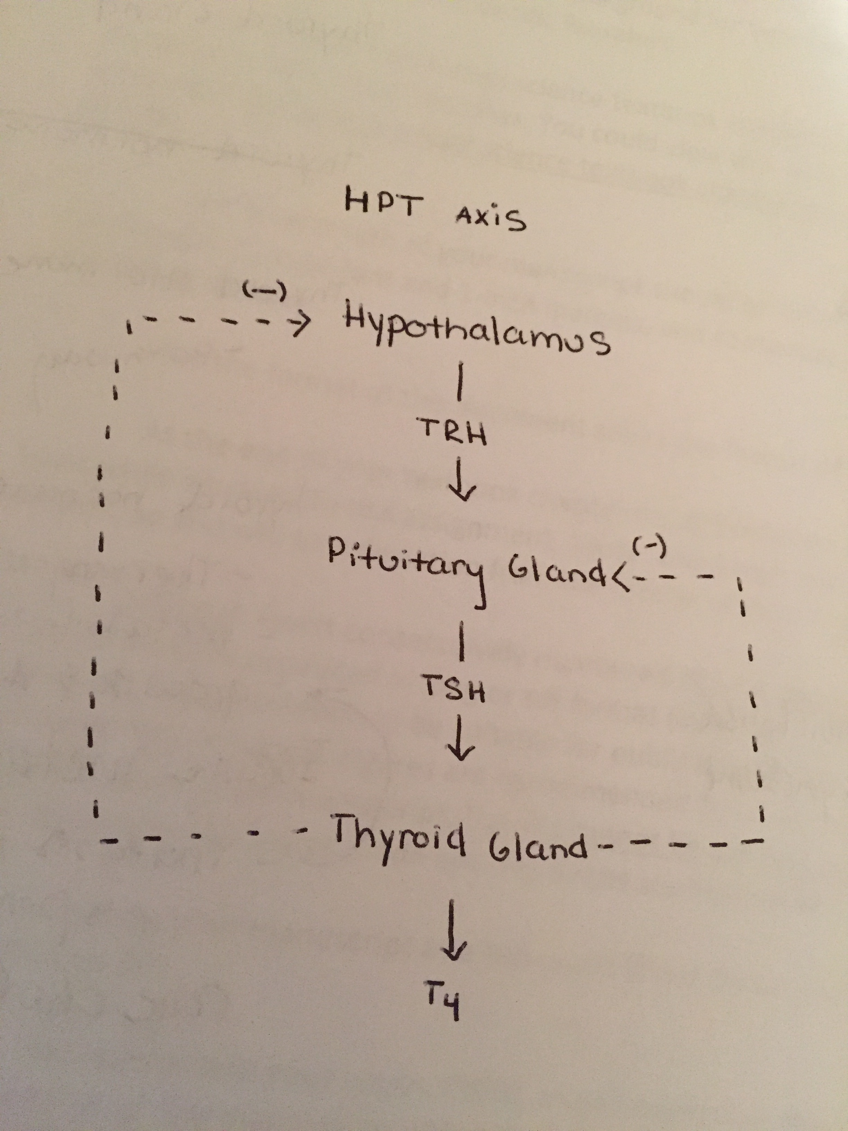
Figure 1:
The Hypothalamus-Pituitary-Thyroid Axis. Basic elements in the regulation of the thyroid function. The hypothalamus secrets thryrotropin-releasing hormone (TRH) which binds to the receptors on the pituitary gland causing the release of thyroid stimulating hormone (TSH). The TSH binds to the receptors on the thyroid gland and stimulates the production of the thyroid hormones.

