The Effects of Hookah and Water Pipes
Hookahs are a growing pastime in the Unites States. Their origin can be traced back over many centuries to the Middle East. According to the Centers for Disease Control, in 2010 one in five boys and one in six girls (age: high school senior) used hookah pipes at least once in the year. These unique pipes are used to burn a flavored tobacco product known as shisha, which can be then inhaled or smoked. Figure 1 is provided below to demonstrate the mechanics of a hookah water pipe. A recent study performed by Dr. Ronald Crystal and his colleagues at Weill Cornell Medicine revealed new information on the effects that can result from smoking water pipes such as the hookah. The findings of this study were published in the American Thoracic Society’s Journal and yielded information showing that this tobacco product can be far more dangerous to its users than cigarettes.
In order to gather information for this research experiment, a group of young hookah smokers was assembled. The members of this group averaged 24 years of age and had smoked no more than three bowls (a bowl is one setting of smoking hookah) per week for fewer than five years. Dr. Crystal’s research showed that the subjects that smoked hookah regularly were found to have measurable changes in the cells lining their airways. These regular smokers were found to produce more sputum in their respiratory tract and also coughed more often. The final piece of information that this study revealed was that individuals smoking hookah showed elevated levels of shed endothelial cells in the lungs. According to Dr. Crystal, the shedding of endothelial cell particles is indicative of damage to the capillaries of the lungs.
By chemical comparison, smoking one bowl of the water pipe was significantly more hazardous than smoking a single cigarette. The hookah bowl had up to four times more nicotine, 7 times the amount of carbon monoxide, 100 times more tar and 17 times more formaldehyde than a single cigarette. This information is important because it sheds light on an emerging pastime in the United States. Dr. Crystal’s findings opened a whole new area of tobacco research relevant to water pipes. Crystal offered comments on the findings of his research, “This is a small study, but our study results justify initiating large epidemiologic studies to further assess the harmful effects of water pipe smoking.”
The development of Dr. Crystal’s study and the procurement of data will open up a new area of research for future scientists. The data found could be vital to helping give this type of tobacco national attention and hopefully help deter its usage. While this study lacked a control group, it shed light on an important and dangerous way that people are using tobacco. The results of this study could lead to further study that could help us better understand the long term effects of smoking hookahs and water pipes.

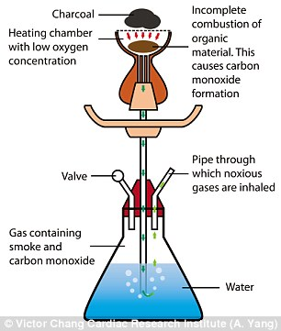

Figure 1 accessed at http://i.dailymail.co.uk/i/pix/2015/05/04/08/284A98D600000578-3066956-image-a-2_1430723879241.jpg

Sources

Study finds evidence of lung function abnormalities in light-use hookah smokers. (2016). Retrieved April 09, 2016, from http://www.news-medical.net/news/20160406/Study-finds-evidence-of-lung-function-abnormalities-in-light-use-hookah-smokers.aspx

Hookahs. (2015, September 14). Retrieved April 23, 2016, from http://www.cdc.gov/tobacco/data_statistics/fact_sheets/tobacco_industry/hookahs/

