In this chapter we will learn about the medical uses of marijuana and touch on the recreational use of marijuana. Since the late 1930’s marijuana has been deemed as a harmful drug even so to be classified with heroin, ecstasy and LSD. The federal government has label marijuana as a schedule 1 drug under the Controlled Substances Act, which means it’s a highly addictive addictive and dangerous drug with no medical use for the drug. In late 1990’s to 2000’s there has been more research on marijuana and now we can say they are multiple medical uses for marijuana with little to none side effects. Marijuana naturally contains tetrahydrocannabinol or as known as THC, THC has been used in other medicines for centuries now but yet medical marijuana in only legal in 28 out of the 50 states. Which is a big jump from 2014 when there were only 9 states that legalized the use of medical marijuana. As far as recreational use of marijuana it is only 9 states that have legalized it. There have been several medical advancements to the use of marijuana, you can use marijuana for different medical reasons such as PTSD, epilepsy, neurologic disorders, anxiety, depression, chemo therapy patients and even has helped with HIV/AIDS patients. Over time people have used THC to relieve pain and inflammation which marijuana naturally contains THC and can be used as a treatment. The THC from marijuana stimulates the body’s senses, colors may appear more vibrant and time may be seen slower. The reason of this affect is the THC from the marijuana attaches to the body’s own natural chemicals which act as the CB (Cannabinoid) receptors. The names of the chemicals that act as the CB receptors anandamides and 2-arachindonoyl glycerol these chemicals are also known as cannabinoids and along with their receptors this makes up the endocannabinoid. These endocannabinoid systems are located inside the brain this is why you move slower and your sense seem to be more stimulate. Even produces anxiety, fear or paranoia, distrust or panic has been seen as the part of the side effects but none of the side effects has been deemed as long termed.
One of the medical uses of marijuana is the treatment of epilepsy. In the case of Charlotte a 5-year girl from Colorado who was diagnosed with SCN1A-confirmed Dravet syndrome when she was 3 months old. At 3 months old Charlotte had her first prolonged epileptic seizure. Charlotte was born with the SCN1A gene mutation and was supposed to only live to the age of 5. Charlotte’s mother looked into using medical marijuana to help with her daughters seizures. Charlotte started adjunctive therapy with a high concentration of cannabidiol/tetrahydrocannabinol strain of cannabis as known as Charlotte’s Web. Over a period of weeks Charlotte slowly is put on THC at a low of dosage, after a couple of days Charlottes seizures went from 50 seizures per day to 2-3 nocturnal convulsions per month. Over time Charlotte’s team of doctors started to slowly increasing the extract does but still keeping the THC content low to keep from having psychotropic effect. There hasn’t been an exact reason why THC has helped with epilepsy but doctors have come up with some ideas on how it helps. The cannabidol doesn’t bind To the CB receptors which we had talked about earlier in the chapter, but the target isn’t completely understood to researchers. The CBD may be agonist of 5-HT1a receptor with the similar affinity as serotonin, or an agonist of a novel endocannabinoid receptor GPR55; it is possible that CBD and THC work synergistically to suppress the seizures. Some of the reservations about this treatment are people who live in states where medical marijuana isn’t legal yet and have to drive cross-country to receive this treatment there is a possible chance that the patient might not make it. Another problem that has risen with the use of medical marijuana is people trying to extract the whole plant compound themselves and extract too much to where it isn’t safe to use. Charlotte’s mother used the stove-top extraction method and making butter instead of smoking or vaporizing method because of the heat it may alter the putative antiepileptic substances. The other method was the ingestion method but Charlottes doctors were worried that Charlottes stomach acid would be too much for the cannabis to survive and can alter Charlottes mental progress.
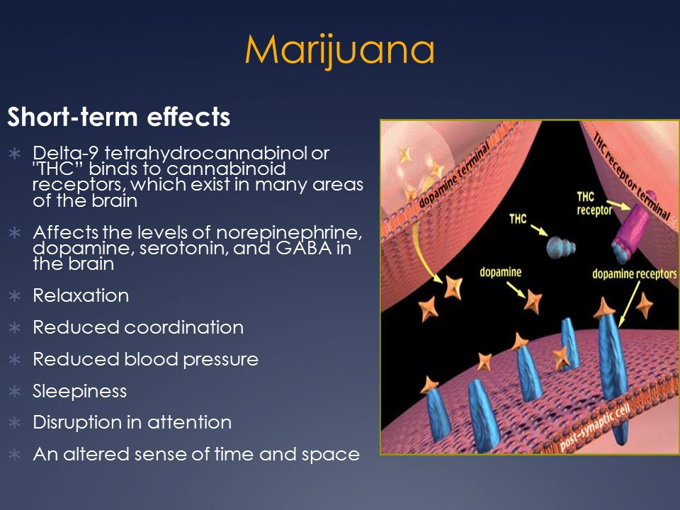
In figure 1.1 the picture depicts how THC attach to receptors in the brain.
There have been other uses for medical marijuana besides epilepsy such as helping people diagnosed with PTSD sleep or even as a coping mechanism. In 2013 there was a study conducted by several scientist, they had over 20 study participants between the ages of 18 to 41 that had PTSD and had trouble sleeping. The study started by examining a group of participants that were put on a 30- day cannabis use, each participant had to state what their reason for the use of medical marijuana was. Then another group was formed and the participants in this group didn’t have PTSD and was using marijuana more for a recreational use. In the PTSD participants found that over the 30 day use of cannabis they were able to sleep better and not have night terrors or have flash backs, as far as coping with PTSD 25% of the participants were able to cope better when using medical marijuana . From this study there were able to have conclusion that people with PTSD would prefer the use of medical marijuana than antidepressants. Medical marijuana is a healthier option than antidepressants because antidepressants have so many side effects that can make the patient worse off than before but with using medical marijuana there were little to none long-term side effects like antidepressants. The study also concluded that people with PTSD were more likely to use marijuana than people who don’t have PTSD.

Since the 21st century there has been over 190 million people using marijuana for recreational use and as time has been going on more and more people have been using marijuana for getting intoxicated without the use of alcohol. In 2007 studies has shown that
People are moving towards the ingestion method of marijuana than the inhalation method. The ingestion method of marijuana can range from brownies, cookies, lollipops, gummy worms and gummy bears to even putting it in every day meals. With eating edibles the smoker is able to maximize their desired psychotropic effects and lower the possible of the negative effects. Most people who use marijuana as a recreational drug use it to relieve stress or forget about problems at the moment. Marijuana also intensify regular activates like listen to music, watching television and also engaging sexual intercourse. The down side of recreational use is the higher the person gets can result in paranoia and increase the degrees of anxiety that in some people can result in a panic attack but only panic attacks happen when in high stressful environments while being high. Marijuana can also affect the brain by increasing short-term, making the ability to focus harder and sleepiness .Some may say marijuana is touted, it helps smooth out social interactions for some people and even lessen self-conscious. Even some people will say they can function better while high. Most states raise the question rather legalizing marijuana for recreational use is worth it. Marijuana causes a cognitive impairment but so does alcohol, adderal and cans which are all legal drugs. The more research that goes into marijuana we will be able to conclude that marijuana has its negative effects but not any effects that will cause a long-term illness.

Cited

Koppel, B. S., J. C. M. Brust, T. Fife, J. Bronstein, S. Youssof, G. Gronseth, and D. Gloss. "Systematic Review: Efficacy and Safety of Medical Marijuana in Selected Neurologic Disorders: Report of the Guideline Development Subcommittee of the American Academy of Neurology." Neurology 82.17 (2014): 1556-563. Web.

Maa, Edward, and Paige Figi. "The Case for Medical Marijuana in Epilepsy." Epilepsia 55.6 (2014): 783-86. Web
Wang, George Sam, Genie Roosevelt, and Kennon Heard. "Pediatric Marijuana Exposures in a Medical Marijuana State." JAMA Pediatrics 167.7 (2013): 630. Web.

Bostwick, J. Michael. "Blurred Boundaries: The Therapeutics and Politics of Medical Marijuana." Mayo Clinic Proceedings 87.2 (2012): 172-86. Web.

