Applied Science

Introduction
Many times students learn about the science topics in their textbooks but are not exposed to the practical applications of these topics. This chapter will focus primarily on how scientists apply different techniques and what specifically they are used for. The goal of this chapter is to expose you to what is actually performed by a biochemist who is interested in learning more about their protein of interest.
There are many different techniques that can be performed by a researcher studying a protein. Some of them focus on purification of the protein, these techniques include: column chromatography, and gel electrophoresis. In addition to purification techniques, there are also amplification techniques. These are used in order to increase the amount of protein or DNA, which allows the researcher to have a larger sample to work with. A Commonly used techniques include polymerase chain reaction(PCR). Finally, there is a technique called transformation, which allows the researcher to make their protein of interest. Each of these techniques will be discussed in detail through the remainder of this chapter.
Chromatography
There are multiple different forms of chromatography that can be used depending on the nature of the protein you are interested in and how you are interested in separating the protein. Common forms include: size exclusion, ion-exchange, and affinity chromatography.
The first one discussed will be size exclusion. This involves filling a column with a gel, typically agarose, then beads with pores in them are distributed throughout the gel. These beads are extremely small, usually having a diameter of 0.1mm. The mixture of proteins is then run through the gel. The pores in the beads allow the large proteins to run through the gel fastest while the small protein get stuck in the pores and do not run through the gel as quickly. This allows the scientist to collect multiple different samples across different time frames and separate the proteins from each other based on their relative sizes.
Ion-exchange is a more specific form of chromatography that can be performed when the researcher knows more specifics about the protein of interest. In order to perform this kind of chromatography, the researcher must know the charge of their protein. This can be determined based on the amino acids that make up the protein the researcher is trying to isolate. Specific amino acids have different charges depending on the environment they are in. If this information is known about the protein, then the column can be set up with the opposite charge. This will cause the protein to bind to the oppositely charged column and let the rest of the protein in the mixture flow through the column. Then a special solution can be run through the column to detach the protein from their opposite charge and the protein is then isolated from the others in the sample.
The final form of chromatography that will be discussed is affinity chromatography. This requires knowing about the specific makeup of the protein before use due to how specific this technique is. In principle, this technique works in a similar way to the ion-exchange chromatography due to the protein of interest being stuck inside of the column. However it differs in that affinity chromatography is much more specific than ion-exchange. Where ion-exchange requires knowing the charge of the protein, affinity chromatography requires knowing the specific makeup of the protein. The reason this is so much more specific is due to what is used in the column. In affinity chromatography, the protein the researcher is trying to isolate must be good at recognizing a specific group. An example of a molecule that a protein can recognize is glucose. If the protein of interest is specific for recognizing glucose, then it will bind with high affinity to any glucose attached to the wall of the column and will remain bonded until intentionally washed away by the researcher using a specific mixture. While ion-exchange and size exclusion chromatography are good at separating by certain characteristics, they are not as specific as affinity chromatography. Therefore, affinity chromatography is a good technique to use when more is known about the protein, because it allows for more specific isolation than the previously mentioned techniques.
These techniques are all necessary tools for a biochemist to have. Because without them, it would be difficult to learn characteristics of individual proteins due to inability to isolate them from the other proteins in the cell.
Gel Electrophoresis
Where chromatography was focused on isolation of proteins, gel electrophoresis is more focused on learning more about the protein. These techniques typically give the researcher more information, which in turn allows him to determine how best to isolate the protein based off of that information.
There are many different kinds of electrophoresis, and each one separates the proteins based on specific criteria. These include: shape, size, charge, and something called isoelectric point(which is the pH at which the amino acid is neutrally charged). One of the most commonly used is SDS-PAGE, which stands for sodium dodecyl sulfate polyacrylamide gel electrophoresis. This technique is used in order to separate proteins in an electric field based on their sizes. The SDS acts to make all proteins unfold into the same shape and give them all a negative charge. This means that the only factor that will determine how they are separated is their size. Unlike the chromatography techniques, SDS-PAGE does not leave the protein in a form that can be further tested on after the experiment. SDS-PAGE is used in order to determine the size of the protein of interest. It involves adding SDS to the sample of proteins, then adding this mixture in to a hole in a solid gel slab. In addition to the protein sample, there is also a standard added to a separate well. This standard gives the researcher something to compare his protein to after it is finished running through the gel in order to determine the approximate size of his protein. This can be seen in figure 1. The standard is typically multicolored and each color band corresponds to a specific molecular weight. Determining which color is closest to his protein of interest is how the researcher determines the approximate weight his protein. The information given by this technique allows the researcher to determine how best to move forward with isolation procedures. For example, if he knows that his protein is substantially smaller than a typical protein, he could use size exclusion chromatography due to the fact that he knows it would flow through the column slower than most other proteins will.

Amplification Techniques
Amplification techniques are used in order to increase the amount of protein or DNA available to be sampled. For proteins, amplification is performed through a method known as transformation and through PCR when working with DNA. Prior to the invention of these techniques, it was much more difficult to obtain a usable amount of sample to test. What used to take days of waiting for bacteria to replicate enough times to give a substantial amount of DNA now takes less than a day due to PCR.
As previously mentioned, both of the techniques that will be discussed function to increase the amount of protein or DNA in a sample that the researcher has to work with. With PCR, the researcher uses restriction enzymes that are specific to cut out the piece of DNA he wants to work with. After cutting out the DNA, polymerase is added. This polymerase functions to replicate the DNA and make multiple copies of it. This allows quick amplification of the total amount of DNA available for the researcher to study and run tests on. What makes this technique so interesting, is the use of a specific polymerase, called taq polymerase. This polymerase was isolated from a strain of bacteria that live at high temperatures. The reason that the temperature is important, is because of the heat that PCR must be performed at. In order for the polymerase to work, the DNA has to be single stranded, which is typically done through increasing the heat. However, the problem this presented was that it would also cause the polymerase enzyme to stop functioning around the same temperature that the DNA unwound. This meant that they had not efficient way to unwind the DNA while retaining a functional polymerase. However, now with the use of taq, the polymerase functions at a temperature much higher than the unfolding of DNA. This temperature resistance allows for much more efficient PCR results.
The second technique mentioned is transformation, also called cloning. In this method, the gene of interest is cut using specific enzymes, and inserted into the desired cell’s genome by cutting it with matching enzymes. This method works because when one section of DNA is cut with restriction enzymes, it will bind to any other section cut with the same restriction enzymes. Because of this affinity to bind to other DNA strands, this method of inserting DNA is effective as long as complementary enzymes are used in both cases. The reason transformation is performed is because some strains of bacteria, are especially good at producing protein. Because of this, many researchers attempt to transform or “clone” the gene that codes for their protein into one of these protein producers. If done correctly, this method will drastically increase the yield of their proteins in comparison to what they would be otherwise. One typical cloning experiment that is performed, is to add a set of genes into bacteria. This set of genes codes for two main things, antibiotic resistance and something called green fluorescence protein (GFP). The GFP is a protein encoded by a set of genes that are only active in the presence of a specific kind of carbohydrate. Therefore, if this experiment is done correctly, then the bacteria with the gene will grow on a growth media made with antibiotics and will glow due to the presence of a specific carbohydrate. This growth can be compared to a control plate, where the bacteria that attempted to grow on the same kind of plate did not have any antibiotic resistance.
If done correctly, the plate with the gene of interest should have growth of colonies that glow when shined with light (fig.2), while the plate without the gene should have no growth whatsoever. This experiment is typically performed due to the ease with which the experimenter can determine if they were successful or not.
Conclusion
While there are many more techniques that can be used, these are some of the first taught to biochemists and microbiologists. This is due to their relative ease of execution as well as their importance in an everyday research setting. If you choose to study biochemistry, then you will become proficient in each of these methods described as well as many more that were not mentioned. Hopefully this has helped to show you how real scientists apply the topics and theories that you have been learning so far.

Figures
Fig. 1 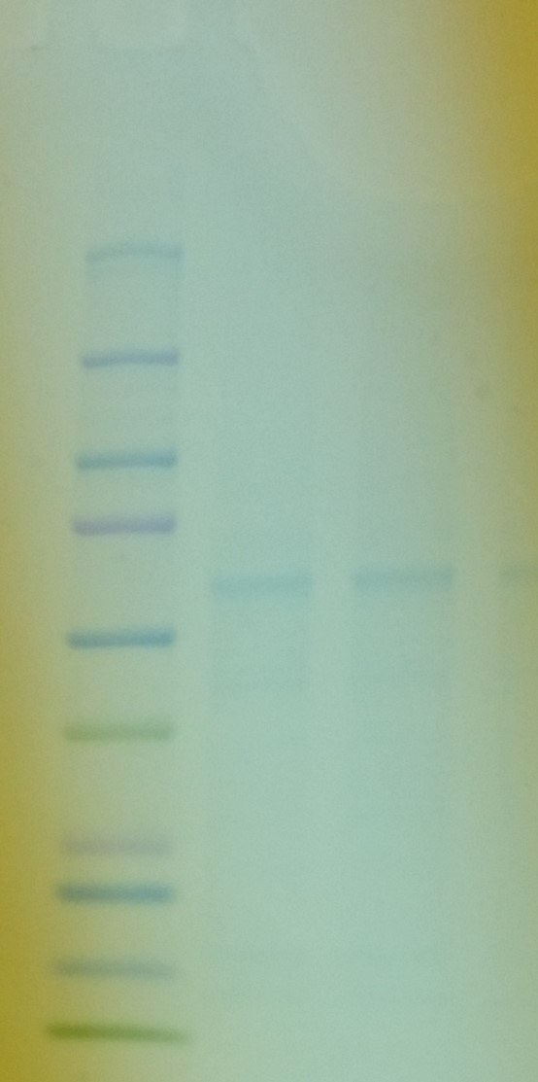

Fig.2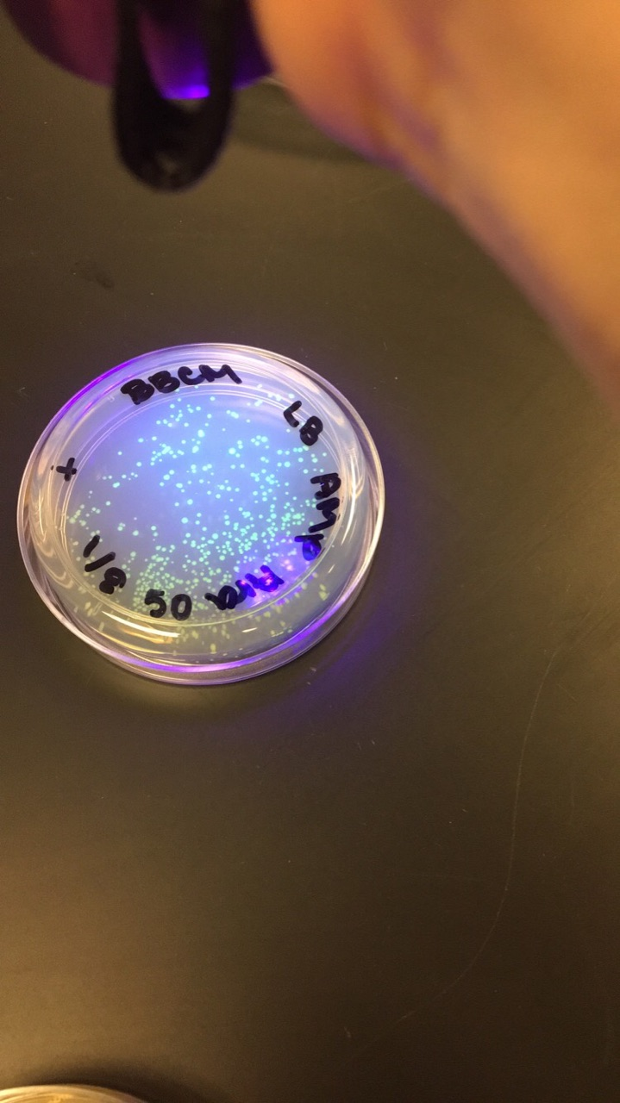

.

References
- Berg Jeremy, Tymoczko John, Gatto Gregory, Stryer Lubert. (2015) Biochemistry. New York, NY. Freeman Macmillan.

