Understanding Microbiology

Contents

  - What is Microbiology? . . . . . . . . . . . . . . . . . . . . . . . . . . . . . . . . . . . . . pg 1-4
  - Identifying Microorganisms. . . . . . . . . . . . . . . . . . . . . . . . . . . . . . . . pg 4-6
  - Medical Advances . . . . . . . .. . . . . . . . . . . . . . . . . . . . . . . . . . . . . . . . . . pg 6-7

Chapter 1

  - What is Microbiology?

Learning Objectives

- Explain what microbiology is
- Identify the 5 major groups of microorganisms
- Describe common illnesses introduced from microorganisms
- Understand the importance of identifying microorganisms

Introduction

Microbiology is the branch of science that studies microorganisms. Microorganisms (microbes) are microscopic organisms that can only be seen by the human eye through the use of a microscope. Microorganisms exist as either a bacterium, a virus, or a fungus that can both be harmful and essential to our bodies. How can it be both? The answer to that question cannot be summed up in one single sentence, but we will introduce the main points behind it as well as the importance of understanding microbiology.

Have you ever gone to see the Doctor because your throat was sore and puffy? The pain in your throat seems to progressively get worse throughout the day so you tell your mom who then later investigates your throat with a flashlight for the sign of any inflammation or presence of white dots. After looking at your throat, your mom then makes a phone call to the local clinic for an appointment that day. When you are finally seen by the doctor, he puts some gloves on and grabs a sterile Q-tip looking rod after he looks into your throat with his Otoscope. He then says “Say Ah” and swabs your throat for a few seconds in order to acquire enough sample onto the Q-tip. Although this is never a fun process when you are a little kid, it is also not an unbearable procedure either and it is essential to 100% accurately diagnose strep throat and other related illnesses. After the doctor swabs your throat you are either sent home or told to sit tight and wait for a bit until the results are in. But have you ever wondered where they send the samples off to and what is then done to determine the results?

Depending on the facility, many hospitals, urgent cares, and doctor’s offices have laboratories within the building where they run many different types of tests on blood samples, skin samples, throat swabs, etc., in order to diagnose an illness. A throat culture is usually done by mixing the suspected sample with a certain substance or chemical that is then placed on a media to observe colony growth of the bacteria. This can take 2-4 days to diagnose due to the incubation time that allows for growth of the bacteria. Some doctor’s offices have what is known as a “rapid strep test”, where results can be read within 10-20 minutes, and is what most offices use today.

Classification of Microorganisms

Microorganisms can be grouped into five different categories, bacteria, algae, fungi, protozoa, and viruses. As you learned in basic biology, there are two types of cells Prokaryotic cells and Eukaryotic cells. Prokaryotic cells have no internal membrane bound nucleus or other cellular structures. Eukaryotic cells do have a true membrane bound nucleus as well as membrane bound organelles. Protozoans, fungi, algae, animals, and plants are all Eukaryotes. Bacteria is the only group of microorganisms that are considered as Prokaryotes, and viruses are also differently grouped as they are considered acellular- without a cell.

Bacteria

Bacterium’s are unicellular prokaryotes that cause illness and disease. We can further classify the different groups of bacteria into three different groups (photosynthetic autotrophs, chemosynthetic autotrophs, and heterotrophs) based on how they obtain their energy. Organisms that use light energy from the sun to produce their own energy are called Photosynthetic autotrophs. These organisms synthesize sugars and other organic molecules from carbon dioxide. Chemosynthetic autotrophs obtain their energy by using a process known as chemosynthesis. Chemosynthesis produces carbohydrates (energy) from oxidation of inorganic materials such as sulfur or iron. Heterotrophs receive their energy by consuming autotrophic organisms that contain the necessary substances for survival. How a bacteria cell looks under a microscope is a very essential and initial characteristic that helps identify the type bacteria. Some bacteriums may appear as rods (bacilli), circular (coccus), spiral (spirillum), or as a curved rod (vibrio) when viewing under a scientific microscope. Another expression involved in the identification of bacteria is whether it is pathogenic, which simply means disease causing, or if it is nonpathogenic (harmless).

Algae

Algae are eukaryotic organisms that can be either unicellular or multicellular that obtain their energy from the sun (photosynthetic autotrophs). Algae are also both motile and non-motile organisms that can widely range in size; kelp is of the largest algae while there are also microscopic forms as well. Motile is an organisms ability to move. Algae are aquatic organisms that are very similar to the plants existing on land, only they lack some structures found within land plants such as stomata, xylem, phloem, phyllids, rhizoids, roots, and leaves. Algae can grow in either freshwater or marine water and are not known for causing disease in humans.

Fungi

Fungi are also eukaryotic organisms that can be either unicellular or multicellular but differ from algae in how they obtain their energy as they are heterotrophic creatures. The fungi group consists of yeasts, molds, and mushrooms that acquire food from absorbing molecules in exchange of secretion of enzymes into the environment. Fungi are important to the ecosystem and all aspects of life because they decompose dead, organic materials and recycle nutrients into the environment. They are non-motile organisms, however some spores have flagellum when traveling through the air or water. A spore is a product of sexual or asexual reproduction of many fungi, plants, algae, and protozoa. Some fungi are harmless and actually used as a food source, such as mushrooms, whereas other fungi’s are capable of causing disease. Mycosis is a fungal infection that can occur in animals as well as humans if fungal spores are inhaled or come into contact with the skin.

Protozoa

Protozoa are also eukaryotic organisms that can be either unicellular or multicellular, and just like fungi, they too are heterotrophic. Protozoa are found in the soil, freshwater, and marine water. Protozoa are very diverse in size and shape as well as the way they move and obtain energy- this is why they are classified into four distinct groups. Amoebas are aquatic organisms that can also live within the human body and if it reaches the intestine, will cause infection. Amoebas engulf their food via pseudopods, long extensions of the amoeba body that surrounds the food. Ciliates are another group of protozoa that are surrounded by many tiny hair-like protuberances called cilia, which allows for motility. Ciliates obtain their energy by capturing and consuming a food source at the mouth-like region of their body. The next group of protozoa are called flagellates. Flagellates usually have just one larger flagella on their bodies that is also used for motion, but in a whip like motion. Trypanosoma brucei is a type of flagellate that causes an illness in humans that is known as “Sleeping Sickness”. This disease is caused by tsetse flies in East Africa and can be life threatening. The last group of protozoa are the sporozoans. Sporozoans are different from the other groups because they are non-motile and live inside of a host as a parasite that will cause many diseases.

Viruses

Viruses are like the protozoa group sporozoans because they also act as a parasite through the means of a host body. Viruses are very small microorganisms, much smaller than bacteria! In fact, the size of a virus ranges from about 1/10 – 1/1000 nm in comparison to the bacteria cell. Viruses are so small that scientists did not actually conclude that they existed until the electron microscope was invented. Then the first virus known as the tobacco mosaic virus, was discovered by Ernst Ruska and Max Knoll in 1939. Viruses are also non-motile and very basic organisms that lack a nucleus, organelles, cell membrane, and cytoplasm. The structure of a virus consists simply of nucleic acid (DNA) within a protein covering.

1.2 Identifying Microorganisms

Learning Objectives

- Identify the safety procedures used in a microbiology setting
- Discuss the importance of the initial gram stain
- Describe the different tests used when first identifying a bacteria sample
- Compare a microbiology classroom to a medical laboratory

Introduction

There are many procedures involved in identifying the numerous different types of microorganisms. One of the very first steps in microorganism identification is obtaining an appropriate sample. Whether it be from a patient within a doctor’s facility, or a sample from another source such as soil, water, or ground, there are a few precautions and procedures that need to be followed accordingly.

Clinical Samples

If the sample comes from a patient, a nurse or doctor has acquired said sample through the use of sterile medical tools equipped with years of knowledge and practice. Tissue, blood, and urine are of the most common samples taken from health care providers. Usually when a patient feels ill, they describe their symptoms to their doctor and depending on the case, the doctor sometimes collects samples to accurately determine the diagnosis and/or the cause of illness. These samples are then brought to a specific laboratory where various tests are ran to access the verdict. Although these tests are not only used just to diagnose an illness, microbiology labs also aid in treatment of chronic diseases such as Cancer, HPV, AIDS, Meningitis, Smallpox, Leprosy, and many other infections.
Microbiology Samples

Some samples taken in within a microbiology classroom or a research facility also involve the use of sterile tools. For example, specimens can be obtained in nature, pond water, sink knobs, door handles, and even from your phone. It is a very common rule that everyone present within a microbiology lab wear appropriate safety gear. This includes gloves, lab coats, closed-toe shoes, and sometimes goggles. After the necessary attire has been addressed, samples are often obtained by using a sterile cotton swab for various reasons such as testing for a specific bacteria present within the soil that may discourage plant growth or simply to identify an unknown bacteria for an assignment.

Gram Stain

To identify a bacteria there are many set tests that are used. The most standard tests consists of gram staining, catalase, coagulase, oxidative fermentation, and bile solubility tests. The first and most important test that is preformed on an unknown bacteria is a gram stain. A gram stain is a method of identification that separates bacteria into two major groups (gram positive and gram negative). To preform the gram stain, a sample of bacteria is aseptically inoculated onto a clear microscope slide and then heat fixed onto the glass by slowing passing the slide through the top flame of a Bunsen burner. Once the slide is heat fixed, a few drops of crystal violet dye is placed onto the smear of bacteria cells for one minute before rinsing off with water. Next, a few drops of grams iodine is placed onto the slide for one minute as well before proceeding onto the decolonization step. To de-colorize the sample, place two or three drops of ethanol onto the slide and then immediately rinse off with water. The final step in the gram staining process is adding the counter stain, safranin. After the counter stain is washed off after one minute, the sample is ready to be viewed under a microscope. Gram positive bacteria will appear purple while gram negative bacteria absorbs the color pink. Once the gram stain, coagulase, and catalase test of the bacteria has been identified, usually a flowchart of bacterial tests is then used in order to further identify the specimen. Figure 1.1 is an image of a gram positive bacteria known as Staphylococcus aureus viewed under an electron light microscope at 100x. Figure 1.2 is the same Staphylococcus aureus sample plated onto a glass slide after being heat fixed and gram stained.

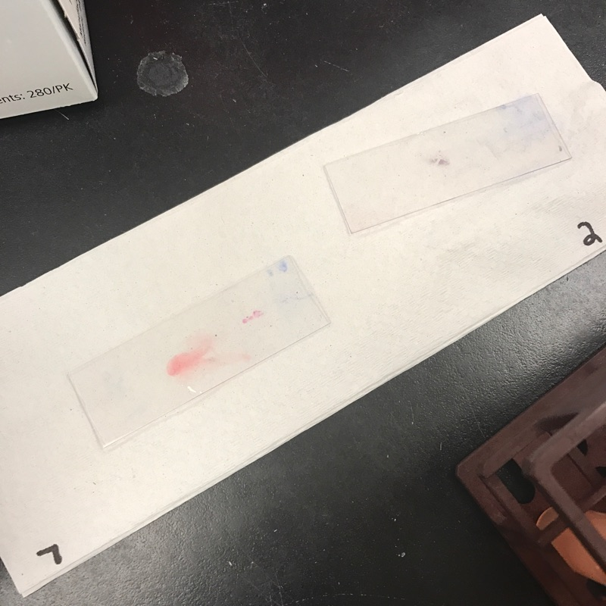
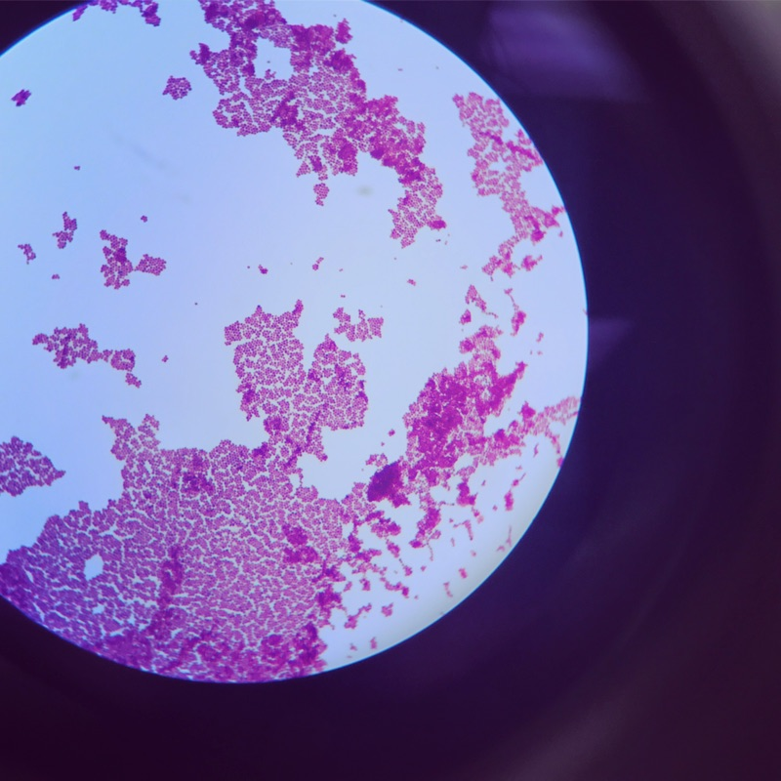

(Figure 1.1) (Figure 1.2)

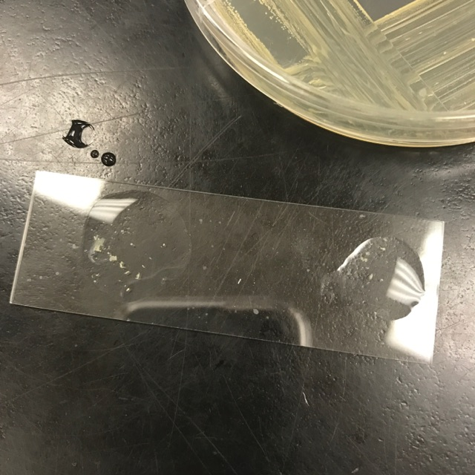
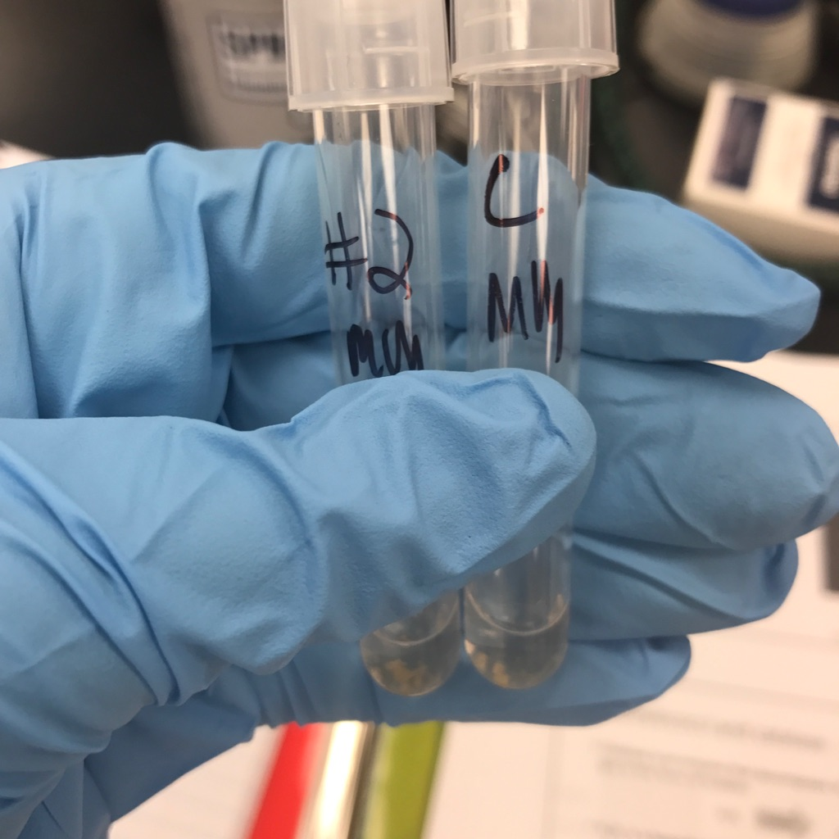

(Figure 1.3) (Figure 1.4)

When preforming any test it is a good idea to compare the unknown to a controlled sample when interpreting results. Figure 1.3 is a coagulase test preformed on a glass slide with a positive control on the right and an unknown sample on the left. Figure 1.4 is the same coagulase test but preformed in test tubes. Both the test tube and slide contain Rabbit plasma which will promote clumping of the bacteria sample indicating a positive result for coagulase.

  - Medical Advances

Learning Objectives

- Explain the importance of microbiology relating to medicine
- Describe the fields in which advances have been made

Introduction

There are so many incredible advances being made in the world of medicine. From flu vaccinations to genetic recombination, the field of microbiology has improved our way of life by discovering various cures for illness, methods in prevention, and has even made an impact on food preservation.

Genetic Recombination

Genetic recombination is the production of an offspring, whether it be a mammal or bacterial cell, that contains genetic information from both parents in mammals and is a product of asexual reproduction in bacteria cells. Genetic recombination usually occurs naturally, but has also been artificially produced by science for purposes involving in-vitro and vaccine development. In-vitro involves microorganisms or cells existing outside their natural environment. Many of these procedures involve temporary settings such as a test tubes or petri dishes in which the cells can be manipulated or transformed in order to achieve the desired results. In mammals, an in vitro procedure is usually done when sexual reproduction has been declared impossible to achieve naturally. Vaccines are another medical breakthrough made possible by microbiology. Vaccines are products of biological preparations that provides immunity against certain strains of bacteria that cause infection and disease by introducing the body to a similar and weaker form of a specific disease causing microorganism so that antibodies can recognize and prevent a future infection.

Food Technology

Microbiology involves much more than identifying and studying the tiny organisms that inhabit almost every inch of the planet, it can also be used to improve many Environmental, Agricultural, and Industrial systems. Genetically modified organisms (GMO’s) are one of the main reasons many parts of the world are not starving. GMO’s are organisms that have been genetically modified through engineering techniques in order to produce larger food items. Most every food product at any given grocery store has been genetically altered. Food preservation is another subtopic of genetically modified organisms that allows many items to be safely consumed. Without the knowledge of how to preserve foods, many people would become sick and food spoilage would be occurring at a much faster rate!

Sources:

"Strep Throat Test." Lab Tests Online: Empower Your Health. Understand Your Tests. A Public Resource on Clinical Laboratory Testing. N.p., n.d. Web. 14 Mar. 2017.

"Photosynthetic Autotroph." The Free Dictionary. Farlex, n.d. Web. 14 Mar. 2017.

"Heterotroph." Wikipedia. Wikimedia Foundation, 14 Feb. 2017. Web. 14 Mar. 2017.

"What Are Protozoa? - The Children's University of Manchester." Children's University Of Manchester. N.p., n.d. Web. 15 Mar. 2017.

“Genetic Recombination.” Wikipedia. Wikimedia Foundation, 15 Mar. 2017. Web. 15 Mar. 2017.”

All of the pictures I used (figures 1.1-1.4) were my own pictures from my microbiology lab courses, I also took a lot of material (notes from lectures, lab manual procedures, textbook information) from the introduction to Microbiology class I took at Oklahoma State University.

