Cellular Biology

Oklahoma State University
Peer Review Science Thesis
Dr. Wouter Hoff
Micr 4990

Cellular Biology

The human body is estimated to contain upwards of 30 to 40 trillion cells, with hundreds of different functions. These functionally different cell types collectively make up the 11 different organ systems thus creating the human body with its diverse cellular make up. Each and every cell in the body contains the same genetic information stored in DNA (Deoxynucleic Acid) and contains the exact same machinery used in reading DNA that codes for the thousands upon thousands of proteins synthesized in the various cell types. The fascinating thing about cells is how a cell knows which sections of DNA to code from? Since every cell in the body contains the information to be a brain cell, what told the cell to be a green-eyed cell versus a blue-eyed cell? Many process go into the formation of cells from DNA replication to RNA splicing. This chapter will discuss how a cell reads DNA and what the outcome of cellular replication is.
Nucleic Acids, discovered by Freidrich Miescher, have a 5’ phosphate group and a 3’ OH group, are the building blocks of DNA. The 3’OH group creates a Phosphodiester bond with the following 5’ phosphate group of the next nucleic acid creating a chain of DNA. Each chain is connected by hydrogen bonding to its correct base pair match. DNA is said to be the Genetic Material (Watson and Crick) that holds the key to heritability, or how genes are passed form parent to offspring. DNA is a double stranded helix that has anti-parallel properties. That means that one strand of the DNA helix is read in a 5’ to 3’ direction, and the other strand is read in the opposite 3’ to 5’ direction. DNA is made up of 4 repeating Nucleic Acids, or the building blocks of DNA, that are only able to bind to their correct base pair match. This gives DNA the basis of heritability meaning that one strand of DNA is able to code for the second strand.
Nucleic Acid | Type | Number of (H) bonds
Adenosine (A) | Purine | Double bonds to Tyrosine
Guanine (G) | Purine | Triple bonds to Cytosine
Tyrosine (T) | Pyrimidine | Double bonds to Adenosine
Cytosine (C) | Pyrimidine | Triple bonds to Guanine

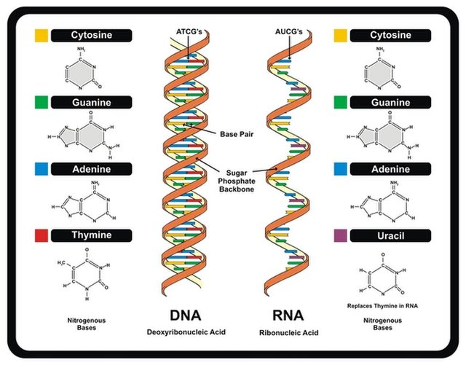- Figure 1.
Cells are able to replicate their DNA at many different locations along the stand of DNA at areas called Origins of Replication (ORI). Before a cell can Proliferate, or divide, it must first copy every single bit of DNA correctly to give to each daughter cell. If strict guidelines for cellular division are not met, the cell will stop cellular replication and die. Using one strand of DNA as the Template, DNA polymerase (Pol) synthesizes the newly formed coding strand. DNA Pol is covalently bonded to the template strand of DNA and continuously reads the nucleic acids 5’ to 3’ in what is called the Continuous Strand. In this direction, DNA Pol copies DNA continuously until replication is complete. The other strand is called the Lagging Strand and is read in chunks in the 3’ to 5’ direction. These sections of double stranded DNA are then bound together with the enzyme Ligase. So in the end of replication, each strand of DNA has a strand that was original, and one strand that is newly synthesized meaning DNA replication is Semiconservative. After Replication, a parent cell divides into two daughter cells each with the same DNA sequences.
Cells do not solely use DNA in cellular replication, that would be detrimental to human life. Instead, cells use DNA for synthesizing proteins like Insulin, Human Growth Hormone, and LH and FSH. The process of reading DNA to make proteins is a complex pathway with many sites of regulation.
The first step in protein production is Transcription. Transcription is the reading of DNA to form mRNA (messenger Ribonucleic Acid). RNA is structurally similar to DNA but it is typically single stranded, replaces Thymine with Uracil, and has both a 2’ and 3’ OH groups. During transcription, a section of ssDNA (single stranded DNA) is bound by RNA Pol. RNA Pol reads DNA 5’ to 3’ forming a strand of single stranded RNA with the exact same coding structure as DNA, except the Thymine is replaced with Uracil which still binds to Adenosine. RNA Pol will synthesize mRNA beginning at a promotor region until it reaches a termination sequence which instructs RNA Pol to destabilize and end transcription. This newly formed mRNA must undergo re-arrangements in order to move on to the next step.
A 5’ cap, poly A tail, and intron splicing is needed for a mature mRNA to leave the nucleolus of the cell. Not all DNA is used as a template for mRNA. Most of DNA are Introns, inhibiting or non-coding DNA. This is the so-called junk of the cell, but modern research may find that it plays a special role in protein production. Only Exons, or expressed DNA, are used for coding proteins. Introns vastly outnumber Exons and makes reading human genomes much more complicated. However, this is only a problem for eukaryotes because prokaryotes do not have them. RNA must undergo these post-transcriptional modifications to keep the strand of mRNA intact when leaving the nucleolus of the cell while being transported to the Endoplasmic Reticulum (ER) where it undergoes Translation. The ER is responsible for protein production and folding.
Translation is the process of reading mRNA and creating a protein which consist of Amino Acids (AA). There are 20 AA used in human cells that are the building blocks of proteins. Ribosomes are the translational machinery of the cell. They recognize the 5’ cap of mRNA, slide down the strand until a start codon of AUG is reached, then they begin translation. Each nucleic acid is read 3 basses at a time. Groups of 3 nucleic acids are called Codons and code for one of the twenty AA. There are a total of 64 codons, and each codon may code for more than one AA giving the code redundancy. Furthermore, the 3rd letter of the codon is the least specific and can be interchanged. This is the wobble effect. Each codon that codes for an AA has its own Transfer RNA (tRNA), that binds to the codon and carries its AA to the growing protein peptide. Since the codons have the Wobble Effect, it allows the cell to only need a smaller number of tRNA to bind specifically to their given codon instead of needing a full set of 64.
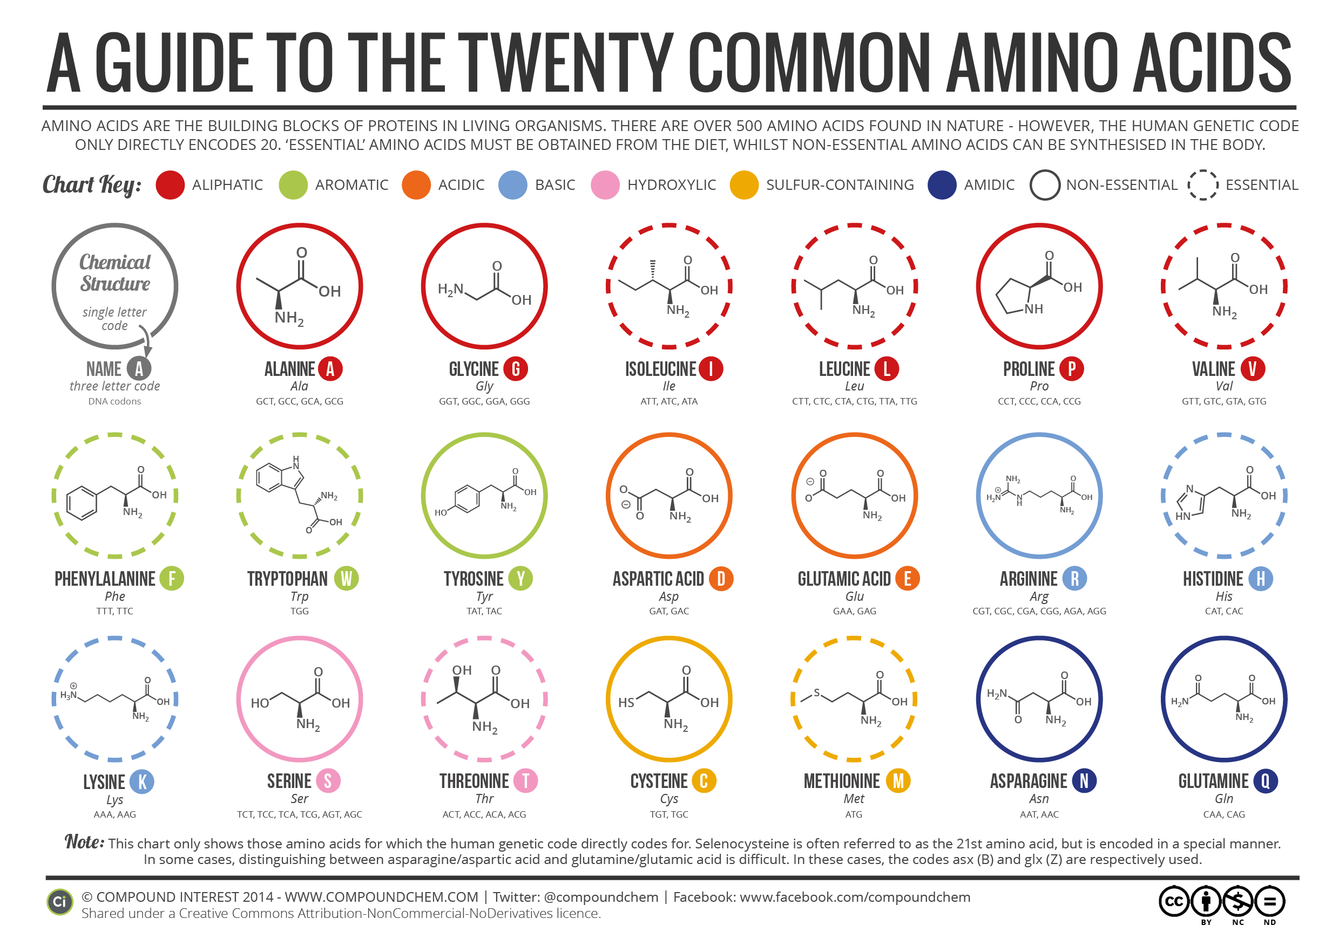
- Figure 2
Translation goes on until the ribosome reaches a stop codon where it is destabilized and falls off of the mRNA strand. Just like transcription and replication, translation occurs in the same 5’ to 3’ direction. Each AA is linked by an Amide bond made between the Carboxyl group of one AA bond to the Amine of the next AA. The structural back bone of a protein is a repeating sequence of N-C-C-N-C-C. The difference between AA is their side chains. Side chains can be polar charged, non-polar charged, negatively charged, or positively charged. As the growing peptide chain is secreted from the ribosome complex, the chain folds into a globular complex with a hydrophobic, or water hating, core that consists of non-polar AAs. Amino Acids that have a charge to them form hydrophilic, or water loving, surfaces of proteins. This is due to the Hydrophobic Effect meaning that non-polar molecules do not favorably bond to H20 due to the loss of hydrogen bonding. Once a folded protein is expressed, it is then utilized within the cell, or is packaged in the Golgi Apparatus where it can be excreted by the cell into the Extracellular Fluid, fluid outside of the cell, and is sent elsewhere in the body where it is needed.
Example of a protein -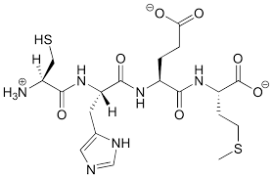

Now that we have covered the process of Protein expression, what controls which proteins a given cell produces? This answer is highly complex and is a highlight of modern research. Several processes must be taken into account to explain this phenomenon. One major factor is the packaging of DNA. Within each cell, there is roughly 1.5 meters of DNA packed into a space that is less than 2 nanometers, that is .0000000001 meters. This is accomplished by tightly wrapping DNA around Histones, positively charged proteins, forming nucleosomes. DNA that is so tightly wrapped around these histones that cannot be read by RNA Pol is referred to as Heterochromatin. Heterochromatin is used to isolate DNA genes that the cell is not expressing. The cell contains certain proteins that work to remodel chromatin in order to access genes that were being inhibited.
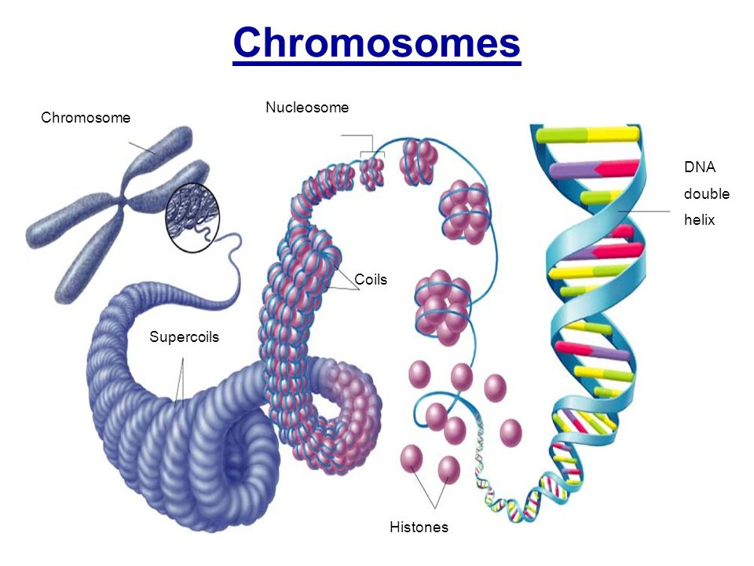
Figure 3.
Simply explained, chromatin remodeling complexes regulate each cell and how each cell type is specialized. This is how a cell “knows” to be a skin cell versus a cardiac cell. Even though each cell contains the exact same cellular information, it only has access to a limited number of nucleotides. If the cell cannot access a certain strand of DNA, then the strand cannot undergo transcription, translation, and therefore the cell cannot produce proteins that the cell does not need.
Each process within the cell is highly regulated at multiple points by a multitude of enzymes and other proteins. For instance, DNA pol must be accompanied by several other co-factors in order to read DNA. There are many mechanisms left out of this chapter in order to simplify a very complex subject.

Sources

Hoff, Wouter. Protein production. Lecture 2018.
Morgenstein, Randy. Cellular replication Machinery. Lecture 2017
Yossef, Noha. Cell Structure. Lecture 2016
- Retreived from https://img.purch.com/w/640/aHR0cDovL3d3dy5saXZlc2NpZW5jZS5jb20vaW1hZ2VzL2kvMDAwLzA1My81ODcvaTAyL2RuYS1ybmEtc3RydWN0dXJlLmpwZz8xMzcwNTQ5MjI1. February 28th, 2018.
- Chromosome. Retrieved from https://pmgbiology.files.wordpress.com/2015/10/00-eukaryotic-chromosomes.jpg. February 28th 2018.
- 20 Common Amino Acids. Retrieved from http://www.compoundchem.com/wp-content/uploads/2014/09/20-Common-Amino-Acids-v3.png. February 28^{th,} 2018

