Chapter 3
Cardiovascular System

In this chapter we will be discussing blood, and its functions. The first section will focus on blood flow. The second section will be about hemoglobin we will be discussing what it does and what it is made up of, as well as what the blood carries and what it can tell us. The last section will be about what happens when there is something wrong with the blood and what that looks like.

Section 1: Blood Flow and the Heart
Blood is a vital part of living. It carries oxygen to the rest of the body. Now how does it do this? Well for this explanation we will start at the heart. You have a muscle in your body about the size of your closed fist just off center of the middle of your chest. This is your heart and it is the hardest working organ in your body. The heart starts beating while you are still inside the womb and it doesn’t stop until the day you die.
The heart is comprised of four main chambers. There are two atriums on the top half of the heart and on the bottom half there are two ventricles. Let’s start with the left atrium. The left atrium receives blood from the pulmonary veins. When the heart beats its chambers contract causing the blood to be moved. When the left atrium contracts it squeezes blood through a valve called the mitral valve. A valve keeps the blood from back flowing once the heart relaxes after a contraction. Once it passes through the mitral valve the blood is in the left ventricle. The left ventricle is strongest chamber in the heart. This is because the left ventricle is the main driving force behind blood flow. When it contracts it shoots blood out of the heart into aorta through aortic valve. The blood then follows the cardio vascular system and goes all throughout the body. Once it has been everywhere it can go the blood flows into the superior/inferior vena cava, depending on if the blood is returning from above or below the heart. Once it returns it flows from the vena cava and into the right atrium. The right atrium will then contract and blood will flow into the right ventricle through the tricuspid valve. Once it is in the right ventricle the heart will contract again and the blood will flow through the pulmonary valve and into the pulmonary arteries. These arteries will carry the blood to the lungs where it will be oxygenated and then it will return through the pulmonary veins and into the right atrium and the whole process will start all over again.

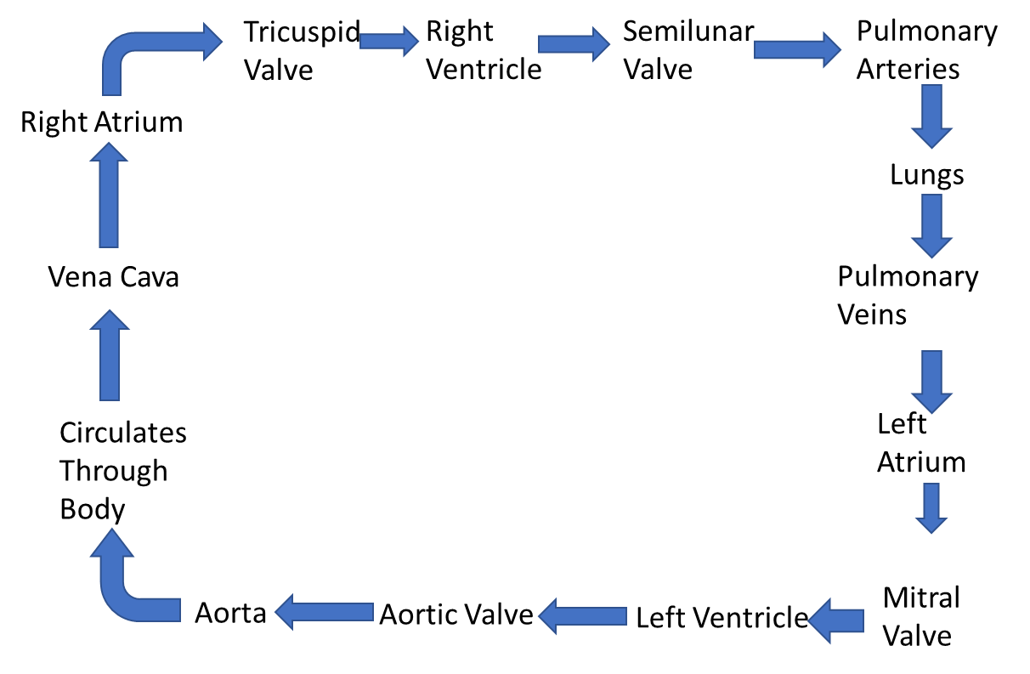
Figure 1.

Section 2: What does the blood do?
So what does the blood do? If you have been to the drive thru at the bank and used the vacuum tubes then think of that. It is a closed system using a fluid (air is a gas but it has fluidic properties) to transport material. The blood carries oxygen through the blood stream and picks it up from the lungs as outlined in the previous section. The question is how does it do this? The answer is hemoglobin. Hemoglobin is present in the blood. Specifically it is present on the red blood cells. These are the cells that make the blood red and they are the red blood cells. Red blood cells have hemoglobin present in them which is a protein and it is made up of four subunits known as heme groups that each hold an iron molecule. They carry O2 and release it when there is excess CO2 detected (1). The Blood also carries water and nutrients.
Another thing that the blood carries is white blood cells. These provide the body with an immune response. When there is an infection present in the body the white cells are sent to the site of the infection. Once there they will begin to perform phagocytosis, where they essentially eat the organism causing the infection.
There are also platelets in the blood stream. The blood also carries platelets in it. These help with clotting.
There is protein in the blood as well. This protein is called albumin and it keeps the things in the blood that don’t need to be filtered out from being filtered. This filtration happens in the kidneys.
The blood also carries enzymes and hormones as well. The enzymes are present in blood and can always be accessed by the cells that need them. The hormones are produced in the endocrine system and then they are sent to the cells that need them.
The blood also carries waste. The waste comes from cellular metabolism. So whenever there is a reaction in the cells the waste is removed to the kidneys.

Substances | Moved From | Moved To
All Cells
Oxygen | Lungs | All cells
Nutrients and Water | Interstitial tract | All cells
Cell to Cell
Immune Cells, Clotting Factors, Proteins, and Enzymes | Present in Blood Continuously | Available to cells that need them
Hormones | Endocrine Cells | Target Cells
Leaving body
Waste | All cells | The Kidneys
Carbon dioxide | All cells | The Lungs
Table 1.

Sections 3: What Blood Can Tell Us.
A doctor can tell a lot about a person based on what they can see in a good blood draw. What happens when things in your blood become too concentrated or to low? Well it depends on what in the blood is out of sorts. Many things can happen when levels in the blood get out of control. It can range from needing to have more iron in your diet to having a bleed somewhere in your body to having cancer.
Let us use white blood cells as an example. If a doctor takes a blood sample and it comes back as having a high white blood cell count then it is safe to assume that there is some kind of infection going on in the body. If the white cells are low this can indicate that there is an infection in the bone marrow or a cancer that effects it.
Another thing that your blood can tell you is if there is a high amount of troponin in your blood then there is a high chance that your heart has suffered damage. When a person has a heart attack the cells in the heart suffer damage due to lack of oxygen from vessels being blocked. Once the event is over the damaged cells release the enzyme troponin. So this is an example of heart disease and there are other types.

Section 4: Heart Disease
There are a number of things that can go wrong with the heart itself if proper diet and exercise are not observed. One such thing is hypertension or high blood pressure. This can lead to a number of health complications and can arise from a lack of exercise and poor dietary choices. The valves of the heart can also become a problem due to a buildup of calcium on them causing them to become stenotic (stiff, and rigid) which will cause the valves to close incorrectly resulting in regurgitation or a back flow of blood. The arteries that feed the heart can also become diseased. Coronary Artery Disease or CAD is caused by plaque buildup in the coronary artery walls, which will eventually clot off and cause a heart attack. CAD is usually caused by uncontrolled high cholesterol in the blood. Another form of heart disease is congestive heart failure or CHF. This is caused either by old age or other problems like hypertension, Coronary Artery Disease, or problems with the heart valves. CHF will cause buildup of fluid in the body as the heart cannot effectively move blood throughout the body. Most of these heart diseases can be prevented or the chances of getting them can be lessened if proper diet and exercise is followed.

Disease | Cause(s) | Consequence | Treatment
Hypertension | Old age, Smoking, Genetics, Obesity, High Salt Diet, and Stress. | Increased risk for Heart Attack, Stroke, Aneurism, Stroke, and Death. | Can be treated through use of a treadmill, and proper diet as well a some drugs.
CAD | Plaque buildup in arteries due to diet or genetics. | Very high risk for Heart Attack and Death. | Can be treated with drugs or if required surgical intervention.
CHF | Can be caused by a history of other heart issues as well as drug and alcohol abuse. | Body will retain fluid and this can cause shortness of breath and edema. | No cure is available but diet and exercise along with proper medical management can help the person live with the disease.
Valve Regurgitation | Buildup of calcium on the Aortic, Mitral, Tricuspid, or Pulmonary Valve | Backflow of blood into heart and a decreased cardiac output resulting in weakening of the body. | Valve replacements are the only widely available treatment that has been proven to be effective.

References:
- “G-H.” Mosby's Dictionary of Medicine, Nursing & Health Professions, 7th ed., Mosby Elsevier, 2006, pp. 865–869.
Text book used for reference
- Silverthorn, Dee A. Human Physiology an Integrated Approach. 5th ed., Pearson Education, Inc, 2010.

