Genetics
Abstract
Starting from a young age, children’s ears are constantly filled with the information of how unique and individualistic they truly are. This motivational phrase that teachers and parents turn to when raising their children is extremely analogous to the molecular life sciences world as each organism is truly created extremely different from another. Although similarities may resonate in organ makeup and function, the genetics of each human being is infinitely different. Each human is a unique individual because of his or her genetic makeup. The variation of each organism is controlled by its genotype (genetic makeup) and phenotype (physical characterization. These terms will be further defined later in this chapter to explain their associated characteristics. This textbook chapter will examine an overview of genetics, its history, components of the science, and the process of passing on genes to one’s offspring.

What is Genetics?
Genetics is simply put the study of heredity. This scientific analysis evaluates the passage of traits from parents to offspring and the processes that this encompasses. Each of these traits is connected to a specific gene that is held within a chromosome. A gene is the unit that serves as the basic element in genetics. For example, a single gene controls the trait of hair color, determining whether a human will have brown hair versus blonde hair. In retrospect, on a more severe note, specific genes are also connected to diseases or disorders, such as Down Syndrome.
As complex as this makes genetics sound, all of this information regarding genes is held solely in the chromosomes in the nuclei of an organism’s cells. A normal functioning human has a total of forty-six chromosomes, which is also known as twenty-three pairs of chromosomes. The twenty-third pair of these chromosomes holds the position of the sex chromosome. Even though the body only totals twenty-three chromosome base pairs, there are an astounding number of approximately twenty to twenty-five thousand genes that the average human holds as part of their genetic makeup. The genes that lie within these chromosomes are made up of the bases: adenine, thymine, cytosine, and guanine. The nucleotide bases join to form base pairs in the pattern of adenine to thymine and cytosine to guanine. These different combinations of the base pairs are what will create the many differences in DNA sequencing across all aspects of life.
The physical appearance of the organism which can differ greatly and may be viewed is termed an individual’s phenotype. This phenotype includes traits such as height, eye color, hair color, etc. As much as an organism’s genes are contributing to their physical appearance, they are also making up the consistency of the individual’s genetic strand. An individual’s genetic makeup is termed their genotype. This expressed trait may be either combinations of dominant or recessive genes. There are three possibilities of arrangements including heterozygous dominant or homozygous dominant (where the dominant trait will be expressed) or homozygous recessive (where the recessive trait will be the visible unit). The term heterozygous is defined as the individual holding different forms of a gene, while homozygous means that the organism holds identical alleles, or units of the gene.
To reveal the probability of an organism to express the dominant or recessive and homozygous or heterozygous gene, a Punnett square may be utilized. A Punnett square is utilized to demonstrate the possibilities of how genes may be paired in an offspring of two parents and which trait will be expressed in turn. Some examples of dominant traits include: brown eyes, dark hair, widow’s peak, curly hair, and clubbed thumbs. Some recessive traits countering these include blue eyes, normal hairline, balding, red or straight hair, etc. In correlation with dominant and recessive traits, there is a much higher likelihood of approximately seventy-five percent that an individual will express a dominant over a recessive trait.

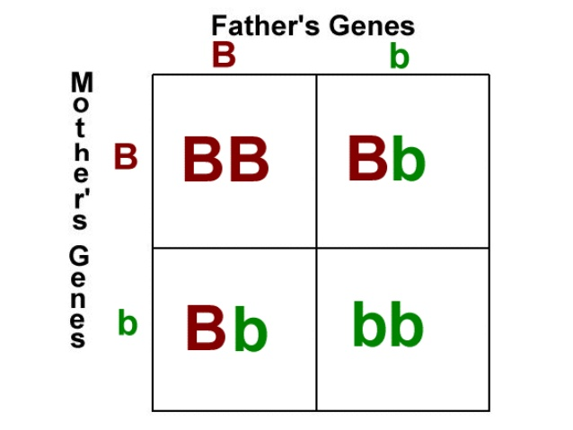
Figure 1.1 An example of a Punnett square to demonstrate the possibilities of gene combinations between two heterozygous parents.

History of Genetics
Gregor Mendel is known to be the father of genetics for his contributions and discoveries within the field. A specific instance that earned him this title in 1865 was his work with pea plants as he recognized the parent plants were passing on traits to their offspring. This term is referred to as plant hybridization. The way plant hybridization aided his findings was the ability for him to follow traits throughout his pea plants as he continued to breed them to one another. Many sub-versions of genetics are termed Mendelian to credit him for his findings. This establishment of the passing down of genetic traits from parents to offspring was only the beginning of genetic findings.
Although Mendel is credited with the title of “father of genetics,” selection and variability were actually discovered in research by Charles Darwin and Alfred Russel Wallace a few years prior, otherwise known as natural selection. Therefore, Mendel’s contribution to the scientific field should not be termed as the discovery of genetics but as the unearthing of traits linked to specific genes. This discovery was the first fundamental technique of isolating these genes.
Some other significant contributions to the field of genetics are as follows. During the early 1900’s, genes began to be linked to traits as well as become identified as sex-linked genes. Another defining moment during the 1950’s occurred when Watson and Crick identified the DNA structure as being constructed of an antiparallel double helix, which consisted of two strands of DNA. This structure that Watson and Crick discovered nearly seventy years still holds accurate today. Shortly following, the processes of transcription, translation and replication are established as holding an important role in the study of hereditary. Most recently, genetic researchers have found ways to isolate genes and implement mutations to alter the genes manually.

Body’s Role in Genetics
So far, it has been established that the gene is held within chromosomes in the nuclei. Each gene is linked to specific traits that contribute to an organism’s phenotypic or genotypic makeup. However, it has not yet been discussed how these genes are replicated, transcribed, and translated. There are three major steps that are involved in the process of producing proteins from genes. The DNA is comprised of many specific components including sugar, phosphate and base nucleotide groups.
DNA replication is the process where the hydrogen bonds break to excise the DNA into two separate single strands to allow primers and enzymes to prepare the genetic sequences for future steps. Once the DNA strand has been completely “unzippered,” complementary nucleotide base pairs will bind to the appropriate base pair to allow two new strands to be formed, hence the phrase DNA replication. The enzyme that is promoting this process is DNA Polymerase. This process most optimally functions at a temperature of seventy-two degrees Celsius to make these additions and replications. In summary, this step in the process is creating an additional copy of DNA to be utilized in the transcription and translation phases (DNA to DNA). This process is provided energy by the molecule ATP (adenosine 5’ triphosphate).
The next phase of this process is the process of transcribing DNA into mRNA. Transcription is the process of changing the DNA strands into RNA in preparation for translation into the final desired protein. Some compositional differences that are present between RNA and DNA is that RNA possesses a base pair of uracil instead of thymine, which is single stranded instead of double stranded, and ribose sugar instead of deoxyribose sugar, and holds a 2’-hydroxyl group. Using the DNA strand, an enzyme called RNA polymerase will act to allow complementary mRNA strand to be formed in accordance with the already replicated DNA strand. Once this mRNA template strand has moved away from the nucleus into the cytoplasm, translation will begin of making a mRNA strand into a protein. Translation is the transition of a mRNA strand to complete protein synthesis.

Genetic Mutations
While genetics has been around for a significantly long period of time, there are still errors that are bound to occur due to the extensive process that each gene must endure. A gene mutation is an alteration to the genetic DNA sequence that occurs in one specific place. Although this small change is very centrally located, it will in turn affect the entire DNA sequence, expression, and translation of RNA to create more proteins. Many different kinds of mutations are capable of occurring.
Some of these mutations include missense, nonsense, deletions, and frameshift mutations. A nonsense mutation is a mutation that only is altering or affecting one base pair in the genetic sequence. This mutation’s role is to prevent the DNA sequence from continuing the translation of the protein. A missense mutation also occurs specifically on one base pair that switches out amino acids in the final protein but does not prevent protein formation such as nonsense mutations do. A deletion is as simple as it sounds where a portion of the DNA strand is removed. This mutation may range in size from a small to large fragment. The last mutation mentioned in this chapter is a frameshift mutation which is the alteration of how the sequence is being read by addition or deletion. Despite these four mutations demonstrating very different techniques to altering the DNA sequence, most will resonate the same in altering the way the protein functions (if it does at all). Although each mutation will hold an impact on the reading of the DNA sequence, detrimental effects may be avoided if it is indicated as a recessive mutation by being camouflaged by a more dominant gene that is additionally present.

Careers in Genetics
Although when one thinks of genetics, they may immediately think of a doctor or lab researcher; there are ample number of job opportunities available in this field. This significant job demand is due to the large amount of discoveries in the field and ever-growing need for personnel with a heart for the study of genetics. Some of these specific careers include but are not limited to: biotechnology sales and marketing, science teachers or writers, bioethicist lawyer, consultants, etc. The career opportunities are endless and are analogous to the vastly increasing list of possibilities that lie within the world of genetics such as cloning and mutations by Clustered Regularly Interspaced Short Palindromic Repeats (CRISPR). These careers are of extreme importance to moving closer towards a goal of solving the unwanted mutations that are indicated above.

References
https://www.ashg.org/education/career_flowchart.shtml
https://ghr.nlm.nih.gov/primer/mutationsanddisorders/possiblemutations
http://www.blinn.edu/socialscience/ldthomas/feldman/handouts/0203hand.htm
Mandal, A. (2013). “What is Genetics.” News Medical Life Sciences. https://www.news-medical.net/life-sciences/What-is-Genetics.aspx
McClean, P. (2011). A History of Genetics and Genomics. https://www.ndsu.edu/pubweb/~mcclean/plsc411/History-of-Genetics-and-Genomics-narrative-and-overheads.pdf

