DNA Repair and Skin Cancer
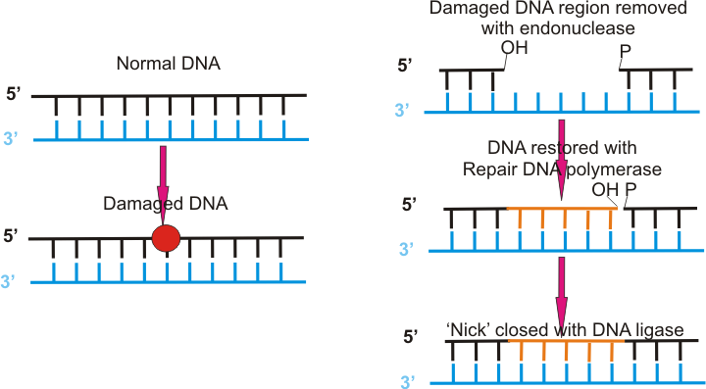
From the moment humans are conceived to the moment they take their last breath, the DNA that courses through their body is responsible for creating and recreating the exact same DNA sequences used to create them. But sometimes mistakes are made because of external or internal factors that are completely unexpected or there may be some indication of an error in the genes the person’s family may carry. A great example of an external factor that causes errors to be made in DNA replication is sunlight. It’s no secret that the sun radiates UV rays of light that are damaging to the skin if not protected properly. Sunscreen reduces the dangers of UV rays penetrating the skin too much and causing skin cancer. Meredith Hamilton is an OSU professor who focuses her studies on repetitive DNA sequences and many other topics. Because of her knowledge on DNA sequencing, she provided the information used in this article. This article will talk about how DNA repair and skin cancer are linked and how each go with one another.
DNA repair is the mechanism in the body that goes through each strand of DNA and checks for “altered nucleotide sequences, structural alterations; distortions, nicks, and pairing within a strand” (Hamilton 2018). Nucleotide sequences are the sequences that code for specific enzymes, proteins, etc., if the sequence is altered the incorrect product will be made causing errors in replication. The shape of proteins has a lot to do with its function, so if the structure is altered or changed in any way, the function of the proteins won’t be carried out properly. It works as a damage control to ensure that the DNA being replicated is correct and prevent any errors from coming up as the DNA moves on through the body. DNA replication is the process of copying a single strand of DNA in order to come out with two of the exact same strands, if anything is wrong when the DNA is being replicated, that mistake is going to be repeated over and over again and could end up being very dangerous to the affected person.
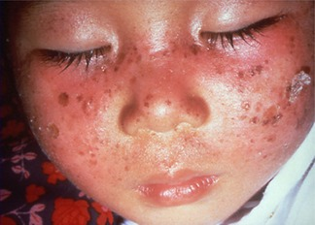
There are three different types of DNA replication, photoreactivation, excision repair, and mismatch. Photoreactivation is something that humans are incapable of, but fungi and bacteria use this method of DNA replication by using the sun light they absorb to repair their DNA. There are two types of excision repair, nucleotide excision and base excision, the only difference between the two is the number of bases each can repair at a time. Nucleotide excision can repair up to 30 damaged bases at a time while base excision can only repair 5 or less at a time. Mismatch repair detects incorrectly paired bases and replaces the incorrect base with the correct base in a single strand of DNA. One in 5 Americans will develop skin cancer by the age of 70 and these children with this disorder have tenfold the risk of developing skin cancer because of the failed enzyme they were born with.
Specific enzymes are responsible for repairing the damage created by the sun on the skin. In those with Xeroderma Pigmentosum (XP), “sun exposure causes cancer legions, blisters, and an increased risk for skin cancer tenfold” (Hamilton 2018). Children are most commonly affected by this as this is something a person is born with. There is no cure for this because these children with XP do not have the correct enzyme to repair sun damage, meaning that the child is unable to be out in the sun for any amount of time without having a reaction to it (such as blisters or freckles). DNA repair is what these children need in order to be able to be in the sun and not have a reaction to the UV rays. This genetic disorder is due to mutations on genes that are involved in DNA repair, making finding a cure for this extremely difficult.

