DNA and DNA Replication
By Jacob Beckham
What is DNA?
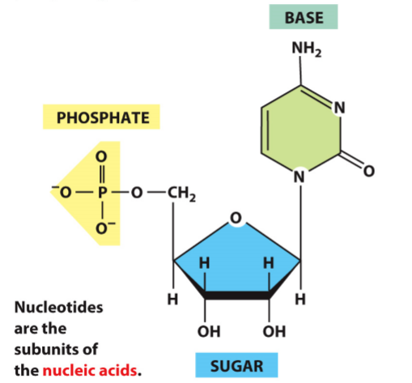
DNA, short for Deoxyribonucleic Acid, is the building block of all life on Earth. It is the material that encodes how everything, from unicellular life forms, all the way to the complex multicellular organisms will function as well as dictating their health and behavioral patterns. It is important to understand what the building block of life is made of in order to understand its importance in life. DNA is comprised of one, of any number of four, nucleic acids, a deoxyribose sugar backbone, and a phosphate bound to the deoxyribose (Figure 1). The four Nucleic Acids that make up DNA are Adenine, Guanine, Cytosine, and Thymine (Figure 2). Adenine and Guanine are considered Purine bases while Cytosine and Thymine are called Pyrimidines, with the major differences between the two is the purines have an extra pentane ring while the pyrimidines are a single hexane ring. The nucleic acids are arranged in a specific order along the DNA in groups of three called Codons, that encode for genes that are then translated into proteins and enzymes. These nucleic acid sequences are the basis of all DNA and protein production.
Figure 1: Structure of a nucleotide. Prade (2017)

DNA Structure Chemistry
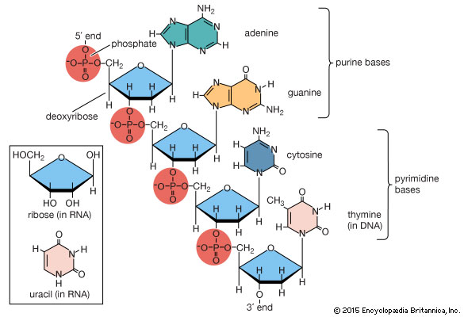
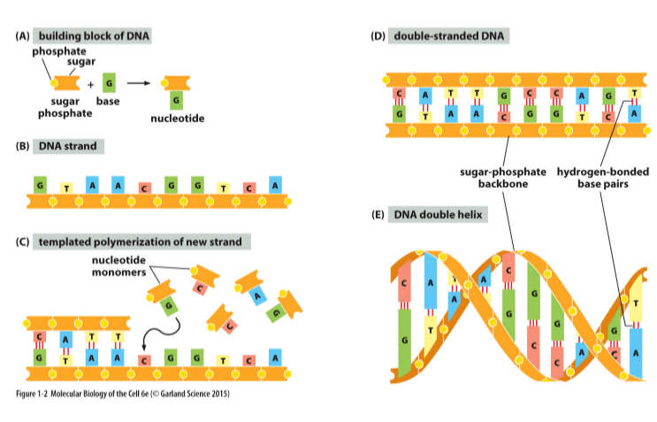
Nucleic Acids are bound to a sugar molecule called deoxyribose which acts as a backbone molecule that stabilizes and holds the nucleic acid in place. Also bonded to the deoxyribose is a phosphate (PO₃⁻²) that gives the DNA molecule a negative charge, this aids in the storage of DNA in the nucleus. Once the nucleic acid, deoxyribose, and phosphate bind to each other the resulting molecule becomes known as a Nucleotide. Individual nucleotides are bound together via phosphodiester bond between the deoxyribose and the phosphate of a nucleotide. Each strand of DNA has a 5’ (read as five prime) and 3’ end to them. The 5’ denotes that the strand ends on the fifth carbon on the last deoxyribose in on the strand, while the 3’ denotes that the strand is beginning on the third carbon of the first deoxyribose on that strand. DNA is also double stranded, meaning that there is another strand that binds the nucleotides together; however, the nucleotides bind in a certain pattern, adenine binds to thymine and guanine binds to cytosine. This means that the strands are complementary to each other, and that DNA always comes in a double stranded form. The complementary nucleotides are bound together by hydrogen bonds, with the guanine/cytosine pair having three bonds and the adenine/thymine pair having 2, meaning the guanine/cytosine pairing has a stronger bond together and is harder to separate than the adenine/thymine pairing. In its natural state, DNA remains a double helix structure that is held in place by hydrogen bonds between the deoxyribose molecules on each strand. These strands run Antiparallel, meaning they run in opposite directions (5’ to 3’ on one strand and 3’ to 5’ on the other), as seen in Figure 3 and allows the DNA to be replicated on either strand.
Figure 2: Chemical structure of a segment of DNA. Britannica (2015)
Figure 3: Components of a DNA molecule and its structure. Prade (2017)

DNA Replication
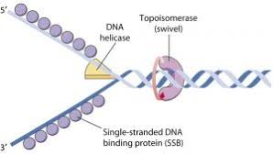
With the basic structure and chemistry of DNA explained, it’s time to ask how DNA is replicated and how many steps are in the process. Before the process, it is important to note that DNA is Semiconservative, meaning that the double helix is unwound and both strands are used as template strands to synthesize new strands of DNA, this results in one double helix replicating into two identical double helixes. In order to begin replication, an Origin of Replication (ORI) is required, this is a site that contains a promoter code that instructs the cellular machinery to begin the replication process at a specific location on the DNA. Eukaryotic DNA possesses many ORI’s in which each one can be active at any given time. There are also Repressor and Enhancer sites that repress the activation of the replication or enhance it, respectively. The next step is the cellular component Helicase. Helicase is a protein structure that breaks the hydrogen bonds between the complementary nucleotides and separates the double helix; additionally, a protein complex called Topoisomerase is binds upstream (in front) of the helicase in order to ease the supercoiling that occurs as the double helix unwinds (Figure 4). The next thing needed is DNA Synthase, DNA synthase comes in and creates an RNA primer on both strands, this allows the DNA polymerase to bind to the DNA. This is done because eukaryotic DNA requires an already present sequence in order to begin replication, this makes the RNA primer a starting platform for the polymerase. After the polymerase begins a protein known as Exonuclease comes in and cleaves the RNA primer out so that the polymerase can synthesize DNA into the strand.
Figure 4: Helicase and Topoisomerase unwinding a DNA molecule. Golifescience.com (2019)
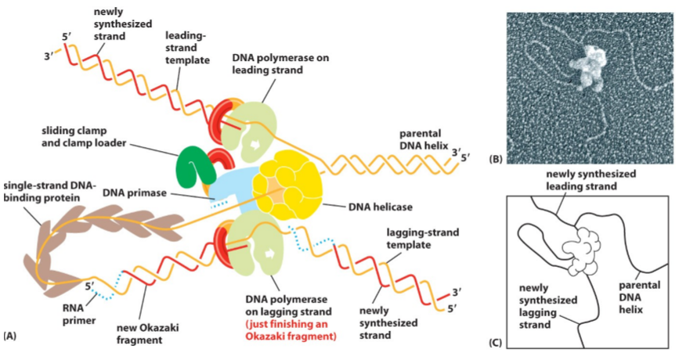
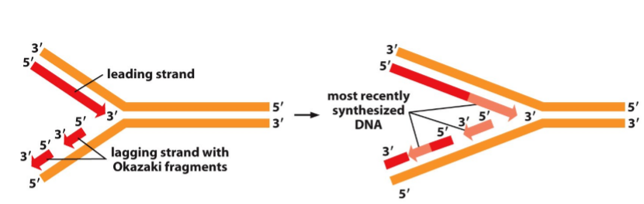
One of the most complex protein complexes involved in DNA replication is DNA Polymerase. This complex binds to the two strands of DNA and begins synthesizing new complementary nucleotides beginning at the 5’ end and finishing at the 3’ end. However, the two strands are not synthesized the same way, there is a Leading Strand and a Lagging Strand, with each strand getting its own polymerase. The leading strand is synthesized 5’ to 3’ and in a continuous fashion; however, since DNA is antiparallel the lagging strand is in a 3’ to 5’ orientation, this is rectified by Single Stranded Binding Proteins (SSB’s) and a Clamp that hold, stabilize, and loop the lagging strand around so the polymerase can synthesize it 5’ to 3’. Albeit, this looping is also not done continuously, the looping causes the polymerase to stagger the synthesis in smaller pieces. This is done by DNA synthase creating an RNA primer on the lagging strand, then the polymerase synthesizes the looped portion of the strand, next the polymerase terminates, and finally exonuclease cleaves out the primer so the next round of polymerization can fill in the space. This results in fragments of DNA called Okazaki Fragments (Figure 5, Figure 6). The fragmentation in synthesis leaves a small gap between the Okazaki fragments that if not joined could cause breaks in the DNA molecule. The gaps are joined together by a protein called Ligase.
Figure 5 (Above): Leading and Lagging strands with Okazaki Fragments. Burnap (2019)
Figure 6 (Below): Image of DNA replication with Lagging/Leading Strands and various molecular machinery. Burnap (2019)
Proofreading
DNA replication is a rapid process, about 50 base pairs per second, and while the rate of error for a DNA polymerase is 1 in 10⁵, mistakes still occur. When Mismatched Base Pairing occurs there are two ways for the polymerase to correct itself, one is immediately after the polymerase creates the error, wherein the polymerase reverses, excises the incorrect base with help from the exonuclease, synthesizes the correct base, and then continues (Figure 7). If the polymerase does not correct itself then a set of mismatch repair proteins MutS and MutL activate, nicks the strand upstream and downstream of error, excises the short sequence with the mismatch, and then polymerase returns to synthesize the gap. Even with different pathways of proofreading errors still occur during replication, if they are not caught the mismatch pairs may be expressed as mutations that can affect the cell and organism as a whole.
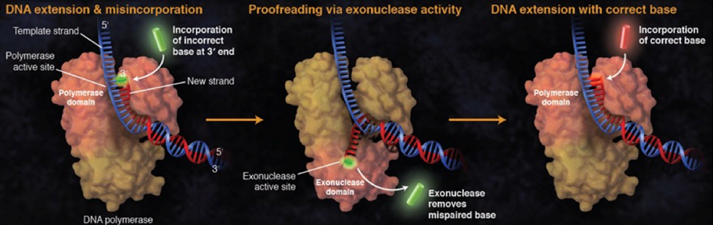
Figure 7: DNA polymerase proofreading and excising a mismatch pair via exonuclease activity. Prade (2017)

References
Burnap, Robert. DNA Replication and Repair. Lecture 2018.
Prade, Rolf. Cellular Machinery and DNA Replication. Lecture 2017.
Roberts, Richard J. "Nucleic acid" Encyclopædia Britannica. September 5, 2016. Encyclopædia Britannica Inc. Retrieved from https://www.britannica.com/science/nucleic-acid March 7, 2019.
Padmini. "What are the Enzymes involved in DNA Replication? (Basic Guide)" Go Life Science. September 15, 2018. Retrieved from https://www.golifescience.com/enzymes-involved-in-dna-replication/ March 7, 2019.

