High Blood Pressure
Learning Objectives:
- Defining and understanding hypertension
- Learning different categories of high blood pressure levels
- Becoming knowledgeable on the diagnosis and causes
- Educating yourself on the treatments

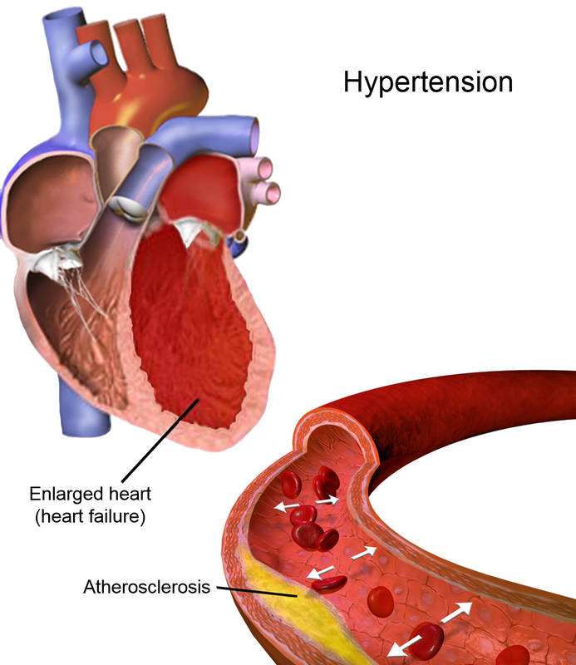
In today’s society sickness and disease have grown enormously and continues to get worse as time goes by. Even with the medications and treatments that have been developed by scientist and doctors, the issue of having these diseases are still a common reason for many deaths within our country. One major issue that American citizens are dealing with is having high blood pressure, scientifically known as hypertension. This is a condition that deals with high forces of blood moving against the artery wall. The blood is being forcefully pumped out of the heart harder which contributes to a lot of diseases and illnesses that potentially can be life threatening. Most of the time symptoms of this illness are not easy to recognize if there are any at all, unless you become at a life-threatening level and experience symptoms that make you concerned about your own health. Within this chapter you will learn about the history, causes, life-threatening symptoms, and also the treatments that can help to lower blood pressure and get it at a controllable level that doctors consider normal and are comfortable with.
Hypertension was discovered about 50 years ago and was looked at as an untreatable condition. In China and India (ancient) an individual’s pulse was the way that the cardiovascular system was checked by doctor’s. Commonly known as “hard pulse”, this was the way that blood pressure was tested, which helped to acquire what hypertension was; a concept founded by Akbar Mahomed. Akbar Mahomed was a physician that worked in a hospital in London and defined high blood pressure as an “essential hypertension”; this definition helped to isolate hypertension from vascular issues similar to what is known as “Bright’s Disease”. He detected that this disease can potentially be as concerning as renal failure and other related diseases. Most of the characteristics of blood pressure that Mahomed saw within patients were that this disease happened among the older population. Which gives more of an idea as to why the older generation seems to have the highest percentage of people that deal with hypertension (high blood pressure).
As many of us know, President Roosevelt dealt with many illnesses in his lifetime and we understand that his death was caused by a hemorrhagic stroke. Knowing the cause of President Roosevelt’s death, it was a huge shock to most because he was given a clean bill of health by his doctors, which brought more attention to the disease itself causing more research to be done because his health was actually in turmoil. When Roosevelt went for check-ups, high blood pressure during that time was not easily discovered because there weren’t any ways to specifically check for it. After his death an act was passed called “National Heart Act”, signed by President Truman, which was created to study the heart diseases. This act also resulted into the study known as the “Framingham Heart Study”. The study helped to show that hypertension was connected with a lot of cardiovascular illnesses like heart failure, stroke, and heart attacks which can lead to deaths prematurely, causing the risk of high blood pressure to become greater with these added issues happening within your body.
Previously stated the symptoms of hypertension are not easily detected unless you are in the stage of it becoming life-threatening. Almost 1/3 of people in the world don’t know they are dealing with high blood pressure. Hypertension is known as a “silent killer” due to the lack of symptoms. Research has been done and some of the symptoms that could be related to hypertension are:
- headache(severe)-happens in a hypertensive crisis
- vision problems
- chest pains
- irregular heartbeat
- pounding in your chest, neck, and ears
- difficulty breathing
- fatigue or confusion
- blood in the urine
Due to many causes and symptoms that are possible to have when dealing with blood pressure, studies have shown that there are two different types of blood pressure known as “primary (essential) hypertension” and “secondary hypertension”. Along with these different types the symptoms vary among them. The primary hypertension in adults, is not always identifiable and develops over the course of a life-span. The secondary hypertension is usually caused within people due to an underlying health issue. It is detected quickly and this is due to the blood pressure being so high, so nurses and doctors can detect it right away. Conditions involved with secondary hypertension include:
- kidney issues
- adrenal gland tumors
- thyroid problems
- sleep apnea
- defects that one is born with
- illegal drug use
all of these can play a factor in secondary hypertension.
With the research that has been done and all of the discoveries that have been made about hypertension there is more information on the causes and symptoms of the disease and how the detection of this disease is founded. Now that there are more high-end technologies, more skilled doctors, and physicians there are many ways to test and detect if a patient has high blood pressure or not. The old treatments weren’t detecting this issue very well which was the reason that many people believed that they had good health and found out later that any other illness they were dealing with were connected to them dealing with high blood pressure (hypertension) just like president John F. Kennedy.
Now that research has been done in regards to high blood pressure and the different potential causes and symptoms have been addressed, measurements of blood pressure, treatments, and ways to check your blood pressure at home will now be discussed.
When a patient goes to a doctor now, blood pressure is one of the first to be checked by the nurse. During this check doctors want to check for the systolic and diastolic numbers to make sure that they are in normal range. The systolic pressure measures the amount of pressure in your blood vessels as your heart beats. The diastolic pressure measures the pressure in your arteries once the heart is at rest between beats. These measurements are read on a sphygmomanometer; this meter has a cuff that wraps around your arm and is attached to a dial that shows digitally the numbers of systolic and diastolic pressure. Once the blood pressure is taken usually the doctor goes over the results and explains the different categories of blood pressure readings for patients that are unsure of what the numbers mean.
Normal range for blood pressure is, if its below 120/80, elevated blood pressure is if the top number (systolic) is between 120 and 129 and the diastolic pressure is below 80, stage 1 hypertension has a systolic pressure between 130 to 139 and a diastolic pressure between 80 to 89, and stage 2 hypertension is more dangerous than stage 1 hypertension the systolic pressure is 140 and higher, and the diastolic pressure of 90, Figure 1 shows a table with the same information so you’re able to visualize.
Blood Pressure | Systolic Pressure (mmHg) |  | Diastolic Pressure (mmHg)
Normal | Less than 120 | and | Less than 80
Elevated | 120-129 | and | Less than 80
Stage 1 Hypertension | 130-130 | or | 90 or higher
Stage 2 Hypertension | 140 or higher | or | 90 or higher
Hypertensive Crisis | Higher than 180 | and/ or | Higher than 120

Along with the information provided in order to treat the more elevated cases of high blood pressure, doctors have found different medications that will help with the more severe cases that also involves the lifestyle change you have to take in helping the process of lowering the blood pressure. There are a list of medications that will help and they include Thiazide diuretics, which are “water pills” and they work on your kidneys to help the body to eliminate sodium and water, which will reduce the blood volume, Angiotensin-converting enzyme (ACE) inhibitors, these include medications such as Lisinopril, captopril, benazepril, and many others that help to relax blood vessels. Angiotensin II receptor blockers (ARBs) are also a medication that doctors would recommend you to take and they also help to relax blood vessels, along with calcium channel blockers who also help relax blood vessels and studies have shown that this particular medication helps with elder people more than the ACE inhibitors. Of course there are more medications that can be subscribed to a patient but it all depends on the type of blood pressure and category you are dealing with.
Of course with many illnesses, most times patients are able to make minor changes within their lifestyle that will help to reduce the high levels and also cure and get rid of whatever they are dealing with. As far as high blood pressure (hypertension) goes home remedies to helping with high blood pressure include exercising daily, changing diet, managing stress better, and keeping away from caffeine. Although these are not the only ways to start helping yourself at home, these are a few of the issues that many people deal with on a daily.
High blood pressure can be maintained and can get back to a normal range. With the help of doctors, physicians, and information provided about hypertension you as the patient can take control yourself to become healthier. Buying a meter to read you blood pressure at home can also be a great source in taking control of the illness and being able to see for yourself if you need to go see a doctor or make a change in your everyday lifestyle.

Vocabulary:
- Hypertension- is a condition that deals with high forces of blood moving against the artery wall
- Systolic pressure- measures the amount of pressure in your blood vessels as your heart beats
- Diastolic pressure- measures the pressure in your arteries once the heart is at rest between beats

References

“Better Information. Better Health.” WebMD, WebMD, www.webmd.com/default.htm.
“High Blood Pressure (Hypertension).” Mayo Clinic, Mayo Foundation for Medical Education and Research, 12 May 2018, www.mayoclinic.org/diseases-conditions/high-blood- pressure/diagnosis-treatment/drc-20373417.
“High Blood Pressure (Hypertension).” Mayo Clinic, Mayo Foundation for Medical Education and Research, 12 May 2018, www.mayoclinic.org/diseases-conditions/high-blood- pressure/symptoms-causes/syc-20373410.
“Hypertension.” Wikipedia, Wikimedia Foundation, 1 Apr. 2019, en.wikipedia.org/wiki/Hypertension.
Pappas, Christopher. “Writing Learning Objectives For ELearning: What ELearning Professionals Should Know.” ELearning Industry, 12 Mar. 2018, elearningindustry.com/writing-learning-objectives-for-elearning-what-elearning- professionals-should-know.
Saklayen, Mohammad G, and Neeraj V Deshpande. “Timeline of History of Hypertension Treatment.” Frontiers in Cardiovascular Medicine, Frontiers Media S.A., 23 Feb. 2016, www.ncbi.nlm.nih.gov/pmc/articles/PMC4763852/.
“Why High Blood Pressure Is a ‘Silent Killer.’” Www.heart.org, www.heart.org/en/health- topics/high-blood-pressure/why-high-blood-pressure-is-a-silent-killer.

