Introduction to Virology
Introduction
Have you ever had the flu or been sick and not prescribed antibiotics? This is due to the fact that these diseases are caused by viruses. Virus blur the line between what is truly alive and what is merely a complex chemical. Virus are all around us, In the soil beneath our feet, the air we breathe, and even the water we drink. Virus have existed since the beginning of primordial organisms and play a key role in the complex but delicate balancing act required to maintain a wholistic balance within the environment and even in our bodies. Influenza, Herpes, Hepatitis, AIDS, and Ebola are all communicable viral infections that impact modern society and that you might have heard from in the media. Just as they play a key role in the environment some viruses can be beneficial to humans while many that we know can be anywhere from annoying to life threatening. Unlike any other living thing on this earth viruses cannot solely produce offspring through their species, they require a host cell and host mechanisms to produce offspring. Through this short chapter you will learn more about virus morphology, modes of infection, role in society, and even the future of viral treatments.

Viral Morphology
A virus is a broad term describing any microscopic being that requires a host cell to proliferate and produce offspring. This process of proliferation Is what makes the virus so unique and ubiquitous from other true living organisms that can reproduce and create an offspring without the need for other organisms outside their species. The relationship between the virus and its host is both delicate and intricate as the ultimate goal of the virus is not to wipe out the host but to use it as a tool for its perpetuation and ultimate survival. In doing so viruses have developed multiple techniques and tricks to avoid innate host responses and manipulate the host to work towards the goals of the virus.

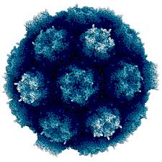
Figure 1: Viral Capsid Source:https://asknature.org/strategy/capsid-proteins-self-assemble-to-form-stable-shell/#.XKbUPC3MxQI
Viruses usually have two key components that assist in primary infection of the host cell. The capsid is the head of the virus and is what contains the viral genome and a few proteins that assist with genome integration into the host cell (Boundless, 2019). Then there is the “Syringe” of the virus that is used to assist in the physical hurdle of the cell’s external membrane and bypassing that membrane. Typically the virus takes advantage of external receptors or produces an enzyme that degrades the external membrane to the point of viral genome insertion (Boundless, 2019). After the host cell has been infected the all parts other than the viral genome are no longer necessary and are essentially abandoned outside the host cell.

Modes of Infection
Viruses are highly specialized agents and are the most lethal component of the ecosystem. With that said viruses are capable of having multiple host and even “accidentally” infecting an organisms that is not their host. The primary introduction of a virus to a multicellular organism is through a mucosal membrane in humans (Gelderblom, 1996). The mucosal membrane is the primary site of interaction that is consistently exposed to environmental agents. Viruses take advantage of this site as a primary pathway to infect somatic cells. Naturally they have to avoid our immune system to prevent form being discovered, specifically from antibodies and antigen recognition pathways as well as CD+ T Cells which can recognize and destroy infected host cells essentially eliminating the chance for progeny to be produced (Gelderblom, 1996).
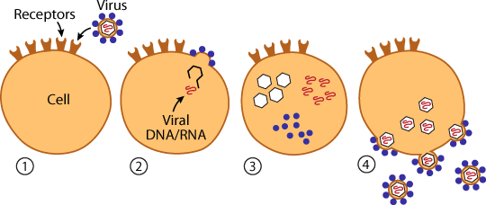
Figure 2:Basic overview of Viral infection of Eukaryotic Cell Source: https://askabiologist.asu.edu/virus

Diseases Caused by Viruses
Viral Disease are some of the most lethal communicable diseases known to medicine. They take advantage of our innate mechanism of survival and use them to self-replicate. The ultimate goals of a human virus is not to kill the host but become incorporated into the hosts genome as a commensal relationship between the human host and the virus. The symptoms are disease due to viral infection are factors of the viral replication either from viral toxins in the genome expressed during replication, lytic cell death due to replication, or intensive activated immune responses such as anaphylaxis (Gelderblom, 1996). The key to viral survival is ultimately not to kill the host and yet we are surrounded by viral infections like Ebola which have terrifying and extremely lethal symptoms.
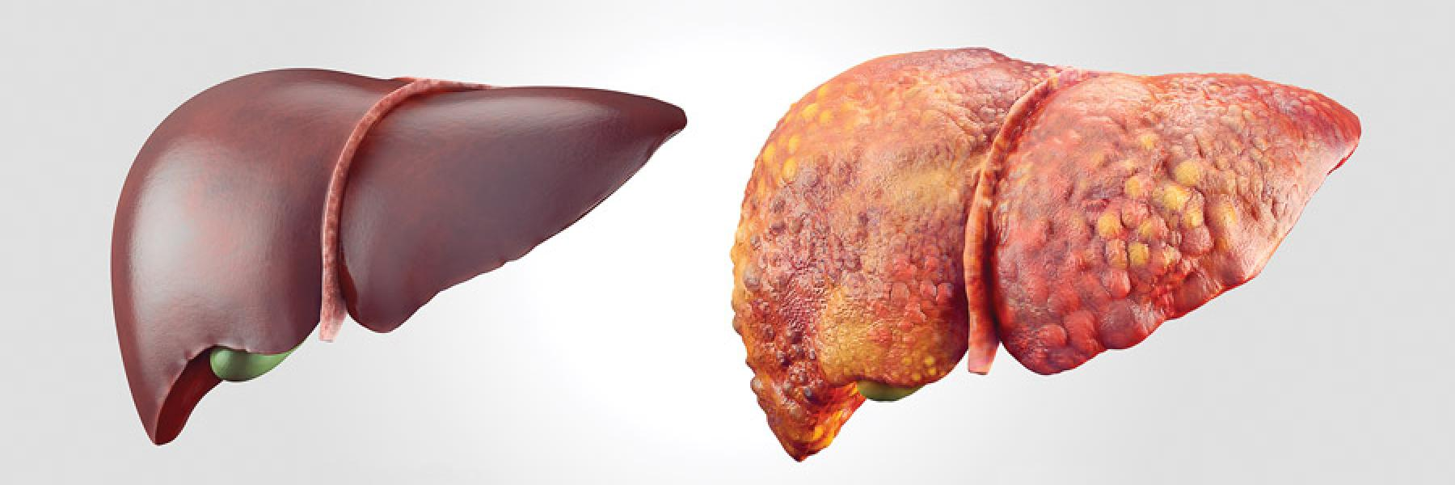
Figure 3:Image of a healthy liver next to one infected with hepatitis Source: https://www.positivelyaware.com/articles/your-liver-and-hepatitis—-primer

Spotlight on Herpes Simplex Virus

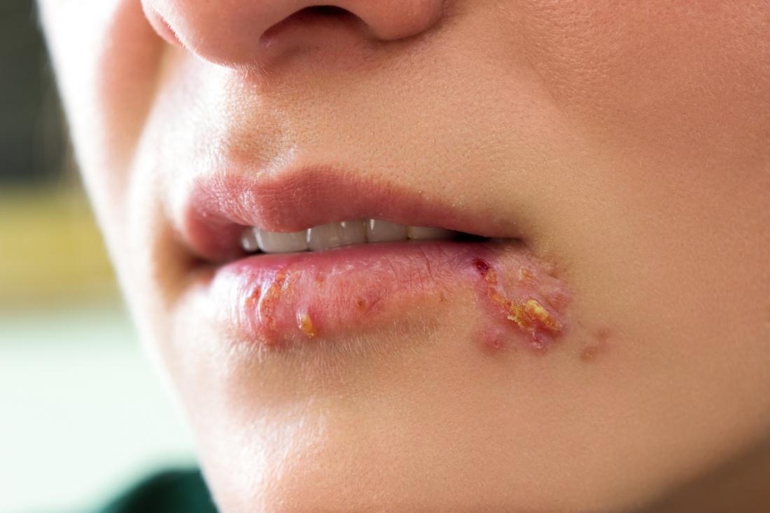
The Herpes Simplex virus is a great example of a common human viral pathogen found across the world. The herpes simplex virus is spread through contact of an infected mucosal membrane with that of an uninfected mucosal membrane. Mucosal membranes are found throughout the body, whether it be in the genital track or within the mouth, and act as the primary immune defense against internal pathogens (Fatahzadeh, 2007). This means the Herpes Simplex virus can be transmitted through unprotected sex with an infected individual and even by directly drinking after an infected person. The Herpes Simplex virus then infects surround cells and integrates its genetic sequence into the genes of the host cell (Fatahzadeh, 2007). By infecting host cells the herpes virus can hide itself from the host immune system, and when the cell is stressed the herpes virus can “jump ship” by breaking free of the cell and infecting the surrounding tissue.
Figure 4: Oral Herpes Source:https://www.google.com/url?sa=i&rct=j&q=&esrc=s&source=images&cd=&cad=rja&uact=8&ved=2ahUKEwju1JzyhrjhAhUHVa0KHVlwCgoQjRx6BAgBEAU&url=https%3A%2F%2Fwww.medicalnewstoday.com%2Farticles%2F151739.php&psig=AOvVaw3I_Q7i3i3UA5hoYy68kwtQ&us
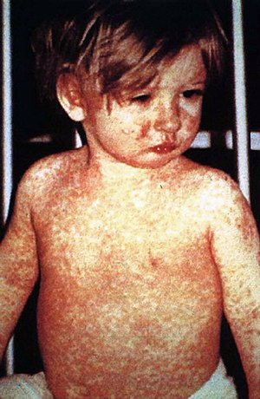
Figure 5: Child with Measels Source:https://www.health.govt.nz/our-work/diseases-and-conditions/measles-information-health-professionals
Viruses in Society and Media
The Media and Society are constantly trying to bring about awareness of disease and person health phenomena that takes place around the world. The Anti-Vax movement is a recent issue that is taking front stage as a considerable amount of communicable viral diseases that are highly lethal can be prevented through vaccination. Vaccines have been so success that some of the public see them as unnecessary and possibly even harmful to the user, most of which has been debunked by verified and accredited sources. Part of the reason why vaccines are so effective is the idea of herd immunity where if 95% of a population is vaccinated against a disease the 5% that cannot receive the vaccine for legitimate reason, either having a compromised immune system or due to age, are protected (WebMD, 2018). When that number drops too low everyone including those who are immunized can be exposed to the viral pathogen.
Measles outbreaks have skyrocketed across the United States and other developed countries that correlates to a decrease in localized immunizations. Oregon recently had an outbreak of the measles virus hospitalizing a group of children and young adults while leaving infants at risk for exposure due to the fact that they are too young to receive the vaccine. Along with the decreasing amount of immunizations and increased number of infections, mutations in these viruses which were at one point almost eliminated could make them physiologically resistant to current vaccines as with each infection and round of replication the viral progeny stand an increased chance of developing the morphological qualities needed to overcome vaccine related antigen recognition (WebMD, 2018).

Sources
Boundless. “Boundless Biology.” Lumen, courses.lumenlearning.com/boundless-biology/chapter/viral-evolution-morphology-and-classification/.
Gelderblom, Hans R. “Structure and Classification of Viruses.” Medical Microbiology. 4th Edition., U.S. National Library of Medicine, 1 Jan. 1996, www.ncbi.nlm.nih.gov/books/NBK8174/.
Fatahzadeh, Mahnaz. “Human Herpes Simplex Virus Infections: Epidemiology, Pathogenesis, Symptomatology, Diagnosis, and Management.” NeuroImage, Academic Press, 14 Oct. 2007, www.sciencedirect.com/science/article/pii/S0190962207010456.
“Immunizations and Vaccines: Benefits, Risks, Effectiveness.” WebMD, WebMD, www.webmd.com/children/vaccines/immunizations-vaccines-power-of-preparation#1.
“Measles | For Healthcare Professionals | CDC.” Centers for Disease Control and Prevention, Centers for Disease Control and Prevention, www.cdc.gov/measles/hcp/index.html.

