A review about commensal bacteria making GPCR ligands that mimic human signaling molecules
Author: Yu Dai
Major: Chemistry
Department of Microbiology and Molecular Genetics, Oklahoma State University, Stillwater, OK 74078, USA
Key Words:
Gastrointestinal bacteria, GPCR, bioinformatics, synthetic biology, gene editing

Abstract: Although the human microbiome is important to human physiology, the mechanisms are poorly explained. Human microbiome (including commensal bacteria) and human cells communicate closely through signaling molecules. This review focuses on identifying these signaling molecules and host receptors. By using the techniques of bioinformatics and synthetic biology, Brady et al. from Rockefeller University discovered that one of the metabolites of gastrointestinal bacteria, N-acyl amides, are ligands of G-protein-coupled-receptors (GPCRs). The interaction between N-acyl and a kind of GPCRs called GPR119 can regulate metabolic hormones and glucose homeostasis. This research illustrated that the chemical mimicry of signaling molecules may be common among commensal bacteria. We can genetically edit the gastrointestinal bacteria, allowing them to produce N- acyl amides, which presents a possible microbiome-biosynthetic gene therapy for relating diseases.

Introduction
Commensal bacteria refer to bacteria that live with organisms. Gastrointestinal bacteria are a kind of commensal bacteria with significant importance in human physiology. They contain more than 2 billion genes and theoretically have extremely complex metabolic pathways. Gastrointestinal bacteria can produce a large number of metabolites that cannot be formed by the human body, such as short-chain fatty acids, vitamins, polyunsaturated fatty acids, oligosaccharides and secreted proteins. And they may also produce various neurotransmitters and neuroactive substances. They use small molecules that they produced to interact with their environment.
However, little is known about the molecular mechanisms by which bacteria regulate mammalian physiology. The study of these small molecules and the identification of host receptors has potential medicinal value because the gene modification of bacteria is rather easy and GPCR is a common drugs target.

Recent Progress
GPCR is the largest class of membrane protein receptors and is the most common target for current drugs. Previous research shows that a human microbiota-encoded long-chain N-acyl amide is able to interact with some kind of GPCRs. And these GPCRs are related to many diseases like diabetes, obesity and cancer. From this we can assume that N-acyl amides metabolized by gastrointestinal bacteria have similar structure with human signaling molecules.
In order to identify N-acyl synthase (NAS) genes within human microbial genomes, Brady from Rockefeller University searched the Human Microbiome Project sequence data and 143 human microbial N-acyl synthase genes were found. Subsequently, 44 different NAS genes were selected for synthesis and heterologous expression. After transfecting these NAS genes into E. coli, the author divided the metabolites into six N-acyl amides families, which are: (1) N-acyl glycine; (2) N-acyloxyacyl lysine; (3) N-acyloxyacyl glutamine; (4) N-acyl lysine/ornithine; (5) N-acyl alanine; (6) N-acyl serinol.
Further experiments concerning NAS genes confirmed that the N-acyl amides above are regular metabolites of the bacteria that contain NAS genes. Meanwhile, compared with bacteria in other parts of human, NAS genes above is more abundant in gastrointestinal bacteria, and its metabolite is mainly the first type, namely N-acyl glycine.
For the purpose of determining the interaction between N-acyl-amides and gastrointestinal GPCRs, the main N-acyl amide was isolated form each classification and their activity against 240 human GPCRs was determined. One of the strongest agonist interactions is the activation of GPR119 by N-palmitoyl serinol. Many other agonist and antagonist activities were found. Those GPCRs targeted by N-acyl amides can interact with immune cells and affect many functions including immune cell differentiation, immune cell transport, metabolism and tissue repair.
The author also analyzed the structural feature of N-acyl amides. The human microbial-encoded N-acyl amides have structural similarities to the endogenous GPCR active ligands. The clearest structural and functional similarity is for the endogenous cannabinoid receptor GPR119. Endogenous GPR119 ligands include oleoylethanolamide (OEA) and the dietary lipid-derivative 2-oleoyl glycerol (2-OG). The structural difference between analogues of N-acyl serinol and OEA or 2-OG is rather small. Experiments showed that oleoyl analogs of N-acyl serinol differs from 2-OG only in that the amide substituted the ester and the difference from OEA was the presence of additional methanol substitution, as is shown in Figure 1.
The author’s research team then focused on the function of GPR119 agonists by experimenting on mice. The result is that, GPR119 agonists (OEA, 2-OG) affect not only glucose homeostasis but also gastric emptying and appetite through metabolic hormones. The regulation is achieved by the release of two hormones: GLP-1 and insulin. It is also demonstrated that N-oleoyl serinol can similarly function as OEA or 2-OG, promoting the release of GLP-1.
Since GPR119 ligand is closely related to glucose metabolism, the authors further studied the effect of bacterial N-acyl amide on glucose metabolism. The authors genetically manipulated E. coli to express N-acyl serinol synthetase, then performed gavage on mice for a week. The blood glucose levels of the treated mice were found to be significantly reduced.

Discussion
The close relationship between gastrointestinal bacteria and disease has been well confirmed, and the gastrointestinal bacteria has been recognized as an important drug target.
The major innovation of the study is using bioinformatics methods to find new drug molecules based on known drug targets. This should give us new ideas in pharmacology research. Then we can genetically edit the gastrointestinal bacteria, allowing bacteria to produce N- acyl amides that bind to GPR119. One of the favorable conditions of editing bacterial genes for disease treatment is that the genes of these gastrointestinal bacteria are easier to manipulate than human genes. Actually, all of the bacterial genes in our human body have been completely sequenced before.
However, besides N-acyl amides, gastrointestinal bacteria must have many other metabolites that mimic human signaling molecules in order to perform complex biological functions. Maybe we can conduct a large-scale functional review of signaling molecules secreted by gastrointestinal bacteria and develop this microbiome-biosynthetic gene therapy.

References

Cohen, Louis J. , et al. "Functional metagenomic discovery of bacterial effectors in the human microbiome and isolation of commendamide, a GPCR G2A/132 agonist." Proceedings of the National Academy of Sciences (2015):201508737.

Cani, Patrice D , et al. "Endocannabinoids - at the crossroads between the gut microbiota and host metabolism." Nature Reviews Endocrinology 12.3(2015):133.

PÃ¡l Pacher, and G. Kunos . "Modulating the endocannabinoid system in human health and disease—successes and failures." Febs Journal 280.9(2013):1918-1943.

Cohen, Louis J. , et al. "Commensal bacteria make GPCR ligands that mimic human signalling molecules." Nature. (2017) doi:10.1038/nature23874

Figure 1

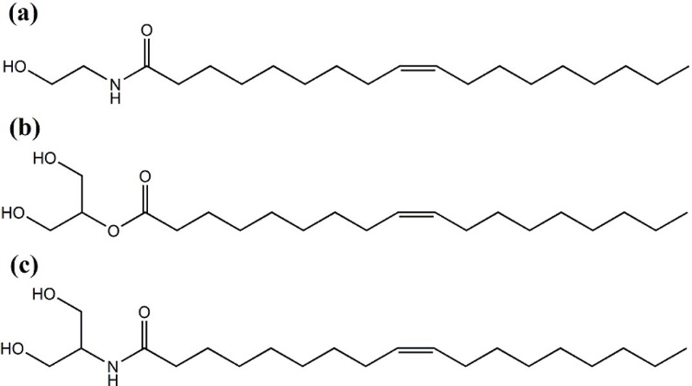

(a) OEA; (b) 2-OG; (c) Oleoyl analogs of N-acyl serinol
They have similar structures.

