Network Analysis Empowers the Prediction of Prognosis of Cancer Patients
Author: Yujie Liu
Major: Biochemistry
Kuang Yaming Honors School, Nanjing University, 163 Xianlin Avenue, Nanjing, Jiangsu Province, China
Key Words:
Network analysis; Gene mutation; Cancer; Prognosis prediction
Abstract Cancer derives from the combination of interactions between mutated genes in the molecular network. Network Analysis is a powerful tool for modeling biological systems, thus is widely used in the field of understanding the interaction between different genes, the development of various diseases. And the prediction of prognosis of cancer patients is highly convincing. Some examples using network analysis to study and research diseases, especially human cancer, are given in the wake of basic principle and operational method.

Introduction

One explanation for the detriment of cancer is that uncommon cancer signaling often disturb normal human signaling networks and motifs by altering and transforming dominant genomic factors through ways such as gene mutation, where the definition of signaling network motifs is that “they are a group of interacting proteins acting in the network together and are capable of signal processing. ^{[1]}” With the study of the distributions and interaction of these crucial network motifs and their signaling process and fluctuations, we can have access to the basic surface of these mechanisms and identify these loops. These can be practically useful in the prediction of prognosis of cancer patients.
A theory has been established that the reason behind the survival, proliferation, dissemination, colonization and metastasis of cancer cells is that “they acquire functional capabilities in different tumors at various time points during tumorigenesis by activating distinct hallmark networks.^{[2]}” With regard to multi-dimensional analysis of cancer survival networks, the significant major drivers of tumorigenesis, i.e. gene mutations, also have other capacities for biological markers. The evolving cells gain other traits mainly based on the activation of the mutation network. Then we can analysis the formation, development and vanishing of these traits to track the change of some cancer cells.
In the paper “Network Analysis Reveals A Signaling Regulatory Loop in the PIK3CA-mutated Breast Cancer Predicting Survival Outcome ^{[1]}” it describes a method for establishing the foundation of network analysis. Essential data are collected from online databases; Luminal A survival network is constructed by mapping relevant essential genes, driving regulators and proliferation-influencing genes(one gene in a given cell line having an RNAi-screening P value < 0.1 but > 0.05) onto the whole signaling network and picking out relevant nodes and links between each useful node afterwards. Then comes to the period of network propagation, motif detection and other auxiliary methods for evaluation and analysis. Network propagation algorithm is applied in this period to obtain diffusion scores of each gene distributed among the whole network and mFinder tool is applied to build mature network motifs. At the time all these above are done, the survival network is successfully established and then we can choose appropriate computational tools to do analysis for related aspects.

Recent Progress

Cancer Hallmark Network Framework has been implied in the investigation of PIK3CA mutations interactions in luminal-breast cancer, as is reported by “Network Analysis Reveals A Signaling Regulatory Loop in the PIK3CA-mutated Breast Cancer Predicting Survival Outcome ^{[1]}” in 2017. The interactions are attempted to be used to do prediction of clinical outcomes, especially the survival chances of breast cancer patients, and receives favorable results. Firstly, the chances of PIK3CA gene mutations are closely linked to luminal A breast cancer subtype, which means PIK3CA gene plays a vital role in the development of this cancer. As the result of some comparative research, PIK3CA mutations alone are not related to the survival of luminal A breast cancer patients, while its interaction with other mutated genes plays an important role in cancer progression and metastasis. Secondly, they did a Cancer Hallmark Network Framework-based study of cancer genome sequencing data in the aspect of FFL (feed forward loop) motifs, whose outcome explains a close relation between FFL and clinical outcomes. It is concluded by “it could be hypothesized that the FFL network motif in the PIK3CA-mutantion/SHC1-loop+ samples may induce a protective mechanism, thus incurring a significantly-reduced recurrence rate in the first 5 years after diagnosis. ^{[1]}”, which represents that the systematic research based on the Cancer Hallmark Network Framework reveals that FFL is significantly enriched in the PIK3CA-mutated luminal-A cancer patients, whose positively regulating loop increases their chances of long time survival. As a predictive index for the survival of the PIK3CA-mutated luminal-A cancer patients, FFL will and should be investigated more precisely and deeply to lead to better predictions and more personalized treatment.
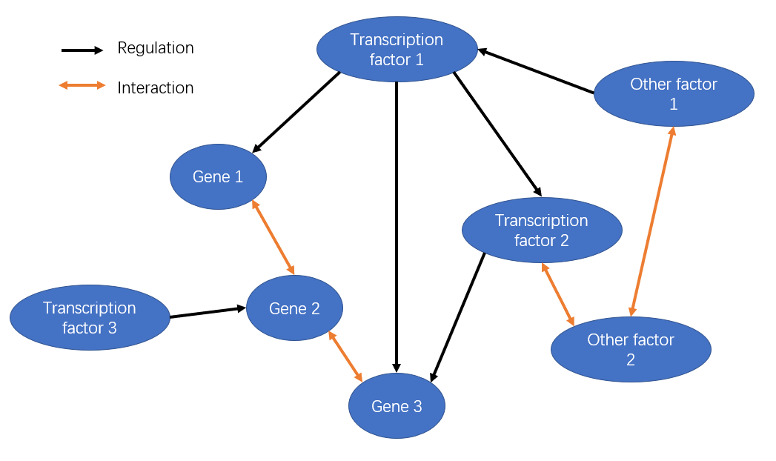
Figure 1. Schematic diagram for FFL

With the progress in genomics and proteome, breast cancer research methods and treatment approaches have been changed due to various molecular characterization. As is reported by “Breast cancer quantitative proteome and proteogenomic landscape ^{[3]}” in Nature Communications, useful products in the form of proteins are located to have interaction with some special non-coding genomic regions, which is identified and classified recently. This may provide one way to develop “a potential new class of tumor-speciﬁc immunotherapeutic targets ^{[3]}”.
Some other cancers’ prognosis predictions have been in quick development. For instance, a few studies are intended to investigate the relationship between the expression of GATA6 (a specific stem cell factor) and its prognosis in ovarian cancer, whose result is that “GATA6 may act as a novel marker for poor prognosis in ovarian cancer ^{[4]}”, which reveals similar mechanism for some other factors insert into the expression and migration of some specific cancer.
Network analysis can also be used in the investigation of anti-lung cancer eﬀects of the natural compounds from Chinese herbs on apoptosis, cell cycle progression, autophagy, and the expression of related proteins, as is reported in a recent publication “Network analysis and mechanisms of action of Chinese herb-related natural compounds in lung cancer cells ^{[5]}”. With such useful and contemporary methods and tools, the mechanisms behind the Chinese life-saving herbs can be understand more clearly.

Discussion

With the development of some contemporary methods and tools, we can view most of lives on earth form a different and entirely new perspective, which is and will also be the biggest advantage we have to investigate some diseases, especially cancer.
However, these computational analysis methods and network building process may not be accepted by all of the scientists, so all the citizens. Based on the database or so called “big data”, these analysis results may not be suitable for all the patients, and some personalized analysis may not be quite precise because the methods and database are based on other people and past cases, which may not be useful in the prediction of just one patient. So these tools can gain some significant results maybe in statistics, and what the next period we should do is that we need to find out some useful and related results from the sink of outcomes and do some trial attempt in developing novel treatment of every individual patient.

References

[1] Mcgee, S. R., et al. "Network Analysis Reveals A Signaling Regulatory Loop in the PIK3CA-mutated Breast Cancer Predicting Survival Outcome:." Genomics Proteomics & Bioinformatics 15.02(2017):77-85.
[2] Gao S, Tibiche C, Zou J, Zaman N, Trifiro M, O’Connor-McCourt M, et al. Identification and construction of combinatory cancer hallmark-based gene signature sets to predict recurrence and chemotherapy benefit in stage II colorectal cancer. JAMA Oncol 2016;2:37–45.
[3] Henrik J. Johansson et al. “Breast cancer quantitative proteome and proteogenomic landscape”. Nature Communications. (2019) 10:1600.
[4] Weiwei Shen, Na Niu, et al.GATA6: a new predictor for prognosis in ovarian cancer,Human Pathology,86,(2019):163-169.
[5] Ying-Ju Lin, Wen-Miin Liang, et al.Network analysis and mechanisms of action of Chinese herb-related natural compounds in lung cancer cells, Phytomedicine. 58,(2019).

